
CAMPUS COIN
Student Financial Management & Campus Wallet System
PROJECT DOCUMENTATION
━━━━━━━━━━━━━━━━━━━━━━━━━━━━
SUBMITTED BY
Muhammed Wasay — 1685946
Saad Ameen — 1655913
Maryam Akbar — 1677643
Abbas Ali — 1676687
Syed Wasil Ali — 1676543
Yousuf Ul Haq — 1685962
APTECH SCHEME 33 • ACADEMIC YEAR 2026
Laravel • PHP • MySQL • HTML • CSS • JavaScript • Bootstrap

1. INTRODUCTION

1.1 Introduction
Campus Coin is a web-based student financial management system designed to simplify and organize financial activities within a campus environment.
The system provides a centralized platform where students can manage their campus-related financial transactions, view their available balance, maintain transaction records, and access relevant financial services.
The purpose of Campus Coin is to reduce dependency on manual financial records and provide a more organized, transparent, and convenient digital solution for managing student campus transactions.
The application uses a web-based architecture with Laravel as the backend framework and MySQL as the database management system. The frontend provides a simple and responsive interface that allows users to access the system through a web browser.

1.2 Background
Students may need to make payments and manage financial transactions related to different campus activities and services. When these activities are handled manually, maintaining accurate records can become difficult.
Traditional methods may involve manual transaction records, cash-based payments, difficulty tracking previous transactions, lack of centralized financial information, time-consuming administrative processes, and the possibility of human errors.
Campus Coin addresses these issues by providing a centralized digital system for managing campus financial information and transactions.

1.3 Problem Statement
Managing student financial transactions through manual methods can create difficulties for both students and administrators.
Students may have limited visibility of their transaction history and current balance, while administrators may need to maintain multiple records manually.
There is therefore a need for a centralized system that can maintain student financial records, track transactions, display account balances, provide secure user authentication, allow administrators to manage system data, reduce manual record keeping, and improve accessibility and transparency.
Campus Coin is developed to provide a digital solution to these requirements.

1.4 Proposed Solution
The proposed system is a web-based campus wallet and financial management application.
The system allows registered users to securely log in and access the features available according to their role.
The main functions of the system include user registration and login, user authentication, student account management, wallet and balance management, financial transactions, transaction history, administrative management, database-based record keeping, and a responsive web interface.
The system stores information in a centralized MySQL database and uses Laravel to process requests and manage application logic.

1.5 Scope of the Project
The scope of Campus Coin includes the development of a web-based platform for managing student-related financial activities.
The system includes:
• User registration
• User login
• Authentication
• User dashboard
• Wallet and balance information
• Transaction management
• Transaction history
• Administrative functions
• Database management
• Secure access to system features
• Responsive web interface
The current version does not necessarily include integration with external banking systems, real-world payment gateways, or physical banking services unless these features are specifically implemented in the project.

1.6 Target Users

Students
Students can use the system to access their accounts, view wallet balance, view transaction history, manage available profile information, and perform available campus transactions.

Administrator
The administrator can manage users, monitor transactions, manage financial records, maintain system data, and access administrative dashboards.

2. PROJECT OVERVIEW AND OBJECTIVES

2.1 Project Overview
Campus Coin is designed as a centralized digital platform for campus financial management.
The application follows a client-server architecture. Users interact with the frontend through a web browser. Requests are processed by the Laravel backend, which communicates with the MySQL database.
The overall system consists of three major components: the user interface, the Laravel application backend, and the MySQL database.
[INSERT SYSTEM ARCHITECTURE DIAGRAM HERE]

2.2 Project Objectives
The main objectives of Campus Coin are:
- To develop a centralized digital financial management system for campus users.
- To provide students with easy access to their financial information.
- To maintain accurate records of financial transactions.
- To reduce dependency on manual record keeping.
- To provide secure authentication and authorization.
- To allow administrators to manage users and transactions.
- To improve transparency by maintaining transaction history.
- To provide a user-friendly and responsive interface.
- To store system information in a structured relational database.
- To develop the application using modern web development technologies.

2.3 Key Features

Authentication
The system provides registration and login functionality for users.

Dashboard
Users can view important account information from their dashboard.

Wallet Management
Students can view their available balance and related wallet information.

Transaction Management
The system records financial transactions and maintains transaction history.

User Management
Administrators can manage registered users.

Database Management
Important system information is stored in the MySQL database.

Responsive Interface
The application is designed to provide a usable interface across different screen sizes.

2.4 Technologies Used
Technology | Purpose
HTML | Structure of web pages
CSS | Styling and presentation
JavaScript | Client-side functionality
Bootstrap | Responsive user interface
PHP | Server-side programming
Laravel | Backend framework
MySQL | Database management
Git/GitHub | Version control
Visual Studio Code | Development environment
WAMP/XAMPP | Local development server

3. REQUIREMENTS ANALYSIS

3.1 Functional Requirements
Functional requirements describe what the system should do.

FR-01: User Registration
The system shall allow new users to register an account by providing the required information.

FR-02: User Login
The system shall allow registered users to log in using valid credentials.

FR-03: Authentication
The system shall authenticate users before providing access to protected areas.

FR-04: Dashboard
The system shall provide an appropriate dashboard after successful login.

FR-05: Wallet Information
The system shall display the user's available wallet and balance information.

FR-06: Transaction Management
The system shall record financial transactions performed through the system.

FR-07: Transaction History
The system shall allow users to view their previous transactions.

FR-08: User Management
The administrator shall be able to manage registered users.

FR-09: Transaction Monitoring
The administrator shall be able to view and monitor system transactions.

FR-10: Database Storage
The system shall store user, wallet, transaction, and other required information in the database.

3.2 Non-Functional Requirements

Security
The system should protect user accounts through authentication and authorization mechanisms.

Performance
The system should process normal user requests within a reasonable amount of time.

Usability
The interface should be simple and understandable for students and administrators.

Reliability
The system should maintain consistent financial and transaction records.

Maintainability
The application should use organized code and a structured database so that future modifications can be made easily.

Scalability
The system architecture should allow additional features to be added in the future.

Compatibility
The application should work with commonly used modern web browsers.

3.3 Hardware Requirements
The system can be developed and tested using a standard computer.
The minimum requirements include:
• Processor: Intel Core i3 or equivalent
• RAM: 4 GB or above
• Storage: At least 10 GB available
• Display: 1366 × 768 or above
• Internet connection for development resources and version control

3.4 Software Requirements
The software requirements include:
• Windows operating system
• PHP
• Laravel
• Composer
• MySQL
• Apache
• WAMP or XAMPP
• Visual Studio Code
• Web browser
• Git/GitHub

3.5 User Roles

Student
Students have access to their own account and financial information.

Administrator
Administrators have additional permissions for managing users, transactions, and other system information.

4. SYSTEM DESIGN

4.1 System Architecture
Campus Coin follows a layered web application architecture.

Presentation Layer
The presentation layer provides the user interface and contains frontend components such as HTML, CSS, JavaScript, Bootstrap, and Blade templates.

Application Layer
Laravel handles routing, authentication, validation, business logic, controllers, models, requests, and responses.

Database Layer
MySQL stores user information, wallet information, transaction information, and other application records.
[INSERT SYSTEM ARCHITECTURE DIAGRAM HERE]

4.2 Use Case Diagram
The main actors of the Campus Coin system are Student and Administrator.

Student Use Cases
A student can:
• Register
• Login
• Logout
• View Dashboard
• View Wallet
• View Balance
• View Transactions
• Manage available profile information

Administrator Use Cases
An administrator can:
• Login
• View Dashboard
• Manage Users
• View Transactions
• Manage Financial Records
• Monitor System Data
[INSERT USE CASE DIAGRAM HERE]

4.3 Data Flow Diagram — Level 0
The Level 0 Data Flow Diagram represents the Campus Coin system as a single major process and shows interaction between external users and the system.
The main external entities are the Student and Administrator. They interact with the Campus Coin system, while the system communicates with the database to store and retrieve information.
Level 0 DFD: Not separately provided in the uploaded materials. The supplied detailed DFD is included in Section 4.4 (Level 1).

4.4 Data Flow Diagram — Level 1
The Level 1 Data Flow Diagram divides the Campus Coin system into its major processes.
The major processes include:
- Authentication
- User Management
- Wallet Management
- Transaction Management
- Administration
Campus Coin Data Flow Diagram — Level 1
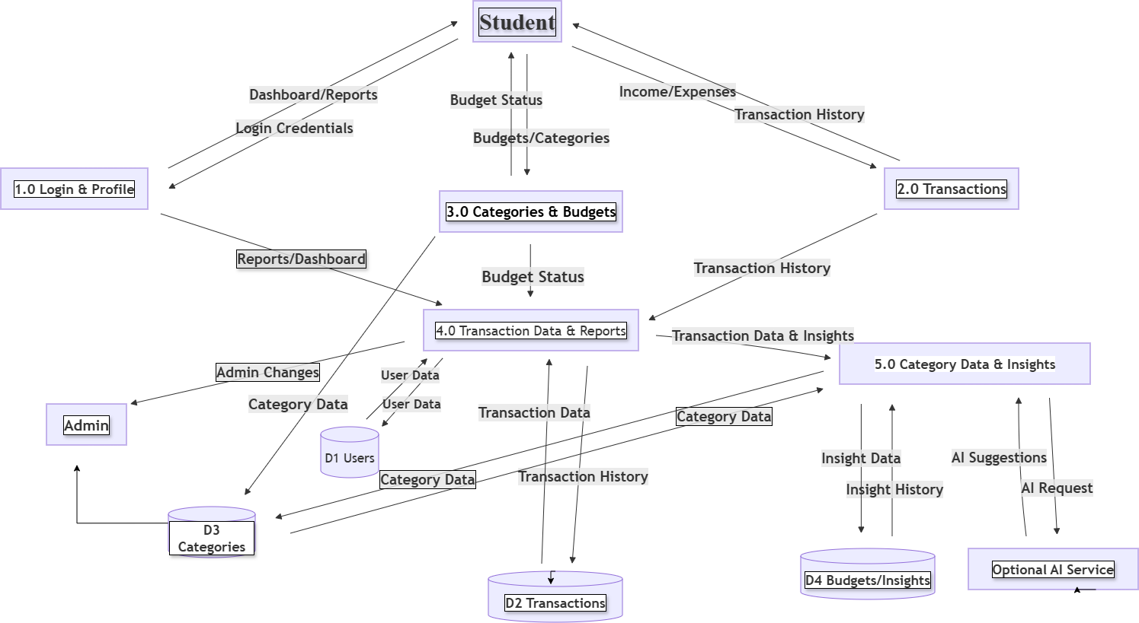
Figure: Data Flow Diagram (DFD) for Campus Coin

4.5 User Interface Design
The Campus Coin interface contains several major pages.

Login Page
Allows existing users to enter their credentials.
Figure: Campus Coin Login Page
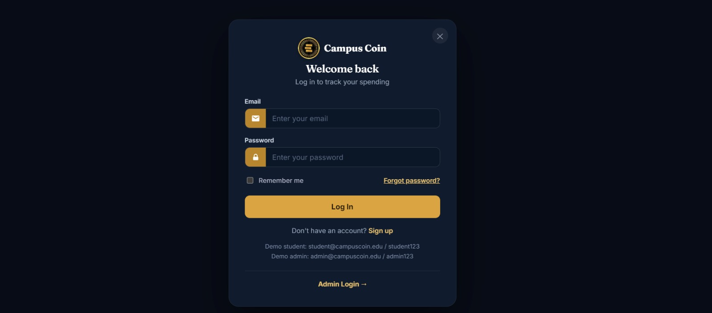
Figure: Campus Coin Login Page

Registration Page
Allows new users to create an account.
Figure: Campus Coin Student Registration Page
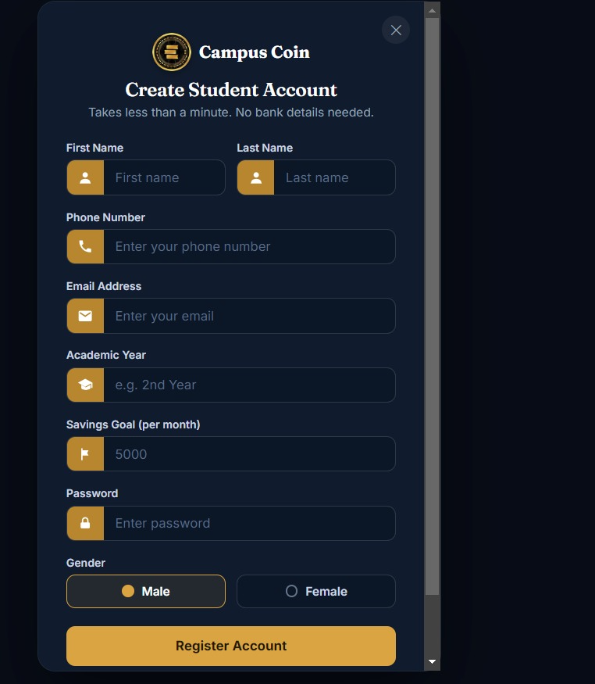
Figure: Campus Coin Student Registration Page

Student Dashboard
Displays important information such as user information, current balance, recent transactions, and available options.
Figure: Campus Coin Student Dashboard
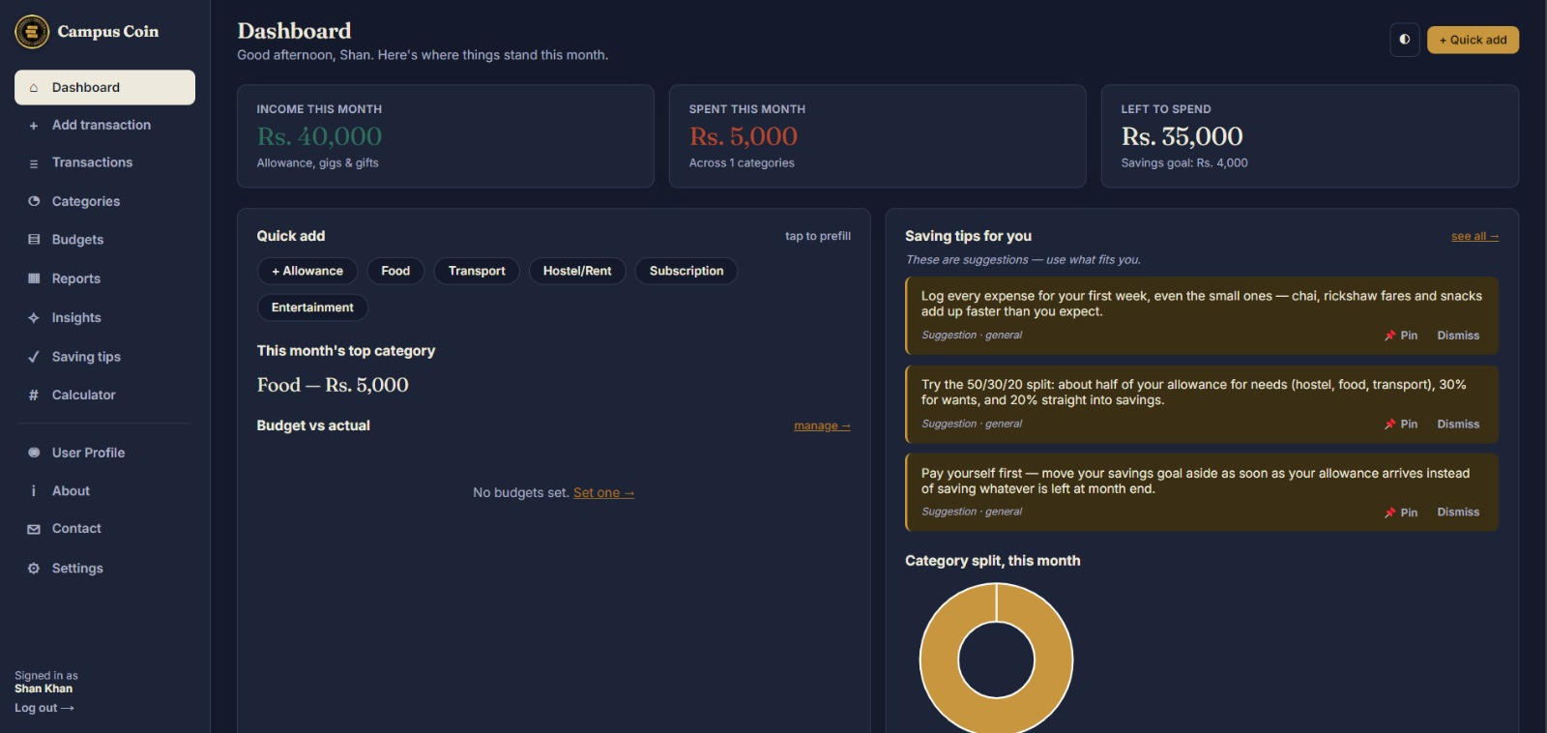
Figure: Campus Coin Student Dashboard

Transaction Page
Displays transaction-related information.
Figure: Campus Coin Transaction History
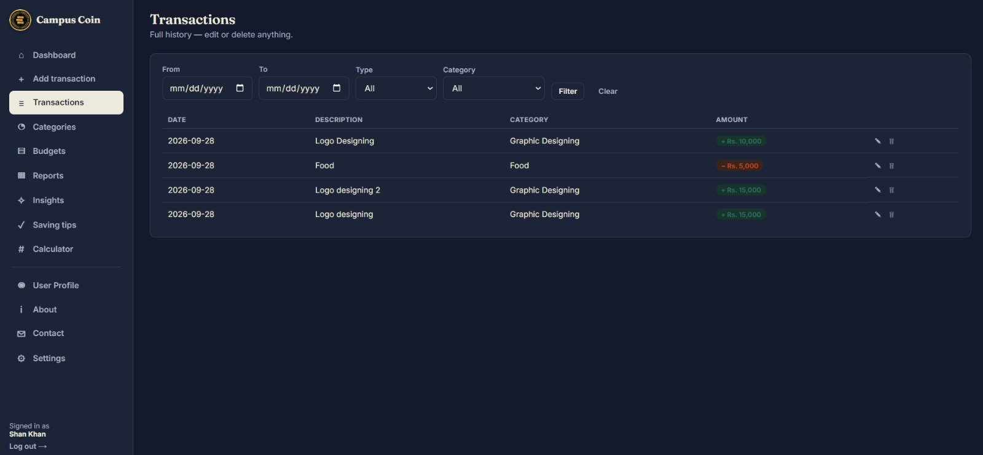
Figure: Campus Coin Transaction History

Admin Dashboard
Provides administrative information and management options.
[INSERT ADMIN DASHBOARD SCREENSHOT HERE]

5. DATABASE DESIGN

5.1 Database Overview
Campus Coin uses MySQL as its relational database management system.
The database is responsible for storing and organizing information required by the application.
The database is designed using relational database principles so that related information can be connected through primary keys and foreign keys.

5.2 Entity Relationship Diagram
The Entity Relationship Diagram represents the relationships between the main entities of the Campus Coin system.
The ERD should be created according to the actual database structure used in the project.
[INSERT ACTUAL ERD HERE]

5.3 Database Tables
The following tables should be documented according to the actual campus_coin.sql database.
Important: Replace this section with the exact tables, columns, data types, primary keys, and foreign keys from your actual database.

Table: Users
Purpose: Stores information about registered users.
Field | Data Type | Key | Description
[Field] | [Type] | [PK/FK] | [Description]
[Field] | [Type] | [PK/FK] | [Description]
[Field] | [Type] | [PK/FK] | [Description]

Table: Wallet
Purpose: Stores wallet-related information.
Field | Data Type | Key | Description
[Field] | [Type] | [PK/FK] | [Description]
[Field] | [Type] | [PK/FK] | [Description]
[Field] | [Type] | [PK/FK] | [Description]

Table: Transactions
Purpose: Stores financial transaction records.
Field | Data Type | Key | Description
[Field] | [Type] | [PK/FK] | [Description]
[Field] | [Type] | [PK/FK] | [Description]
[Field] | [Type] | [PK/FK] | [Description]

5.4 Primary Keys
A primary key uniquely identifies each record in a database table.
Each major table in the Campus Coin database should have an appropriate primary key.

5.5 Foreign Keys
Foreign keys establish relationships between database tables.
They allow records in one table to be associated with records in another table.

5.6 Database Relationships
The database relationships should be documented according to the actual relationships implemented in the Campus Coin database.
[INSERT DATABASE RELATIONSHIP DIAGRAM HERE IF REQUIRED]

6. SYSTEM IMPLEMENTATION

6.1 Development Environment
The Campus Coin application was developed using a local development environment.
The backend is implemented using Laravel and PHP, while MySQL is used for database management.
The project was developed and tested using Visual Studio Code and a local web server environment such as WAMP or XAMPP.

6.2 Laravel Project Structure
The Laravel project is organized into different directories responsible for different parts of the application.
The main directories include:
• app — application logic, controllers, models, and other backend components
• database — migrations and seeders
• resources — views, CSS, and JavaScript resources
• routes — application routes
• public — publicly accessible files
• storage — generated and stored application files
• tests — testing-related files

6.3 Routing
Laravel routes define how the application responds to different URLs.
Routes can be used for pages and functions such as:
• Home page
• Login
• Registration
• Dashboard
• Wallet
• Transactions
• Administrative pages
Web routes are generally maintained in the routes/web.php file.

6.4 Controllers
Controllers handle application requests and contain the logic required to process user actions.
Controllers may be used for:
• Authentication
• Users
• Wallets
• Transactions
• Administration
Controllers communicate with models and return appropriate responses or views.

6.5 Models
Laravel models represent database entities.
Models are used to interact with corresponding database tables and can define relationships between different entities.
Examples of models may include User, Wallet, and Transaction, depending on the actual project implementation.

6.6 Authentication
Authentication is used to ensure that only registered users can access protected areas of the system.
The authentication process involves submitting login credentials, validating the credentials, authenticating the user, checking the user's role where applicable, and redirecting the user to the appropriate dashboard.

6.7 Authorization
Authorization controls what an authenticated user is allowed to access.
Students should only access functionality available to students, while administrators can access administrative functionality according to their permissions.

6.8 Form Validation
The application validates user input before storing it in the database.
Examples of validation include:
• Required fields
• Valid email format
• Password requirements
• Numeric transaction amounts
• Valid user IDs
• Duplicate account prevention
Validation helps maintain data accuracy and improves system security.

6.9 Transaction Processing
When a transaction is performed, the application processes the request through the Laravel backend.
The general process includes submitting the transaction, validating the input, checking relevant wallet or account information, processing the transaction, updating the required information, saving the transaction record, and displaying the result.

6.10 Error Handling
The application provides appropriate responses when errors occur.
Examples include:
• Invalid login credentials
• Missing required fields
• Invalid transaction amount
• Unauthorized access
• Database errors
• Invalid routes
Error messages help users understand problems and correct their input.

7. TESTING AND RESULTS

7.1 Testing Introduction
Testing was performed to verify that the Campus Coin application works according to the specified requirements.
Different test cases can be used to verify authentication, user functions, wallet functions, transaction functions, and administrative functionality.

7.2 Functional Testing

Test Case 01 — User Registration
Test Objective: Verify that a new user can register.
Steps:
- Open the registration page.
- Enter valid user information.
- Submit the registration form.
- Verify that the account is created.
Expected Result: The system should successfully create the user account.
Actual Result: [Enter actual result.]
Status: [PASS/FAIL]

Test Case 02 — User Login
Test Objective: Verify login functionality.
Steps:
- Open the login page.
- Enter valid credentials.
- Click Login.
Expected Result: The user should be authenticated and redirected to the appropriate dashboard.
Actual Result: [Enter actual result.]
Status: [PASS/FAIL]

Test Case 03 — Invalid Login
Test Objective: Verify that invalid credentials are rejected.
Steps:
- Open the login page.
- Enter incorrect credentials.
- Click Login.
Expected Result: The system should display an error message and should not authenticate the user.
Actual Result: [Enter actual result.]
Status: [PASS/FAIL]

Test Case 04 — Dashboard Access
Test Objective: Verify dashboard access after login.
Steps:
- Login using a valid account.
- Open the dashboard.
Expected Result: The appropriate dashboard should be displayed.
Actual Result: [Enter actual result.]
Status: [PASS/FAIL]

Test Case 05 — Wallet Balance
Test Objective: Verify wallet balance display.
Steps:
- Login as a student.
- Open the wallet or dashboard.
- View the current balance.
Expected Result: The correct balance should be displayed.
Actual Result: [Enter actual result.]
Status: [PASS/FAIL]

Test Case 06 — Transaction Record
Test Objective: Verify that transactions are stored correctly.
Steps:
- Perform a valid transaction.
- Submit the transaction.
- Open transaction history.
Expected Result: The transaction should be stored and displayed in transaction history.
Actual Result: [Enter actual result.]
Status: [PASS/FAIL]

Test Case 07 — Unauthorized Admin Access
Test Objective: Verify role-based authorization.
Steps:
- Login as a normal student.
- Attempt to access an administrative page.
Expected Result: The student should not be allowed to access administrative functionality.
Actual Result: [Enter actual result.]
Status: [PASS/FAIL]

7.3 Testing Summary
Test Case | Function | Expected Result | Status
TC-01 | Registration | Account created | [PASS/FAIL]
TC-02 | Login | User authenticated | [PASS/FAIL]
TC-03 | Invalid Login | Access rejected | [PASS/FAIL]
TC-04 | Dashboard | Dashboard displayed | [PASS/FAIL]
TC-05 | Wallet | Balance displayed | [PASS/FAIL]
TC-06 | Transaction | Record stored | [PASS/FAIL]
TC-07 | Authorization | Unauthorized access restricted | [PASS/FAIL]

7.4 System Results
After implementation and testing, the Campus Coin system provides a centralized platform for managing student financial information and transactions.
The implemented system includes the major functionalities defined for the project, including user authentication, role-based access, dashboard functionality, wallet and balance management, transaction recording, transaction history, administrative management, database integration, and a responsive user interface.
The final testing results should be updated according to the actual tests performed by the project team.

7.5 Screenshots
The following screenshots should be added to demonstrate the implemented system:
Home Page
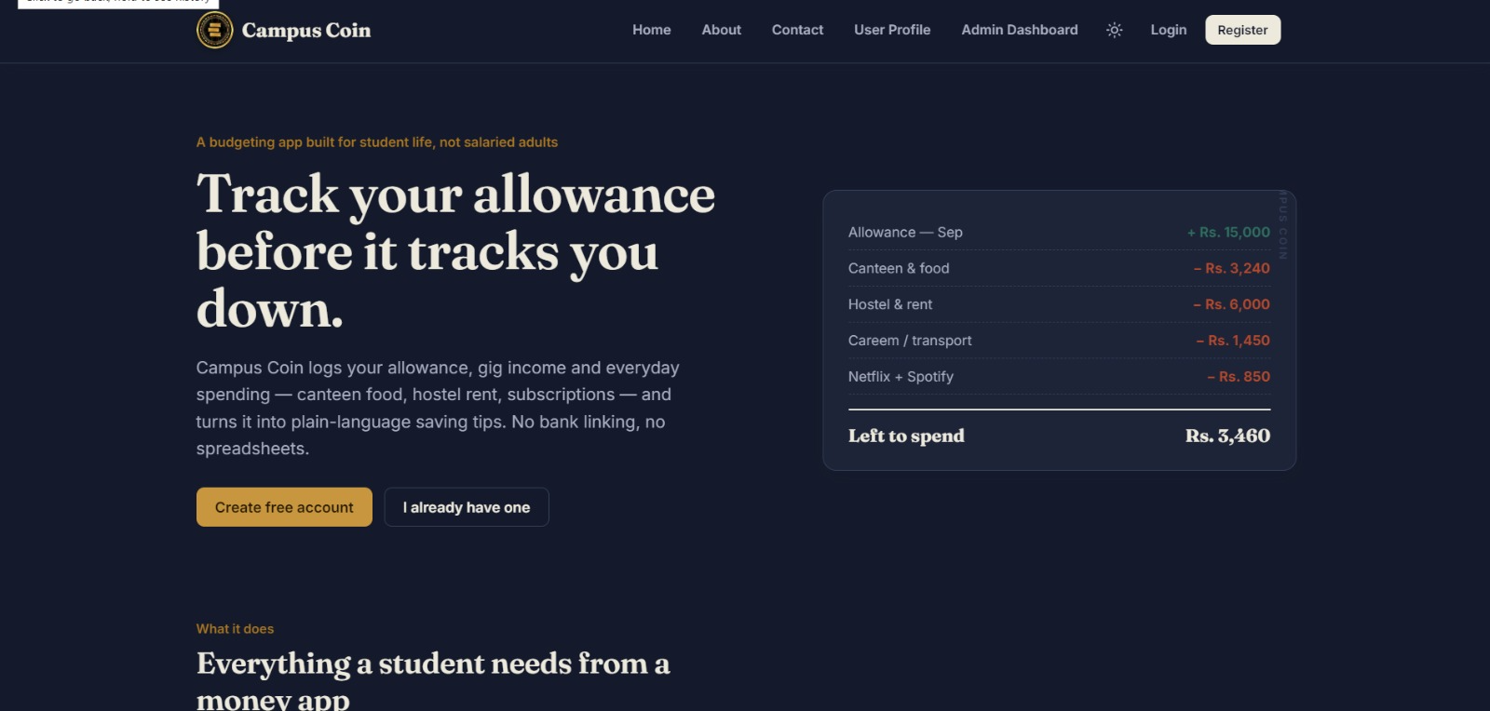
Figure: Home Page
Registration Page
Figure: Registration Page
Login Page
Figure: Login Page
Student Dashboard
Figure: Student Dashboard
Screenshot 5 — Wallet/Balance
[Not separately provided; balance is visible on the Student Dashboard screenshot.]
Transaction History
Figure: Transaction History
Screenshot 7 — Admin Dashboard
[Not provided among the uploaded website screenshots.]
Screenshot 8 — User Management
[Not provided among the uploaded website screenshots.]
Screenshot 9 — Database / phpMyAdmin
[Not provided among the uploaded website screenshots.]
7.6 Additional Website Screenshots
Features / What It Does
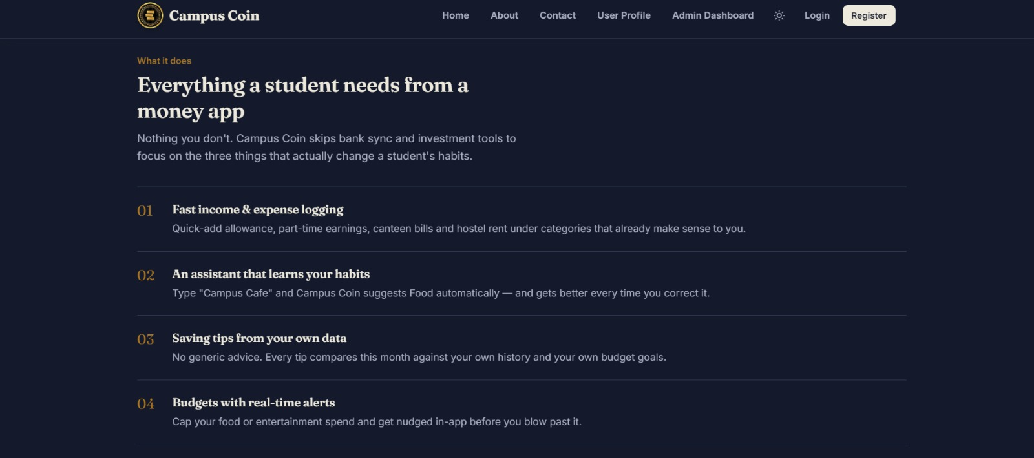
Figure: Features / What It Does
Sitemap / Navigation Layout
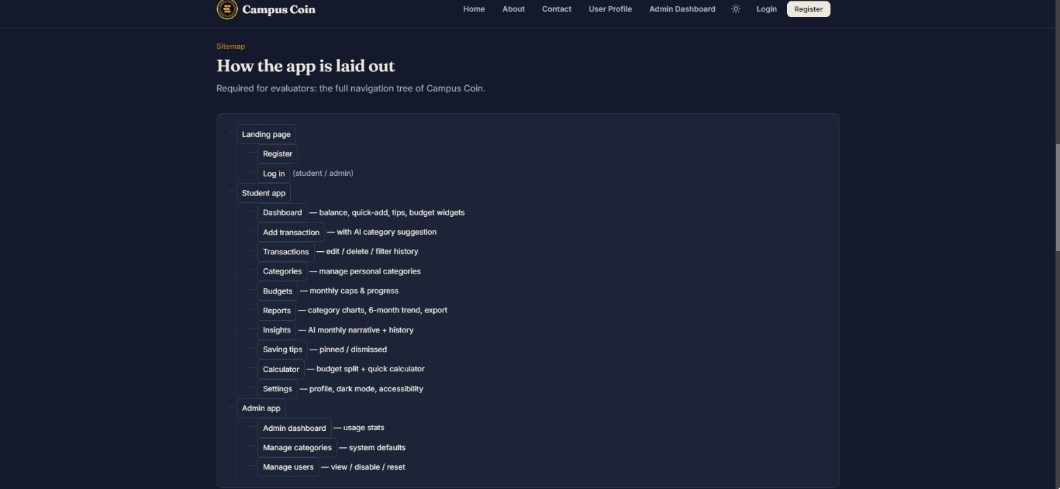
Figure: Sitemap / Navigation Layout
About Campus Coin

Figure: About Campus Coin
Contact Page
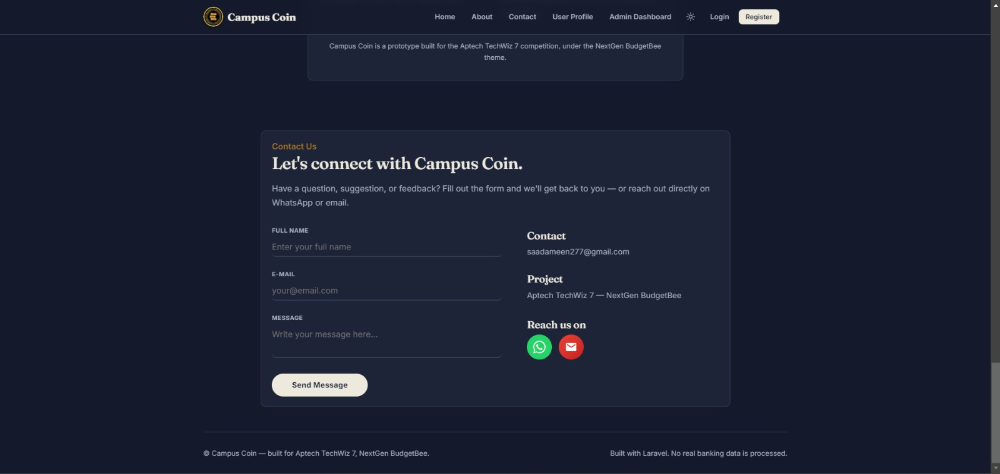
Figure: Contact Page
Add Transaction Page
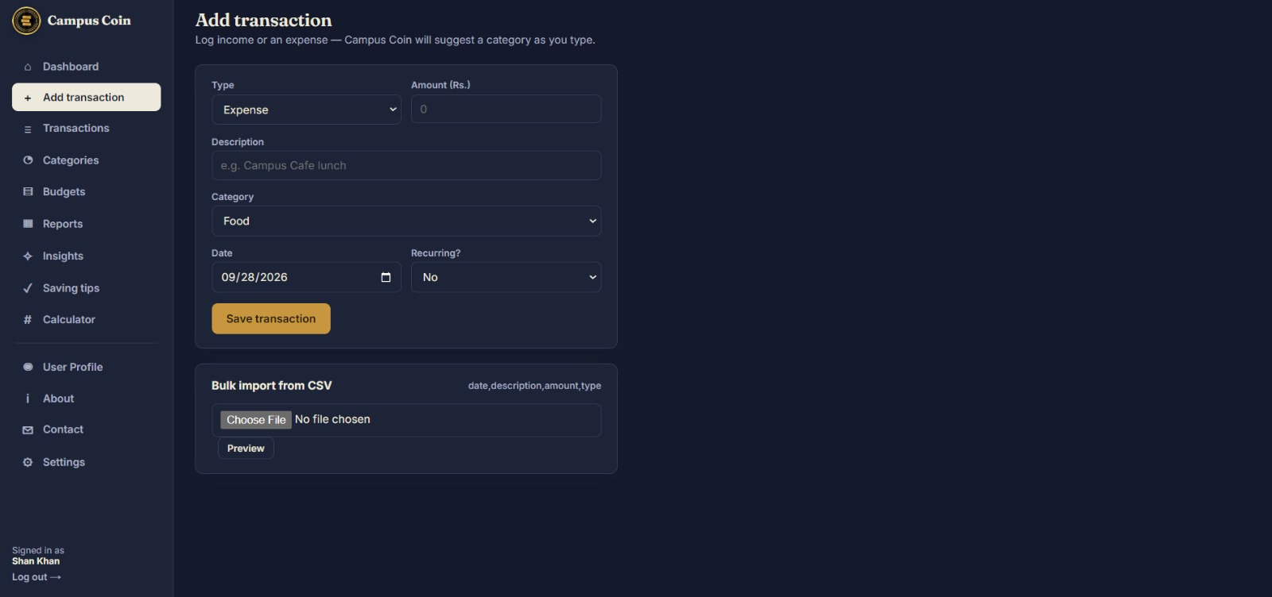
Figure: Add Transaction Page
Categories Page
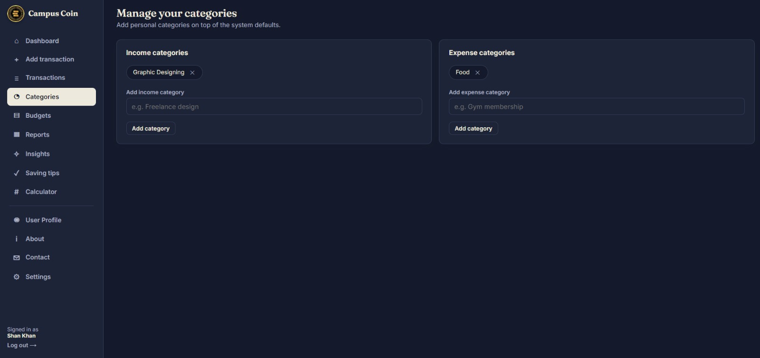
Figure: Categories Page
Budget Goals Page
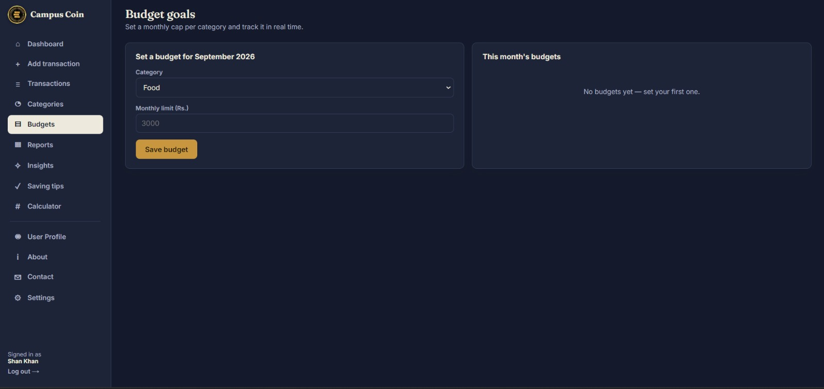
Figure: Budget Goals Page

8. CONCLUSION
Campus Coin provides a web-based approach to managing student financial information and campus-related transactions.
The system brings user accounts, wallet information, transaction records, and administrative functions into a centralized platform.
The project demonstrates the practical implementation of web development concepts including Laravel, PHP, MySQL, authentication, authorization, database relationships, CRUD operations, validation, and responsive interface development.
The system provides a structured approach to managing campus financial information and can serve as a foundation for additional financial and campus-related services in future versions.

