**机械臂**

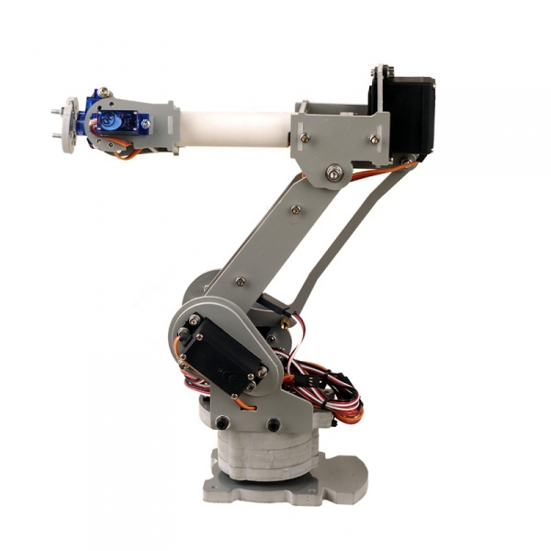

**名称：SainSmart DIY 6-Axis Servos Control Palletizing Robot Arm Model**

特点：

**1、Simulate real palletizing robot arm structure**

2、PVC material, CNC processing

3、Adopts MG996 55g metal gear servo 4pcs

**4、Active joint bearing connection**

**开发版**

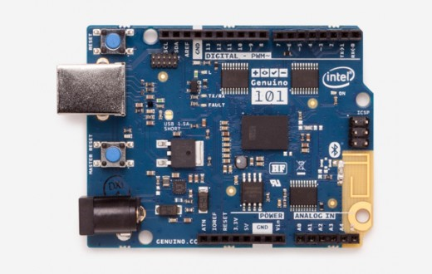

**名称：Arduino / Genuino 101**

简介（官网）：**The Arduino/Genuino 101 is a learning and development board** which contains the Intel® Curie™ Module, **designed to integrate the core's low power-consumption and high performance** with the Arduino's ease-of-use. **The 101 adds Bluetooth Low Energy capabilities and has an on-board 6-axis accelerometer/gyroscope, providing exciting opportunities for building creative projects in the connected world.**

**The module contains two tiny cores,** an x86 (Quark) and a 32-bit ARC architecture core, both clocked at 32MHz. The Intel toolchain compiles your Arduino sketches optimally across both cores to accomplish the most demanding tasks. The Real-Time Operating Systems (RTOS) and framework developed by Intel is open sourced. The Arduino core communicates with the RTOS via static mailboxes to accomplish a predefined list of tasks (interface with PC using USB, program the sketch into flash, expose Bluetooth LE functionality to sketch, perform PWM). The RTOS for Intel Curie is still under development and new functions and features will be released in the near future. **The 101 comes with 14 digital input/output pins** (of which 4 can be used as PWM outputs), **6 analog inputs, a USB connector for serial communication and sketch upload, a power jack, an ICSP header with SPI signals and I2C dedicated pins.**  **The board operating voltage and I/O is 3.3V but all pins are protected against 5V overvoltage.**  The Arduino 101 and the Genuino 101 boards have been designed in collaboration with Intel®.

参数：

Microcontroller Intel Curie

Operating Voltage 3.3V (5V tolerant I/O)

Input Voltage (recommended) 7-12V

Input Voltage (limit) 7-17V

Digital I/O Pins 14 (of which 4 provide PWM output)

PWM Digital I/O Pins 4

Analog Input Pins 6

DC Current per I/O Pin 20 mA

Flash Memory 196 kB

SRAM 24 kB

Clock Speed 32MHz

LED_BUILTIN 13

Features Bluetooth LE, 6-axis accelerometer/gyro

Length 68.6 mm

Width 53.4 mm

Weight 34 gr.