WEEK 5 FINAL PROJECT REPORT
Comprehensive Data Science Project Reporting and Strategic Recommendations
Integrating data preparation, machine learning, evaluation and stakeholder recommendations

Executive Summary
This report consolidates a reproducible data-science workflow using the Wisconsin Diagnostic Breast Cancer dataset available in scikit-learn. It focuses on preparing a structured dataset, training two classification models, evaluating them with complementary metrics, and translating the results into recommendations for stakeholders. Logistic Regression and a constrained Decision Tree were trained using the same stratified train/test split. Logistic Regression performed better across the reported test-set metrics in this experiment, including recall and ROC-AUC. The finding supports retaining Logistic Regression as the baseline for further research, but not deploying it in a real clinical environment. The dataset is small and historical, and the experiment is educational rather than a validated diagnostic study.

1. Introduction and Project Goals
The final-week task integrates the preceding skills into one end-to-end project report. The workflow includes defining a problem, selecting a dataset, preparing features and labels, selecting algorithms, training and validating models, interpreting visual evidence, discussing limitations, and proposing practical next steps. The purpose is not merely to report a score, but to show how model evaluation can support careful decisions.

2. Problem Definition
The project studies a binary classification problem: distinguishing malignant from benign examples based on 30 numeric features. The positive class is defined as malignant so that recall indicates the fraction of malignant examples correctly identified. This makes the consequences of false negatives explicit during evaluation. The task is a demonstration of machine-learning methods, not medical diagnosis.

3. Dataset and Features
The scikit-learn Wisconsin Diagnostic Breast Cancer dataset has 569 observations and 30 numeric input features derived from digitized images of fine-needle aspirates. Features include measurements related to radius, texture, perimeter, area, smoothness, compactness, concavity and symmetry. The data loader makes the dataset reproducible without a separate download. The target labels are transformed so malignant = 1 and benign = 0.
A limitation is that the dataset is small, historical and specialized. Its class patterns may not reflect a current clinical population, other equipment, or different data collection procedures. Any use beyond education would require an independently collected and representative validation dataset.

4. Data Preparation and Methodology
- Separate input features from the target label.
- Split data into 75% training and 25% test sets using stratification and random_state=42.
- Apply median imputation inside the pipelines to handle any missing values without fitting preprocessing on the test set.
- Standardize features for Logistic Regression; leave Decision Tree features unscaled because tree splits do not require standardization.
- Fit both algorithms on the training data and use the held-out test set only for final comparison.
- Run five-fold cross-validation on the training split using ROC-AUC to examine model stability.

5. Models Considered

5.1 Logistic Regression
Logistic Regression provides a relatively simple baseline for binary classification. It estimates class probabilities using a linear combination of input features. Feature scaling is included because the variables have different numeric ranges. Its simplicity makes it a useful reference model before considering more complex methods.

5.2 Decision Tree
A Decision Tree creates feature-based rules and can represent non-linear relationships. Its flexibility can lead to overfitting, so the tree is constrained to a maximum depth of four and a minimum of five samples per leaf. These limits reduce complexity, though they do not guarantee generalization.

6. Evaluation Metrics
- Accuracy: overall fraction of correct predictions.
- Precision: fraction of predicted malignant cases that are actually malignant.
- Recall: fraction of actual malignant cases correctly identified.
- F1-score: harmonic mean of precision and recall.
- ROC-AUC: ability of predicted scores to rank positive examples above negative examples across thresholds.
No single metric fully describes model quality. In this example, recall and false-negative counts deserve special attention because the positive class is malignant. The ROC-AUC summarizes ranking performance but does not establish that predicted probabilities are calibrated or that a particular threshold is appropriate.

7. Test-Set Results
Model | Accuracy | Precision | Recall | F1-score | ROC-AUC
Logistic Regression | 0.965 | 0.980 | 0.925 | 0.951 | 0.996
Decision Tree | 0.888 | 0.951 | 0.736 | 0.830 | 0.969
On the fixed test split, Logistic Regression achieved 96.50% accuracy, 98.00% precision, 92.45% recall, 95.15% F1-score and 99.62% ROC-AUC. The constrained Decision Tree achieved 88.81% accuracy, 95.12% precision, 73.58% recall, 82.98% F1-score and 96.91% ROC-AUC. These values describe this split only and should not be interpreted as guaranteed future performance.

8. Visualization 1 — Performance Comparison
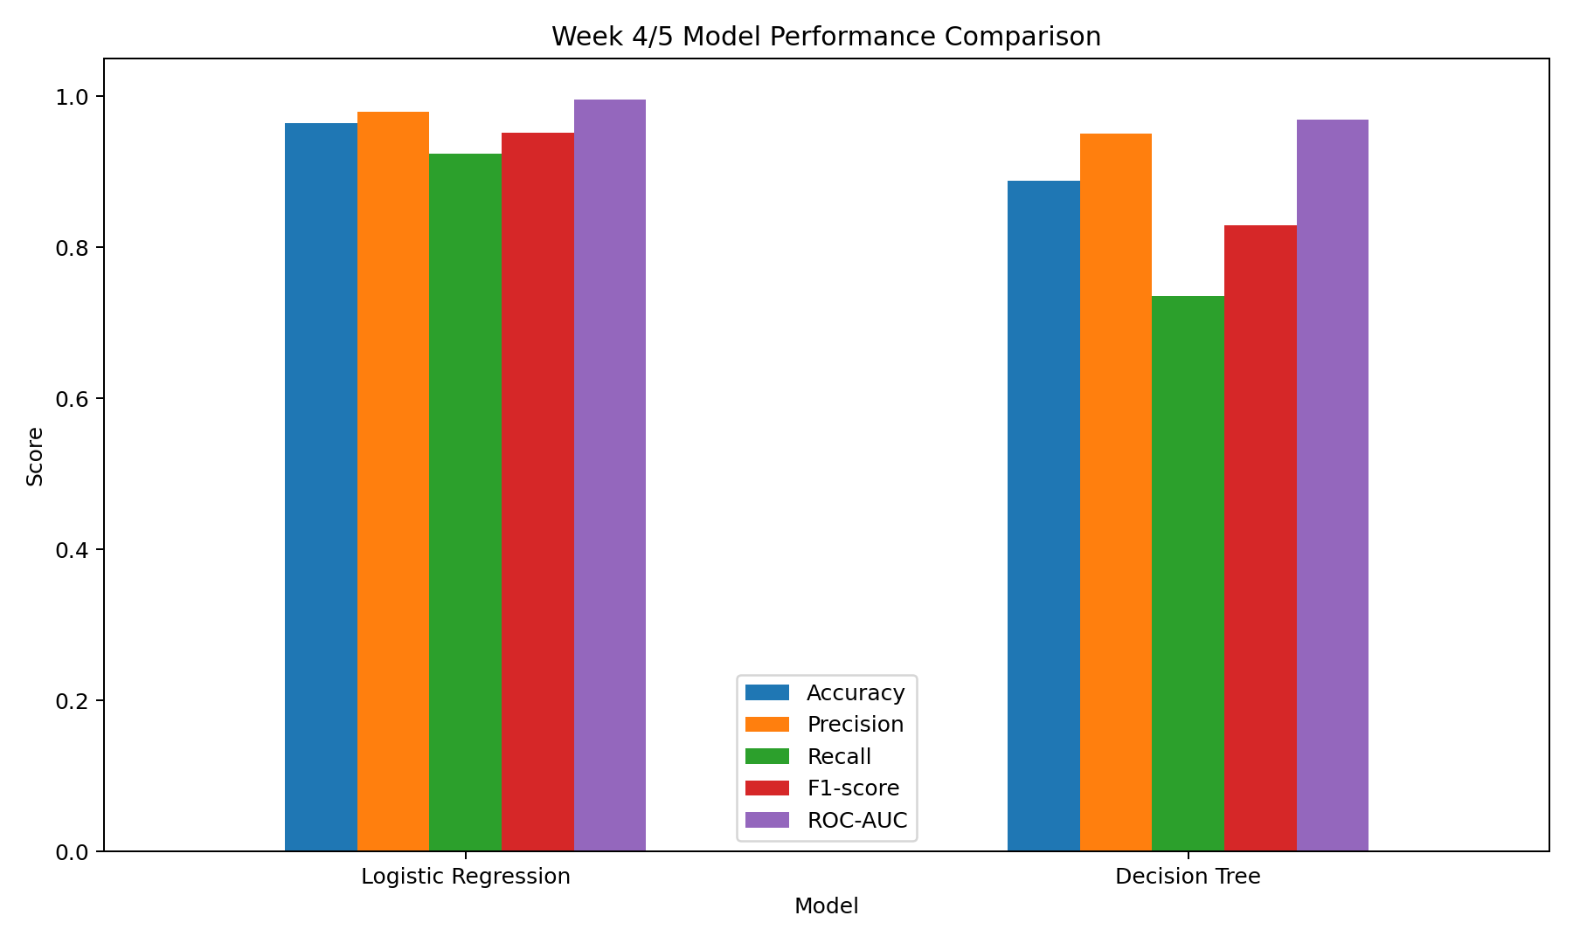
The grouped bars show Logistic Regression leading on all five test metrics. The recall difference is particularly relevant: the Decision Tree misses a larger fraction of malignant examples at its default threshold. This suggests the tree would need further tuning and error analysis before it could be considered competitive.

9. Visualization 2 — Confusion Matrix
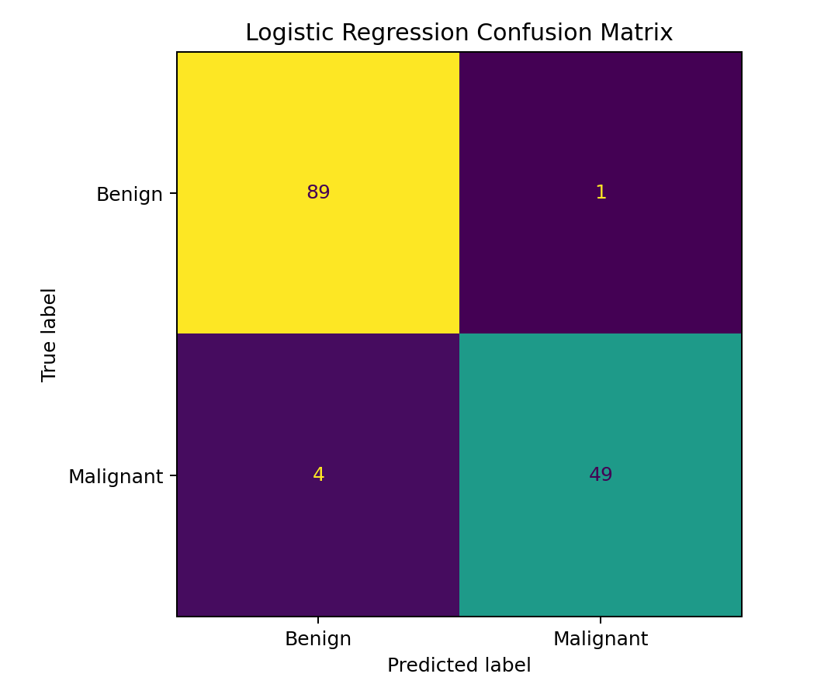
The confusion matrix separates correct and incorrect predictions. True negatives are benign cases correctly classified, true positives are malignant cases correctly identified, false positives are benign cases predicted malignant, and false negatives are malignant cases predicted benign. In a real setting, the costs of these error types would need to be agreed with clinical experts and stakeholders.

10. Visualization 3 — ROC Curve
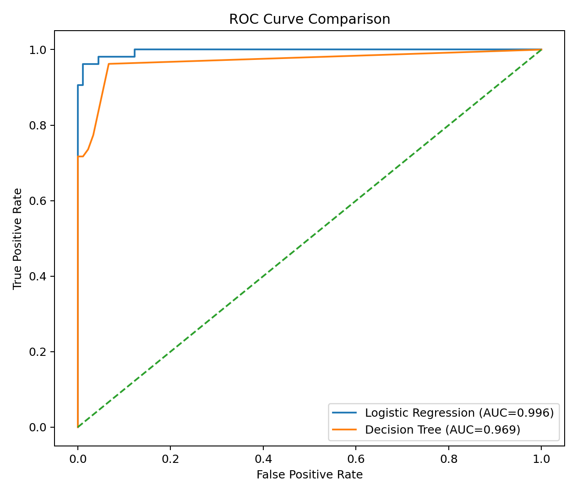
The ROC curves compare true-positive and false-positive rates across thresholds. Both models show strong ranking performance on this test split, with Logistic Regression's AUC higher. AUC is threshold-independent and should be complemented by threshold-specific measures, calibration checks and an assessment of the practical costs of errors.

11. Visualization 4 — Cross-Validation
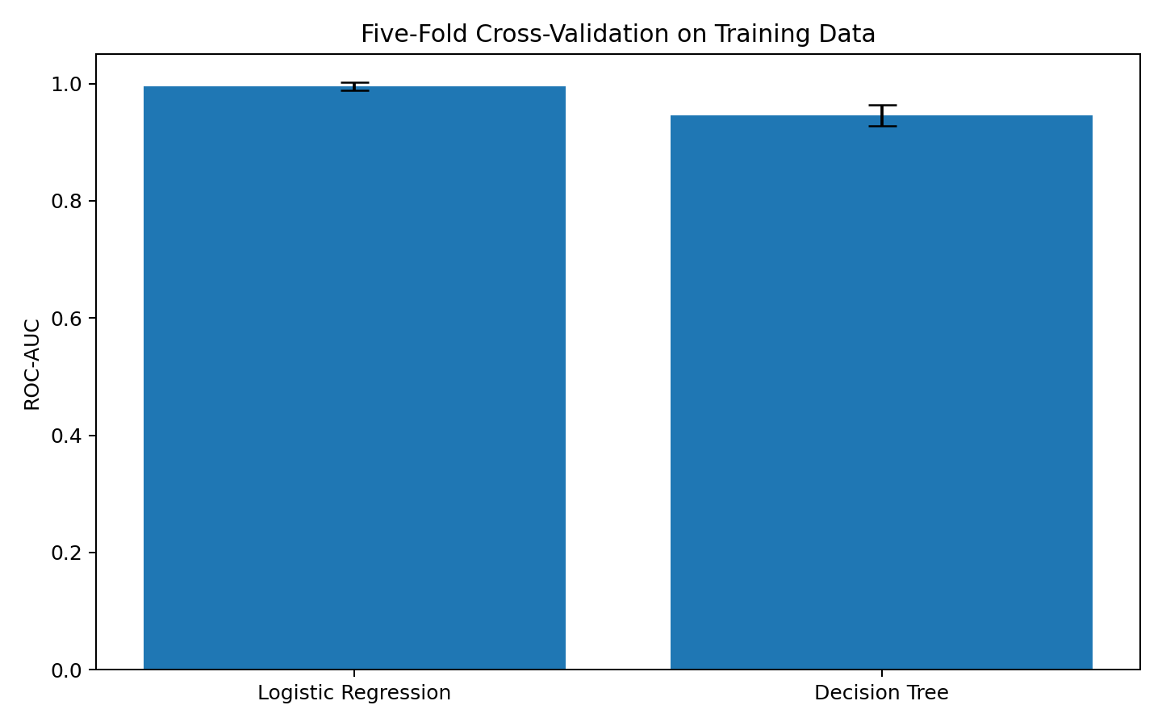
Five-fold cross-validation is performed on the training split only. The bars show mean ROC-AUC and error bars show fold-to-fold standard deviation. Cross-validation provides a more informative stability check than relying on one train/test split, but it does not replace external validation.

12. Key Findings
- Logistic Regression is the stronger baseline across all five metrics on this fixed test split.
- The Decision Tree's recall is notably lower, indicating more missed positive-class examples at the default classification threshold.
- Both models have high test ROC-AUC, but threshold selection and calibration remain separate questions.
- Using a pipeline helps prevent preprocessing leakage by fitting imputation and scaling within the training workflow.
- Training-only cross-validation adds evidence about model stability but does not demonstrate generalization to a different population.

13. Strategic Recommendations

13.1 For a learning or portfolio project
- Keep Logistic Regression as the baseline because it performed better in this experiment and is straightforward to explain.
- Add threshold analysis to show how recall and precision change as the decision threshold changes.
- Inspect false positives and false negatives, and include example-level error analysis.
- Add calibration plots and confidence intervals for metrics to communicate uncertainty more clearly.
- Record the dataset version, package versions, random seed and evaluation procedure so the results can be reproduced.

13.2 For a real organization or healthcare setting
- Do not deploy this model for diagnosis or patient management based on this exercise.
- Require an independent, representative external validation study and review by qualified domain experts.
- Assess subgroup performance, potential bias, calibration, data drift, privacy, governance and applicable regulatory requirements.
- Choose thresholds only after stakeholders define the relative costs of false positives and false negatives.
- Establish monitoring, audit trails, incident response and a process for periodic revalidation before any operational use.

14. Business Impact and Research Outcomes
For a portfolio or research exercise, the value is the demonstrated ability to build a repeatable model-comparison workflow and explain trade-offs with evidence. For a hypothetical healthcare stakeholder, false-negative risk, fairness and reliability would be central considerations. No actual business savings, clinical benefit or patient outcome can be inferred from this experiment, because it does not include deployment, prospective testing or operational cost data.

15. Limitations and Future Improvements
- The dataset is small, historical and not necessarily representative of current clinical populations.
- Only two algorithms and one fixed test split are compared.
- Cross-validation estimates may vary because the sample is limited.
- Default classification thresholds may not reflect the relative costs of errors.
- The report does not perform external validation, probability calibration or formal subgroup fairness analysis.
- Future work should compare additional baselines, tune hyperparameters within cross-validation, quantify uncertainty, test calibration and evaluate an independent dataset.

16. Reproducibility and Code Documentation
The included final_project.py script loads the dataset, prepares the target, splits the data, trains both pipelines, calculates test metrics, runs five-fold training cross-validation, and saves the four visualizations. The project uses fixed random seeds to support reproducibility. Install the listed requirements and run the script from the extracted project folder.
Command: pip install -r requirements.txt
Command: python final_project.py

17. Conclusion
This final project combines data preparation, model development, validation, visualization and strategic interpretation in a single documented workflow. Logistic Regression outperformed the constrained Decision Tree across the reported test metrics on the chosen split, so it is the preferred baseline for further educational experimentation. The findings also show why recall, confusion matrices, ROC curves and cross-validation matter alongside accuracy. The appropriate recommendation is to continue improving and validating the workflow—not to deploy this model in clinical practice. Any real-world use would require independent evidence, domain-expert governance and a careful evaluation of risks, fairness and reliability.

18. References
Scikit-learn — Wisconsin Diagnostic Breast Cancer dataset: https://scikit-learn.org/stable/modules/generated/sklearn.datasets.load_breast_cancer.html
Scikit-learn — Model evaluation: https://scikit-learn.org/stable/modules/model_evaluation.html
Scikit-learn — Pipelines and composite estimators: https://scikit-learn.org/stable/modules/compose.html#pipeline

