WEEK 4 TASK REPORT
Machine Learning Model Development and Evaluation
A comparative classification study using Python and scikit-learn

1. Introduction and Objective
The purpose of this project is to demonstrate a reproducible machine-learning workflow, from selecting a dataset and preparing the features to training, validating and evaluating classification models. Two supervised learning algorithms are compared, and their results are explained using standard evaluation metrics and visualizations.
The chosen dataset is the Wisconsin Diagnostic Breast Cancer dataset available through scikit-learn. The target is configured so that malignant cases are the positive class (1) and benign cases are the negative class (0). This convention makes recall especially important to discuss, because a false negative would mean a malignant example was classified as benign. This is an educational demonstration only, not a diagnostic tool.

2. Dataset Description
The dataset contains 569 observations and 30 numeric input features computed from digitized images of fine-needle aspirates. The features describe cell-nucleus characteristics such as radius, texture, perimeter, area, smoothness and concavity. The built-in dataset is convenient for reproducibility and does not require downloading data at runtime.
The original scikit-learn target labels malignant as 0 and benign as 1. For this project, the labels are inverted so malignant is 1. The train/test split is stratified to preserve approximately the same class proportions in each partition.

3. Data Preparation
- Separate the 30 input features from the target label.
- Use a stratified 75% training and 25% testing split with a fixed random seed of 42.
- Use a median imputer inside each pipeline so any missing values are handled without leaking information from the test set.
- Standardize features for Logistic Regression because it is sensitive to feature scale.
- Keep the held-out test set separate until final evaluation.

4. Model Selection
Logistic Regression is selected as a simple linear classification baseline. It is efficient, interpretable relative to many complex models, and benefits from feature scaling. A Decision Tree is used as a second model because it can learn non-linear decision rules and is easier to explain as a sequence of feature-based splits. The tree depth is limited to four and each leaf must contain at least five samples, which helps control complexity and reduce overfitting.

5. Evaluation Metrics
- Accuracy: proportion of all predictions that are correct.
- Precision: proportion of predicted malignant cases that are actually malignant.
- Recall: proportion of actual malignant cases correctly identified.
- F1-score: harmonic mean of precision and recall.
- ROC-AUC: ability of the model's scores to rank positive examples above negative examples across thresholds.
Accuracy alone is not sufficient for a medical-style classification example. Recall and the confusion matrix are important because false negatives may be more consequential than false positives. In a real clinical setting, performance would need external validation, calibration, expert review and a careful assessment of risks before any deployment.

6. Results
Model | Accuracy | Precision | Recall | F1-score | ROC-AUC
Logistic Regression | 0.965 | 0.980 | 0.925 | 0.951 | 0.996
Decision Tree | 0.888 | 0.951 | 0.736 | 0.830 | 0.969

7. Visualization 1 — Model Comparison
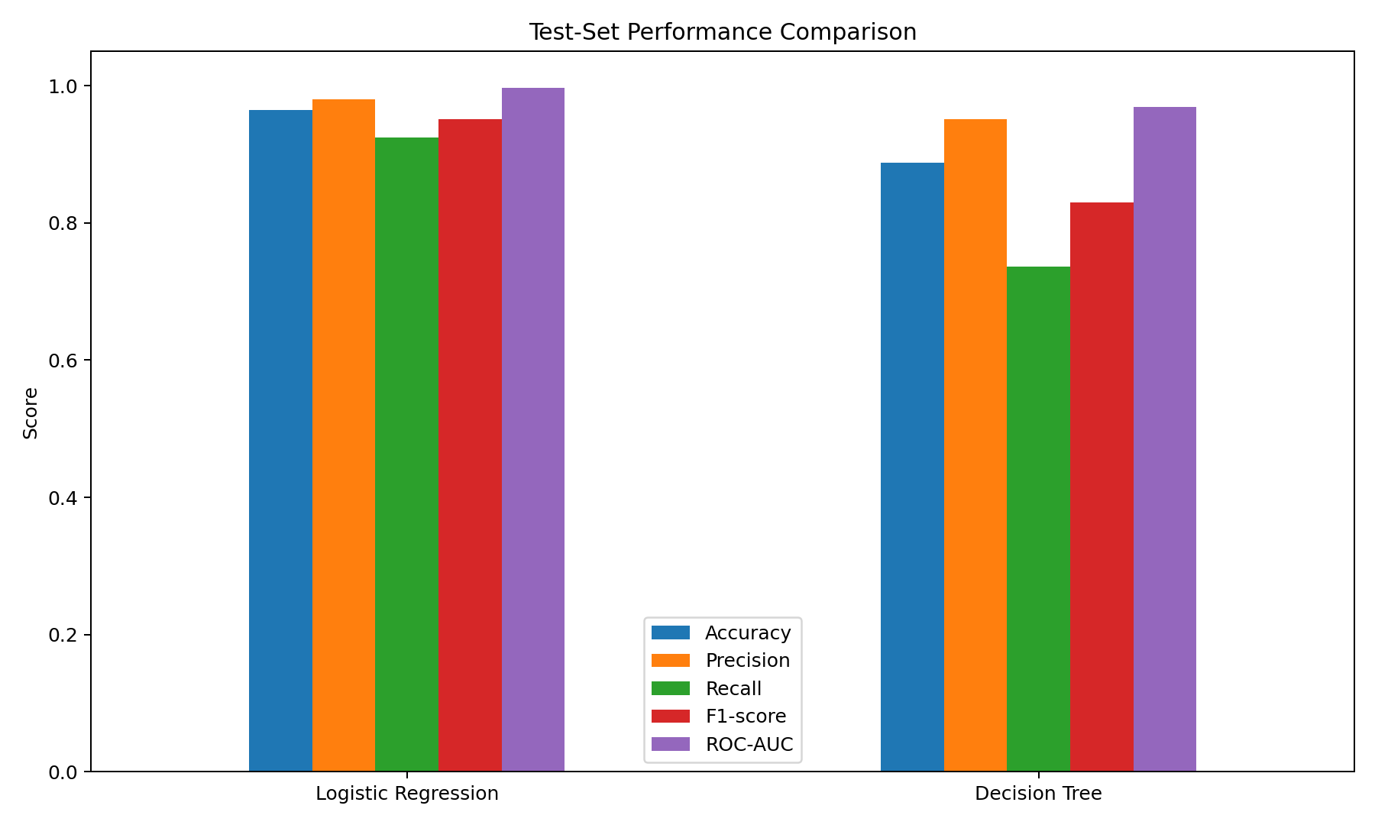
This grouped bar chart compares five metrics for the two models. The best model should not be chosen solely by accuracy; recall, F1-score and ROC-AUC also help describe how well the classifier distinguishes malignant from benign examples.

8. Visualization 2 — Confusion Matrix
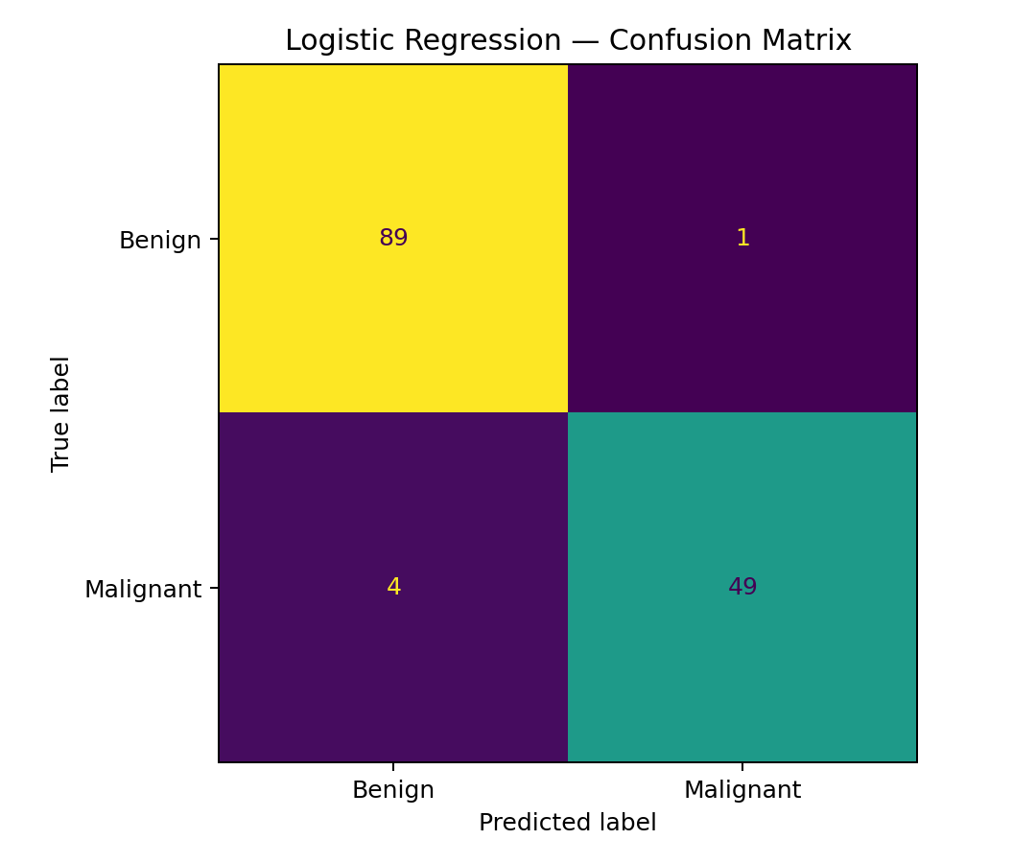
The confusion matrix displays true negatives, false positives, false negatives and true positives for Logistic Regression. Because malignant is defined as the positive class, the false-negative cell is particularly important to inspect.

9. Visualization 3 — ROC Curves
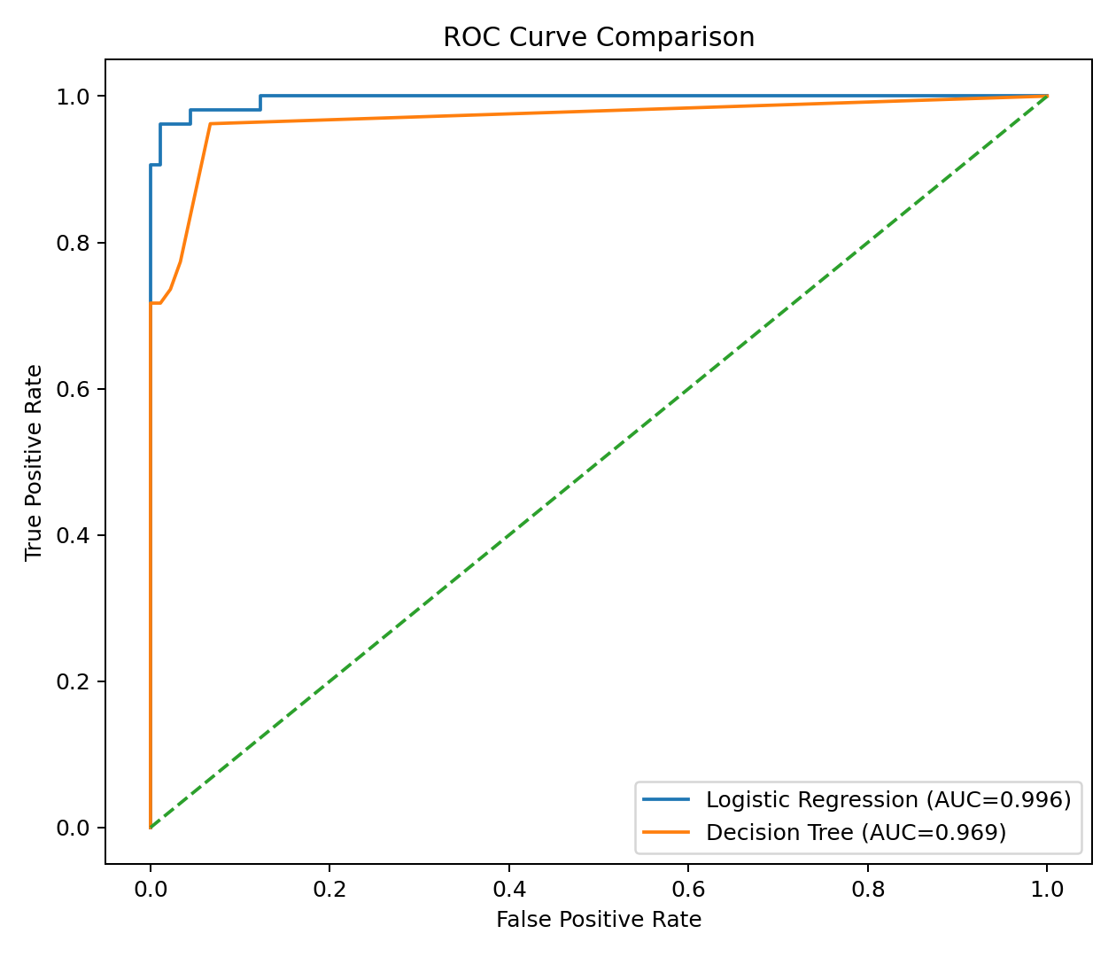
The ROC curve plots true-positive rate against false-positive rate at different thresholds. A curve closer to the upper-left corner and a higher AUC indicate better ranking performance on this held-out test set.

10. Validation and Overfitting
The test set is held out from training, while five-fold cross-validation is applied only to the training set. This provides a second view of model stability without repeatedly tuning against the test examples. Logistic Regression is constrained by its linear form; the Decision Tree may capture non-linear patterns but can overfit if allowed to grow without limits. The depth and minimum leaf size are therefore restricted.

11. Error Analysis and Improvements
- Review false negatives and false positives individually instead of relying only on aggregate metrics.
- Tune the classification threshold based on the intended cost of false negatives versus false positives.
- Use nested cross-validation or a validation split if extensive hyperparameter tuning is added.
- Evaluate calibration and confidence intervals for metrics.
- Test on an independent external dataset before claiming generalization.
- Check for data provenance, sampling bias and feature/label leakage.
- For any real healthcare application, require qualified clinical oversight and regulatory review.

12. Limitations
The dataset is small, historical and specialized; it does not represent every population or modern clinical setting. The test split is only one partition, so its metrics have sampling uncertainty. The model outputs should not be interpreted as medical advice, and no deployment decision can be made from this educational experiment alone.

13. Conclusion
Two classification models were trained and compared using a fixed, stratified train/test split. On this run, Logistic Regression has the higher ROC-AUC (0.996), while the full comparison table should be consulted to understand the trade-offs in accuracy, precision, recall and F1-score. The project demonstrates why evaluation should use multiple metrics, confusion-matrix analysis, ROC curves and training-only cross-validation rather than relying on a single score. The next improvement would be to conduct systematic threshold selection and external validation.

14. Reproducibility and Code
The included train_evaluate.py file loads the dataset, creates the split, fits both pipelines, prints metrics, performs five-fold ROC-AUC cross-validation on the training set, and saves the three evaluation figures. The experiment uses random_state=42 so the split and results are reproducible in a compatible environment.

15. References
Scikit-learn dataset documentation: https://scikit-learn.org/stable/modules/generated/sklearn.datasets.load_breast_cancer.html
Scikit-learn model evaluation: https://scikit-learn.org/stable/modules/model_evaluation.html
Scikit-learn pipelines: https://scikit-learn.org/stable/modules/compose.html#pipeline

