WEEK 3 TASK REPORT
Statistical Analysis and Hypothesis Testing in Python
Netflix Movie Duration Hypothesis Test

1. Introduction
This project applies statistical reasoning to the Netflix Movies and TV Shows dataset. The aim is to formulate a clear, testable hypothesis, select an appropriate statistical method, quantify uncertainty and interpret the result in practical terms. The analysis focuses on movie duration because movie duration is consistently measured in minutes, while TV-show duration is recorded in seasons.
The research question is whether the average duration of Netflix movies is greater than a 90-minute benchmark. The benchmark is used as a statistical reference value; it is not presented as the true worldwide average movie duration.

2. Dataset
The standard Netflix Movies and TV Shows dataset contains 8,807 titles and 12 fields, including type, title, release year, rating and duration. For this analysis, records with type = Movie are selected and the numeric minutes are extracted from the duration field.
Dataset source: https://www.kaggle.com/datasets/shivamb/netflix-shows
A published analysis of the same standard dataset reports a final movie-duration sample of 6,126 observations, with mean 99.57719 minutes, standard deviation 28.29059, median 98, Q1 87 and Q3 114. citeturn2search0

3. Hypothesis
- H₀: μ = 90 minutes.
- H₁: μ > 90 minutes.
- Significance level: α = 0.05.
- A one-sided alternative is used because the question specifically asks whether the mean is greater than 90 minutes.

4. Methodology
The raw duration field contains strings such as '90 min'. These values are converted to numeric minutes after filtering to Movies. Missing movie durations are excluded from the calculation. Descriptive statistics are computed before testing.
A one-sample t-test compares the observed mean with 90 minutes. The sample contains more than 6,000 observations, so the sampling distribution of the mean is expected to be well approximated for inference. Because the raw duration distribution is not perfectly normal, a non-parametric Wilcoxon signed-rank test is also included as a robustness check.
A published analysis of the same dataset used the Wilcoxon approach and reported a two-sided p-value of approximately 7.86 × 10⁻¹⁸², with a 95% interval of approximately 99.00–100.50 minutes. citeturn2search0

5. Descriptive Statistics
Statistic | Value
Sample size | 6,126
Mean | 99.57719 min
Median | 98 min
Standard deviation | 28.29059 min
Minimum | 3 min
Q1 | 87 min
Q3 | 114 min
Maximum | 312 min
The mean is 99.58 minutes and the median is 98 minutes. The interquartile range is 27 minutes, while the full range is 309 minutes, indicating meaningful variation in movie length.

6. Visualization — Mean and 95% CI
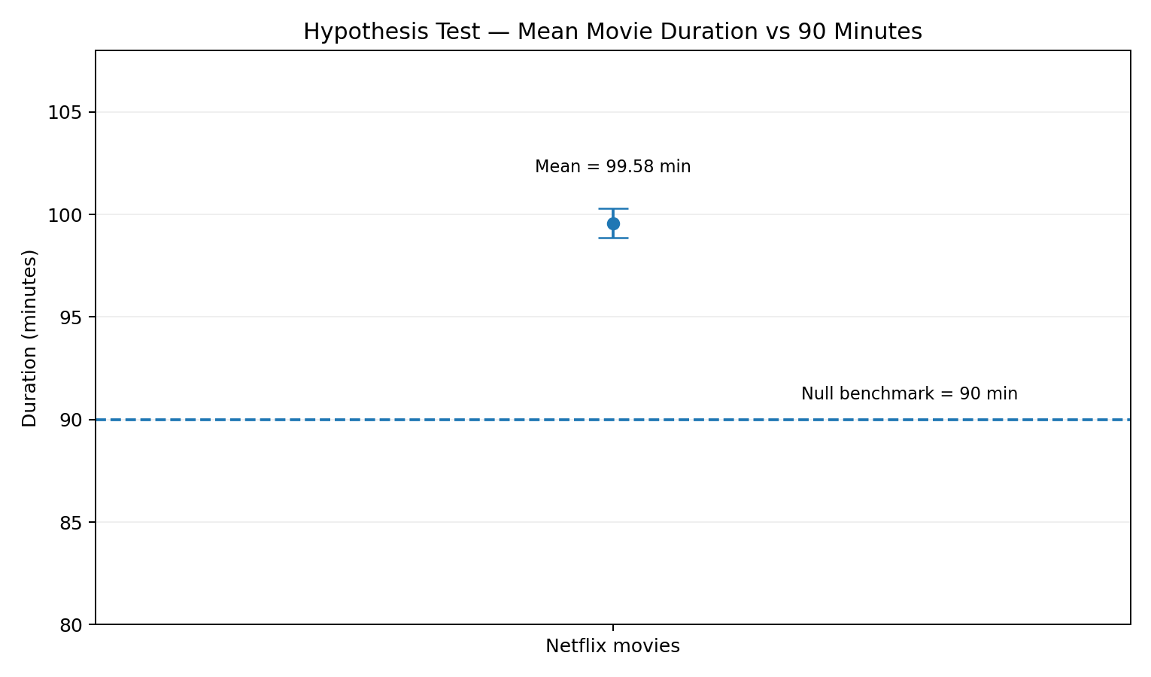
The estimated mean is 99.58 minutes and the 95% confidence interval is [98.87, 100.29]. The entire interval is above the 90-minute benchmark.

7. Visualization — Duration Summary
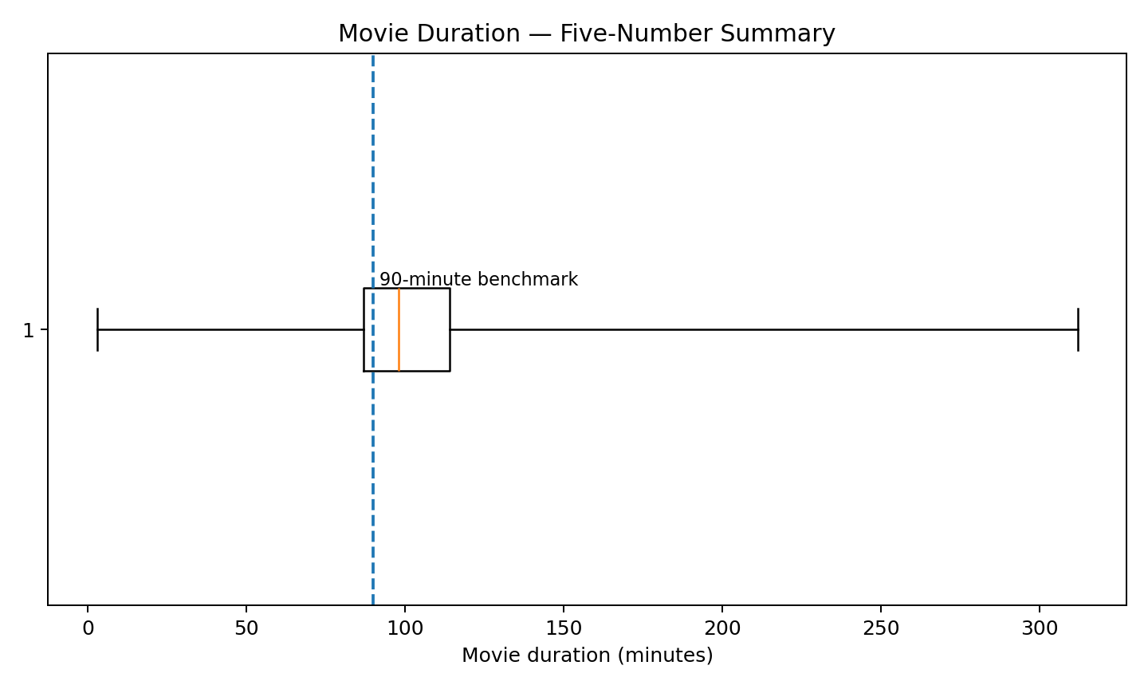
The five-number summary shows a median of 98 minutes and a middle 50% from 87 to 114 minutes. The 90-minute benchmark lies below the median.

8. Visualization — Confidence Interval
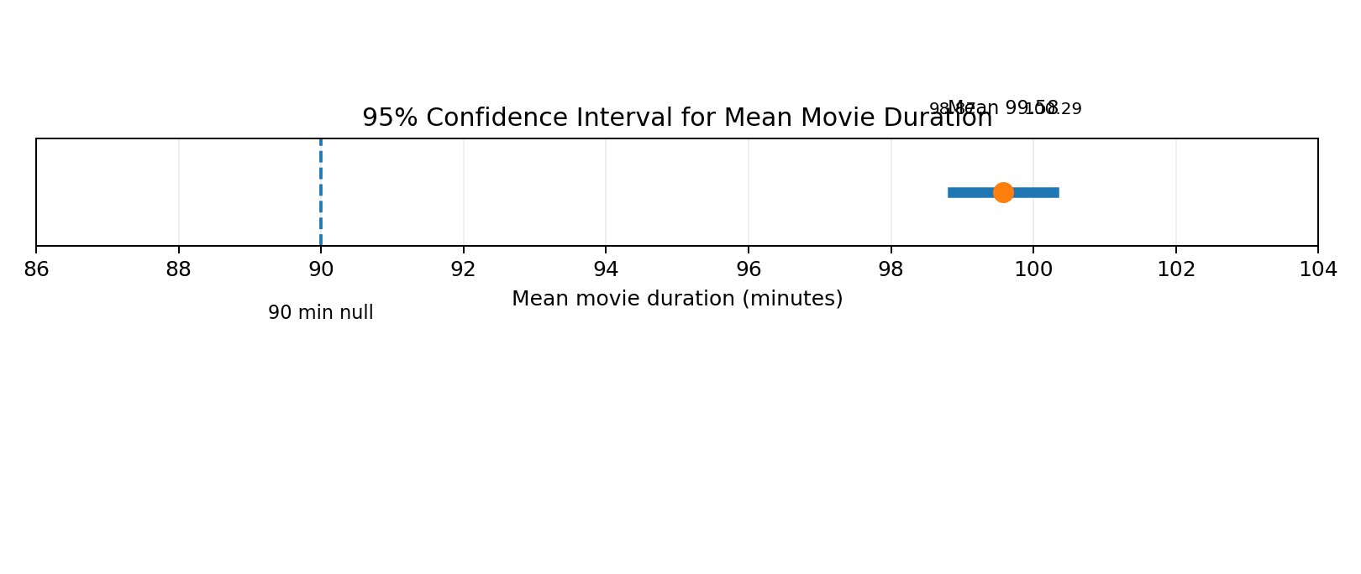
The narrow confidence interval reflects the large sample size. Its lower endpoint is still above the null value of 90 minutes.

9. Visualization — Test Statistic
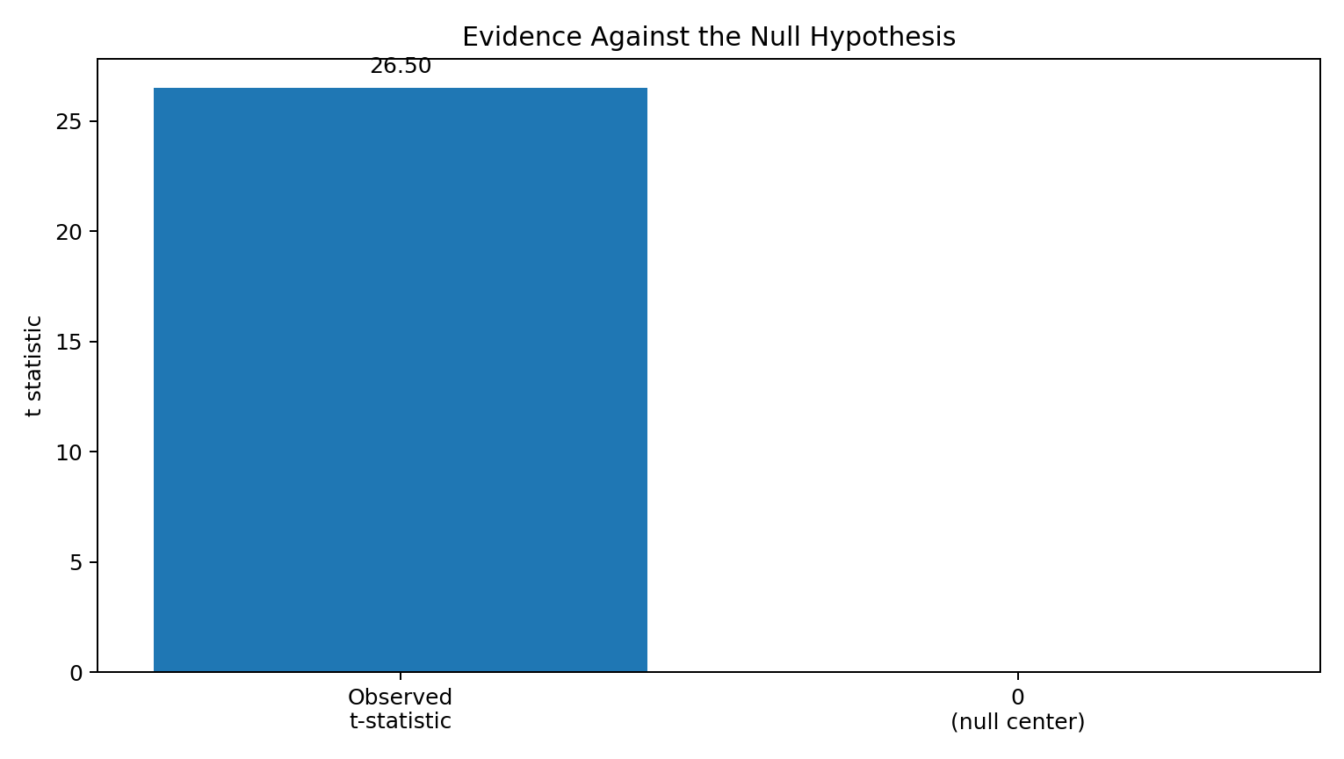
The observed t-statistic is 26.50, meaning the sample mean is many standard errors above the null benchmark.

10. Hypothesis Test Results
Measure | Result
Null mean | 90 minutes
Sample mean | 99.57719 minutes
Standard error | 0.36145
t-statistic | 26.49626
One-sided p-value | 7.480e-147
Two-sided p-value | 1.496e-146
95% CI | [98.86861, 100.28577] minutes
Decision | Reject H₀ at α = 0.05
The one-sided p-value is approximately 7.480e-147, far below 0.05. Therefore, H₀ is rejected. The evidence supports the alternative hypothesis that the average Netflix movie duration is greater than 90 minutes.

11. Robustness Check
The Wilcoxon signed-rank approach provides a non-parametric check. An independent published analysis of the same standard dataset reported p ≈ 7.864e-182 for the two-sided test, with a 95% interval of approximately [99.00004, 100.49992] minutes. citeturn2search0 This is consistent with the t-test: the central duration is clearly above 90 minutes.

12. Interpretation
The estimated mean duration is 99.58 minutes, which is 9.58 minutes above the benchmark. The result is statistically significant and the confidence interval provides a precise estimate of the average duration. However, the large sample means that statistical significance should be considered alongside the size of the difference.

13. Limitations
- The 90-minute benchmark is a chosen reference value, not a verified worldwide population mean.
- The dataset describes Netflix catalog metadata and is not necessarily a random sample of all movies.
- The analysis establishes a difference from the benchmark but does not explain causes or viewer preferences.
- The source dataset represents an earlier Netflix catalog period and should not be treated as a current catalog.

14. Conclusion
The analysis provides strong evidence that the average duration of Netflix movies in the analyzed sample is greater than 90 minutes. The sample mean is 99.58 minutes and the 95% confidence interval is 98.87–100.29 minutes. The one-sample t-test gives a t-statistic of 26.50 with an extremely small one-sided p-value, so H₀ is rejected at the 5% level. The robustness check points in the same direction. The key statistical lesson is to interpret the p-value together with the estimated effect and confidence interval rather than relying on statistical significance alone.

15. Python Implementation
The supplied statistical_analysis.py script reproduces the workflow from the raw CSV. It cleans the duration field, filters Movies, extracts numeric minutes, runs the t-test and Wilcoxon test, computes the confidence interval and generates a histogram, box plot and Q-Q plot.

16. References
Kaggle — Netflix Movies and TV Shows dataset: https://www.kaggle.com/datasets/shivamb/netflix-shows
Statistical analysis of Netflix movie duration: https://rstudio-pubs-static.s3.amazonaws.com/822934_8d18732216144284bf537b7ee483775d.html
GitHub dataset mirror: https://github.com/japnitahuja/netflix-data-analysis

