NAME:DHAIRYA MEHTA

BATCH:A2

ROLL NO:1811023

SUBJECT:PYTHON MINI PROJECT(USER MANUAL)

**EMAIL OTP VALIDATOR**

**Before running the GUI,you have to make a couple of changes regarding the mail id through which the mail has to be sent.They are:**

**Step 1:In line 63 of the code inplace of sender’s email id and password replace them with an existing mail ID and a password and in line 65 too replace sender’s email id with the same email id.**

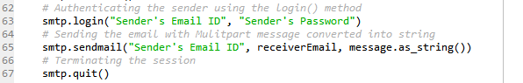

**Step 2:There is a chance that google is not allowing you to log in via smtplib because it has flagged this sort of login as "less secure", so what you have to do is go to this link while you're logged in to your google account, and allow the access:**

**<https://www.google.com/settings/security/lesssecureapps>**

**It might take up to half hour for the changes to reset but generally it happens instantly**

**Step 3:As soon as the user runs the application,it asks for the user to enter the email ID and user enters it**

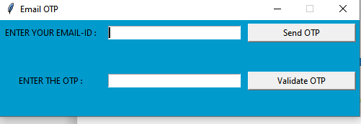

**Step 4:User has to click on ‘Send OTP’ button and an email will be sent to the Mail ID entered**

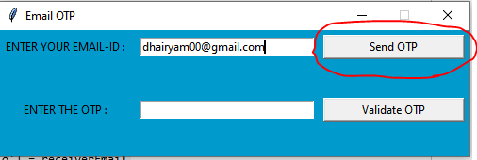

**Step 5:User has to click on ‘Send OTP’ button and an email will be sent to the Mail ID entered**

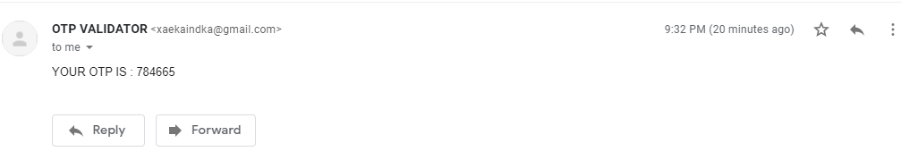

**NOTE:There is a chance that the mail might not be sent due to the Security and Authentication protocols of Gmail and also SMTP Protocols of Python smtplib library (if step 2 is not done)**

**Step 6:User has to enter the OTP received on the mail and click on the ‘Validate OTP’ button**

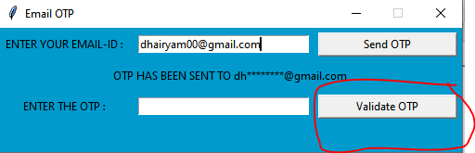

**Step 7:It will show either the message as ‘OTP VALIDATED SUCCESSFULLY’ or ‘INVALID OTP’ based on the input,if it shows invalid OTP,please check the input and try again**

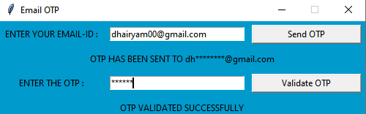

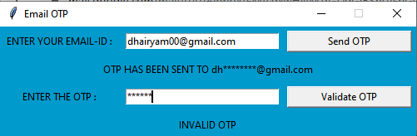

Python Modules used for the project development:

1. Tkinter(For creating the GUI for the project)
2. Smtplib(defines an SMTP client session object for sending the mail)
3. email.mime.multipart(to build a complete message structure from scratch)
4. email.mime.text(to build a complete message structure from scratch)
5. Random(To generate random numbers)

What to do if the mail is not being received?

The mail will definitely have been sent but in the slightest of chance that it is not,

Follow this link:

<https://accounts.google.com/DisplayUnlockCaptcha>

Click continue and this might again take a couple of minutes for the changes to reset. So proceed to doing another login attempt now and it should work.