**WEEK-11**

AIM:

To Configure any two application layer protocols using packet tracer.

SOFTWARE USED:

NS2

**PROCEDURE:**

1.Drag and drop a server, at least 3 PCs and a switch. Connect them using copper straight through cables.

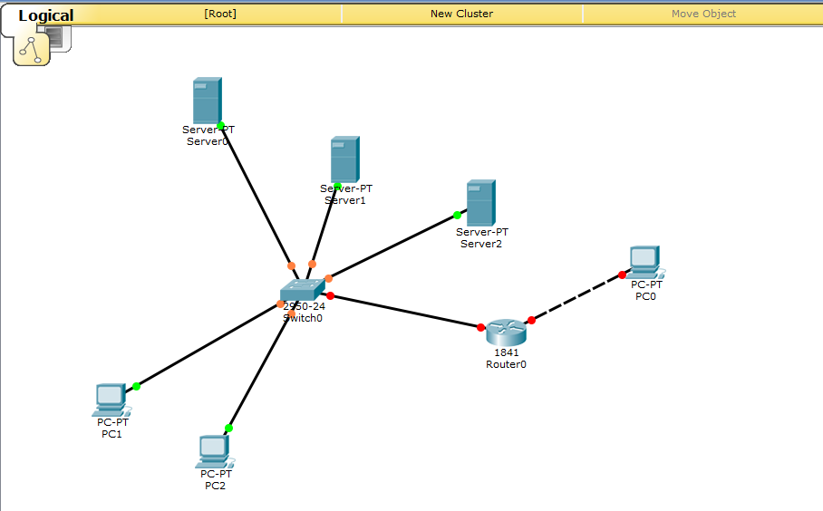

2. Firstly, configure the server’s IP Address by clicking on the server, going to the desktop tab and IP Configuration. Click on the static radio button and give it an IP between 0.0.0.0 and 255.255.255.255, press enter. The subnet mask must appear automatically.

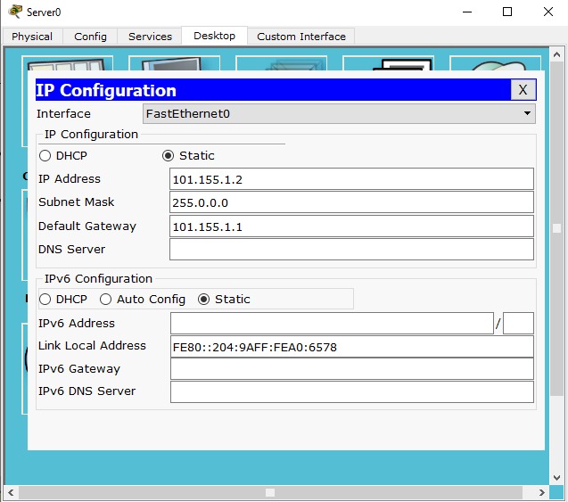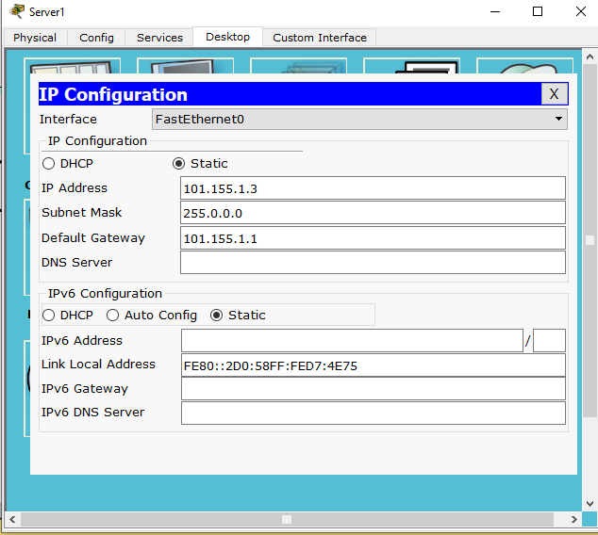 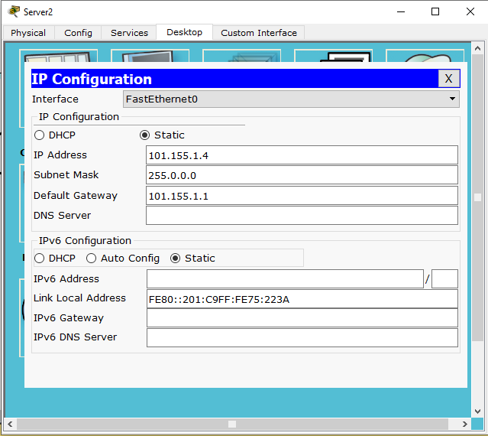

3. The DNS Server and Default Gateway must be given the IP of the server as it is acting as the server for those services too.

4. In the Services tab on the same server page, click on DHCP and click on the ON radio button. Change the server pool name as necessary. Enter the DNS Server and Default Gateway as the servers’ IP Address. Type in the necessary values for the start IP Address and the subnet mask must update automatically.

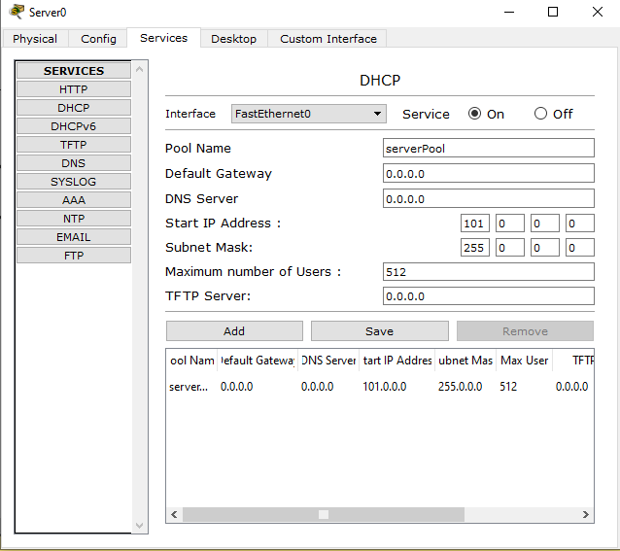 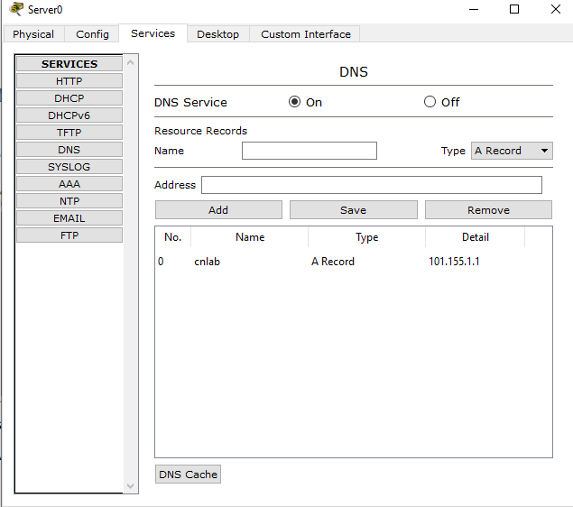

5.Set the maximum number of users as required and click on Add/Save as per requirements.

6. To test the DHCP, click on the PCs one after another and under the Desktop tab in the IP Configuration section, click on the DHCP radio button. An IP Address must be automatically assigned in a short while.

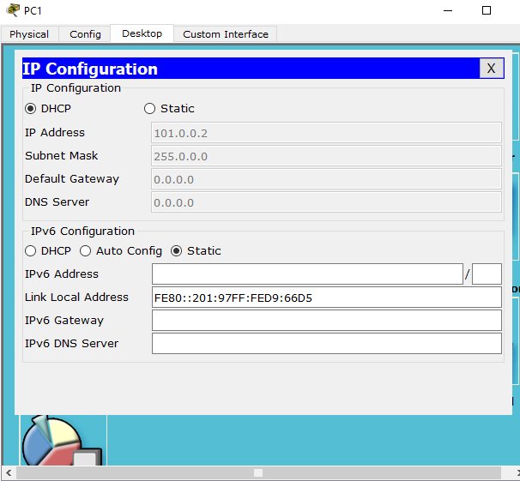

6. To setup the Web Browser services, under the Services tab of the Server, navigate to HTTP and ensure that the HTTP and HTTPS radio buttons are turned to ON.

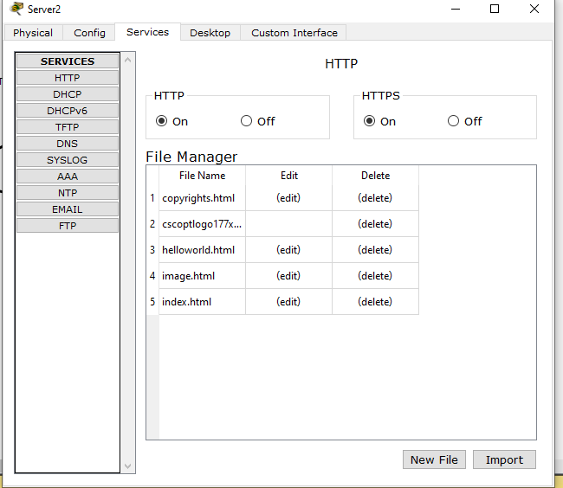

7. To test the Web Browser Services, click on a PC and under the Desktop tab, navigate to Web Browser and type in the IP Address of the Serve in the URL box. It must show the default web page.

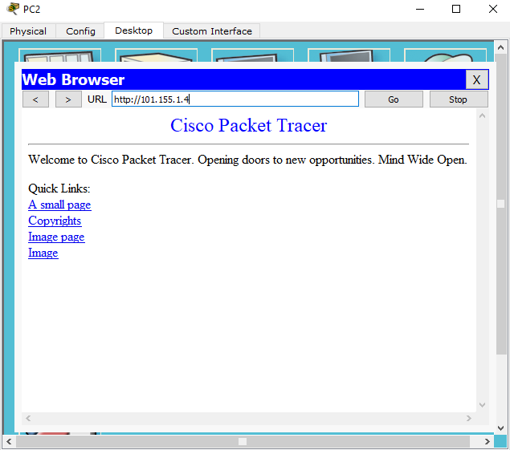

8. To ensure the DNS service, navigate to DNS in the Services tab of the Server and turn the DNS Service radio button ON. Type in the desired name of the webpage in the Name box and the Address box must contain the server IP Address and click Add. This is to configure A Record type DNS Service.

9. For a CNAME DNS Service, type in the desired webpage name and let the Host Name be the webpage that must be cloned to desired name and click on Add.

10. To check the DNS Service, under the web Browser in Desktop tab of the PC, in the URL Box, type in the previously declared web page names and check if it takes you to the desired webpage.

11. To set up the FTP service, navigate to FTP under the Desktop tab. Here, turn the radio button to the service to ON. Here, give the desired username and password in their respective boxes and click on Add.

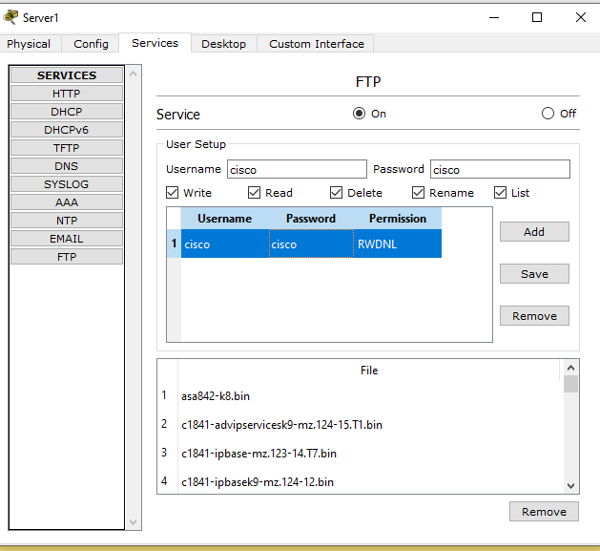

12. to check the FTP service, navigate to the Command Prompt under the Desktop tab of one of the PCs and type in ftp IP Address of Server. Then , an authentication is required. Type in the Username and Password as prompted.

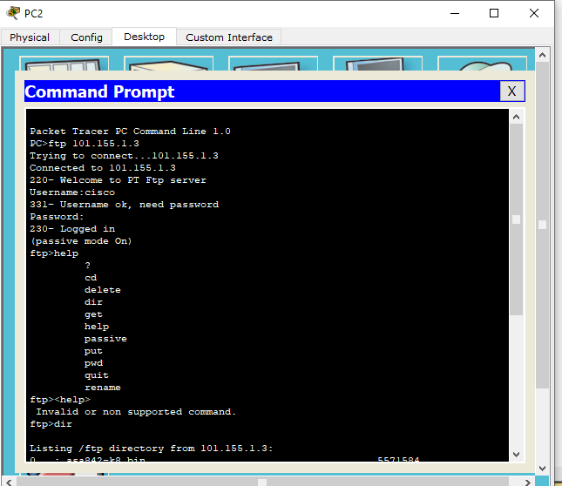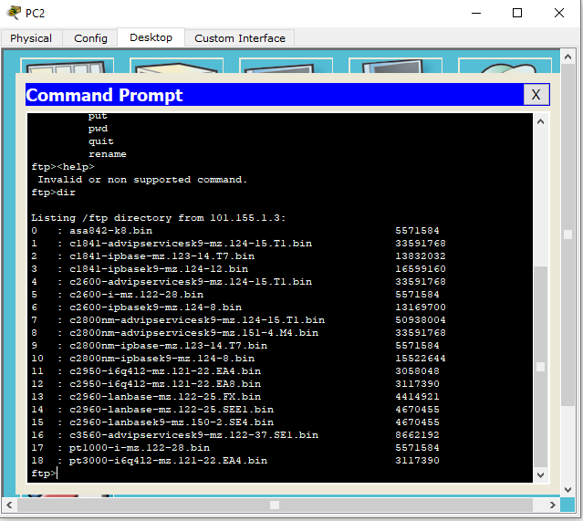

13. Next, type <help> to get a list of useful commands. Put <filename> will send a file from current device to the Server whereas get <filename> will get the file from the server.

14. To enable the email services, navigate to EMAIL under Desktop tab in the server and ensure that SMTP and PPo3 service radio buttons are ON.

15. type the domain name in the Domain Name box and click on set. under User Setup, type the username and password and click on “+”.

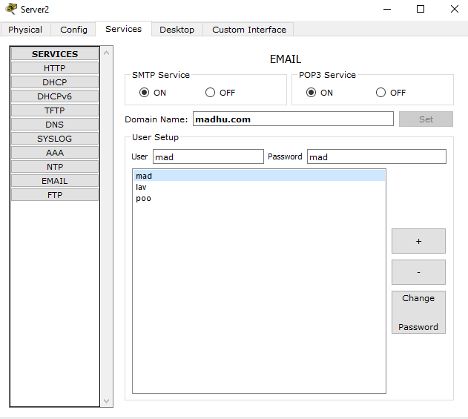

16. To test the Email service, navigate to email under Desktop tab in one of the PCs. Type in the name and email address in the relevant boxes. Give the previously decided username and password and click on save.

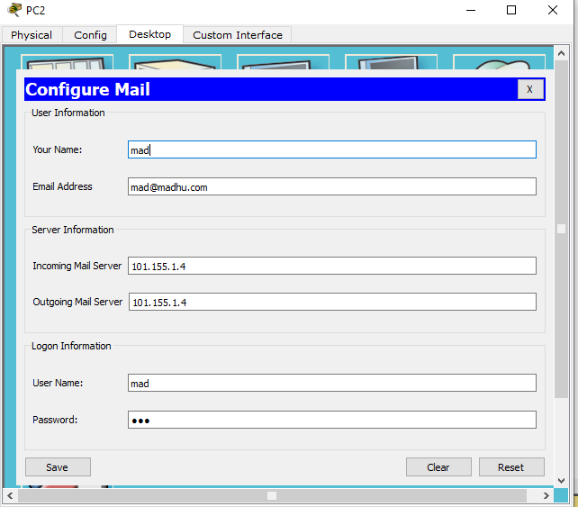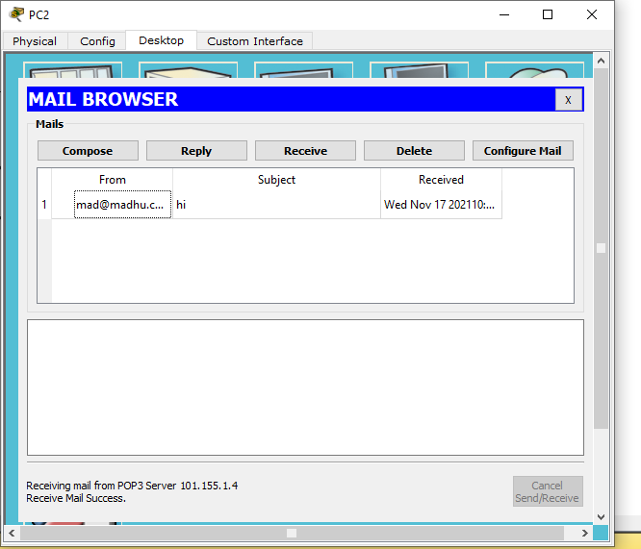

17. Navigate to the compose section to compose an email. Click on send. A message declaring “successfully sent” should appear. Under the received tab, check whether the message has been delivered.