# Aim:-

COMPUTER NETWORKS LAB

WEEK 2

Configure the LAN using packet tracer.

# LAN and its topologies:-

A LAN(Local Area Network) is a computers group that consists of several connected computers in an area of about 1000 m.

The common LAN topologies used here are as follows:

* Ring topology
* Star topology
* Bus topology
* Mesh topology

# RING topology:-

A **ring topology** is a [network](https://www.computerhope.com/jargon/n/network.htm) configuration where device connections create a circular [data](https://www.computerhope.com/jargon/d/data.htm) path. Each networked device is connected to two others, like points on a circle.

**Steps:-**

1. Open Cisco Packet Tracer and place computers on drawing area (logical area).
2. Draw switches on drawing area.
3. Create communication links. Connect computer to switch Connect switches in ring pattern
4. Configure IP Address.

Click on Computer/end device

In ‘Desktop’ tab ,click IP Configuration

Fill IP Address and Subnet Mask for configuration

1. Test the Ring topology created by sending messages between computers and checking status whether successful or not.

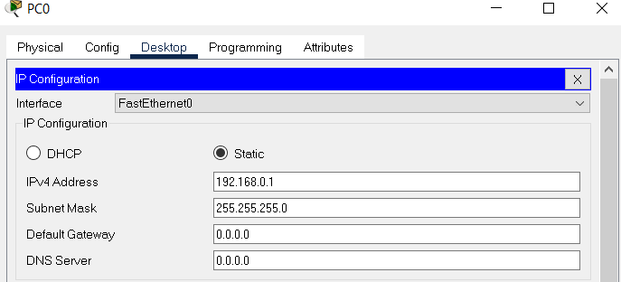

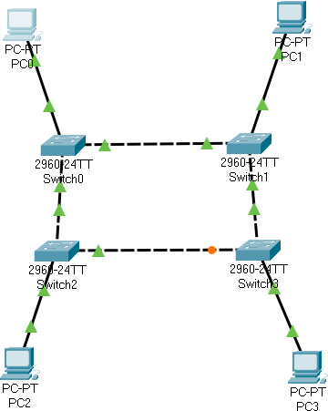



# STAR topology:-

A star topology is constructed with each node such as offices, printers, laptops, servers, etc., connected directly to a central computer known as a network switch.

**Steps:-**

1. Open Cisco Packet Tracer and Open Networking Device Menu
2. Select Desired Switch Model
3. Choose End Devices for your Star Network
4. Draw End Devices of your Star Network on the Drawing Area
5. Choose Connecting Cable for Device Connections

## Initiate Cable Connections

1. **Complete Cable Connections**
2. **Connect All Devices to Central Switch**
3. **Click on the device, Open Desktop Menu and Select IP Configuration Settings**
4. **Configure IP Address and Subnet Mask**
5. Test the Star topology created by sending messages between computers and checking status whether successful or not.

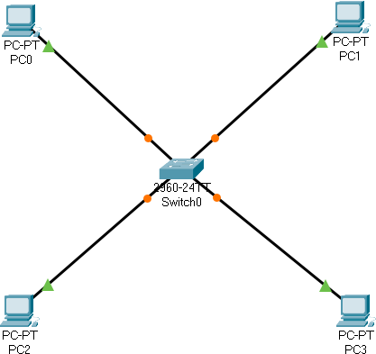



# BUS topology:-

Alternatively referred to as **line topology**, **bus topology** is a network setup where each computer and network device is connected to a single cable or [backbone](https://www.computerhope.com/jargon/b/backbone.htm).

**Steps:-**

* 1. Open Cisco Packet Tracer and draw switches on drawing area. Connect switches in a line pattern
  2. Place computers on drawing area (logical area).
  3. Create communication links. Connect computer to switch
  4. Configure IP Address.

Click on Computer/end device

In ‘Desktop’ tab ,click IP Configuration

Fill IP Address and Subnet Mask for configuration

* 1. Test the Bus topology created by sending messages between computers and checking status whether successful or not.

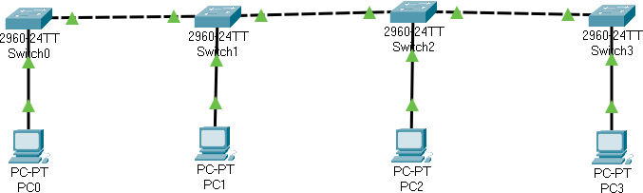



# MESH topology:-

Mesh topology provides a direct link between each pair of nodes (routers) on the [backbone network](https://networkencyclopedia.com/backbone-in-networking/) to provide redundant data paths in case of any failure.

**Steps:-**

1. Open Cisco Packet Tracer **,**then **Select and Draw End Devices of Your Mesh Network**

## Select and Draw Switches for each End Device

1. Connect Each Pair of Computer and Switch
2. Select Each Switch and Connect it to Other Remaining Switches
3. Configure IP Address.

Click on Computer/end device

In ‘Desktop’ tab ,click IP Configuration

Fill IP Address and Subnet Mask for configuration

1. Test the Mesh topology created by sending messages between computers and checking status whether successful or not.

