**COMPUTER NETWORKS LAB**

**19131A0532**

**WEEK-3**

**1.**

**AIM:**

To create bus topology using NS2 Simulation tool.

**HARDWARE / SOFTWARE REQUIREMENTS:**

NS-2

**PROCEDURE:**

1. Create a simulator object

2. Open a nam trace file and define finish procedure then close the trace file, and execute nam on trace file.

3. Create five nodes that forms a network numbered from 0 to 5

4. Create duplex links between the nodes and add Orientation to the nodes for setting a LAN topology by setting bandwidth and delay

5. Setup TCP Connection

6. Apply CBR Traffic over TCP.

7. Create and call finish procedure.

8. Schedule the events if necessary and run the simulator.

**PROGRAM IMPLEMENTATION:**  
set ns [new Simulator]

set nf [open CN_Week3Bus.nam w]

$ns namtrace-all $nf

proc finish {} {

global ns nf

$ns flush-trace

close $nf

puts "running nam"

exec nam CN_Week3Bus.nam &

set n2 [$ns node exit 0

}

set n0 [$ns node]

set n1 [$ns node]

]

set n3 [$ns node]

set n4 [$ns node]

set n5 [$ns node]

set lan [$ns newLan "$n0 $n1 $n2 $n3 $n4 $n5" 0.5Mb 40ms LL Queue/DropTail MAC/Csma/Cd Channel]

$ns at 1.0 "finish"

$ns run

**OUTPUT:**

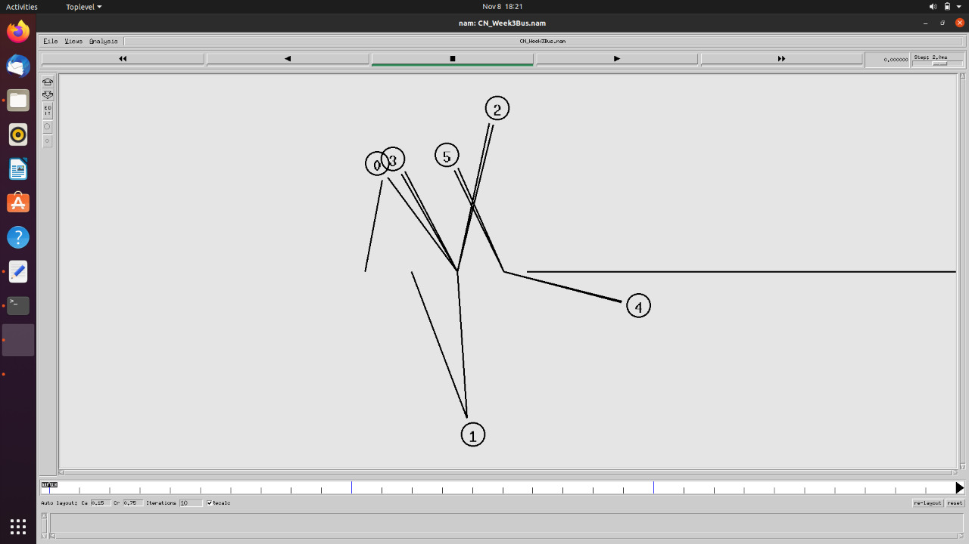

**2.**

**AIM:**

To create Ring topology using NS2 Simulation tool.

**HARDWARE / SOFTWARE REQUIREMENTS:**

NS-2

**PROCEDURE:**

1. Create a simulator object

2. Open a nam trace file and define finish procedure then close the trace file, and execute nam on trace file.

3. Create five nodes that forms a network numbered from 0 to 5

4. Create duplex links between the nodes and add Orientation to the nodes for setting a Ring topology by setting bandwidth and delay

5. Setup TCP Connection

6. Create and call finish procedure.

7. Schedule the events if necessary and run the simulator.

**PROGRAM IMPLEMENTATION:**  
set ns [new Simulator]

set nf [open CN_Week3Ring.nam w]

$ns namtrace-all $nf

proc finish {} {

global ns nf

$ns flush-trace

close $nf

puts "running nam"

exec nam CN_Week3Ring.nam &

exit 0

}

set n0 [$ns node]

set n1 [$ns node]

set n2 [$ns node]

set n3 [$ns node]

set n4 [$ns node]

set n5 [$ns node]

$ns duplex-link $n0 $n1 10Mb 10ms DropTail

$ns duplex-link $n1 $n3 10Mb 10ms DropTail

$ns duplex-link $n4 $n2 10Mb 10ms DropTail

$ns duplex-link $n3 $n5 10Mb 10ms DropTail

$ns duplex-link $n2 $n0 10Mb 10ms DropTail

$ns duplex-link $n5 $n4 10Mb 10ms DropTail

$ns duplex-link-op $n0 $n1 orient right

$ns duplex-link-op $n1 $n3 orient right-down

$ns duplex-link-op $n4 $n2 orient left-up

$ns duplex-link-op $n3 $n5 orient left-down

$ns duplex-link-op $n2 $n0 orient right-up

$ns duplex-link-op $n5 $n4 orient left

$ns at 1.0 "finish"

$ns run

**OUTPUT:**

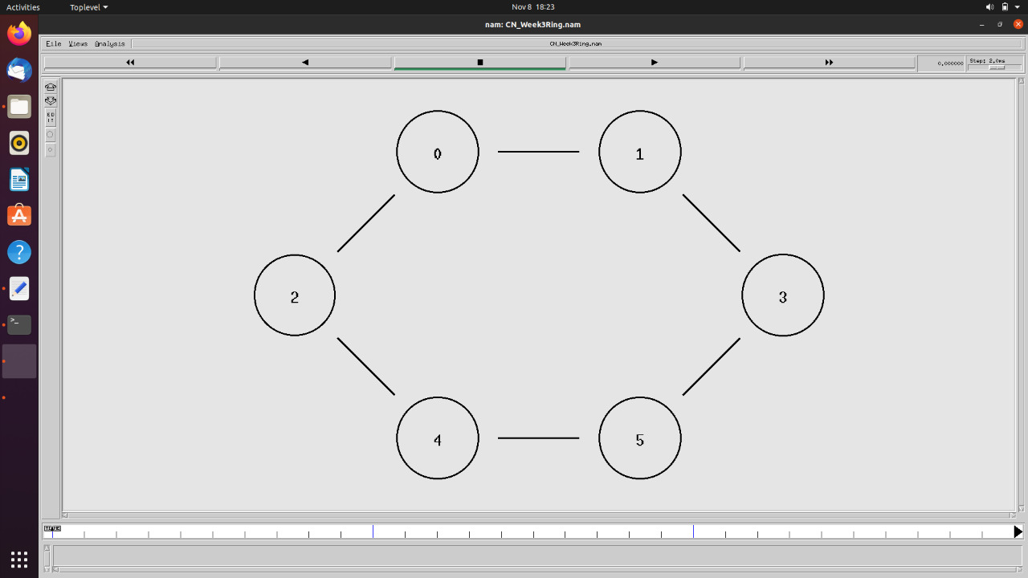

**3.**

**AIM:**

To create star topology using NS2 Simulation tool.

**HARDWARE / SOFTWARE REQUIREMENTS:**

NS-2

**PROCEDURE:**

1. Create a simulator object

2. Open a nam trace file and define finish procedure then close the trace file, and execute nam on trace file.

3. Create five nodes that forms a network numbered from 0 to 5

4. Create duplex links between the nodes and add Orientation to the nodes for setting a star topology by setting bandwidth and delay

5. Create and call finish procedure.

6. Schedule the events if necessary and run the simulator.

**PROGRAM IMPLEMENTATION:**  
set ns [new Simulator]

set nf [open CN_Week3Star.nam w]

$ns namtrace-all $nf

proc finish {} {

global ns nf

$ns flush-trace

close $nf

puts "running nam"

exec nam CN_Week3Star.nam &

exit 0

}

set n0 [$ns node]

set n1 [$ns node]

set n2 [$ns node]

set n3 [$ns node]

set n4 [$ns node]

set n5 [$ns node]

set n6 [$ns node]

$ns duplex-link $n0 $n1 10Mb 10ms DropTail

$ns duplex-link $n0 $n2 10Mb 10ms DropTail

$ns duplex-link $n0 $n3 10Mb 10ms DropTail

$ns duplex-link $n0 $n4 10Mb 10ms DropTail

$ns duplex-link $n0 $n5 10Mb 10ms DropTail

$ns duplex-link $n0 $n6 10Mb 10ms DropTail

$ns duplex-link-op $n0 $n1 orient up

$ns duplex-link-op $n0 $n2 orient right-up

$ns duplex-link-op $n0 $n3 orient right-down

$ns duplex-link-op $n0 $n4 orient down

$ns duplex-link-op $n0 $n5 orient left-down

$ns duplex-link-op $n0 $n6 orient left-up

$ns at 1.0 "finish"

$ns run

**OUTPUT:**

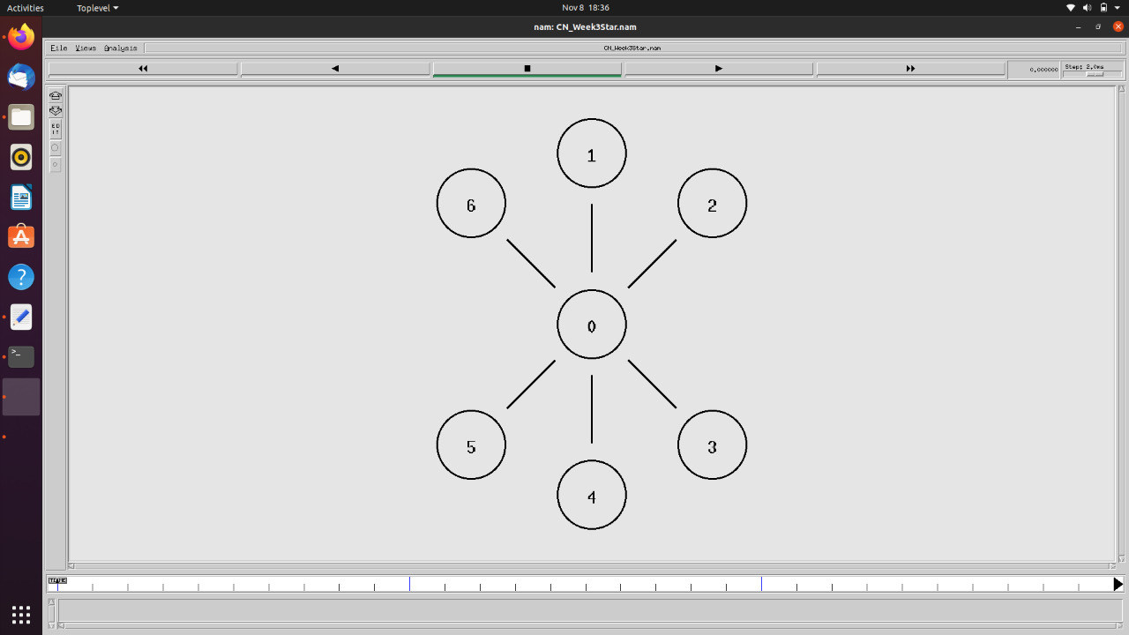

**4.**

**AIM:**

To create mesh topology using NS2 Simulation tool.

**HARDWARE / SOFTWARE REQUIREMENTS:**

NS-2

**PROCEDURE:**

1. Create a simulator object

2. Open a nam trace file and define finish procedure then close the trace file, and execute nam on trace file.

3. Create five nodes that forms a network numbered from 0 to 4

4. Create duplex links between the nodes and add Orientation to the nodes for setting a mesh topology by setting bandwidth and delay

5. Create and call finish procedure.

6. Schedule the events if necessary and run the simulator.

**PROGRAM IMPLEMENTATION:**  
set ns [new Simulator]  
set nf [open mesh1.nam w]  
$ns namtrace-all $nf  
set n0 [$ns node]  
set n1 [$ns node]  
set n2 [$ns node]  
set n3 [$ns node]  
$ns duplex-link $n0 $n1 10mb 10ms DropTail  
$ns duplex-link $n0 $n2 10mb 10ms DropTail  
$ns duplex-link $n0 $n3 10mb 10ms DropTail  
$ns duplex-link $n1 $n3 10mb 10ms DropTail  
$ns duplex-link $n1 $n2 10mb 10ms DropTail  
$ns duplex-link $n2 $n3 10mb 10ms DropTail  
$ns duplex-link $n1 $n0 10mb 10ms DropTail  
$ns duplex-link $n2 $n0 10mb 10ms DropTail  
$ns duplex-link $n3 $n0 10mb 10ms DropTail  
$ns duplex-link $n3 $n1 10mb 10ms DropTail  
$ns duplex-link $n2 $n1 10mb 10ms DropTail  
$ns duplex-link $n3 $n2 10mb 10ms DropTail  
$ns duplex-link-op $n0 $n1 orient left-down  
$ns duplex-link-op $n0 $n2 orient right-down  
$ns duplex-link-op $n0 $n3 orient left  
$ns duplex-link-op $n1 $n3 orient right-down  
$ns duplex-link-op $n1 $n2 orient up  
$ns duplex-link-op $n2 $n3 orient left-down  
$ns duplex-link-op $n1 $n0 orient right-up  
$ns duplex-link-op $n2 $n0 orient left-up  
$ns duplex-link-op $n3 $n0 orient right  
$ns duplex-link-op $n3 $n1 orient left-up  
$ns duplex-link-op $n2 $n1 orient down  
$ns duplex-link-op $n3 $n2 orient right-up  
                                                    
proc finish {} {  
 global ns nf  
 $ns flush-trace  
 close $nf  
 exec nam mesh1.nam &  
 exit 0  
}  
$ns at 1.0 "finish"  
$ns run

