**COMPUTER NETWORKS LAB**

**19131A0532**

**WEEK-6**

**1**

**AIM:**

To Simulate and to study stop and Wait protocol

**SOFTWARE REQUIREMENTS:**

NS-2 Simulator

**PROCEDURE:**

1. Create a simulator object

2. Open a nam trace file and define finish procedure then close the trace file, and execute nam on trace

file.

3. Create two nodes that forms a network numbered 0 and 5

4. Create duplex links between the nodes to form a STAR Topology

5. Setup TCP Connection between n(1) and n(3)

6. Apply CBR Traffic over TCP

7. Schedule events and run the program.

**IMPLEMENTATION:**

set ns [new Simulator]

set n0 [$ns node]

set n1 [$ns node]

set nf [open stop.nam w]

$ns namtrace-all $nf

set f [open stop.tr w]

$ns trace-all $f

$ns duplex-link $n0 $n1 0.2Mb 200ms DropTail

$ns duplex-link-op $n0 $n1 orient right

$ns queue-limit $n0 $n1 10

Agent/TCP set nam_tracevar_ true

set tcp [new Agent/TCP]

$tcp set window_ 1

$tcp set maxcwnd_ 1

$ns attach-agent $n0 $tcp

set sink [new Agent/TCPSink]

$ns attach-agent $n1 $sink

$ns connect $tcp $sink

set ftp [new Application/FTP]

$ftp attach-agent $tcp

$ns at 0.1 "$ftp start"

$ns at 3.0 "$ns detach-agent $n0 $tcp ; $ns detach-agent $n1 $sink"

$ns at 3.5 "finish"

proc finish {} {

global ns nf

$ns flush-trace

close $nf

puts "running nam..."

exec nam stop.nam &

exit 0

}$ns run

**OUTPUT:**

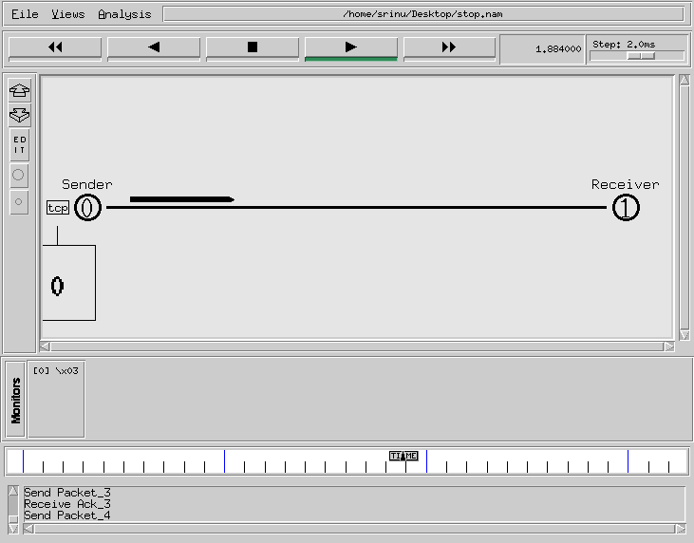

**2**

**AIM:**

To Simulate and to study sliding window protocol

**SOFTWARE REQUIREMENTS:**

NS-2 Simulator

**PROCEDURE:**

1. Create a simulator object

2. Open a nam trace file and define finish procedure then close the trace file, and execute nam on trace

file.

3. Create two nodes that forms a network numbered 0 and 5

4. Create duplex links between the nodes to form a STAR Topology

5. Setup TCP Connection between n(1) and n(3)

6. Apply CBR Traffic over TCP

7. Schedule events and run the program.

**IMPLEMENTATION:**

set ns [new Simulator]

set n0 [$ns node]

set n1 [$ns node]

set nf [open sliding.nam w]

$ns namtrace-all $nf

set f [open sliding.tr w]

$ns trace-all $f

$ns duplex-link $n0 $n1 0.2Mb 200ms DropTail

$ns duplex-link-op $n0 $n1 orient right

$ns queue-limit $n0 $n1 10

Agent/TCP set nam_tracevar_ true

set tcp [new Agent/TCP]

$tcp set windowInit_ 4

$tcp set maxcwnd_ 4

$ns attach-agent $n0 $tcp

set sink [new Agent/TCPSink]

$ns attach-agent $n1 $sink

$ns connect $tcp $sink

set ftp [new Application/FTP]

$ftp attach-agent $tcp

$ns at 0.1 "$ftp start"

$ns at 3.0 "$ns detach-agent $n0 $tcp ; $ns detach-agent $n1 $sink"

$ns at 3.5 "finish"

proc finish {} {

global ns

$ns flush-trace

# close $nf

puts "running nam..."

exec nam sliding.nam &

exit 0

}

$ns run

**OUTPUT:**

