**COMPUTER NETWORKS LAB**

**19131A0532**

**WEEK-7**

**1**

**AIM:**

To Simulate and to study Goback-N protocol

**SOFTWARE REQUIREMENTS:**

NS-2 Simulator

**PROCEDURE:**

1. Create a simulator object

2. Open a nam trace file and define finish procedure then close the trace file, and execute nam on trace

file.

3. Create two nodes that forms a network numbered 0 and 5

4. Create duplex links between the nodes to form a STAR Topology

5. Setup TCP Connection between n(1) and n(4)

6. Apply CBR Traffic over TCP

7. Schedule events and run the program.

**IMPLEMENTATION:**

set ns [new Simulator]

set n0 [$ns node]

set n1 [$ns node]

set n2 [$ns node]

set n3 [$ns node]

set n4 [$ns node]

set n5 [$ns node]

set nf [open goback-n.nam w]

$ns namtrace-all $nf

$ns duplex-link $n0 $n2 1Mb 20ms DropTail

$ns duplex-link $n1 $n2 1Mb 20ms DropTail

$ns duplex-link $n2 $n3 1Mb 20ms DropTail

$ns duplex-link $n3 $n4 1Mb 20ms DropTail

$ns duplex-link $n3 $n5 1Mb 20ms DropTail

$ns duplex-link-op $n0 $n2 orient right-down

$ns queue-limit $n0 $n2 5

$ns duplex-link-op $n1 $n2 orient right-up

$ns duplex-link-op $n2 $n3 orient right

$ns duplex-link-op $n3 $n4 orient right-up

$ns duplex-link-op $n3 $n5 orient right-down

Agent/TCP set_nam_tracevar_true

set tcp [new Agent/TCP]

$tcp set fid 1

$ns attach-agent $n1 $tcp

set sink [new Agent/TCPSink]

$ns attach-agent $n4 $sink

$ns connect $tcp $sink

set ftp [new Application/FTP]

$ftp attach-agent $tcp

$ns at 0.05 "$ftp start"

$ns at 0.06 "$tcp set windowlnit 6"

$ns at 0.06 "$tcp set maxcwnd 6"

$ns at 0.25 "$ns queue-limit $n3 $n4 0"

$ns at 0.26 "$ns queue-limit $n3 $n4 10"

$ns at 0.305 "$tcp set windowlnit 4"

$ns at 0.305 "$tcp set maxcwnd 4"

$ns at 0.368 "$ns detach-agent $n1 $tcp ; $ns detach-agent $n4 $sink"

$ns at 1.5 "finish"

proc finish {} {

global ns nf

$ns flush-trace

close $nf

exec nam goback-n.nam &

exit 0

}

$ns run

**OUTPUT:**

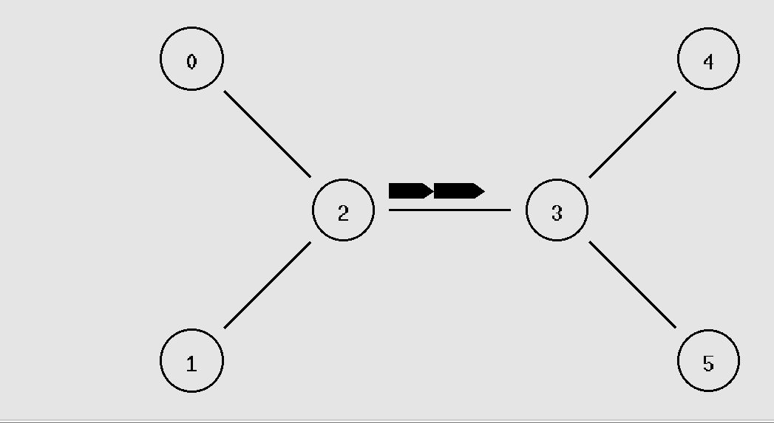

**2**

**AIM:**

To Simulate and to study selective repeat protocol

**SOFTWARE REQUIREMENTS:**

NS-2 Simulator

**PROCEDURE:**

1. Create a simulator object

2. Open a nam trace file and define finish procedure then close the trace file, and execute nam on trace

file.

3. Create two nodes that forms a network numbered 0 and 5

4. Create duplex links between the nodes to form a STAR Topology

5. Setup TCP Connection between n(1) and n(4)

6. Apply CBR Traffic over TCP

7. Schedule events and run the program.

**IMPLEMENTATION:**

set ns [new Simulator]

set n0 [$ns node]

set n1 [$ns node]

set n2 [$ns node]

set n3 [$ns node]

set n4 [$ns node]

set n5 [$ns node]

set nf [open Srepeat.nam w]

$ns namtrace-all $nf

set f [open Srepeat.tr w]

$ns trace-all $f

$ns duplex-link $n0 $n2 1Mb 10ms DropTail

$ns duplex-link $n1 $n2 1Mb 10ms DropTail

$ns duplex-link $n2 $n3 1Mb 10ms DropTail

$ns duplex-link $n3 $n4 1Mb 10ms DropTail

$ns duplex-link $n3 $n5 1Mb 10ms DropTail

$ns duplex-link-op $n0 $n2 orient right-down

$ns queue-limit $n0 $n2 5

$ns duplex-link-op $n1 $n2 orient right-up

$ns duplex-link-op $n2 $n3 orient right

$ns duplex-link-op $n3 $n4 orient right-up

$ns duplex-link-op $n3 $n5 orient right-down

Agent/TCP set_nam_tracevar_true

set tcp [new Agent/TCP]

$tcp set fid 1

$ns attach-agent $n1 $tcp

set sink [new Agent/TCPSink]

$ns attach-agent $n4 $sink

$ns connect $tcp $sink

set ftp [new Application/FTP]

$ftp attach-agent $tcp

$ns at 0.05 "$ftp start"

$ns at 0.06 "$tcp set windowlnit 8"

$ns at 0.06 "$tcp set maxcwnd 8"

$ns at 0.25 "$ns queue-limit $n3 $n4 0"

$ns at 0.26 "$ns queue-limit $n3 $n4 10"

$ns at 0.30 "$tcp set windowlnit 1"

$ns at 0.30 "$tcp set maxcwnd 1"

$ns at 0.30 "$ns queue-limit $n3 $n4 10"

$ns at 0.47 "$ns detach-agent $n1 $tcp;$ns detach-agent $n4 $sink"

$ns at 1.75 "finish"

proc finish {} {

global ns nf

$ns flush-trace

close $nf

exec nam Srepeat.nam &

exit 0

}

$ns run

**OUTPUT:**

