**Before you start:**

* **Recreate the database using the provided script.**
* **Recreate ADO Entity Model.**

**ProductInfo.aspx**

* **Query string already is passed in with the product code**
* **We do not need to see the category page’s left nav bar anymore**
* **Load the product with this product code (prod.getProductByProductCode(prodcd))**
* **Include all fields somewhere on the form (Example: Future Shop page below)**
* **For the image, just put a placeholder until we add product images to database**
* **This page does a redirect to CartItems.aspx via AddToCart (Add the item’s product code and quantity (1 by default) to a session list BEFORE redirecting to CartItems.aspx)**

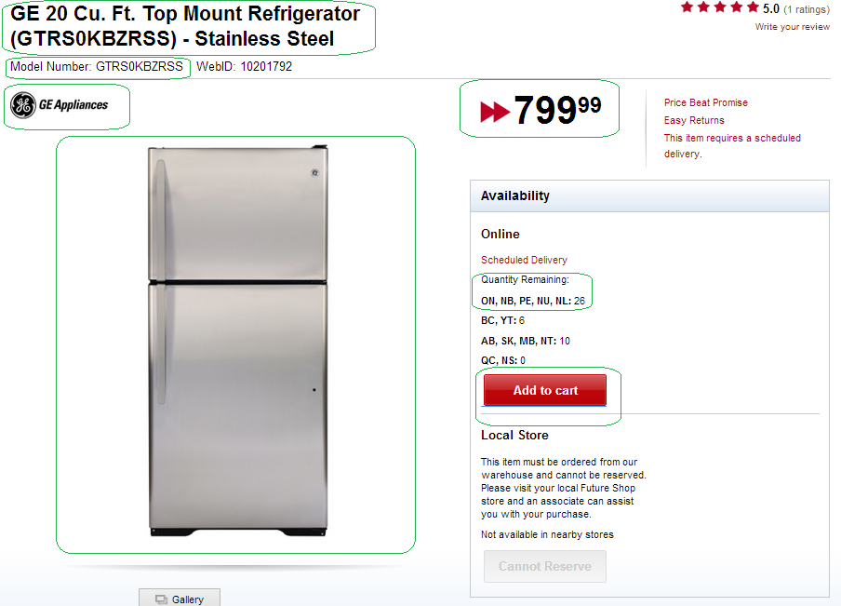

**CartItems.aspx**

* **After clicking “Add To Cart” on “ProductInfo.aspx” (the previous page), the product was added to the cart in the session along with any other products that were already in the cart.**
* **CartItems.aspx should have an ASP Data List control similar to the one in the Future Shop screenshot below. I used one in Category.aspx if you need a reference.**
* **The user should be able to edit the quantity of each cart item here (all recently added products default to 1)**
* **The user should be able to advance to the Checkout.aspx page via the Checkout button.**
* **If you have time, the Cart Order Total estimate box (seen below) would be nice to have at some point. Instead of asking for postal code, load all from StatesProvinces table into a dropdown and do a calculation when they click “Calculate”**
* **If they want to continue shopping, they can click “Continue Shopping” and be sent to the website’s homepage.**
* **In the master page, update the user panel in the top left panel (The “Items In Cart” and “Subtotal” fields)...See screenshot of what i mean below.**

