# SMARTHEAL

*A Report*

*Submitted in partial fulfilment of the Requirements for the completion of*

*THEME BASED PROJECT*

## BACHELOR OF ENGINEERING

IN

## INFORMATION TECHNOLOGY

By

## Anoohya Narsingi 1602-21-737-070

## Bhavani Lavanga 1602-21-737-076

## Mirza Rafiq Ahmed 1602-21-737-095

## *Under the guidance of*

## Mrs. B. Leelavathy

## Assistant Professor



**Department of Information Technology**

**Vasavi College of Engineering (Autonomous)**

**ACCREDITED BY NAAC WITH 'A++' GRADE.**

**(Affiliated to Osmania University and Approved by AICTE)**

**Ibrahim Bagh, Hyderabad-31**

**2024**

**Vasavi College of Engineering (Autonomous)**

***ACCREDITED BY NAAC WITH 'A++' GRADE***

**(Affiliated to Osmania University and Approved by AICTE)**

**Ibrahim Bagh, Hyderabad-31**

**Department of Information Technology**



### DECLARATION BY CANDIDATES

We, **ANOOHYA NARSINGI, BHAVANI LAVANGA and MIRZA RAFIQ AHMED,** bearing hall ticket numbers, **1602-21-737-070**, **1602-21-737-076** and **1602-21-737-095,** hereby declare that the project report entitled  **“SMARTHEAL”** under the guidance of **Mrs. B. Leelavathy, Assistant Professor**, Department of Information Technology, Vasavi College of Engineering, Hyderabad, is submitted in partial fulfillment of the requirement for the completion of Theme-based project , VI semester, Bachelor of Engineering in Information Technology.

This is a record of bonafide work carried out by us and the results embodied in this project report have not been submitted to any other institutes.

## Anoohya Narsingi 1602-21-737-070

## Bhavani Lavanga 1602-21-737-076

## Mirza Rafiq Ahmed 1602-21-737-095

**Vasavi College of Engineering (Autonomous)**

***ACCREDITED BY NAAC WITH 'A++' GRADE***

**(Affiliated to Osmania University and Approved by AICTE)**

**Ibrahim Bagh, Hyderabad-31**

**Department of Information Technology**

### BONAFIDE CERTIFICATE

This is to certify that the project entitled “**SMARTHEAL**” being submitted by **ANOOHYA NARSINGI , BHAVANI LAVANGA and MIRZA RAFIQ AHMED,** bearing hall ticket numbers, **1602-21-737-070**, **1602-21-737-076** and **1602-21-737-095,** in partial fulfillment of the requirements for the completion of Theme-based project of Bachelor of Engineering in Information Technology is a record of bonafide work carried out by them under my guidance.

|  |  |  |
| --- | --- | --- |
| **Mrs. B. Leelavathy, Assistant Professor** | **External Examiner** | **Dr. K. Ram Mohan Rao**  **Professor, HOD IT** |
|  |  |  |

## ACKNOWLEDGEMENT

The satisfaction that accompanies the successful completion of the project would not have been possible without the kind support and help of many individuals. We would like to extend our sincere thanks to all of them.

It is with immense pleasure that we would like to take the opportunity to express our humble gratitude to **Mrs. B. Leelavathy, Associate Professor, Information Technology** under whom we executed this project. Her constant guidance and willingness to share their vast knowledge made us understand this project and its manifestations in great depths and helped us to complete the assigned tasks.

We are very much thankful to **Dr. K. Ram Mohan Rao, Professor and HOD, Information Technology,** for his kind support and for providing necessary facilities to carry out the work.

We wish to convey our special thanks to Dr. S. V. Ramana**, Principal** of **Vasavi College of Engineering** for giving the required information in doing my project work. Not to forget, we thank all other faculty and non-teaching staff, and my friends who had directly or indirectly helped and supported me in completing my project in time.

We also express our sincere thanks to the Management for providing excellent facilities. Finally, we wish to convey our gratitude to our family who fostered all the facilities that we need.

**ABSTRACT**

SmartHeal emerges as a pivotal solution in the landscape of healthcare management, offering an unparalleled fusion of advanced technology and patient-centric care delivery. At its core, SmartHeal embodies a commitment to efficiency and empathy, striving to simplify administrative tasks while enhancing the overall patient experience. Through its multifaceted features and intuitive design, SmartHeal empowers healthcare administrators to navigate complex workflows with ease. With features such as profile management, scheduling, and performance tracking, SmartHeal enables administrators to efficiently manage their medical staff, ensuring optimal coverage and patient access to care. Appointment scheduling is another cornerstone of SmartHeal's platform, offering patients and providers alike a streamlined and intuitive experience. Through online booking, appointment reminders, and real-time availability updates, SmartHeal simplifies the scheduling process, reducing wait times and enhancing patient satisfaction. Moreover, SmartHeal prioritizes effective communication between patients and healthcare providers, recognizing its crucial role in delivering high-quality care. The platform's patient communication tools enable secure messaging, appointment reminders, and access to medical records, fostering a collaborative and informed approach to healthcare delivery. In addition to its patient-facing features, SmartHeal also addresses the administrative burden faced by healthcare facilities through automation and customization. By automating routine administrative tasks such as billing, documentation, and inventory management, SmartHeal enables staff to focus their time and energy on delivering exceptional patient care.

### TABLE OF CONTENTS

|  |  |  |  |  |  |  |  |
| --- | --- | --- | --- | --- | --- | --- | --- |
| 1. INTRODUCTION | | | | 1 | | | |
| 1.1 Overview | | | | 2 | | |
| 1.2 Problem Statement | | | | 3 | | |
| 1.3 Motivation of theme & title | | | | 4 | | |
| 2. LITERATURE SURVEY | | | |  | | | |
| 3. EXISTING SYSTEM | | | |  | | | |
| 4. PROPOSED SOLUTION | | | |  | | | |
| 4.1. System Design | | | |  | | | |
| 4.1.1 Architecture Diagram | | | |  | | | |
| 4.1.2 Use-Case Diagram | | | |  | | | |
| 4.1.2.1 Use-case descriptions | | | |  | | | |
| 4.2 Functional Modules | | | |  | | | |
| 4.2.1 Screenshots & Pseudocode | | | |  | | | |
| 5. EXPERIMENTAL SETUP & IMPLEMENTATION | | | |  | | | |
| 5.1 System Specifications | | | |  | | | |
| 5.1.1 Hardware Requirements | | | |  | | | |
| 5.1.2 Software Requirements | | | |  | | | |
| 6. RESULTS | | | |  | | | |
| 7. CONCLUSION & FUTURE SCOPE | | | |  | | | |
| 8. REFERENCES | | | |  | | | |

1. **INTRODUCTION**
   1. **OVERVIEW**

***SmartHeal*** is revolutionizing healthcare management with a comprehensive platform that integrates advanced digital technologies to optimize various administrative and clinical processes. By ensuring efficient doctor availability, streamlining appointment scheduling, and enhancing administrative workflows, ***SmartHeal*** significantly boosts operational efficiency within healthcare facilities. The platform aims to reduce patient wait times, improve resource allocation, and elevate the overall quality of care delivered. Through its innovative approach, ***SmartHeal*** aspires to create a seamless, efficient, and patient-centric healthcare experience**.**

* 1. **PROBLEM STATEMENT**

***SmartHeal*** aims to modernize healthcare management by offering a comprehensive platform that optimizes doctor availability, appointment allocation, and administrative processes. Through seamless integration of digital technologies***, SmartHeal*** aims to enhance operational efficiency, minimize patient wait times, and elevate the quality of patient care.

* 1. **MOTIVATION OF THEME & TITLE**

The motivation behind ***SmartHeal*** stems from a deep-seated desire to revolutionize the healthcare industry by addressing the pressing challenges faced by healthcare facilities worldwide. With escalating demands for efficiency, patient satisfaction, and resource optimization, traditional healthcare management methods have become increasingly inadequate***. SmartHeal*** seeks to bridge this gap by harnessing the power of technology to streamline administrative processes, improve communication channels, and enhance overall operational efficiency.

1. **LITERATURE SURVEY**

In their seminal work, Rohleder and Klassen (2000) meticulously investigate the utilization and impact of online booking systems within the healthcare sector. The book offers a comprehensive analysis of the adoption of digital platforms for appointment scheduling and management, exploring the intricate interplay between technology and healthcare service delivery. Through rigorous research methodologies, including case studies and empirical data analysis, the authors elucidate the advantages and challenges associated with the integration of online booking systems in healthcare settings.

Central to their findings is the transformative effect of online booking systems on patient satisfaction and operational efficiency. Rohleder and Klassen reveal how these digital solutions revolutionize the patient experience by providing convenient and accessible means for scheduling appointments, reducing wait times, and minimizing administrative burdens. Moreover, the book underscores the potential of online booking systems to optimize resource allocation, streamline workflows, and enhance healthcare service delivery.

Beyond the pragmatic benefits, Rohleder and Klassen delve into the nuanced implications of digital innovation in healthcare, addressing concerns regarding data security, patient privacy, and equity of access. They navigate the complex landscape of technological integration within healthcare institutions, offering practical insights and strategic recommendations for maximizing the effectiveness and sustainability of online booking systems.

In essence, The Use of Online Booking Systems in Healthcare serves as a seminal reference for stakeholders across the healthcare ecosystem, from clinicians and administrators to policymakers and technology developers. Its comprehensive analysis and empirical rigor provide invaluable guidance for harnessing the potential of digital solutions to optimize appointment scheduling and advance patient-centered care delivery in the modern healthcare landscape.

1. **EXISTING SYSTEM**

* In the current healthcare system, patient appointments are typically managed manually or through basic scheduling software.
* Patient waiting times are often long due to inefficient appointment scheduling and lack of real-time doctor availability tracking.
* Doctors' schedules may not be optimized, leading to either overbooking or underutilization of their time.
* Patients often have to wait unnecessarily for tests and procedures due to inefficient coordination between medical staff and resources

1. **PROPOSED SOLUTION**

* Implement a comprehensive digital platform that integrates advanced allocation withreal-time tracking of doctor availability.
* Develop a user-friendly interface for patients to book appointments based on their convenience and doctors' availability.
* Analyze patient flow and allocate resources efficiently, reducing waiting times.
* Overall, the proposed solution aims to optimize doctor availability, reduce patient waiting times, and streamline the entire healthcare process through smart digital solutions

**4.1 SYSTEM DESIGN**

**4.1.1 ARCHITECTURE DIAGRAM**

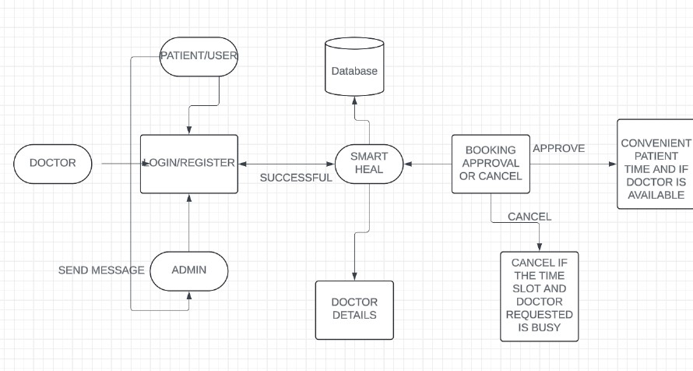

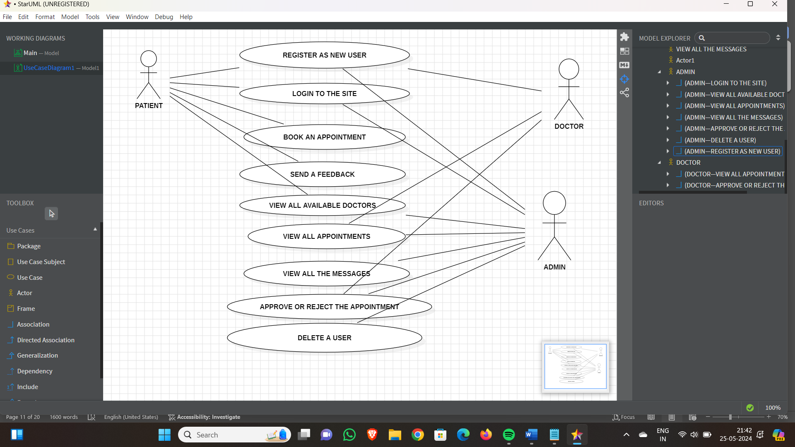**4.1.2 USE – CASE DIAGRAM**

**4.1.2.1 USE CASE DESCRIPTION**

**1. Register as New User**

- Actor: Patient, Admin

- Description: Allows a new patient or admin to create an account on the system by

providing necessary details such as name, email, password, and other relevant information.

- Preconditions: User must have a valid email address.

- Postconditions: New user account is created and stored in the database.

**2. Login to the Site**

- Actor: Patient, Admin

- Description: Enables an existing patient or admin to log into the system using their

registered email and password.

- Preconditions: User must be registered in the system.

- Postconditions: User gains access to their respective dashboard.

**3. Book an Appointment**

- Actor: Patient

- Description: Allows a patient to book an appointment with a doctor by selecting a date,

time, and doctor from the available slots.

- Preconditions: User must be logged in.

- Postconditions: Appointment is scheduled and recorded in the system.

**4. Send a Feedback**

- Actor: Patient

- Description: Enables a patient to send feedback regarding the service, doctors, or any

other aspect of the system.

- Preconditions: User must be logged in.

- Postconditions: Feedback is submitted and stored for review.

**5. View All Available Doctors**

- Actor: Patient, Admin

- Description: Allows users to see a list of all doctors available in the system along with

their details such as specialization, availability, and contact information.

- Preconditions: User must be logged in.

- Postconditions: List of doctors is displayed.

**6. View All Appointments**

- Actor: Patient, Doctor, Admin

- Description: Allows users to view all their appointments. Patients can see their booked

appointments, doctors can see their scheduled appointments, and admins can see all

appointments in the system.

- Preconditions: User must be logged in.

- Postconditions: List of appointments is displayed.

**7. View All the Messages**

- Actor: Admin

- Description: Enables admin to view all messages, including feedback and

communications between patients and doctors.

- Preconditions: User must be logged in as an admin.

- Postconditions: Messages are displayed for review.

**8. Approve or Reject the Appointment**

- Actor: Doctor, Admin

- Description: Allows doctors and admins to approve or reject appointment requests made

by patients.

- Preconditions: User must be logged in.

- Postconditions: Appointment status is updated in the system.

**9. Delete a User**

- Actor: Admin

- Description: Enables an admin to delete a user from the system. This could be a patient or

another admin.

- Preconditions: User must be logged in as an admin.

- Postconditions: User account is removed from the system.

**4.2 FUNCTIONAL MODULES**

**4.2.1 SCREEN SHOTS & PSUEDO CODE**

**PSUEDO CODE**

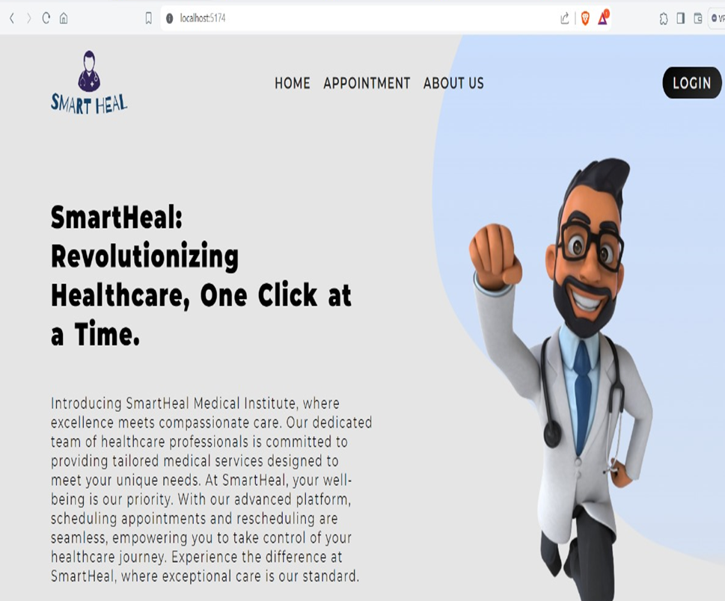

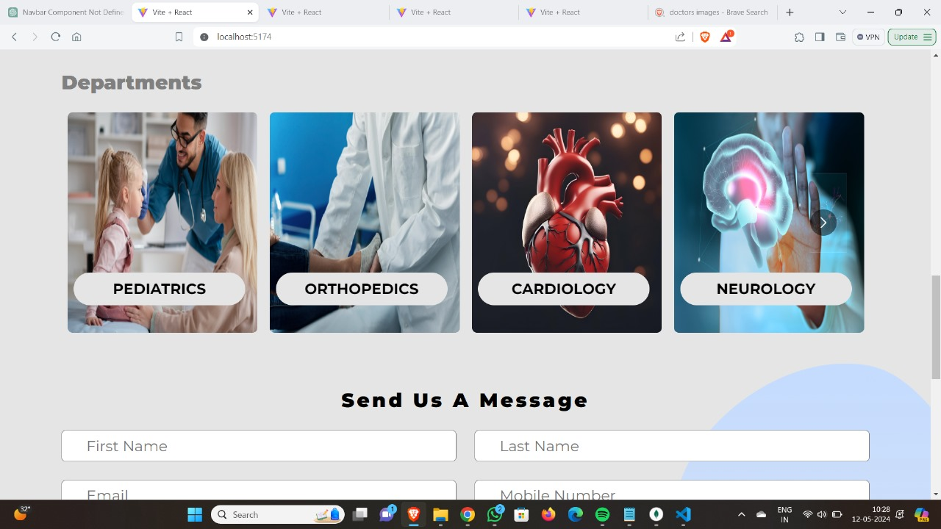

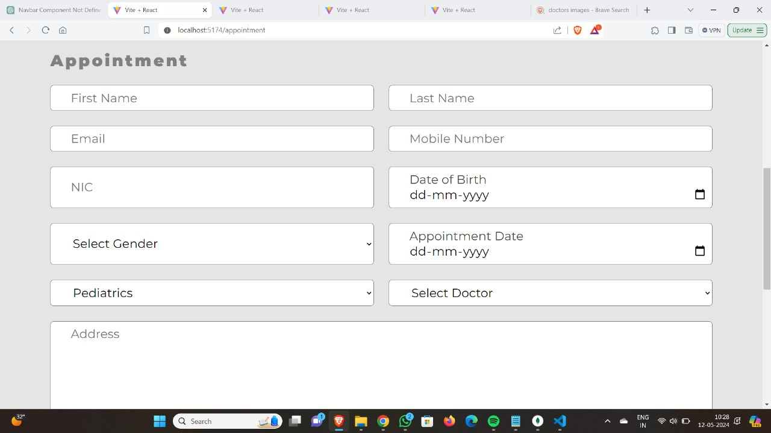

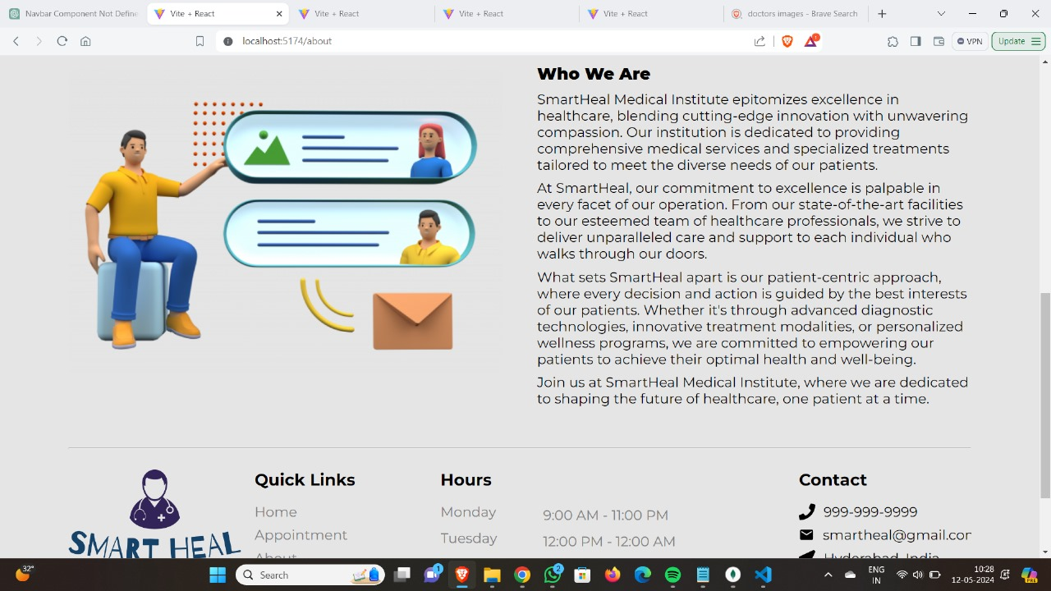

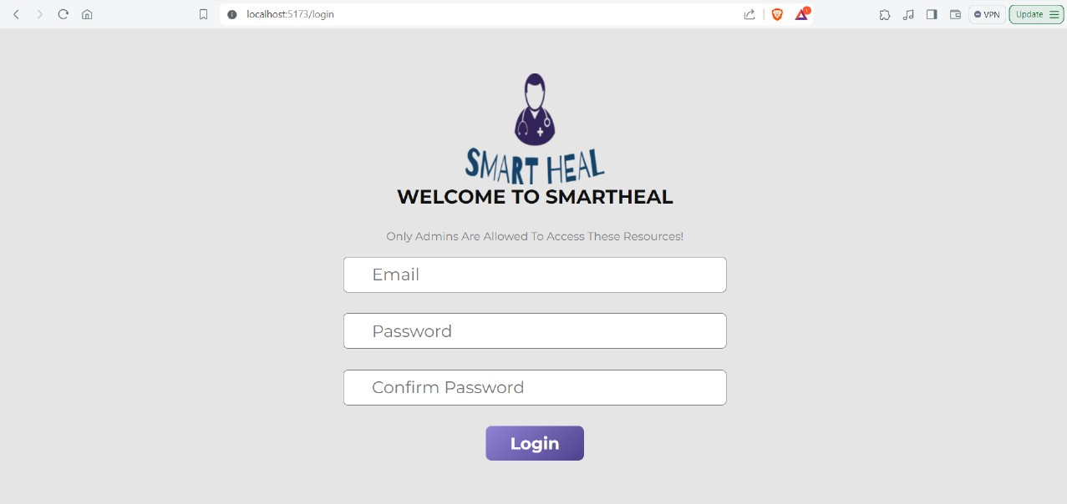

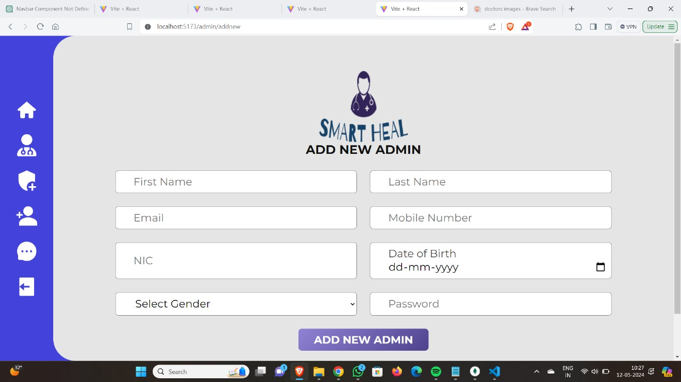

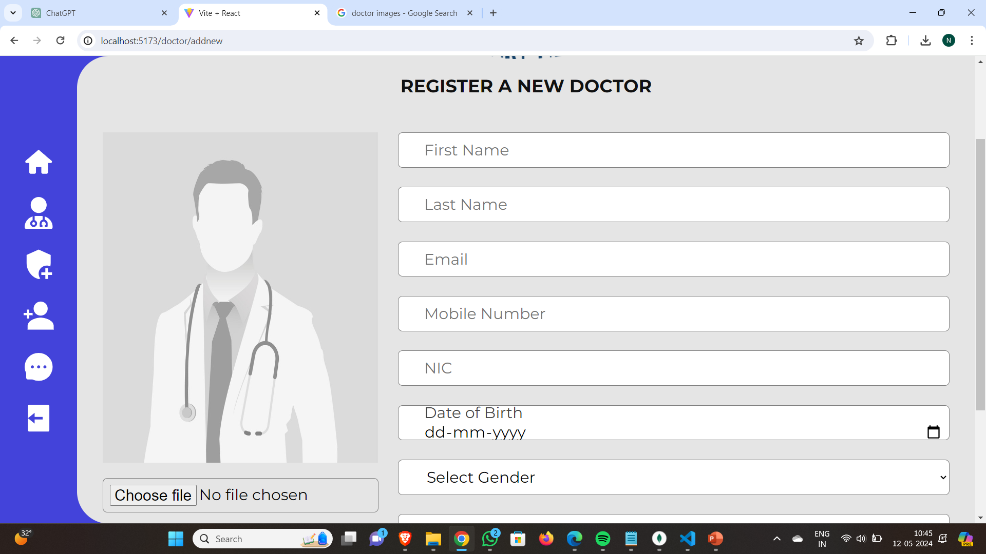

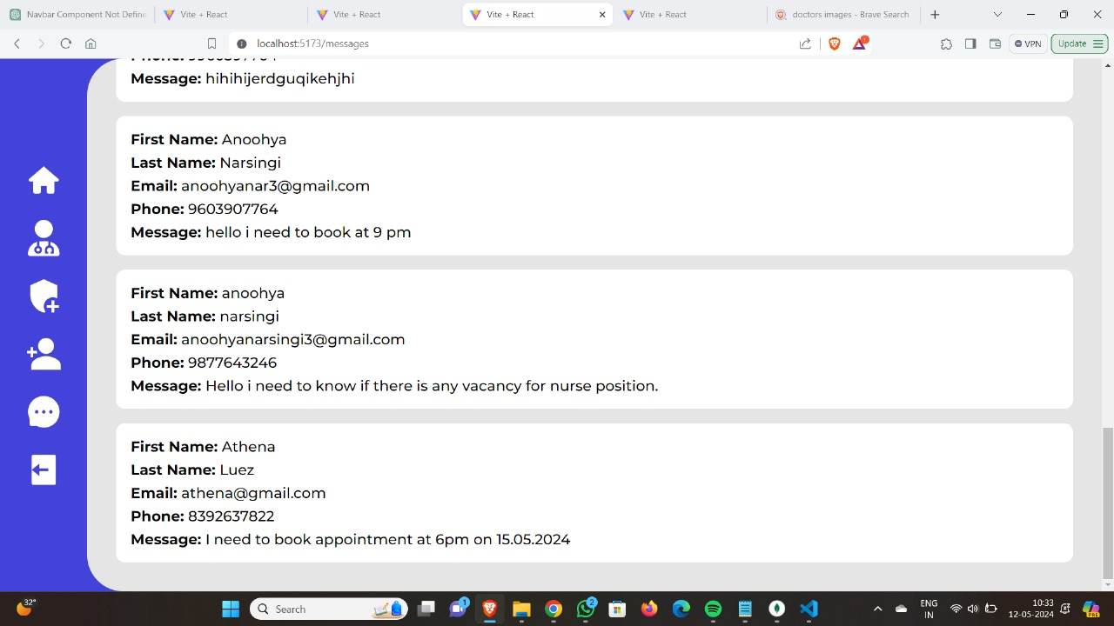

1. **EXPERIMENTAL SETUP & IMPLEMENTATION**

**5.1 SYSTEM SPECIFICATIONS**

**5.1.1 HARDWARE REQUIREMENTS**

* **Desktops/Laptops**: Specifications: Intel i5 or AMD Ryzen 5, 8 GB RAM, 256 GB SSD
* **Main Application Server**: High-performance server with at least 32 GB RAM
* **Internet Connectivity**: A stable internet connection is necessary

**5.1.2 SOFTWARE REQUIREMENTS**

* **Operating Systems**:

Server OS: Windows Server, Linux (Ubuntu Server, CentOS)

Client OS: Windows 10/11, macOS, Linux

* **Database Management System**:

NoSQL Database: MongoDB, for handling unstructured data.

* **Application Development Frameworks**:

Frontend: HTML5, CSS3, JavaScript, React

Backend: Node.js, Express.js

* **Integration Middleware**:

API Management: Postman

1. **RESULTS**
2. **CONCLUSION & FUTURE SCOPE**

**CONCLUSION**

***SmartHeal*** emerges as a beacon of efficiency in healthcare administration. By integrating user-friendly interfaces with robust features, it not only optimizes operational workflows but also enhances patient satisfaction. With ***SmartHeal***, healthcare facilities embark on a journey towards seamless coordination and improved patient outcomes.

***SmartHeal*** – **Where Efficiency Meets Empathy.**

**FUTURE SCOPE**

* **AI-driven Virtual Health Assistants**: Introducing AI-powered virtual assistants for patients can revolutionize interactions, offering personalized support from appointment scheduling to medical inquiries.This can conduct initial assessments based on patient symptoms, providing valuable insights before the consultation. This streamlines the diagnostic process, improves efficiency, and ensures patients receive timely care.This decreases the load on healthcare staff.
* **Advanced Scheduling Algorithms and Predictive Analytics**: The project can evolve by incorporating more sophisticated scheduling algorithms and predictive analytics. By analyzing historical data on patient fldwdow, doctor availability, and appointment patterns, the system can anticipate future demand and dynamically adjust scheduling to optimize efficiency. Additionally, predictive analytics can be used to forecast patient arrivals, predict consultation durations, and allocate resources accordingly. This proactive approach can further reduce waiting times, improve patient satisfaction, and enhance overall operational efficiency.
* **Expanding to Multiple Facilities**: By standardizing processes and integrating with existing hospital software, our project can scale up to serve larger patient populations across different locations. This benefits patients by improving access to care and enables more effective collaboration among healthcare providers. Establishing interoperability standards facilitates seamless data exchange, leading to more integrated healthcare delivery.
* **Integrating RFID, Mobile Proximity, and Face Detection for Patients and Doctors**: Our system utilizes RFID tags for doctors and patients, enabling real-time tracking of their locations within the facility. Mobile proximity technology ensures seamless communication between staff and patients, optimizing their interactions. Additionally, face detection tools enhance security and streamline check-in processes for both patients and doctors. Together, these technologies create a cohesive environment where both patients and doctors experience improved efficiency and convenience."

1. **REFERENCES**

* Benson, T. (2012). "Principles of Health Interoperability HL7 and SNOMED."
* Rohleder, T. R., & Klassen, K. J. (2000). "The Use of Online Booking Systems in Healthcare."
* Bove, R., et al. (2013). Evaluation of Secure Messaging Between Patients and Healthcare Providers."
* Liu, C., & Zhang, J. (2016). "Customization of Healthcare Systems for Improving Efficiency."
* Shortliffe, E. H., & Cimino, J. J. (2006). "Biomedical Informatics: Computer Applications in Health Care and Biomedicine."
* Rohleder, T. R., & Klassen, K. J. (2000).
* W3SCHOOLS