Assessment 3
Paper Prototype & Usability Report
SpinSync
26509909 – Kushal Aryal
Group 4 – Fantastic Four

Introduction

The name of your group: Group 4 – Fantastic Four
List of student names and numbers:
- Tanay Chougule – 26497053
- Kushal Aryal – 26509909
- Lily Burke – 26316481
- Shreya Ghosh – 26282638
The title of your design idea: SpinSync
Summary of the idea
Small groups of friends often struggle to decide what to do together. Different budgets, energy levels and opinions stall the conversation, and the group falls back on old habits or their phones. SpinSync is a table-top hub with a companion phone app that helps a group choose an activity together. Friends join a session, agree on the practical limits of the evening (time, budget, energy, location and group size), then each privately submits one idea by tapping their phone on the hub. The hub fills its ring with the five ideas plus five wildcard activities, and a spin picks the group’s activity. Because ideas are private until the end and the spinner makes the final choice, no one has to decide for the group.

Section 1: Persona

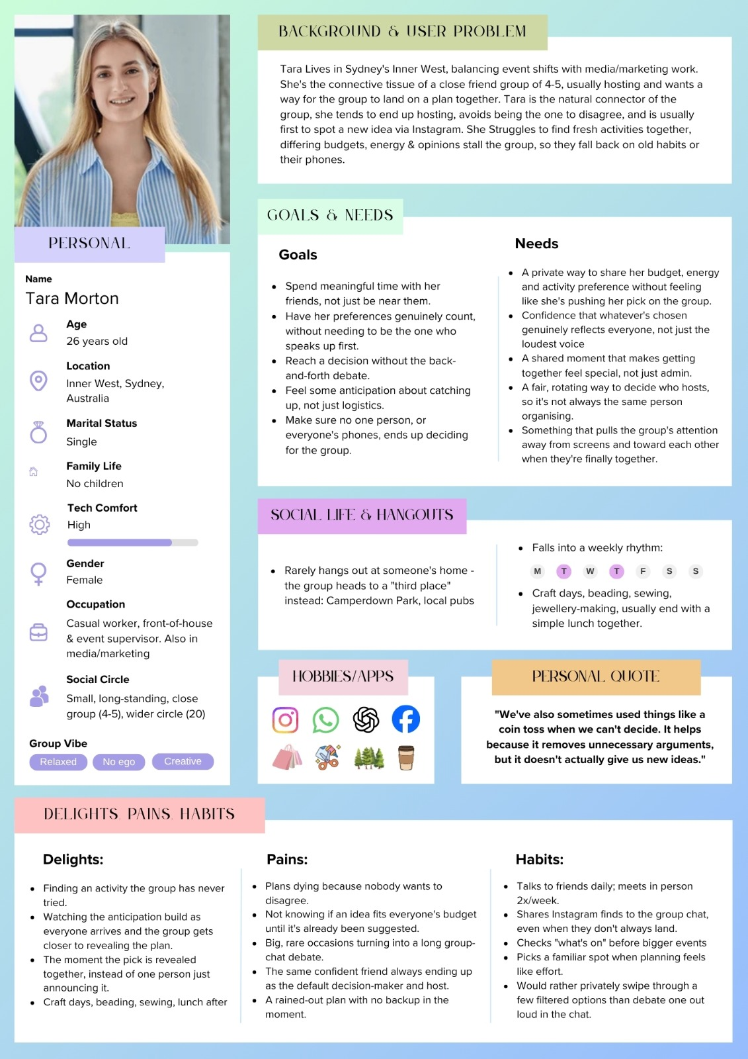

Section 2: Problem Scenario

It’s Saturday evening and Tara has four close friends over after a busy week. All are pleased to finally meet up, but when asked, “So, what is it we need to do?” the group has a hard time deciding on anything. One person wants to go out, another wants to stay in and some says let’s go somewhere new to eat. Tara still becomes the person who tries to keep the conversation moving, but she does not want to make the decision for everyone. As the discussion continues, different priorities begin to shape the options. One friend is tired after work, another is trying to save money, and travelling too far feels like too much effort for the group. A few ideas are suggested, but each one seems to create another reason why it might not work. Eventually, people start reaching for their phones. They search for nearby activities, restaurants and events, send links into the group chat and scroll through different options. Instead of making the decision easier, the growing number of choices makes the discussion longer.
After going back and forth, the group starts losing interest in deciding. Someone suggests doing what they usually do because it is simple and everyone already knows it works. They end up ordering food and putting on a movie. Tara still enjoys being with her friends, but she feels that their catch-ups often fall into the same routine. The group wants to try new things and create memorable experiences together, but different preferences, budgets, energy levels and opinions can make even a simple decision feel like unnecessary effort.

Section 2: Future Use Scenario

So, a few weeks later, Tara gets the same bunch of people over on a Saturday evening. Instead of another extended discussion about what to do, when the common question arises, “What should we do?” Tara puts SpinSync right in the center of the table. The friends open the companion App, and they enter Tara’s group with the group code. They were able to establish together the practical constraints of the evening: amount of time, budget, location and group size. Each friend makes one of the activities they would really like to do, in private. Since the suggestions are not visible to the others, no one feels compelled to agree with the loudest voice or defend their choice. They tap the NFC on their phones one by one, lighting up a slot for each idea they submit. The remaining places are then occupied by contextually suited wildcard activities, in line with the boundaries the group has established.
Everyone has all ten slots filled, and everyone looks away from their phones and focuses on the spinner. The LEDs flash around the ring and slowly slow down, creating excitement until the pointer is pointing to the last option. The group laughs at the surprise, and clicks the activity details in the app. They have made their own contributions and there are options available to them which is why no one will have to make the final decision.
Rather than having to discuss what to do, the choice itself is a part of the social experience. The group rushes from considering possibilities to doing something together. Tara is allowed to catch up without the burden of making all the arrangements and every friend gets a turn to make a plan.

Section 3: Storyboard

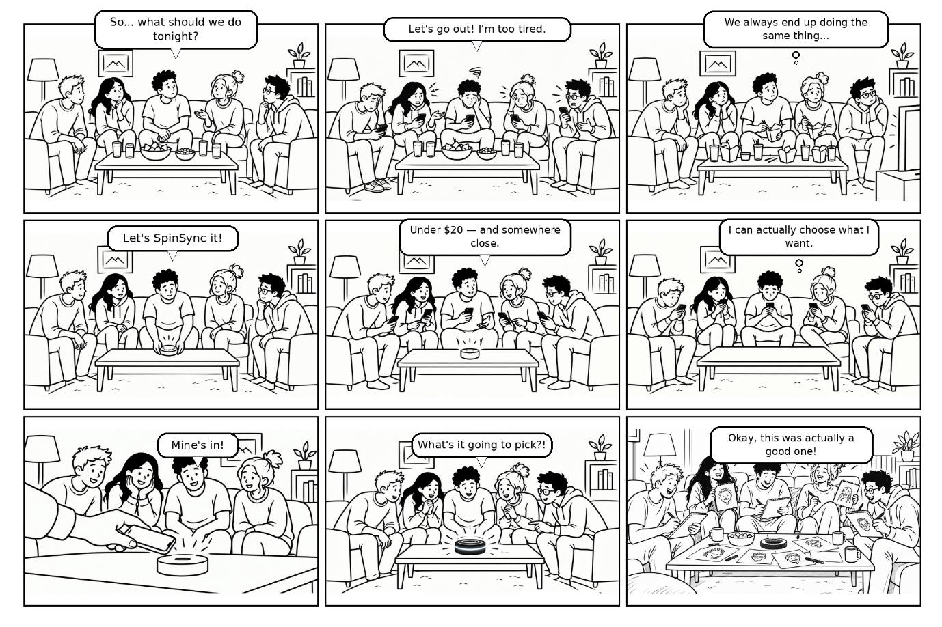

Section 4: Specified Goal

User context: It’s a Saturday evening. You and your friends are at home and can’t decide what to do tonight.
Goal (instruction given to the participant):
“Use the SpinSync app and the table to start a session, set the limits for the evening, submit your own idea, and find out what the group will do.”
This is the wording on the card given to the participant (see Figure A7 in the appendix).

Short version for the Heuristic Evaluation Sheet: Start a SpinSync session, submit your idea and find out what the group will do.

Section 5: Prototype Evaluation
Video link: https://youtu.be/Pe3zKQK9bNc

Participant and test set-up
Participant: J.A., 27 years old, works in retail. J.A., a young adult, spends time with friends often and runs into the same issue as Tara, which is that the group has difficulty finding collective action on what to do. He's also been interviewed during the preliminary research work in this project, which made him a good fit for Tara.
Method: I tested the paper prototype with ten hand-drawn screens, one per sheet. I put the sheets into a paper phone frame, and the participant looked at one screen at a time. When he tapped, I showed him the next sheet, acting as the computer. The second device, the SpinSync hub, was a paper wheel with 10 slots (5 ideas and 5 wild cards) and a fixed pointer, placed on the table and spun by hand at the spin step. At the beginning, the participant was told and handed in written form (on paper) the goal from Section 4. The participant read the text on the screens aloud as they were presented in sequence whilst using the prototype. The test was held on Wednesday evening, 14 October 2026. The facilitator omitted an explanation of the screens. During the spin step (around 2:30), the participant reacted aloud as the paper hub wheel was spun. No additional pieces of paper were required – just the phone frame, the ten screen sheets and the hub wheel were used for the test.
Link to the team work. The participant is asked to do the same thing as in Section 4, which follows the persona (Section 1), the future-use scenario (Section 2) and the storyboard (Section 3): a group of friends gather around the hub, join a session, set their limits, submit one idea each and spin to choose the activity. The usability findings below are organised into the heuristics of Nielsen (1994), where V indicates a heuristic that was violated and C indicates a heuristic that was complied with.
The finished Heuristic Evaluation Sheet is on the next page.

Heuristic Evaluation Sheet
Evaluator name (you): | Kushal Aryal | User’s name (participant): | J.A. (27)
Date: | 14 October 2026 (evening) | User’s goal (from Section 4): | Start a SpinSync session, submit your idea and find out what the group will do.
List of heuristics
1. Match system to the real world | 6. Aesthetic/minimal design
2. Consistency & standards | 7. Recognition, not recall (minimise demands on human memory)
3. Visibility of system status & feedback | 8. Help users with errors & recovery
4. Error prevention | 9. Flexible/efficiency of use
5. User sense of control & freedom | 10. Help & documentation
Quotes are from the participant’s speech in the test video; times in brackets are video times.
Bold = violated (V); normal = complied with (C).
Screen / State | USABILITY ASSESSMENT – positive and negative findings: the screen, and the part of the task the user was doing | IDENTIFICATION OF HEURISTICS – violated (V) or complied with (C) | EXPLANATION OF HEURISTICS – how, and which design aspects | USABILITY IMPACT – on the user experience and task completion | USABILITY SUGGESTION(S) – at least one intervention
Screen 1  Landing / session start | Positive findings:  At 0:00 to 0:15 he read the tagline aloud (“What are you doing tonight?”) and the line about no one having to push their own picks, then said “Start a new session”, which he did. He knew what to do straight away.  Negative findings:  The long supporting line was only partially read (the caption shows that he missed some of the words in it), and the small text was not as significant as the button and the title. The screen doesn't mention anything about the hub and the phone working together, and he didn't ask. | C – H1 Match real world  C – H6 Minimal design  C – H7 Recognition not recall | The everyday language [1] is applied in the title “What are you doing tonight?”. The entire interface was clear and contained one obvious red Start button, so that there were no additional items that the participant had to remember to do or work out [6, 7]. | The participant started off on the task quickly and independently – this is the correct beginning for the goal. | Under the tagline, type: “Tap the hub, everyone joins on their phone, then spin.” Why: the line informs first-time users that the hub is part of the session; the screen worked in the test. Effort: low (one text line).
Screen 2  Create / join session | Positive findings:  He read the screen aloud (“new session, create, join, bring the group in, session code”) and selected to create the session. A list of the people who had joined (3/5) was accessible.  Negative findings:  He was not sure as to what would happen thereafter: “So I’ll create the session and I’m guessing I’ll go to another.” (0:15–0:30). He didn't press “All in – Continue”. This still did not indicate any action to take and indicated two persons as “Waiting”. | C – H7 Recognition not recall  V – H3 Visibility of status  V – H2 Consistency & standards | The live list displays who is in without having to remember [7]. It does not indicate to the user what he should do when someone is still waiting, and the next step is not known [3]. “All in – Continue” is a full sentence, unlike the short labels on the other screens (Start, Next, Submit) [2]. | He made an educated guess as to what the next step would be, as opposed to knowing, and he didn't move on alone, which prevents the task propagation from moving forward. | Update the label to the short form used elsewhere (“Continue”) and include a hint: “Waiting for Priya – tap Continue when everyone is in.” This is to clear the uncertainty of action while waiting. Low effort (text only).
Screen 3  Time, budget & energy | Positive findings:  He tested out the functions verbally (“time available, I can increase… budget, I can decrease, increase… energy, low”), then said “cool, and next” and proceeded (0:30–0:46). The sliders' operation was as desired.  Negative findings:  He tried out the sliders prior to choosing (“I can increase… I can decrease”), indicating that he required the sliders to be manipulated to gain insight into what they did. The value that is selected can only be seen on the paper screen, given by where the knob is. | C – H1 Match real world  V – H3 Visibility of status | Sliders with labelled ends (Low–Full, Free–$$$) are like real controls [1]. The paper screen shows the chosen value only by the knob position, so the user has to read the knob to know the value [3]. | The participant finished the constraints in a short time, and the screen is suitable for the task. | Include the selected value above each slider (e.g. “$$ · up to $20”) and increase the size of the end labels. Why: the sliders functioned in the test, but there's no need to consult the position of the knob when the value is shown. Effort: low.
Screen 4  Location & group size | Positive findings:  He reads out the options (“stay home, go out, or either”) and the group box (“five people in the session… I guess friends”), and says “Let's go out today” and hits Next (0:46–1:05).  Negative findings:  He had to guess what the group box meant (“five people in the session… I guess friends”): nothing on the paper screen said these were the people who had joined. When “Go out” is selected, the selected state on the paper screen is not displayed, either. | C – H6 Minimal design  C – H7 Recognition not recall  C – H1 Match real world  V – H3 Visibility of status | Large icons with short labels (Stay home, Go out, Either) allow the user to recognise options rather than read or recall them [7]. Few elements are on the screen [6], and familiar words are used [1]. The paper screen shows no selected state once “Go out” is chosen [3]. | The decision was quick, and the participant went over to the next step without hesitation. | Include a clear selected state (thicker outline and a check mark) to the selected spot. Why: provides confirmation for the user – same fix as Screen 6. Effort: low.
Screen 5  Constraints summary | Positive findings:  He reads the entire summary out loud (time “two to three hours”, budget “up to twenty dollars”, energy “low”, location “go out”, group “five people”), and once he has, he says “Right, cool” and then goes on (1:05–1:21).  Negative findings:  He concluded with “Right, cool, so that…” and moved on without saying what he expected next, so the screen did not tell him what happens after he continues. He didn't bother with the Edit links, and there is no evidence whether they work or not. | C – H3 Visibility of status  C – H5 User control & freedom  C – H7 Recognition not recall | All answers are displayed in one list [3], so the user will be aware of what the group will use. Edit links are provided to give a route back to changing an answer [5], and there is no need to remember any answers [7]. | When the participant is confident in their choices, the likelihood of mistakes later will be reduced. | Add “Shared with the group when you submit” under the list. Why: informs the user who will read the answers, and is important as the idea is private. Effort: low.
Screen 6  Submit your idea | Positive findings:  He reads the heading, the privacy notice – “Private, no one will see this” – and each category out loud – food, active, chill, creative, surprise – (1:21–1:42). He knew what the icons and the privacy note meant.  Negative findings:  He didn't pick a category: he read out all 5, skipped Food, and continued. He also read out the pre-written text “Ramen crawl downtown” as if it was his idea. There was no message directed to him to choose a category or to tell him if one had been selected. This was one of the slowest screens in the video at ~16 seconds. | C – H1 Match real world  V – H4 Error prevention  V – H3 Visibility of status  V – H2 Consistency & standards | Symbols are well known [1]. There was no indication on the screen on how to proceed and how many categories to select, making it easy to skip [4]. No instruction or selected state reported to the user what is expected, and whether the user is selecting a choice [3]. The submit control doesn't look like the red main action as it does on other screens [2]. | The participant did not finish the step properly; therefore, no category was selected. A real session group might not contain a given category. | Change the text to “Pick ONE category”, show a selected state on the selected category icon, and make “Submit idea” a full-width red button like on other screens. Why: the user then knows what to do, sees a choice registered and can see what to do next. Effort: low.
Screen 7  Waiting for others | Positive findings:  He read the screen aloud (“three out of five submitted”, “ideas stay secret until the last person submits”, “waiting on Priya and Theo to submit their idea, this screen updates on its own”) (1:42–2:08). The waiting message and the count were clearly understood by him.  Negative findings:  This paper screen didn't have a Continue button after it, so after reading this one, he had to wait until the next one was displayed. | C – H3 Visibility of status  C – H6 Minimal design  V – H5 User control & freedom | Users are informed by the count and ticks what is happening [3], and the screen is simple [6]. The user is not given a choice at this point; there is no button, back arrow or edit option [5]. | The participant was capable of reading the screen but not able to advance independently. In actual application, the user will be stuck on a waiting screen. | Include a red “See the ring” button which becomes available when all ideas are in, and “Edit my idea” plus a back arrow. Why: provides a path forward and a path back. Effort: low.
Screen 8  Ready to spin | Positive findings:  He then read out what was on the screen (“all five ideas are in, the ring's full… your five picks plus five wildcard activities”) and then said “Spin” (2:08–2:29).  Negative findings:  No issues seen on this screen. The ring on the phone is similar to the hub, so a user might have no idea which ring to spin. | C – H3 Visibility of status  C – H1 Match real world  C – H6 Minimal design | The filled ring indicates the system is ready [3] and is the same design as the real hub on the table [1]. There is one red button on the screen, and it's obvious what to do [6]. | The participant proceeded from reading to spinning, maintaining the process. | Add the line “Spin the hub or tap Spin”. Why: it notifies that the spin may be initiated from both the hub and the phone. Effort: low.
Screen 9  Spin in progress | Positive findings:  He read aloud “Spinning… hang on tight, the group sees the result together” and looked on as the hub spun until it stopped (2:29–2:46).  Negative findings:  “So the prototype was spin like this” and “Okay, so I'm spinning?”, he asked about the spin as he was checking it out. “WC” may be misinterpreted on the label in the wheel, and there's no method to cancel a spin. | C – H3 Visibility of status  V – H1 Match real world  V – H5 User control & freedom | While the spin is in progress, a message “Spinning…” and the text “Hang tight” are displayed [3]. Who is spinning, the hub or the phone, is not indicated on the screen, so the user had to ask [1]. | He waited for the result, but he had to stop partway and check how the spin worked, which interrupted the flow of the task slightly. | Make it clear who is spinning (“The hub is spinning”), do not abbreviate Wildcard to WC, and include a small “Cancel” link. This is because it eliminates any confusion he expressed (“So I'm spinning?”) and provides an option when accidentally spinning (H1, H5). Effort: low.
Screen 10  Result revealed | Positive findings:  He saw the hub had landed on food, checked out the results and suggested “All right, let's go” (2:46–3:02). He knew his conclusion and what to do next.  Negative findings:  He likened the hub to the phone itself (“it landed on food… and then tonight's pick, ramen crawl downtown”); the screen does not elaborate on how the hub category and the phone result are related. Additionally, there isn't a “Spin again” choice if the group isn't pleased with the outcome. | C – H3 Visibility of status  C – H1 Match real world  V – H5 User control & freedom | The result is presented in simple language [1], and the “Let's go” button clearly provides a way to complete the task [3]. There is no “Spin again” option, so the group cannot reject the result [5]. | The participant reached a goal and had an understanding of this goal. | Put a “Spin again” button down below the result. Why: provides the group with control in case it does not like the result (H5). Effort: low.

Section 6: Recommendations for Improvement
Each recommendation comes from a row of the Evaluation Sheet. It shows the screen as tested on paper, the existing digital version, and an improved digital version. The numbered notes give each change and the test evidence behind it.

Recommendation 1: Make Screen 6 clearer so users pick a category
Screen 6: Idea submission. Sheet row: Screen 6 (violation of H4, H3, H2)
Evidence from the test: J.A. read all five categories aloud (food, active, chill, creative, surprise) and the pre-written “Ramen crawl downtown” example, then moved on without choosing a category (1:21–1:42). It was one of the slowest screens (~16 s).
Change: Add “Pick ONE category”, show a selected tile with a tick (nothing pre-selected), and use a full-width red “Submit idea” button. Principles: error prevention, visible feedback (Norman, 2013) and consistency (Nielsen, 1994).
Before: paper prototype as tested  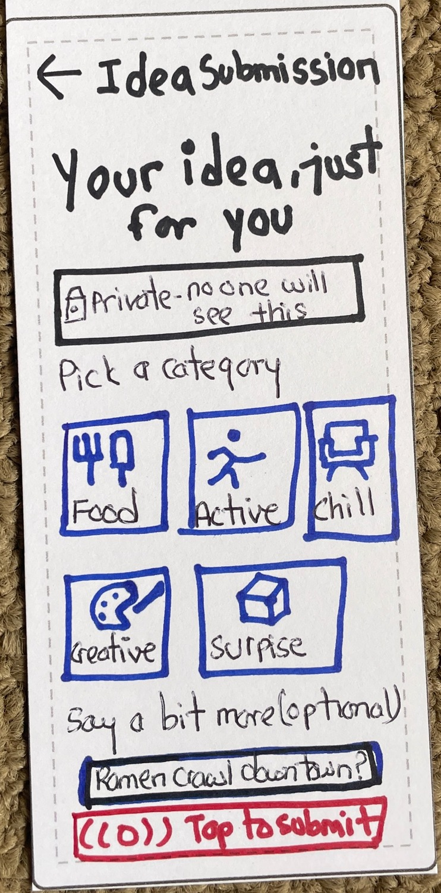 | Before: digital version of the same screen  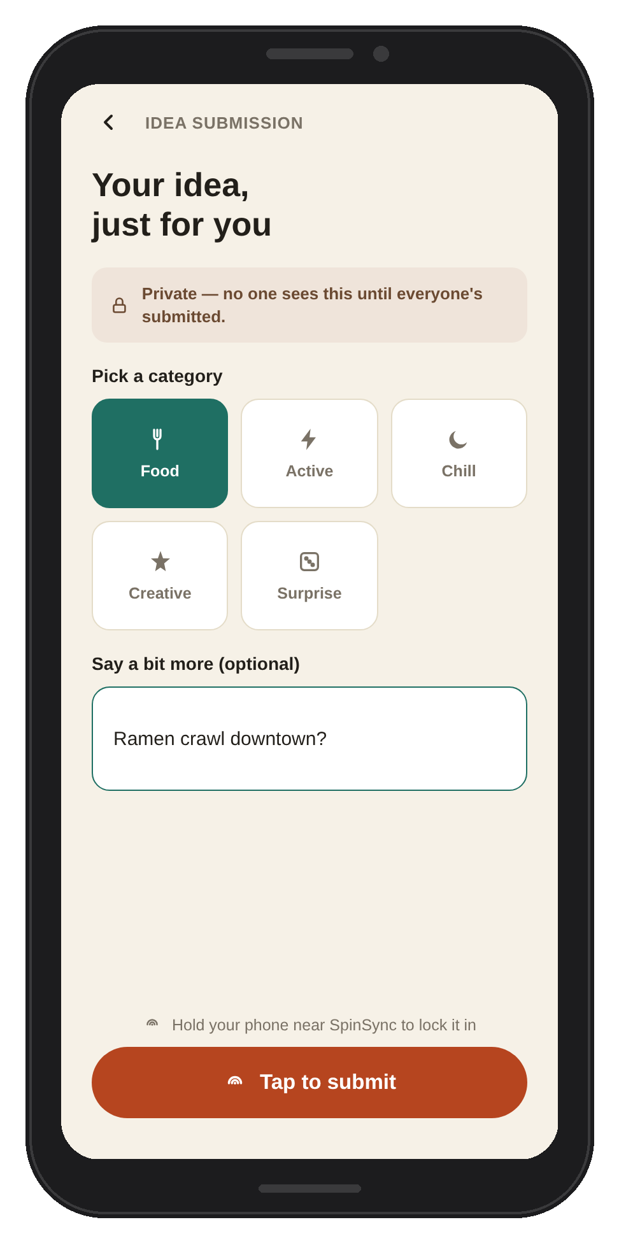 | After: improved digital design  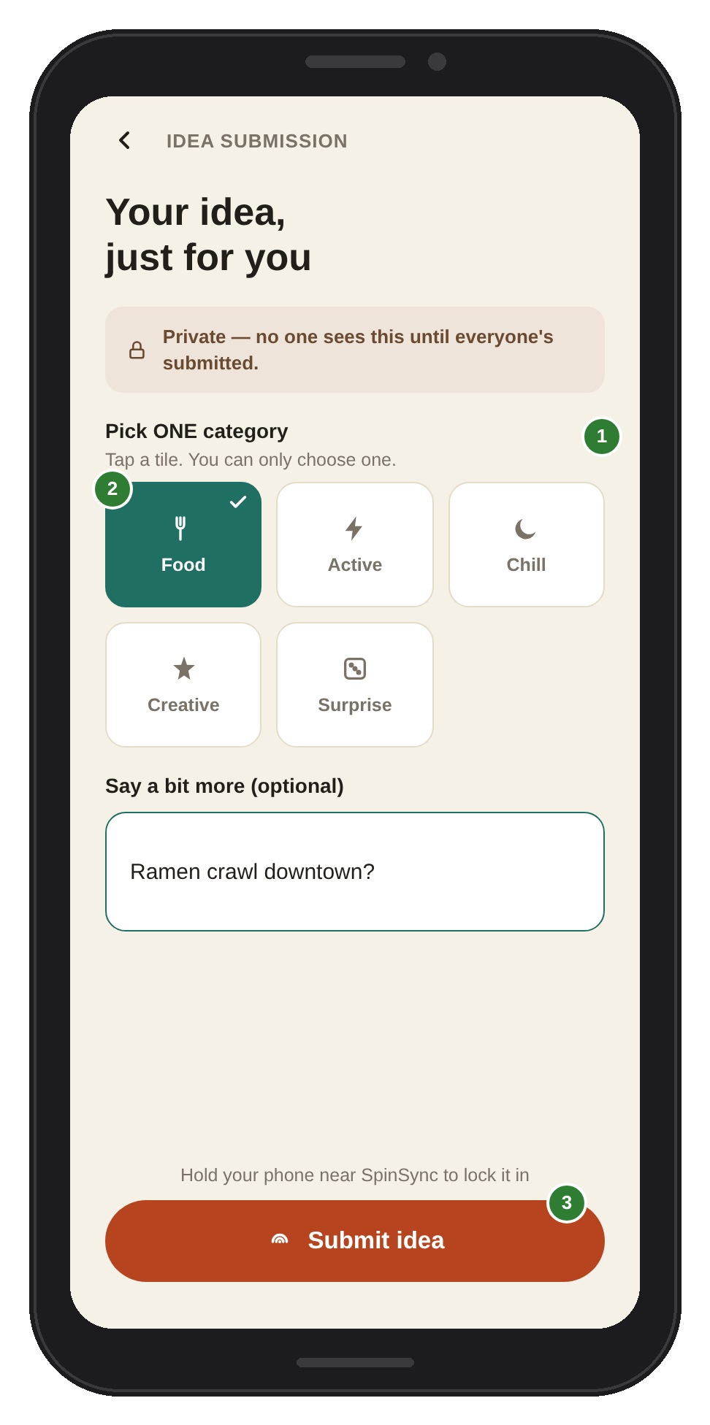
1. This “Pick ONE category” spans the full width of the panel, with “Tap a tile. You can only choose one.” (H4). He read all the categories but opted not to pick any.
2. Selected tile with a tick (H3); no tile pre-selected. The paper screen had no way to show a selection, so he moved on without choosing one.
3. Full-width red “Submit idea”, similar to the main action of other screens (H2). He only reached the submit step after reading through every category.

Recommendation 2: Provide a clear next step for Screen 7
Screen 7: Waiting for others. Sheet row: Screen 7 (H5 violated)
Evidence from the test: J.A. read the count and the message aloud (“three out of five submitted… this screen updates on its own”), but finished with “Okay.” and waited, because there was no such button to ‘Tap’ on the paper screen (1:42–2:08).
Change – Add a “See the ring” button that becomes active when all ideas are in, plus “Edit my idea”, “Nudge Priya & Theo” and a back arrow. Criteria: user control and apparent next steps (Nielsen, 1994).
Before: paper prototype as tested  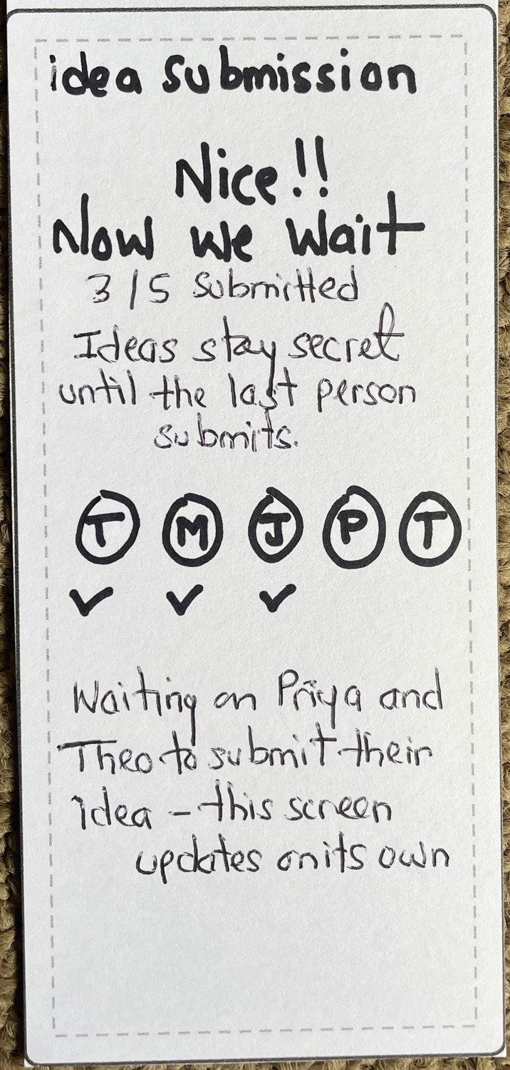 | Before: digital version of the same screen  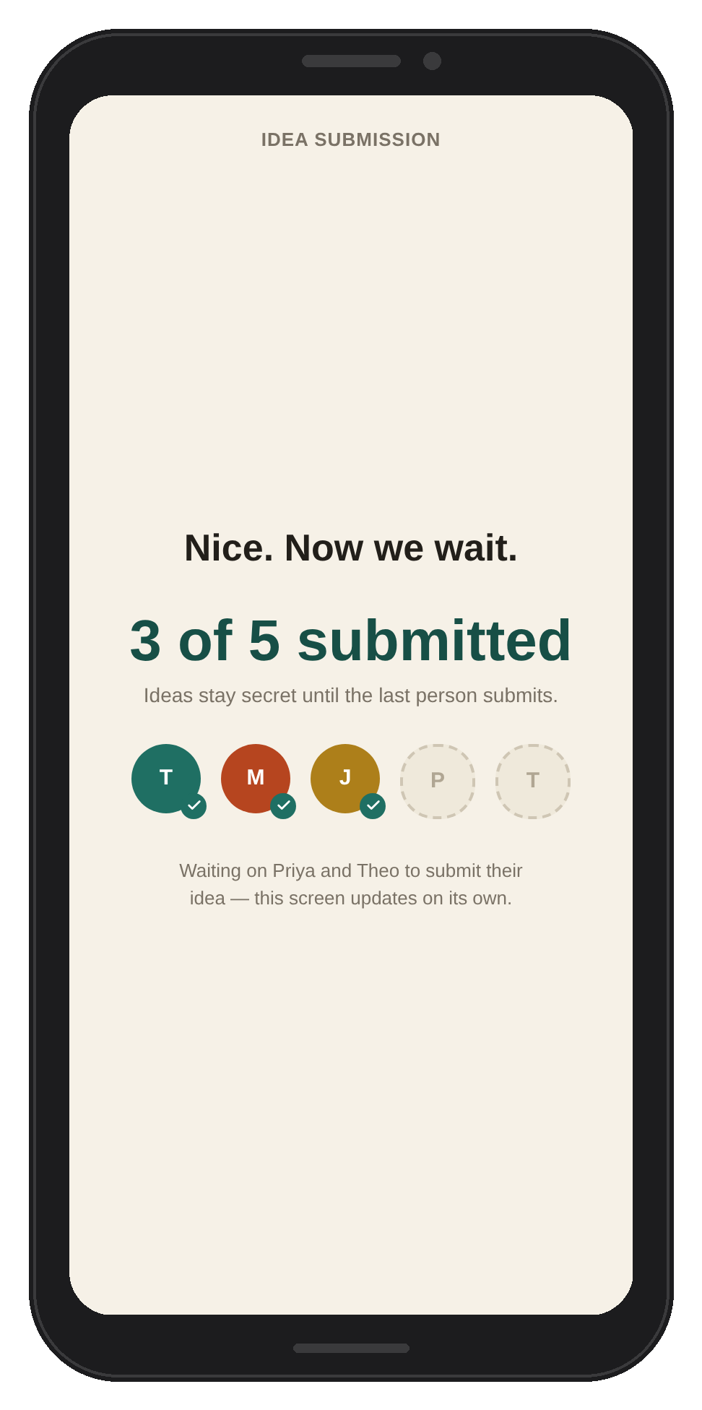 | After: improved digital design  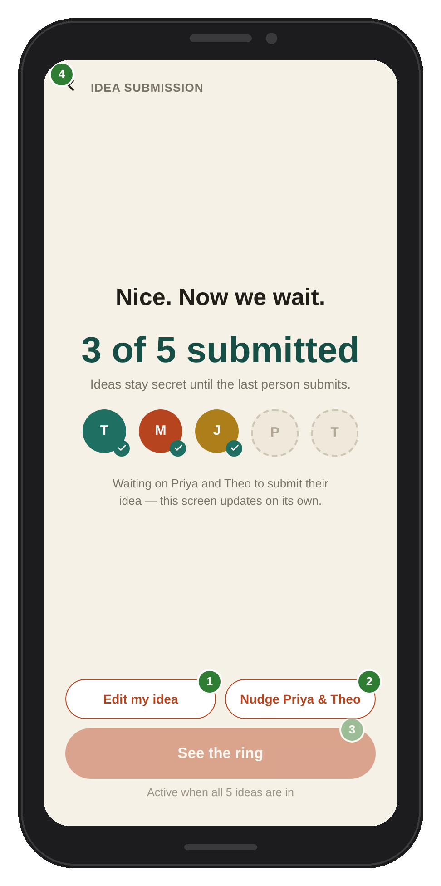
1. “Edit my idea” (H5). Not available on the paper screen, so J.A. had no way to change his idea once it was submitted.
2. “Nudge Priya & Theo” (H9). Not seen: the screen only stated “updates on its own”.
3. “See the ring”, inactive until all ideas are in (H3, H5). J.A. said “Okay.” and waited, because nothing on the screen showed what to do next.
4. Back arrow (H5). Not seen in the test: can't go back from this screen.

Recommendation 3: Make the next step on Screen 2 clear
Screen 2: Create / join session. Sheet row: Screen 2 (violated H3, H2)
Evidence from the test: J.A. read the code for the session and the sharing line, then stated “So I’ll create the session and I’m guessing I’ll go to another.” He didn't hit “All in – Continue” as two people (0:15–0:30) remained in “Waiting” status.
Change: Shorten the label to “Continue” and add the following hint: “Waiting for Priya and Theo — tap Continue when everyone is in”, and increase the size of the session code. The principles: visible and consistent (Nielsen, 1994).
Before: paper prototype as tested  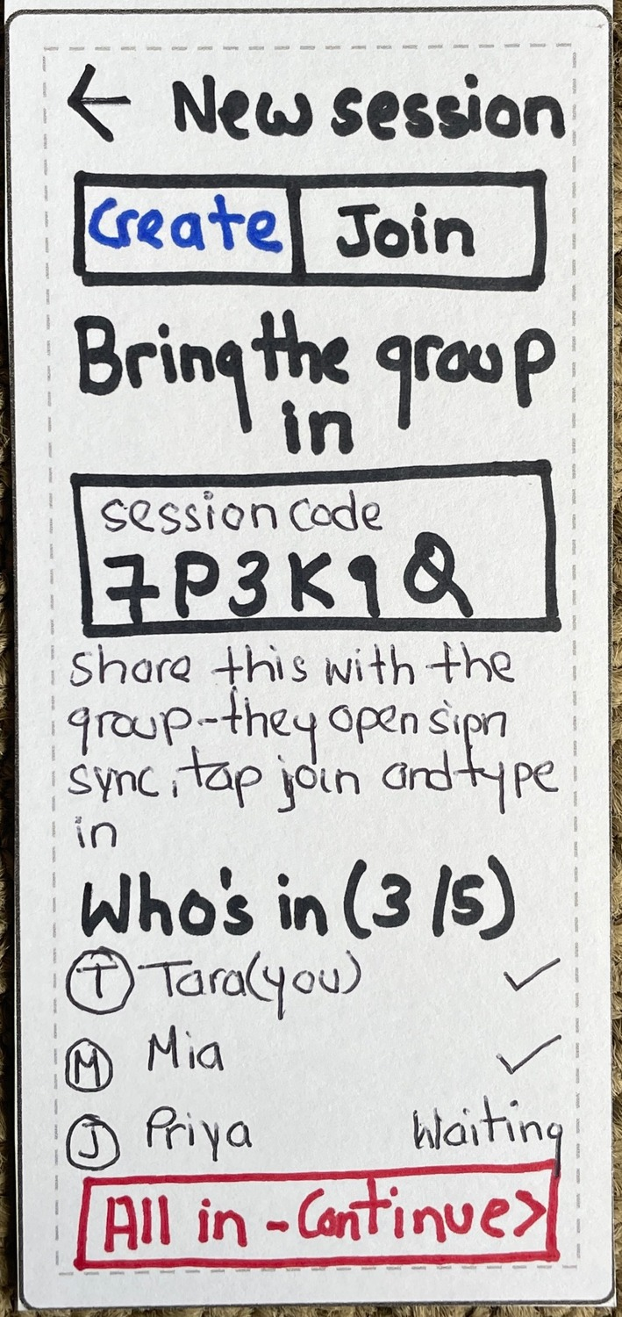 | Before: digital version of the same screen  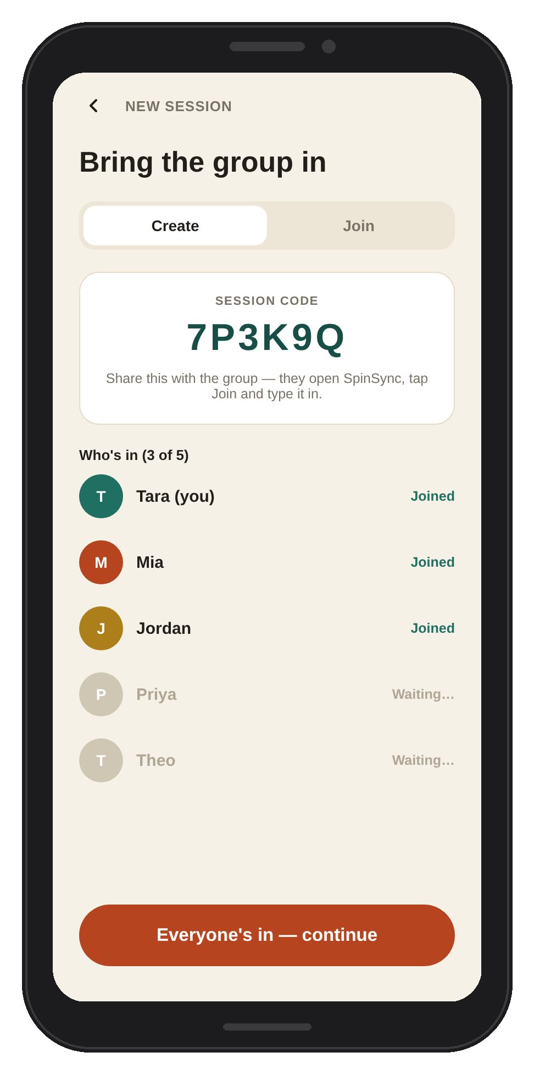 | After: improved digital design  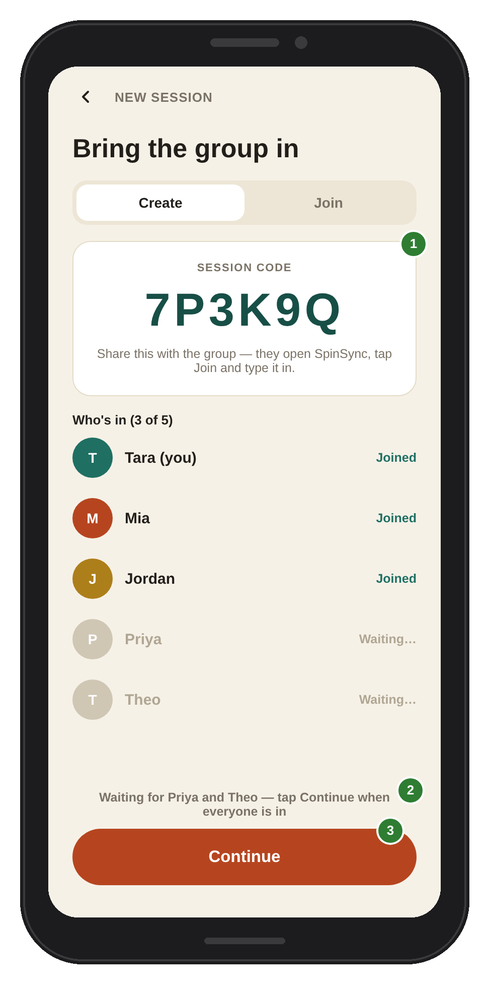
1. Larger session code (H1, H7). He read the code aloud to share it, so it should be easy to read at a glance.
2. Hint describing the wait (H3). He said, “I’m guessing I’ll go to another”, so he had to guess what came next.
3. Shorter “Continue” label (H2). “All in – Continue” is longer than the other buttons and he did not tap it. A short label matches the rest of the app.

Further improvements shown in the digital version
The digital version of the screens (not the version tested) in the team's work already corrects several issues identified or found in the paper version of the prototype. The table illustrates the comparison between the two, why these changes are beneficial and what is still missing.
Screen 2: Create / join
Paper (as tested) | Digital version  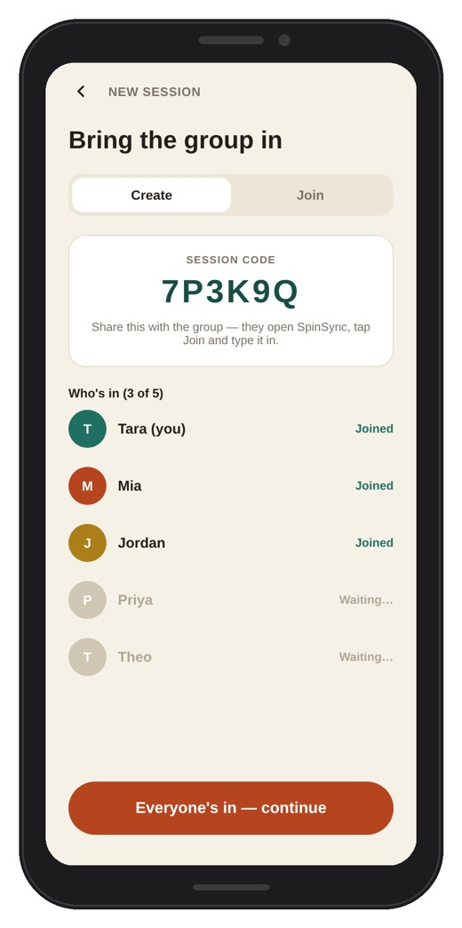 | What improved: The selected tab is a white pill and the unselected tab is greyed (H2 Consistency, H3 Status). “Joined” or “Waiting…” is displayed for each individual, and waiting individuals are faded (H3 Visibility of status).  To be improved: The label of the button remains long (“Everyone’s in — continue”), and there's no hint about what to do while people are waiting. Use “Continue” with the hint “Waiting for Priya”.
Screen 3: Time, budget & energy
Paper (as tested)  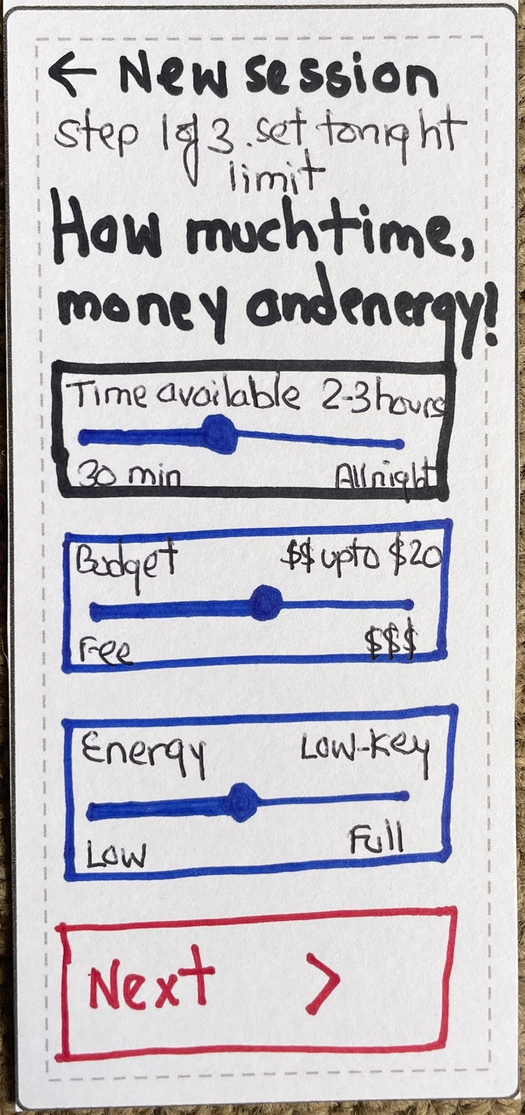 | Digital version  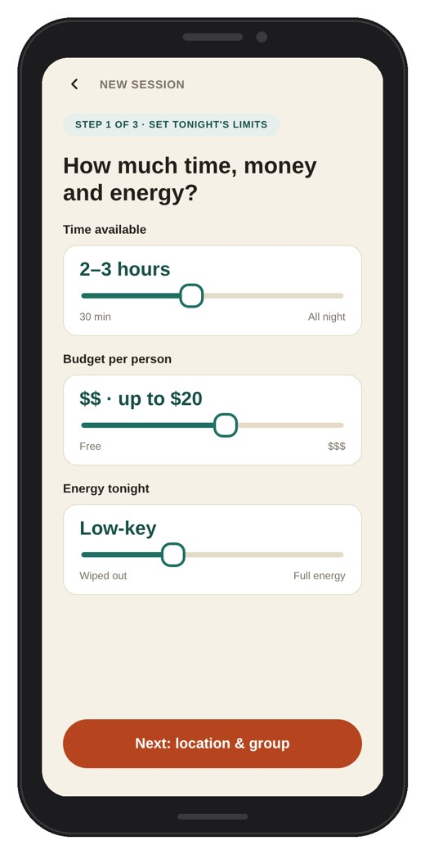 | What did improve: The selected value is also large and displayed above each slider: “2–3 hours”, “$$ · up to $20”, “Low-key”, etc., so that the user does not need to read it on the knob position (H3 Status, H7 Recognition not recall).  Still to improve: Nothing major remains. The step indicator (“Step 1 of 3”) is clear.
Screen 4: Location & group size
Paper (as tested)  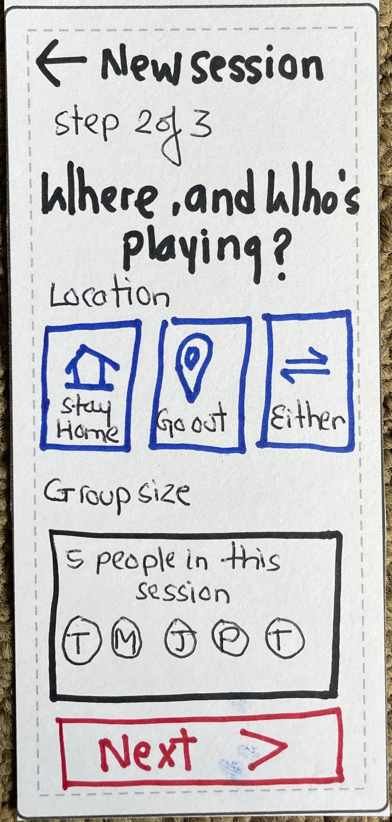 | Digital version  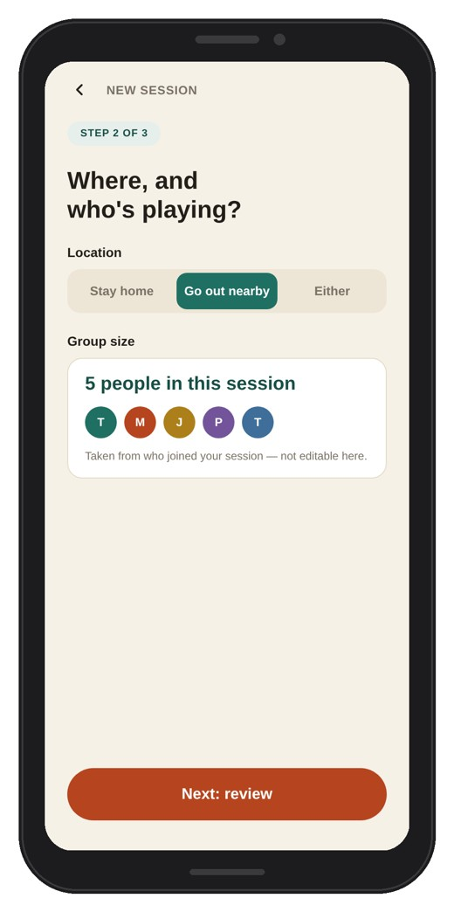 | What was made better: “Go out nearby” is clearly marked as selected (filled), and the group box is labelled “Taken from who joined your session — not editable here” (H3 Status, H2 Consistency). The group box appeared to be an editable option on paper.  Still to improve: None seen.
Screen 6: Submit your idea
Paper (as tested) | Digital version  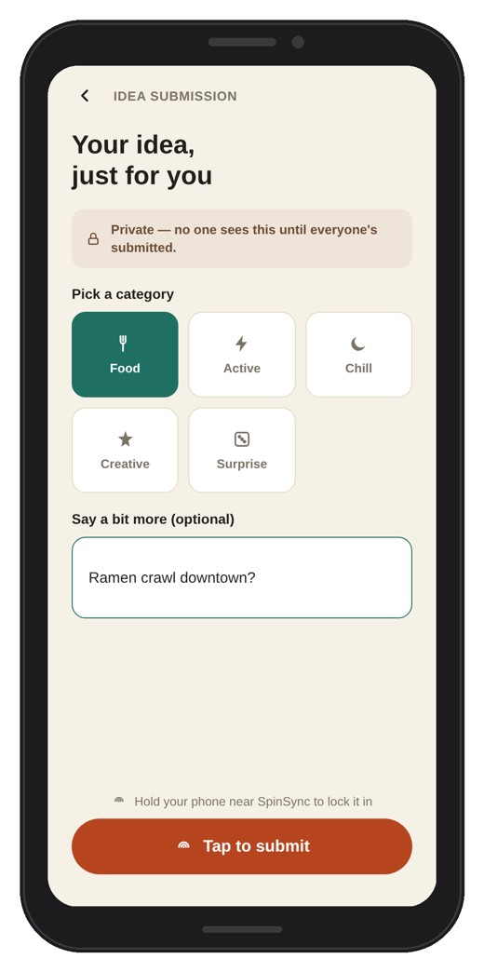 | What improved: The selected category (Food) is filled and there is a clear indication for it (H3 Status); also, the red full-width “Tap to submit” button is identical to the other screens (H2 Consistency).  Still to improve: No “Pick ONE category” instruction is provided, and Food has been preselected, which hides the problem seen in the test (the participant skipped the category). Remove the pre-selection and add the instruction.
Screen 9: Spin in progress
Paper (as tested)  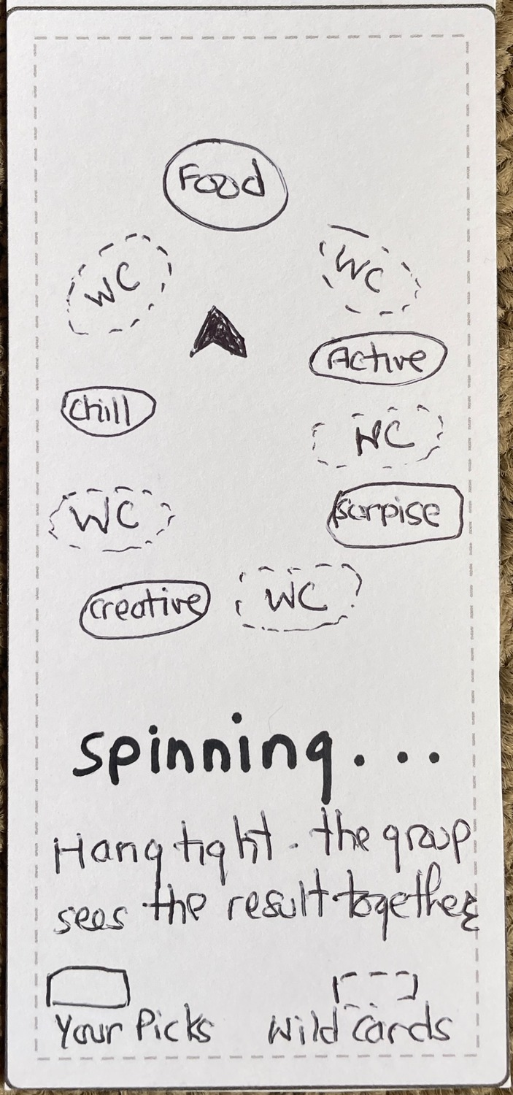 | Digital version  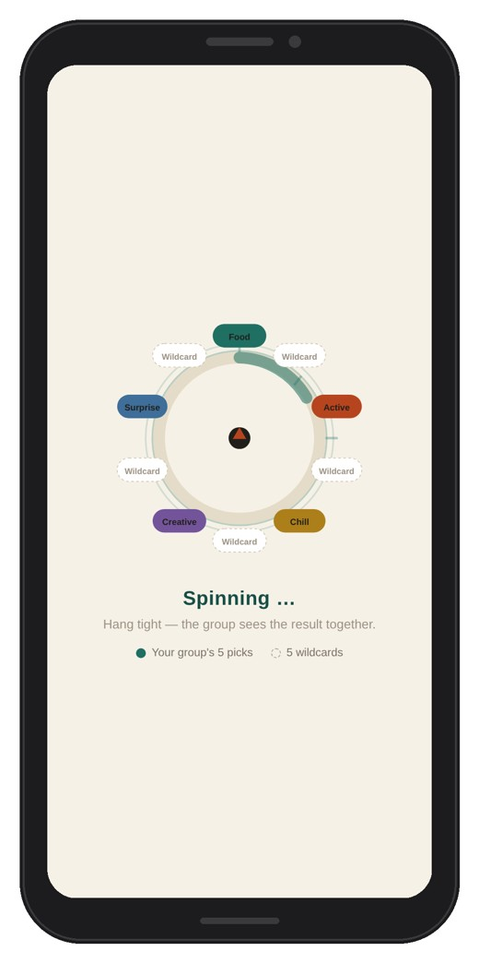 | What changed: “WC” has been replaced with “Wildcard”, picks and wildcards are different styles, and a legend is stated (H1 Match real world, H3 Status).  Still to improve: there is no way to cancel a spin by mistake.
Screen 7 (waiting) is the same in the digital version – no Continue button; Recommendation 2 is the same.

Section 7: Appendix

7.1 Paper prototype screens (hand-drawn)
All 10 screens of the hand-drawn paper prototype, numbered to correspond with the Heuristic Evaluation Sheet.
Principles applied in the paper prototype: Consistency – one red primary button and short labels (Start, Next, Submit) across the screens. Visibility of status – the joined list on Screen 2 and the filled ring on Screen 8. Recognition over recall – the summary list on Screen 5. Match with the real world – sliders with labelled ends on Screen 3, and a paper hub that looks like the real one. Error prevention – one choice per step, although Screens 4 and 6 lack a selected state, which the test showed.
Screen 1: Landing / session start  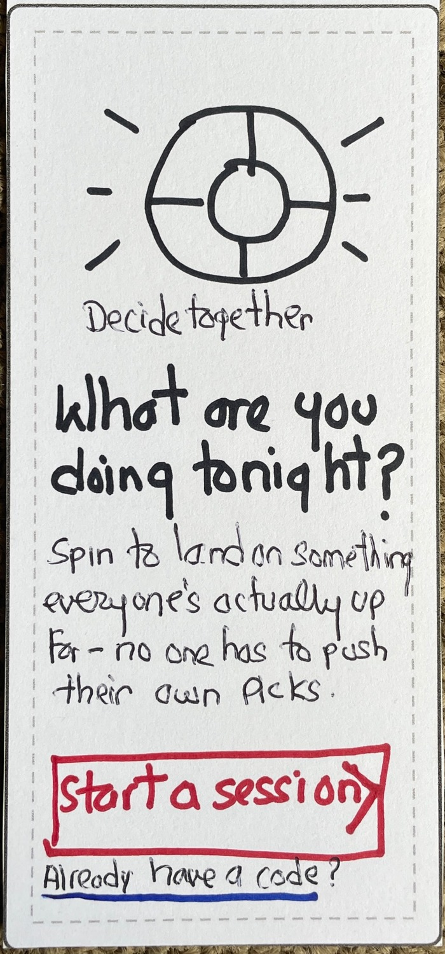 | Screen 2: Create / join session | Screen 3: Time, budget & energy
Screen 4: Location & group size | Screen 5: Constraints summary  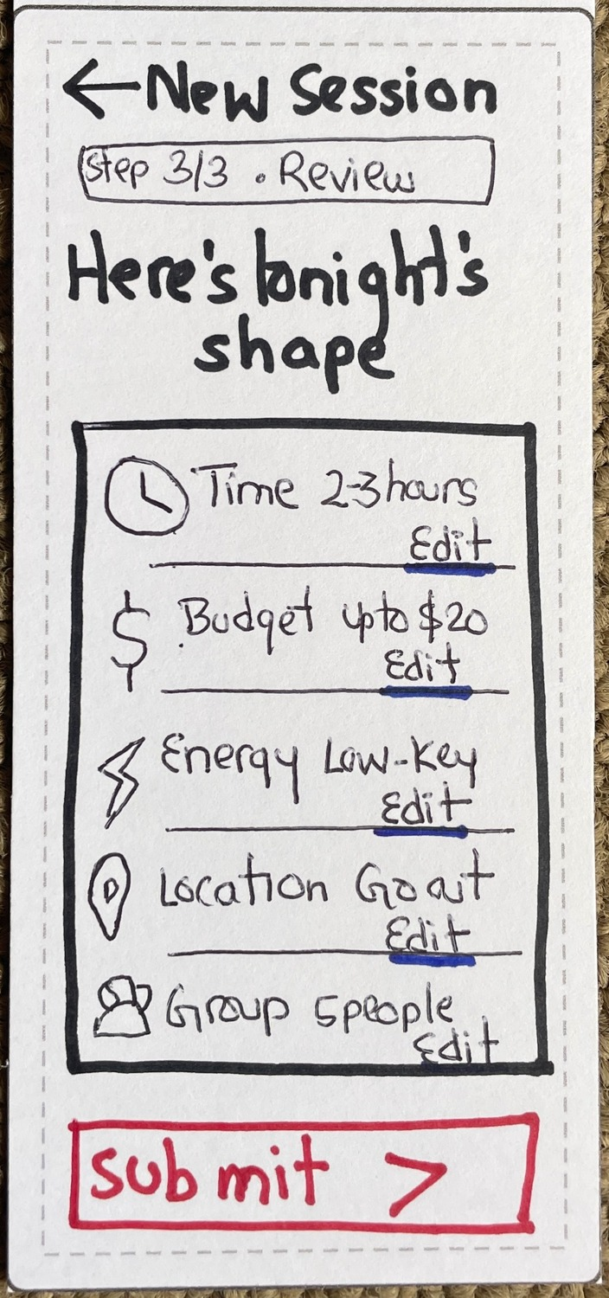 | Screen 6: Submit your idea
Screen 7: Waiting for others | Screen 8: Ready to spin  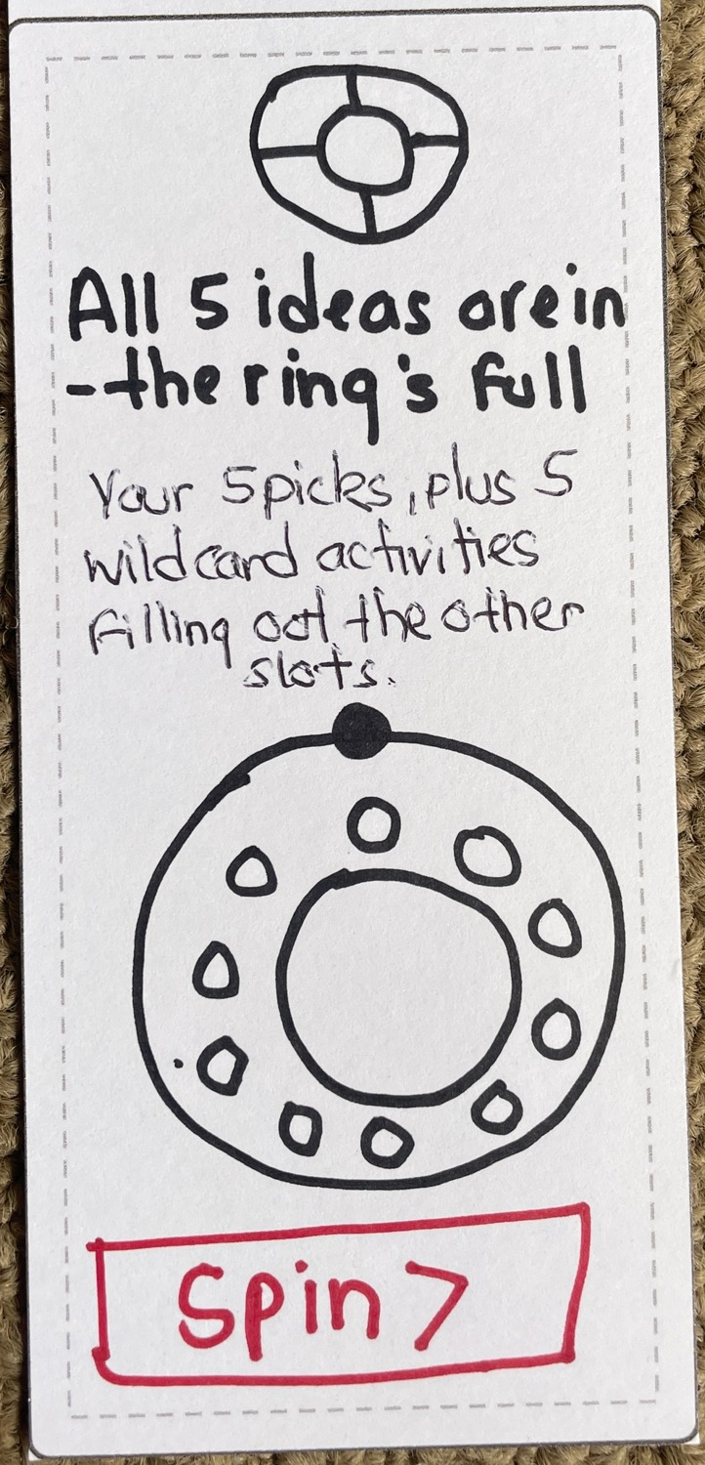 | Screen 9: Spin in progress
Screen 10: Result revealed
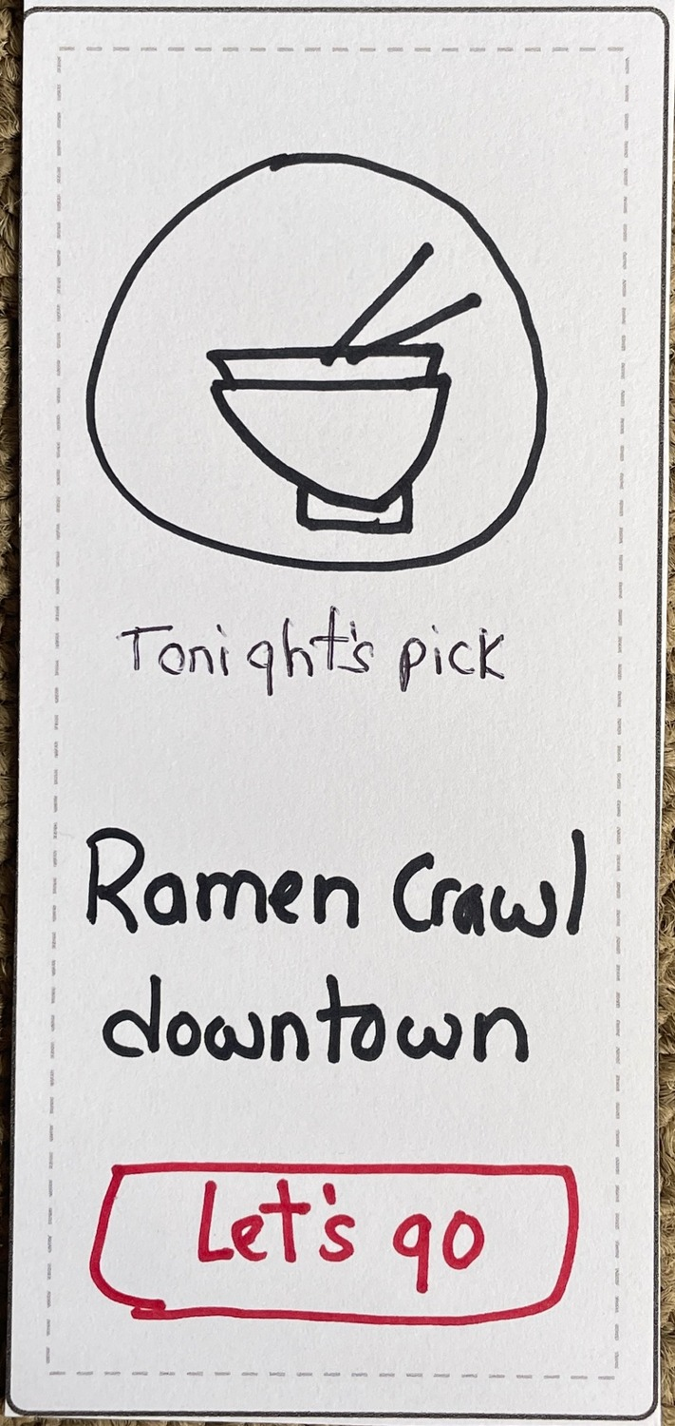

7.1a Digital version of the screens (not used in the test)
The team created these digital screens, which were not presented to the participant, based on the paper prototype. They are provided to illustrate improvements mentioned in Section 6.
Screen 1  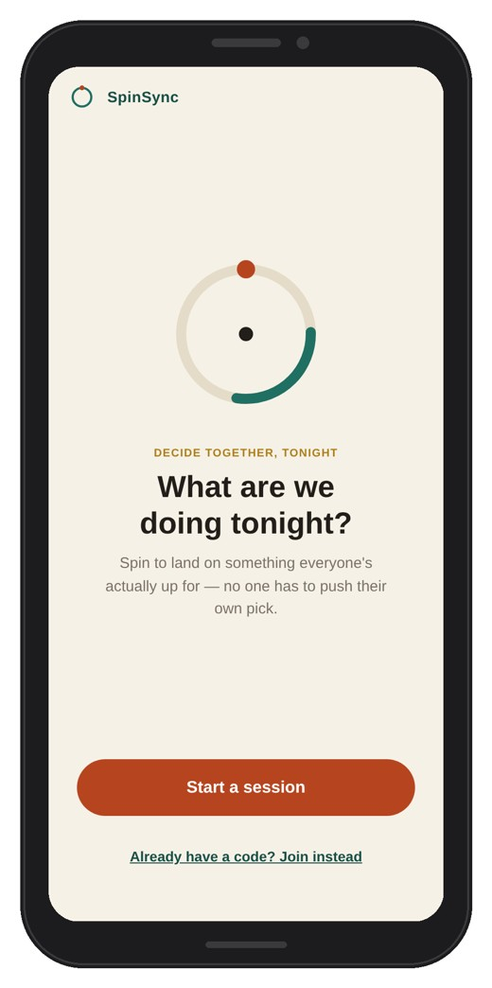 | Screen 2 | Screen 3 | Screen 4
Screen 5  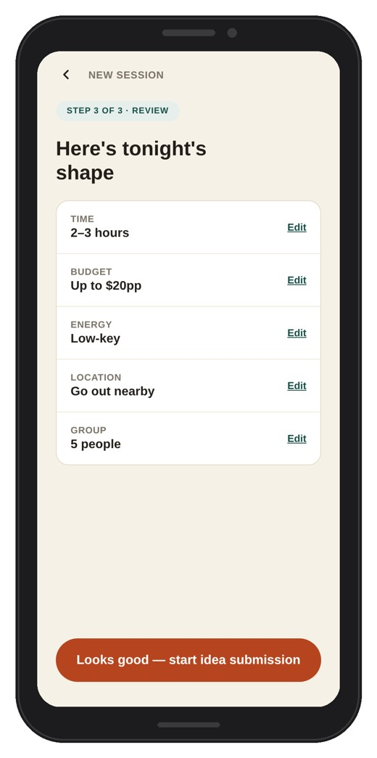 | Screen 6 | Screen 7  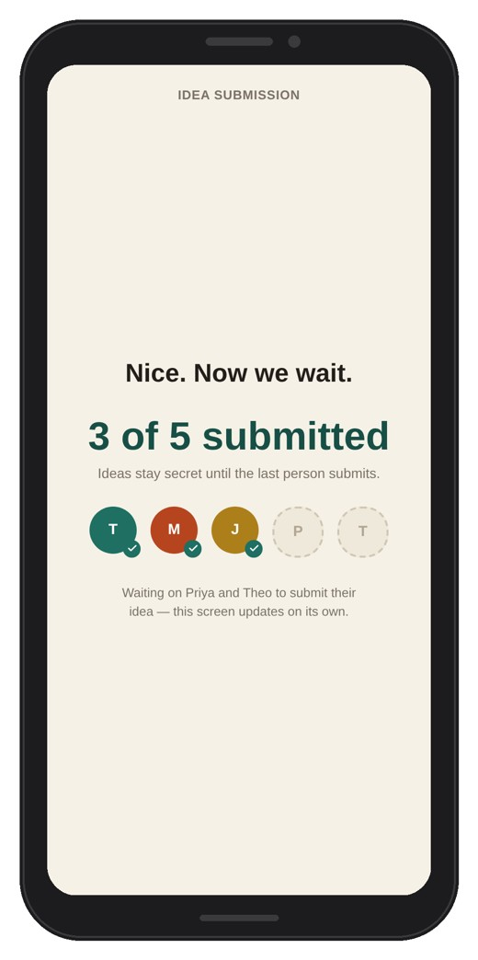 | Screen 8  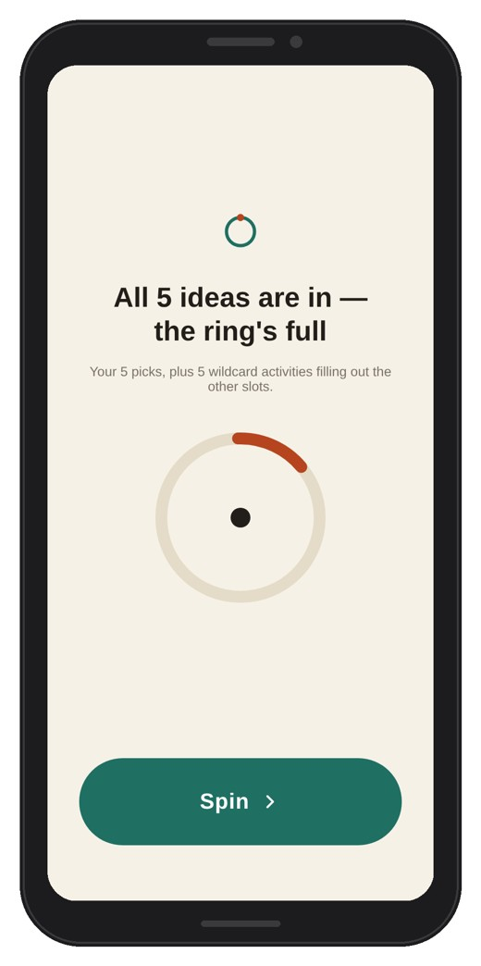
Screen 9 | Screen 10  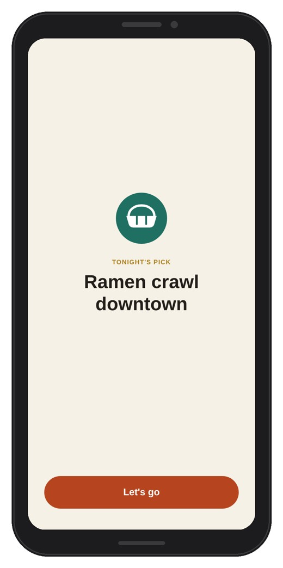

7.2 The hub (second device)
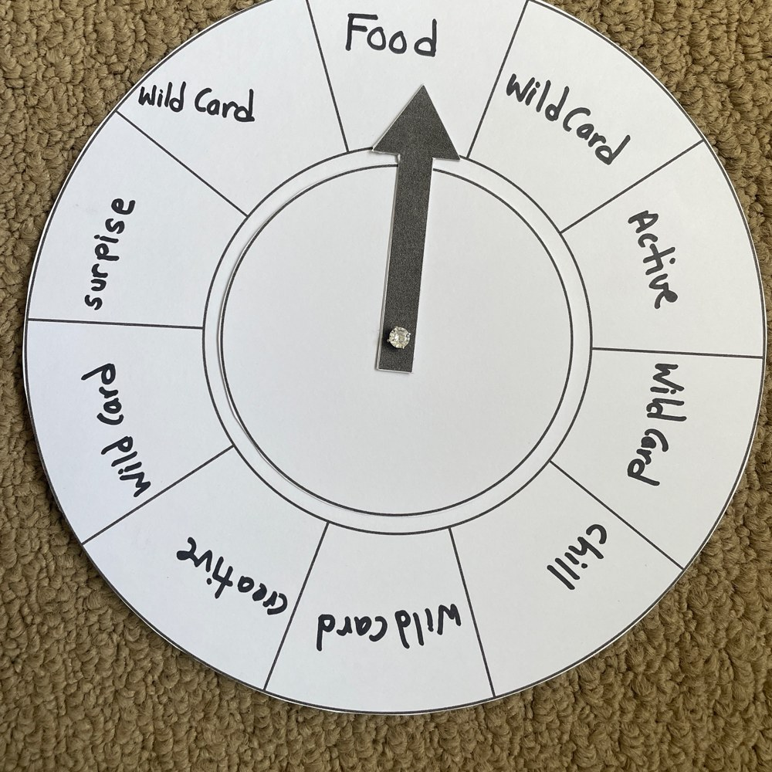
Figure A1. The paper hub: a wheel of ten slots (five ideas and five wild cards) and a fixed pointer. The wheel is spun by hand; here the pointer has landed on Food.
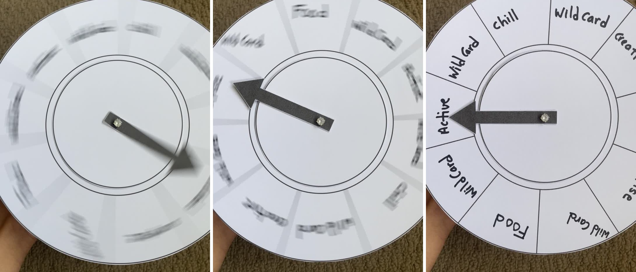
Figure A1b. The paper hub spinning (left and middle) and stopped on a slot (right). Frames from a short demo video of the hub.
Short video of the paper hub spinning (not the usability test): https://youtube.com/shorts/SmW_sNCcEfs

7.3 Testing set-up and the prototype in use
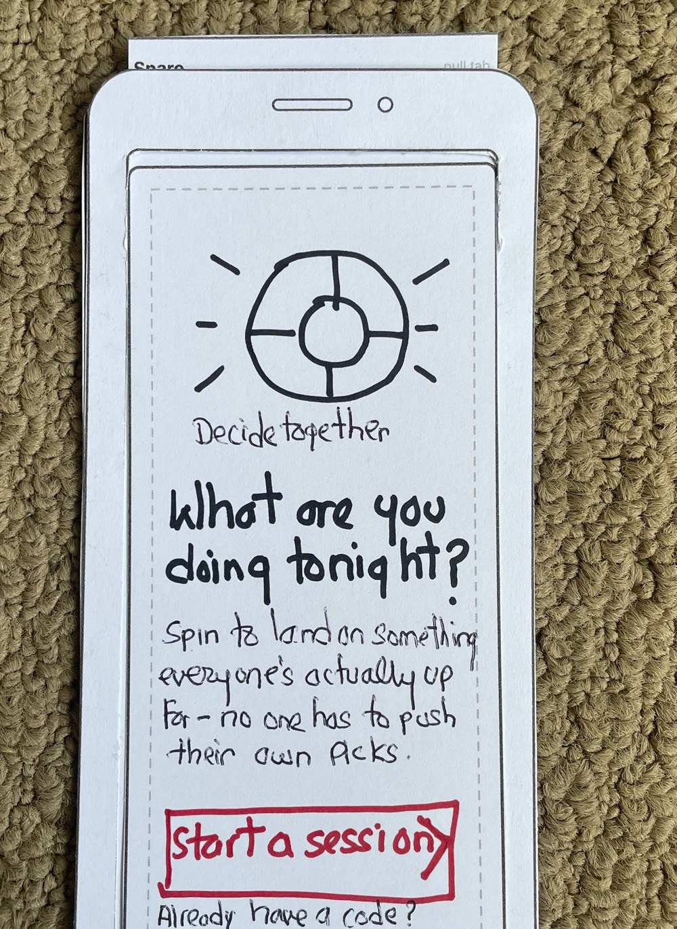
Figure A2. Screen 1 (paper phone frame with screen sheet in place). It will only display the current sheet as the sheets are shuttled through the frame.
The following 4 images are sample images from the test video. They demonstrate how the participant constructs/uses the paper prototype, how the facilitator cycles the papers in the phone frame, and the hub during the spin step.
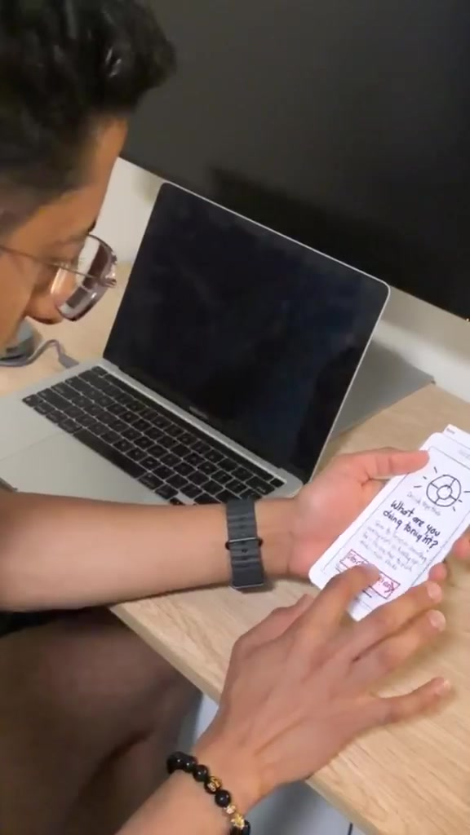  Figure A3. The participant holds the paper phone and taps Screen 1. | 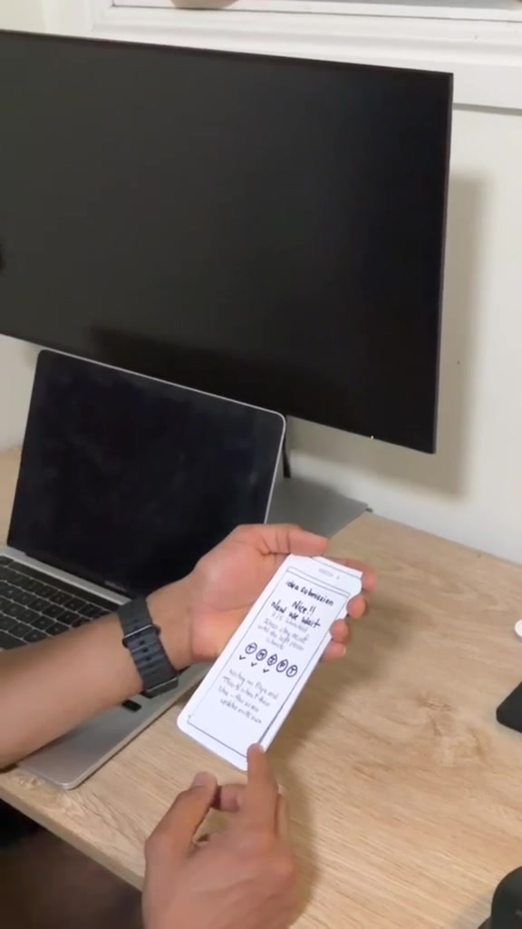  Figure A4. The participant reads Screen 6 and decides what to tap. | 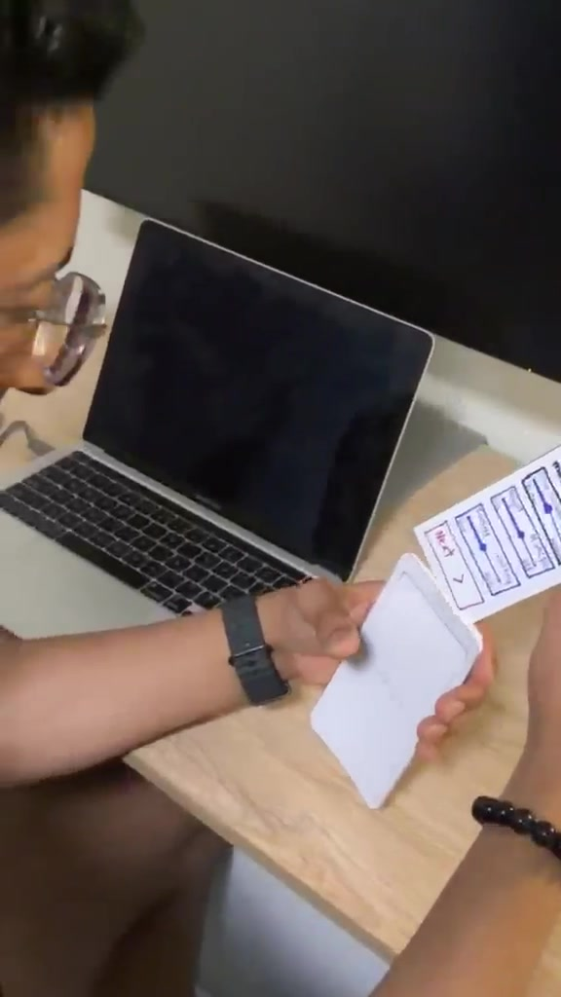  Figure A5. The facilitator slides the next sheet into the frame. | 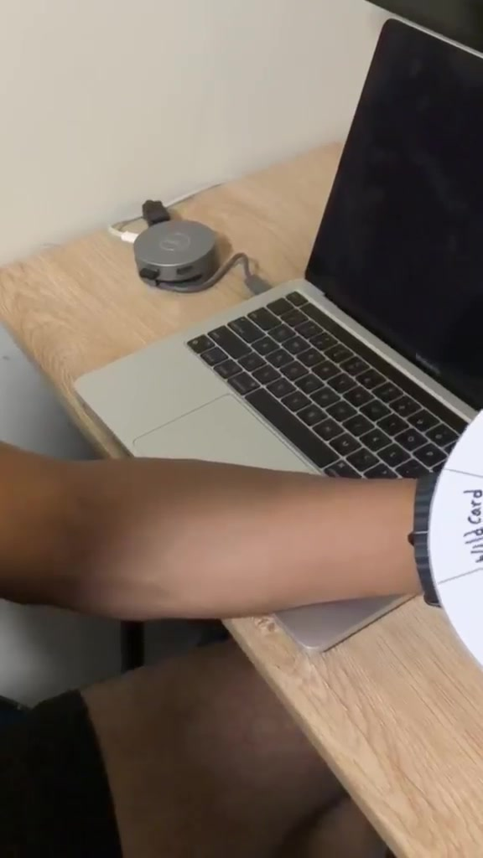  Figure A6. The paper hub wheel at the spin step.
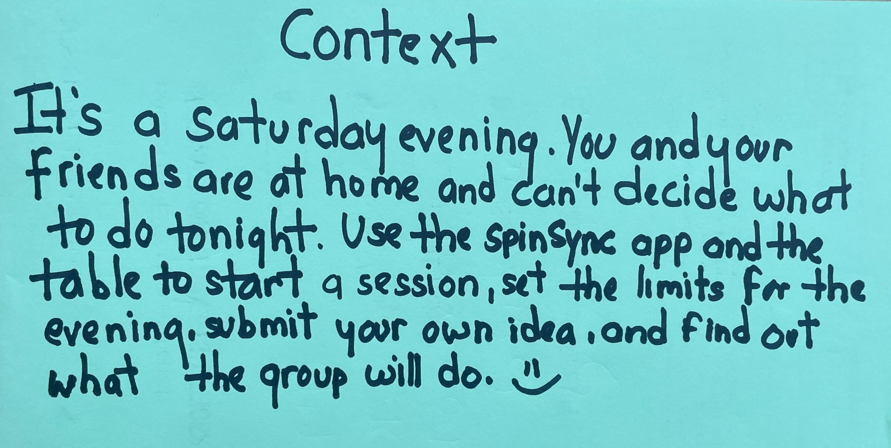
Figure A7. The goal card given to the participant (handwritten on paper).

7.4 Informed consent form
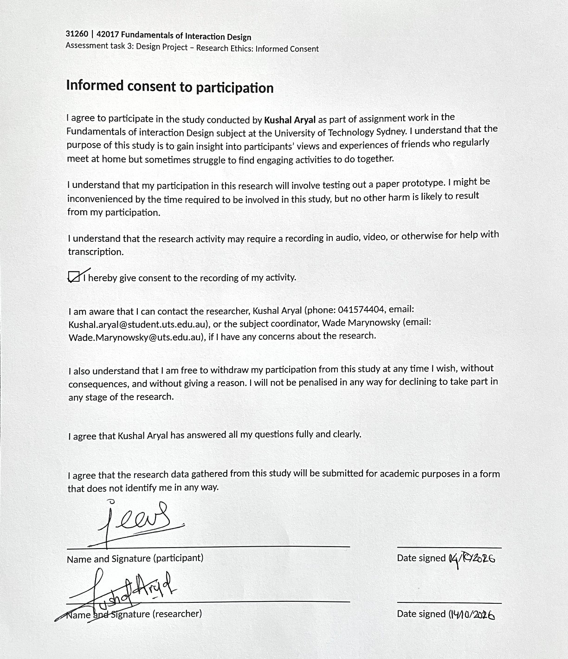
Figure A8. Informed consent form, signed by the participant and by me and dated 14 October 2026.

7.5 Declaration of use of Generative AI

I used Claude (Anthropic) to help prepare this assessment. It helped me with: printable templates for the paper prototype (phone frame, screen sheets and hub); advice on colour and visual hierarchy for the hand-drawn screens; feedback on my screens against the brief and the team documents; analysis of still frames from my test video; wording of the heuristic evaluation sheet and the recommendations from my own written observations; the digital “after” redraws and the digital screens in the appendix; a template for the consent form; and the structure of this report. I drew the paper screens, ran and filmed the test, and gave all observations myself, and I checked and edited the text for accuracy.

Reference list
Nielsen, J. (1994, April 24). 10 usability heuristics for user interface design. Nielsen Norman Group. https://www.nngroup.com/articles/ten-usability-heuristics/
Norman, D. A. (2013). The design of everyday things (Rev. and expanded ed.). Basic Books.

