 | 
EPE3305
Project Proposal
Project Title: Power Distribution System (KIV)
Name:
Student ID:
Academic Supervisor:

Executive Summary
The following discussions and suggested chapters are meant to serve as a baseline. Your Academic Supervisor may advise you to add additional chapters based on his/her preference. Prior to drafting the proposal, review the formatting instructions to understand the required documentation standards and submission guidelines. Limit your proposal to 10 pages long excluding Table and Figure, Cover Page, Content Page, Reference, Acknowledgement (if required), and Appendices (if any).
This document helps to remind you of the initial project’s scope and the innovation(s) you intend to propose. Thus, the more specific details you include, the more valuable this report will be in guiding your daily executions and the results you aim to gather. In addition, and more importantly, treat this document as a continuous working report rather than a one-time use. Update it periodically with new findings and developments so that by the end of the course, it naturally evolves into your thesis (must NOT treat Proposal and Thesis as a separate working document).
The project proposal weighs 15% of the overall module and will be assessed solely by your Academic Supervisor. Submission of your project proposal will be in xSiTe-LMS, Dropbox and it is due on 25th Oct, end of Week 8.
Do not get too fixated on the algorithm formulation details at this early stage. It is common for them to change slightly as your project develops. Thus, not limited to, you may provide initial discussions by demonstrating basic understanding of why they are adopted, where you would deploy them, and what the expected outputs are, all within the scope of your project.

Contents
Executive Summary 2
1. Introduction 4
1.1. Project Background 4
1.2. Project Aim and Objectives 5
1.3. Hypothesize and Potential Limitations 5
2. Literature Review 6
2.1. Review of Key Concepts 6
2.2. Synthesis of Existing Research 6
3. Research Design 7
4. Proposed Methodology 9
5. Expected Results/Outcomes 10
6. Gantt Chart 10
7. Sustainable Development Goal 11
8. References 11

Figure 1: SSMC electrical distribution overview 4
Nomenclature
Acronyms
DER | Distributed Energy Resources
EMS | Energy Management System
RES | Renewable Energy Sources

Introduction
The aim of this project is to provide engineers with a visual representation through generating drawings for maintenance or hook-up (a term used at SSMC). The electrical facility team is trained to expect that a power failure or circuit breaker trip could happen at any time, engineers will open the SLDs and Excel sheets to find the circuit connections. Engineers require the ability to locate and identify the circuit records easily.

This project develops a desktop application that digitalises the existing power distribution network records and creates single line diagrams and a distribution overview from the given historical data. This matters because Systems on Silicon Manufacturing Company (SSMC) is a continuous process plant which produces semiconductors and requires an uninterruptible source of power. The distribution records are usually static drawings that can only be changed by contractors or Excel sheet documents updated by hand. As sites expand, the drawings and real installation drift apart. The scope covers the distribution of 22kV/6.6KV, low-voltage switch boards and individual circuit breaker modules. It does not include live metering and SCADA readings or power flow simulations. The application will reduce engineer’s lookup time and increase reliability in-between collected records and data without time wastage.

Project Background
The SSMC electrical distribution overview is made up of the following four 22 kV incoming feeders that supply the 22 kV switchboard. 22 kV switchboard feeds the LVSB rooms. Two 22 kV switchgear feed the 22 kV/6.6 kV transformers, which feed the 6.6 kV switchboard and supplies 10 chillers and emergency power to selected low-voltage switchboards (LVSBs). Four backup generators are connected to the 6.6 kV switchboard which will start when the incoming supply fails the generator will supply power to the chillers and emergency loads.
“Case study of prev event”
What industry facing and current issue and existing practises. Rectify or give solution to existing problems.
Paint the current scenario on how engineers to do things when found problem
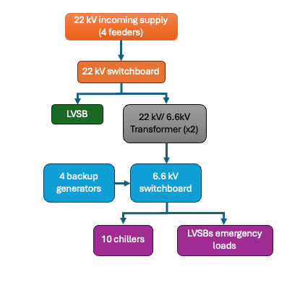
Figure 1: SSMC electrical distribution overview

The as-built single-line diagrams (SLDs) are maintained by contractors, who hold the editable files; SSMC has no access to CAD and keeps non-editable copies such as scanned images or PDFs, So any changes to the drawings must be made through the contractor which may take up to four days. Printed SLDs are displayed on the office walls for reference. The records of the network are kept in excel sheets which list the location of the LVSBs and electrical drawers which house the circuit breakers within them. The SLDs and Excel sheets are stored in separate folders located their respective drives.

To find a breaker and its rating, an engineer needs to open multiple SLDs and Excel sheets, which are stored on different drives and cover several sites. A breaker may have different names in these records, so finding the correct information takes 5 to 10 minutes. Another problem is that drawings do not always match what is installed on site. After installation, engineers must ask contractors for an updated as-built SLD which can take up to four days. Sometimes the updated drawings are neither requested nor provided. Instead, engineers make changes to the printed drawing, scan it and save over the old file. This means the latest updates are only hand-written notes on a scanned image, while the contractor’s original editable drawing is out of date.

Over time, these manual changes can make drawings different from the real setup. This makes it difficult for engineers to trust the drawings when identifying equipment increasing the risk of isolating the wrong breaker, which could lead to production loss. Currently, there is no single system that combines the electrical diagrams and equipment records in a way SSMC can easily manage and update themselves.

Project Aim and Objectives
The aim of this project is to develop a desktop application that stores SSMC’s power distribution records in a single system which will generate single-line diagrams from the data, so that engineers can locate equipment quickly and allocate manpower during power outage, equipment hook-up and secondary use for auditing to keep records up to date between contractor revisions.

To achieve this aim, the project has the following objectives:
- To provide a web-based, central repository where engineers can monitor the status of distribution assets to add, change or remove. Where every change will be logged automatically into an up-to-date audit trail.
- To pinpoint any MCCB, MCB that is down for maintenance or fault, so that engineers can locate it quicky and allocate manpower.
- To allow engineers, LEWs and engineers with SSMC’s approval, to record the maintenance and work carried out on the network. To quickly identify asset updates and when the last incident took place.

Hypothesis and Potential Limitations
It is hypothesised that storing SSMC’s distribution records in a single database, with SLDs from the data, will reduce the time taken to search for a circuit breaker and its rating from 5-10 minutes to under a minute. This consolidation will also help reduce the chances of discrepancies between the database records and the actual installation on site. The current records and the application will be evaluated to assess the upgrading, or replacement works against a set of queries used for lookup.
“Increase efficiency 80% in pinpointing a circuit breaker. As SSMC’s internal downtime cost is no available, the industry estimate of $100K-$500K/hour for a broad semiconductor and electronics manufacturer” [CONSILIEN, 2026].

The application will not replace the current as-built drawings, but to be used in conjunction with them, and complement the contractor’s existing records. Any official alterations of the drawings will still be carried by the contractor.

The project presents several limitations:

- The application will encompass 22 kV and 6.6 kV distribution systems, LVSBs, electrical drawers, and individual circuit breakers. Excluded from its scope are live metering, SCADA readings and power-flow simulations.

- Data records will be entered manually as SSMC’s data confidentiality policy does not allow the data to be exported out of the company; this applies to SLDs and Excel sheets. Manual entry is time consuming and may result in typing errors, so not all LVSB rooms may be entered or completed during the project period.

- The application is only as accurate as the information entered into it. If the existing SLDs and Excel sheets are out of date, those errors may be carried over unless found during the on-site check.

- The benefit depends on engineers keeping the application up to date after each change rather than marking up printed drawings. It is not possible to test this completely within the scope of the project.

2 Literature Review
This chapter presents a review of relevant concepts and prior research pertaining to the project. Section 2.1 introduces the key concepts behind the application: SLDs, the importance of keeping them up to date, consistent equipment naming, and control of asset records. Section 2.2 then evaluates existing approaches for handling electrical records, such as CAD drawings, power system analysis software and asset management systems. This comparative review identifies the research gap that the project seeks to address.

Review of key concepts
A single line diagram (SLD) shows three-phase power system, which provides how power flows from the incoming supply throughout the switchboards and breakers to final circuits. Engineers us it to quickly identify the load that is supplied by which breaker, it must match the installation on site.

Compliance with SS638 and EMA
In Singapore, SS638 and Energy Market Authority (EMA) requires a SLD to show the point of common coupling, cable specifications, busbar configuration, the hierarchical distribution of from mains to final circuit, circuit breaker details, emergency generator interlocking. The SLD must be endorsed by a Licensed Electrical Worker (LEW), include room or unit locations, and use standardised symbols with a dated revision code for changes to the drawing [Energy Market Authority, 2004]. The proposal application will record the distribution hierarchy, breaker details and locations and logs changes with date included, but it will not replace the LEW-endorsed drawing.

The network is stored in a relational database with linked tables of switchboards, MCCBs, MCBs and circuits. The SLDs are created from these records and any changes to the records are reflected in the drawing. All changes will be logged and monitored in an audit trail and access to data is restricted according to the user roles and limits what each user can do.

include sub chapter header
Conventional spreadsheets do not enforce the links between records, and CAD files can only be edited by authorized users. PostgreSQL was chosen over other databases for several reasons such as single-user databases like Microsoft Access and SQLite are unsuitable when several engineers update records at the same time, and commercial databases like SQL server and Oracle require paid licenses. While PostgreSQL is free and open source, supports many simultaneous users, and enforces data integrity within the database itself: where every MCB must belong to an existing MCCB, ratings must be positive, and breaker status can only be in service, under maintenance or faulted. Transactions also ensure that each change saved and its audit record are saved together or not at all (PostgreSQL Global Development Group, 2026).

Synthesis of Existing Research
Computerised maintenance management systems (CMMS) are widely used to organise maintenance work through work orders. [Jasiulewicz-Kaczmarek et al, 2017] describe a CMMS module at a medical device manufacturer in which technicians use RFID tags and tablets to link each task to the machine, the worker and the spare parts used. Comparing 2015 with 2016, they report that tasks were completed 23% faster, the failure rate fell by 27% and the average wait for spare parts fell from over four days to just over one. However, the results come from a before-and-after comparison at a single site, and the authors acknowledge that not all the improvement was due to the system. More importantly for this project, the system manages individual machines rather than an electrical network and cannot indicate which circuit breaker is powering a machine that is not working.

Even when the documentation is in a computerised system, it is incomplete and the record is oftentimes not updated. [Conte et al, 2021] found that 93% of all work orders were marked completed on Fridays within 10 years of HVAC maintenance work order record, instead of when they were completed, work was closed in weekly batches. As a result, the recorded dates does not indicate the time of maintenance and the recorded median job duration was overstated by 30% longer. The authors point to the manual entry of data by staff under pressure as causes for such omissions and demonstrate how missing data affect the results of maintenance performance indicators. Their study however does not improve the data capture process but corrects statistically the data after, which is covered for a single HVAC facility, instead of an electrical network.

Locating faults is an additional challenge. As stated from [Numair et al, 2023] Current approaches for exact fault detection in Low Voltage (LV) Distribution Networks (DNs) typically utilise high-cost devices such as the micro-Phasor Measurement Unit (µPMU), which could be unfeasible given the extensive number of nodes in LVDNs. Instead, the authors applied a digital twin and smart meter data to accurately identify faults in a 41-node feeder scenario for simulation only within 95.77% accuracy, and the authors state that their results are tied to characteristics of the anaylsed network. The topology of the network is extracted from the utility’s database and is updated when a fault or network topology is changed. This method relies on changes in the network being reported in the first place, which the study does not address it. This cannot be assumed at SSMC, where not all changes made on site are recorded.

These studies have identified two major shortcomings which the current project attempts to address. First, records entered manually after the fact don't reliably show what was changed or when; the application logs every change to the network records automatically, with its date and time, at the moment it is made. Second, existing fault-finding techniques require expensive equipment or updated records; the current application ensures records are always up-to-date and provides the ability to show the status of all MCCBs and MCBs (in service, under maintenance or faulted) including information about the assigned engineer, enabling an engineer to quickly locate a faulted breaker on a single line diagram.

Research Design
This project is done using a design-and-build approach (Figure 2). The SSMC records are examined to determine what should be held in the application, a data model is created, the application is built and then populated with the existing SSMC records. A sample of entries from the application is compared to the installation on-site, any discrepancies are corrected and the application evaluated. The application is then evaluated by the SSMC by timing the same lookups for both the current method and the application. This approach was chosen because the application must reflect how the SSMC’s network and records are currently structured. This can only be verified against the actual installation on-site. Also, the benefits of the application could be determined simply by comparing the time taken to perform the same lookups in both the current system and the application.

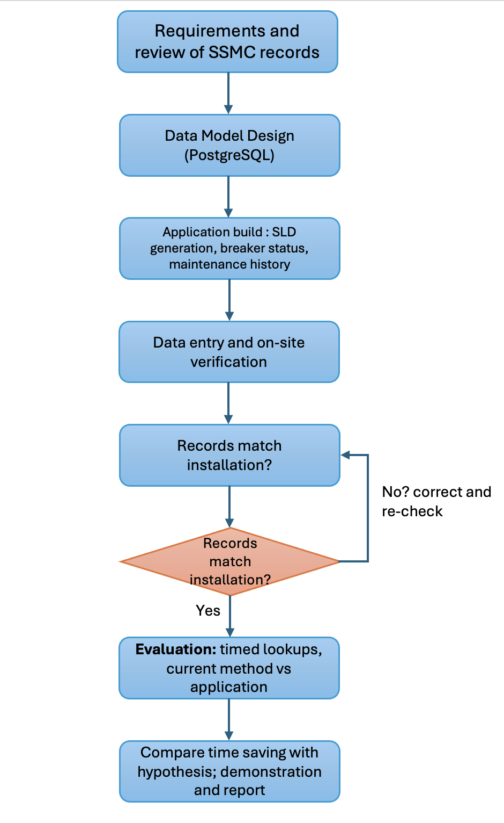
Figure 2: Research Design Flow Chart

Engineer uses the application. An engineer selects which board that a way supplies from the high voltage overview screen, clicks on the board name to view the single-line diagram, and scrolls down from the MCCB to the MCB to the circuit. If the circuit is faulted or being maintained, the engineer changes the status of the breaker and assigns an engineer. If there has been an equipment change on site, the record is amended and the single-line diagram redraws itself. Every alteration is stored in the activity log along with the date and time of the change.
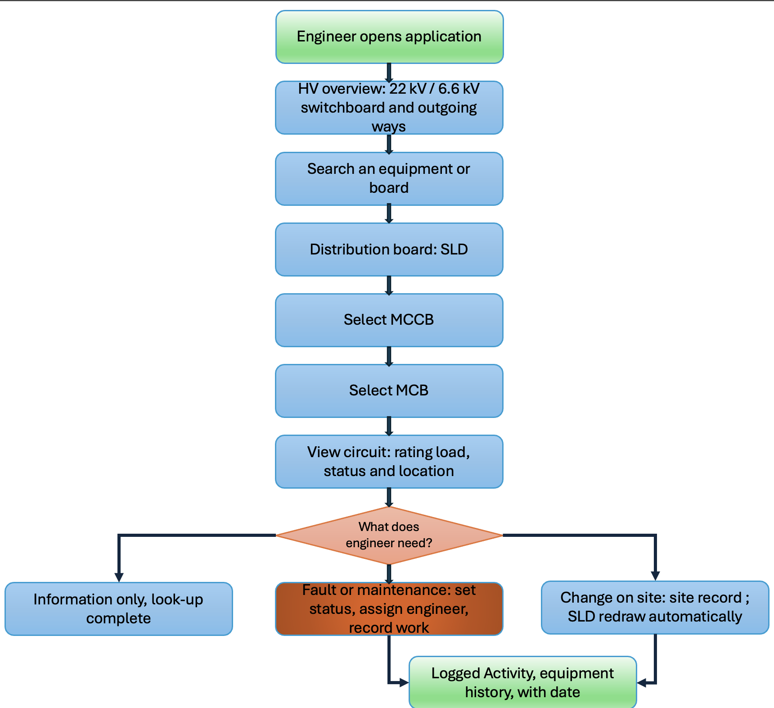
Figure 3: User Workflow
Include formula of utilization…

Proposed Methodology (how to replicate)
Sql how to import or build SLD and how to build program. Build it in a cloud or use URL to see the app temporarily. Role based access control.

- To design a database using PostqreSQL that holds records of the distribution network from the 22kV and 6.6kV switchboards down to the LVSBs, electrical drawers and individual circuit breakers, with consistent naming.
- transfer the existing records [using add Board function] of several LVSB rooms from current SLDs and Excel sheets into the database and verify it against the installation on site.
- To generate SLDs and distribution overview directly from records in the database, rather than drawing them by hand, so that any changes will be made automatically to the drawings.
- To allow engineers to add, edit and move an equipment in the application, with every change recorded in an audit log displaying who made it and when.
- Pinpoint MCB or MCCB whether it is down for maintenance or currently there is a fault. Assign.
- How to transfer to sql. Role based hierarchy
- Do take note…..how to use functions of the application

Expected Results/Outcomes
The project will result in the following, linked to objectives in Section 1.2: A central repository of SSMC’s distribution records, viewed via a web browser, consisting of the entire network from the 22 kV and 6.6 kV switchboards to individual circuit breakers, with single line diagrams generated from the records, and all changes being recorded automatically with date and time (Objective 1).

A display of the breaker status showing whether each MCCB and MCB is in service, undergoing maintenance, or faulted, and the engineer assigned to it, so that a faulted breaker can be located on the single-line diagram and manpower will be allocated (Objective 2).

A record of maintenance and changes to assets, including any 22 kV switchboard, MCCB, or MCB, on which engineers will record inspections, repairs, replacements, tests, and incident response for each asset, along with all changes made to the record, and the only remaining requirement being to add a system of named users, allowing different users to be assigned logon credentials and granting LEWs and vendor engineers to be given permission (with SSMC’s approval) (Objective 3).

In quantifiable terms, time to locate a circuit breaker and its rating is expected to drop from 5 to 10 minutes to less than 1 minute, equating from the lowest baseline of 5 minutes i.e., at least 4 minutes saved per lookup, representing at least US$6,700 per occurrence of a lookup delaying the restoration of production (Section 1.3). Ten entries will be checked on site to confirm that the application data matches the physical plant.

If the hypothesis is incorrect, i.e. lookups using the application are not much quicker than other methods, the timed results will show where the time is being spent, such as navigating diagrams or user unfamiliarity with the application. This would serve to provide information that could be used to improve the design of the application. Similarly, any inconsistencies found during the on-site verification will show which records in the database are out-of-date, also useful information for SSMC.

Gantt Chart
The project is to be developed over two trimesters (Figure 4). Requirements, data model and main application (HV overview, SLD generation, breaker status, maintenance records and change history) were complete at the time of submission for this proposal on 25 October. Named user logins and hosted demonstration will be undertaken in weeks 9-12, and LVSB data entry from week 10 and continuing through the term break. At the start of trimester 2, 10 entries will be checked on site prior to the poster presentation in week 4. The timed lookup evaluation will run in weeks 5-7, allowing any results to be used to improve the application prior to the final demonstration in weeks 9-10 and to include in the final technical report due in week 12.

Sustainable Development Goal
This project supports the Sustainable Development Goal 9 (SDG9), industry innovation and infrastructure, specifically 9.5. SSMCs distribution records include static drawings that only contractors can edit, and Excel sheets that are updated by SSMC’s engineers. Replacing them with a single database that stores and keeps generated up to date SLDs upgrades or changes and allows engineers to see how the plant manages its electrical network which allows them to quickly isolate and restore faulted circuits where every change and maintenance task is logged against the equipment.

References
Kong, E. (2026, August 21).
The real cost of IT downtime in semiconductor manufacturing. Consilien.Com. https://www.consilien.com/news/it-downtime-cost-semiconductor-manufacturing

Essential details to be incorporated in schematic single-line diagrams for electrical installation. (2004). [Technical guideline for electrical schematic diagrams]. https://elise.ema.gov.sg/eguides/SLD_Details_for_EISI_220403.pdf

PostgreSQL 16.15 documentation. (2026). PostgreSQL Documentationhttps://www.postgresql.org/docs/16/

Malgorzata, J.-K., Mariusz, P., & Piotr, S. (2017). Improvement maintenance processes through CMMS system-case study. Proceedings of the 2017 International Conference on Management Science and Management Innovation (MSMI 2017). https://doi.org/10.2991/msmi-17.2017.43

Conte, A., Bolland, C., Phan, L., Brundage, M., & Sexton, T. (2021). Impact of data quality on maintenance work order analysis: A case study in historical HVAC maintenance work orders. PHM Society European Conference, 6(1), 11. https://doi.org/10.36001/phme.2021.v6i1.2814

United Nations. (2025). Goal 9 | department of economic and social affairs. United Nations; United Nations. https://sdgs.un.org/goals/goal9

