Circular Motion — FRQ Practice Pack
AP Physics 1 · Unit 2 (Topic 2.9) · all four AP free-response types
How to use this pack
Day | Do | Time
1 | FRQ 1 — Mathematical Routines (MR), then self-score | 25 min + 10
2 | FRQ 4 — Qualitative/Quantitative Translation (QQT), then self-score | 20 min + 10
3 | FRQ 2 — Translation Between Representations (TBR), then self-score | 30 min + 10
4 | FRQ 3 — Experimental Design and Analysis (LAB), then self-score | 30 min + 10
5 | Redo ONLY the parts you lost points on, without looking at the guide | 20 min

- Time yourself. The times are the College Board's suggested times for each FRQ type.
- Score yourself with the Scoring Guide strictly: a point counts only if your answer says what the guide asks for.
- Fill in the score log on the last page. The pattern of *why* you lose points matters more than the total.
- Take one scored FRQ to your teacher's extra-help block and ask: "Would this justification get the point?"
Ten rules that win FRQ points
- Free-body diagrams: forces only. Each arrow starts on the dot and points away from it. Label each one (F_g, F_N, F_f, F_T).
- Never draw a "centripetal force" arrow. Centripetal is a direction, not a new force. The net force from the real forces points toward the center. An extra "F_c" arrow costs the FBD point.
- No velocity or acceleration arrows on an FBD. No components on the FBD itself.
- Derive = start from a law in symbols. Write ΣF = ma, then a = v²/r, then substitute. The final answer uses only the variables the question lists.
- Calculate = show the substitution with units, then give the answer with units (about 3 significant figures).
- Justify = claim + physics law or equation + link to THIS situation. "Because the friction force is the only horizontal force, it must supply the net force m·v²/R, so …" One-word or "it is bigger" answers score 0.
- If the question says "in terms of m, v, r and physical constants", any other variable in your answer loses the point.
- Graph sketches: label both axes. Show the shape (straight line? curve?) and where it crosses the axis.
- "Is it consistent with part (b)?" questions: refer to part (b) by name, and use its equation.
- Never leave a part blank. FRQ points are awarded line by line, so a correct first step still earns credit.
Use g = 9.8 m/s². Calculator allowed.

FRQ 1 — Mathematical Routines (10 points · suggested 20–25 min)
A car of mass m drives at constant speed v around a flat (unbanked) curve of radius R. The coefficient of static friction between the tires and the road is μ_s.
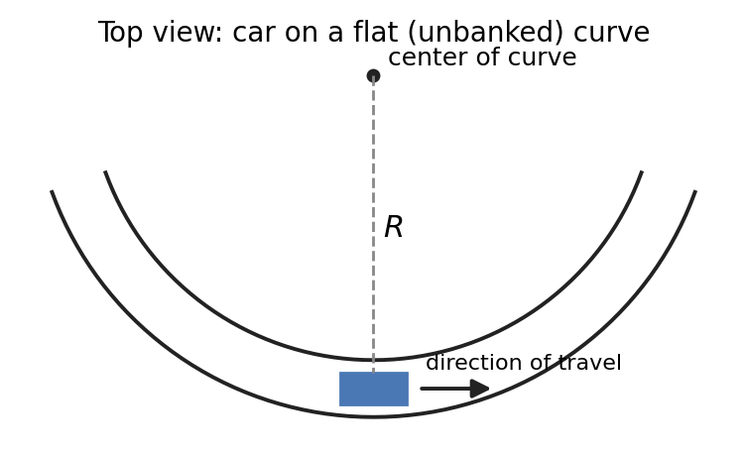
(a) The dot below represents the car, seen from behind at the instant shown. The center of the curve is to the LEFT. Draw and label the forces (not components) exerted on the car. Each force must be a distinct arrow that starts on, and points away from, the dot.
● (center of curve is to the left ←)

(b) Starting with Newton's second law, derive an expression for v_max, the maximum speed at which the car can go around the curve without sliding. Express your answer in terms of μ_s, R, and physical constants as appropriate.
______________________________________________________________________________________
______________________________________________________________________________________
______________________________________________________________________________________
______________________________________________________________________________________
______________________________________________________________________________________
______________________________________________________________________________________
(c) The curve has R = 45 m and μ_s = 0.85. Calculate v_max.
______________________________________________________________________________________
______________________________________________________________________________________
______________________________________________________________________________________
(d) A loaded truck with twice the mass of the car drives around the same curve. A student claims: "The truck must go slower than the car, because it is heavier." Do you agree or disagree? Justify your answer using your expression from part (b).
______________________________________________________________________________________
______________________________________________________________________________________
______________________________________________________________________________________
______________________________________________________________________________________
(e) On a rainy day, μ_s is reduced to half its dry value. Determine the new v_max for the curve in part (c).
______________________________________________________________________________________
______________________________________________________________________________________
______________________________________________________________________________________

FRQ 2 — Translation Between Representations (12 points · suggested 25–30 min)
A ball of mass m = 0.20 kg is attached to a light string and swung in a vertical circle of radius r = 0.80 m. Point A is the top of the circle and point B is the bottom. Air resistance is negligible.
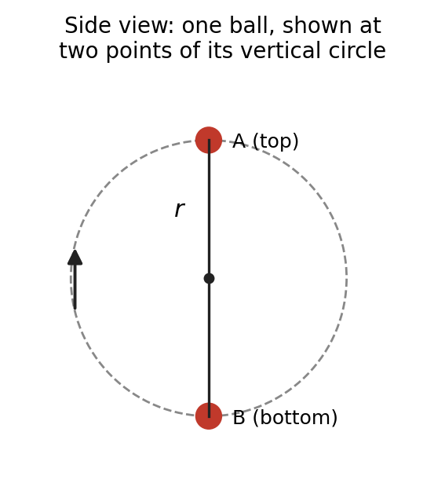
(a) In the boxes below, draw and label the forces (not components) exerted on the ball (i) at point A and (ii) at point B. Draw the relative lengths of the arrows in (ii) correctly.
(i) Ball at A (top) | (ii) Ball at B (bottom)
● | ●

(b) Derive an expression for the tension T_B in the string at point B when the ball's speed there is v_B. Express your answer in terms of m, v_B, r, and physical constants as appropriate.
______________________________________________________________________________________
______________________________________________________________________________________
______________________________________________________________________________________
______________________________________________________________________________________
______________________________________________________________________________________
(c) Derive an expression for the MINIMUM speed the ball can have at point A and still keep the string taut. Express your answer in terms of r and physical constants.
______________________________________________________________________________________
______________________________________________________________________________________
______________________________________________________________________________________
______________________________________________________________________________________
______________________________________________________________________________________
(d) The ball is swung at several different speeds. On the axes below, sketch a graph of T_B (vertical axis) versus v_B² (horizontal axis). Label any intercept with an expression.

(e) Using the given values of m and r, calculate the slope and the vertical-axis intercept of your graph in part (d). Include units.
______________________________________________________________________________________
______________________________________________________________________________________
______________________________________________________________________________________
(f) A student says: "If the ball just hangs at rest at point B, the tension is zero because the ball has no centripetal acceleration." Use your answers to parts (b) and (d) to explain whether the student is correct.
______________________________________________________________________________________
______________________________________________________________________________________
______________________________________________________________________________________
______________________________________________________________________________________

FRQ 3 — Experimental Design and Analysis (10 points · suggested 25–30 min)
A group of students wants to find out how the speed of an object in uniform circular motion depends on the net force on it, when the radius of the circle is kept the same. They have a rubber stopper tied to a string that runs through a hollow tube to a hanging mass M. When the stopper is whirled in a horizontal circle at steady speed, the tension in the string equals Mg.
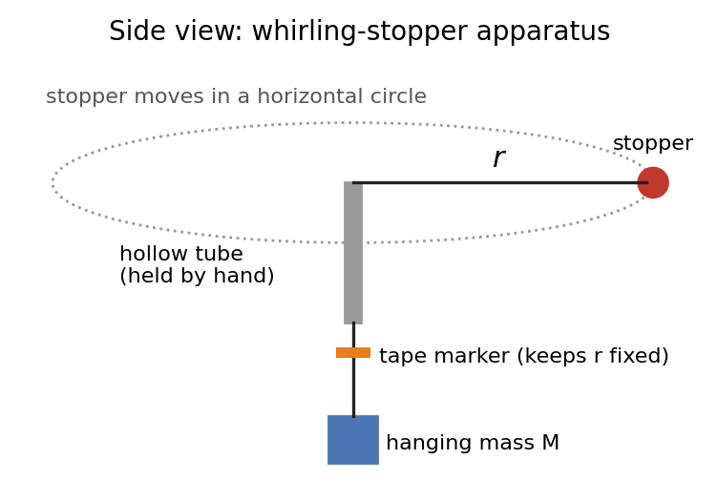
Available equipment: the apparatus shown, a set of hanging masses, a meterstick, a stopwatch, tape, and an electronic balance.
(a) Describe an experimental procedure the students could use to collect the data. Include enough detail that another student could repeat it. Say what is measured, with which equipment, what is kept constant, and how the speed is obtained.
______________________________________________________________________________________
______________________________________________________________________________________
______________________________________________________________________________________
______________________________________________________________________________________
______________________________________________________________________________________
______________________________________________________________________________________
______________________________________________________________________________________
______________________________________________________________________________________
The students keep the radius at r = 0.50 m and collect the data below.
Hanging mass M (kg) | Time for 10 revolutions (s) | F_T = Mg (N) | v (m/s) | v² (m²/s²)
0.050 | 10.2
0.100 | 7.0
0.150 | 5.9
0.200 | 4.9
0.250 | 4.5

(b) Indicate which quantities could be graphed to produce a straight line whose slope can be used to determine the mass of the stopper. Complete the empty columns of the table as needed.
______________________________________________________________________________________
______________________________________________________________________________________
(c) On the grid below, plot the data. Label the axes with quantities and units, use a suitable scale, and draw a best-fit line.
(d) Using your best-fit line, determine the mass of the stopper. Show your work.
______________________________________________________________________________________
______________________________________________________________________________________
______________________________________________________________________________________
______________________________________________________________________________________

FRQ 4 — Qualitative/Quantitative Translation (8 points · suggested 15–20 min)
Two identical coins rest on a flat horizontal turntable. Coin 1 is a distance r from the center and coin 2 is a distance 2r from the center. The coefficient of static friction between each coin and the turntable is μ_s. The turntable starts from rest and very slowly speeds up, so the time T for one revolution gets shorter and shorter.
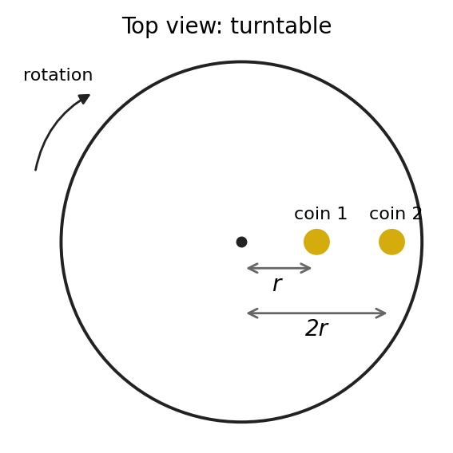
(a) Which coin begins to slide first? In a clear, paragraph-length response that uses NO equations, explain your reasoning. Discuss the speeds of the coins and the maximum friction force on each.
______________________________________________________________________________________
______________________________________________________________________________________
______________________________________________________________________________________
______________________________________________________________________________________
______________________________________________________________________________________
______________________________________________________________________________________
______________________________________________________________________________________
(b) Derive an expression for T_slip, the period of the turntable at which a coin at distance r from the center begins to slide. Express your answer in terms of μ_s, r, and physical constants as appropriate.
______________________________________________________________________________________
______________________________________________________________________________________
______________________________________________________________________________________
______________________________________________________________________________________
______________________________________________________________________________________
______________________________________________________________________________________
(c) Explain how your expression from part (b) is consistent with your claim in part (a).
______________________________________________________________________________________
______________________________________________________________________________________
______________________________________________________________________________________
______________________________________________________________________________________

Score log
For each part where you lost a point, put a tick under the reason. After 4 FRQs, the column with the most ticks is what to fix first.
FRQ | Part | Points earned | Didn't know the physics | Set-up / derivation | Justification too vague | Careless / units
FRQ 1 MR /10 | a
 | b
 | c
 | d
 | e
FRQ 2 TBR /12 | a
 | b
 | c
 | d
 | e
 | f
FRQ 3 LAB /10 | a
 | b
 | c
 | d
FRQ 4 QQT /8 | a
 | b
 | c

Total: ______ / 40

