Forces & Newton's Laws — FRQ Practice Pack
AP Physics 1 · Unit 2 (Topics 2.2–2.5) · do this AFTER the Newton's Laws Quest web lesson
How to use this pack
When | Do | Time
Session 1 | FRQ 1 (MR), timed, then self-score with the Scoring Guide | 20 min + 10
Session 2 | FRQ 3 (QQT), timed, then self-score | 15 min + 10
Session 3 | FRQ 2 (TBR), timed, then self-score | 25 min + 10
Day before test | Redo ONLY the parts you lost points on, without looking at the guide | 20 min

- Timer on, notes away, calculator allowed. Use g = 9.8 m/s².
- Score strictly: a point counts only if your answer says what the guide asks for.
- Fill in the score log on the last page. Look for the reason you lose points, not only the total.
Five habits for every FRQ
- FBD first. Dot, arrows start on the dot, one arrow per real force, labelled. No "force of motion", no "ma" arrow.
- Symbols before numbers. Write ΣF = ma, substitute forces from the FBD, solve, *then* plug in.
- Justify = Claim → Law → Link. Answer, name the law, apply it to this situation.
- Units on every number. Labelled axes on every graph.
- Never leave a blank. A correct first line still earns a point.

FRQ 1 — Mathematical Routines (10 points · suggested 20 min)
Two blocks, 1 and 2, of masses m₁ and m₂, sit side by side on a horizontal frictionless surface. A constant horizontal force of magnitude F is applied to block 1 as shown, and both blocks accelerate together.
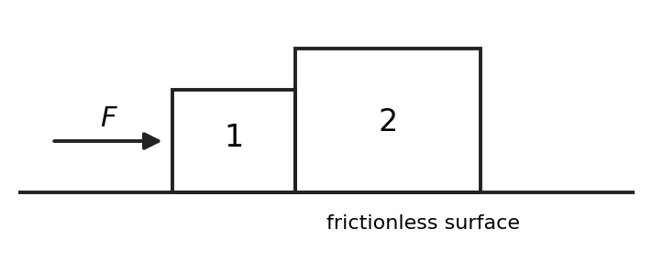
(a) The dot below represents block 2. Draw and label the forces (not components) exerted on block 2. Each force must be a distinct arrow that starts on, and points away from, the dot.
●

(b) Derive an expression for the acceleration of the blocks. Express your answer in terms of F, m₁, m₂, and physical constants as appropriate.
______________________________________________________________________________________
______________________________________________________________________________________
______________________________________________________________________________________
______________________________________________________________________________________
(c) Derive an expression for the magnitude of the force that block 1 exerts on block 2. Express your answer in terms of F, m₁, and m₂.
______________________________________________________________________________________
______________________________________________________________________________________
______________________________________________________________________________________
______________________________________________________________________________________
(d) F = 30 N, m₁ = 2.0 kg and m₂ = 4.0 kg. Calculate the acceleration of the blocks and the force block 1 exerts on block 2.
______________________________________________________________________________________
______________________________________________________________________________________
______________________________________________________________________________________
(e) The same force F is now applied to block 2 instead, pushing to the LEFT, so block 2 pushes block 1. Is the force between the blocks now greater than, less than, or equal to your answer in part (d)? Justify your answer using your expression from part (c).
______________________________________________________________________________________
______________________________________________________________________________________
______________________________________________________________________________________
______________________________________________________________________________________

FRQ 2 — Translation Between Representations (12 points · suggested 25 min)
A student of mass m = 50 kg stands on a bathroom scale in an elevator. The graph shows the elevator's velocity as it travels from the ground floor to an upper floor. Upward is positive.
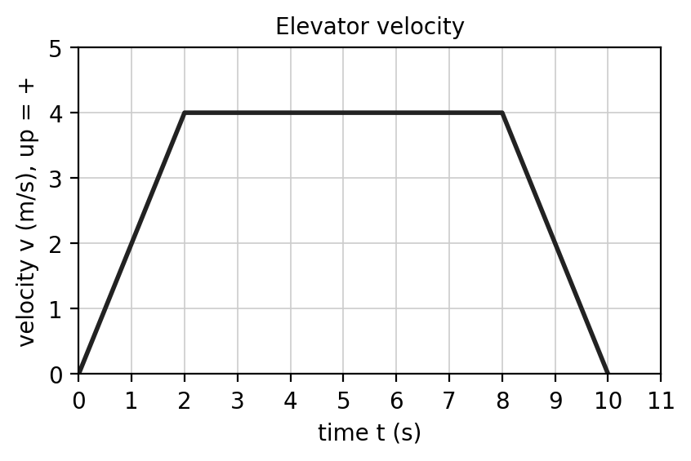
(a) In the boxes below, draw and label the forces (not components) exerted on the student at (i) t = 1 s, (ii) t = 5 s, and (iii) t = 9 s. Draw the relative lengths of the arrows correctly in each box.
(i) t = 1 s | (ii) t = 5 s | (iii) t = 9 s
● | ● | ●

(b) Derive an expression for the scale reading F_N when the elevator has an upward acceleration of magnitude a. Express your answer in terms of m, a, and physical constants as appropriate.
______________________________________________________________________________________
______________________________________________________________________________________
______________________________________________________________________________________
______________________________________________________________________________________
(c) Calculate the scale reading during each of the three time intervals 0–2 s, 2–8 s, and 8–10 s.
______________________________________________________________________________________
______________________________________________________________________________________
______________________________________________________________________________________
______________________________________________________________________________________
(d) On the axes below, sketch the scale reading F_N as a function of time from t = 0 to t = 10 s. Label the vertical axis with a scale and units.
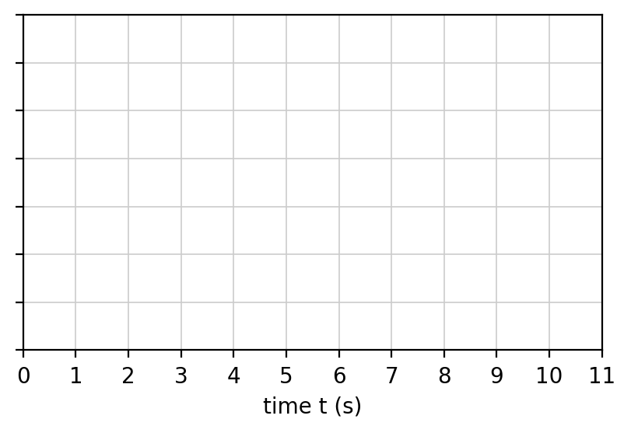
(e) A student claims: "The scale reads more than your weight whenever the elevator is moving upward." Use your answers to parts (c) and (d) to explain whether the claim is correct.
______________________________________________________________________________________
______________________________________________________________________________________
______________________________________________________________________________________
______________________________________________________________________________________

FRQ 3 — Qualitative/Quantitative Translation (8 points · suggested 15 min)
A horse of mass M is hitched to a cart of mass m by a light horizontal rope. Starting from rest on a level road, the horse and cart speed up together. The ground exerts a forward static friction force of magnitude F_h on the horse's hooves. A backward friction force of constant magnitude f acts on the cart's wheels. Ignore air resistance.
(a) The horse argues: "The rope pulls the cart forward with the same size force that it pulls me backward. These forces cancel, so the cart can never speed up." In a clear, paragraph-length response that uses NO equations, explain what is wrong with the horse's argument, and explain what causes the cart to speed up.
______________________________________________________________________________________
______________________________________________________________________________________
______________________________________________________________________________________
______________________________________________________________________________________
______________________________________________________________________________________
______________________________________________________________________________________
______________________________________________________________________________________
(b) Derive an expression for the acceleration of the horse and cart. Express your answer in terms of F_h, f, M, and m.
______________________________________________________________________________________
______________________________________________________________________________________
______________________________________________________________________________________
______________________________________________________________________________________
(c) Derive an expression for the tension T in the rope. Express your answer in terms of F_h, f, M, and m.
______________________________________________________________________________________
______________________________________________________________________________________
______________________________________________________________________________________
______________________________________________________________________________________
(d) Explain how your expression from part (c) is consistent with your explanation in part (a) about why the cart speeds up.
______________________________________________________________________________________
______________________________________________________________________________________
______________________________________________________________________________________

Score log
For each part where you lost a point, tick the reason. After all three FRQs, the column with the most ticks is what to fix first.
FRQ | Part | Points earned | Didn't know the physics | Set-up / derivation | Justification too vague | Careless / units
FRQ 1 MR /10 | a
 | b
 | c
 | d
 | e
FRQ 2 TBR /12 | a
 | b
 | c
 | d
 | e
FRQ 3 QQT /8 | a
 | b
 | c
 | d

Total: ______ / 30

