ReX Workflow Management System
Technical Implementation Document

1. Introduction
This document outlines the technical implementation of a secure, scalable workflow management system designed for enterprise use. The system integrates Single Sign-On (SSO) with PingID for authentication, enforces Role-Based Access Control (RBAC), and provides dynamic workflow configuration capabilities.
Key Features:
- PingID SSO with Multi-Factor Authentication (MFA)
- Database-driven workflow configuration
- Real-time approval system with audit trails
- Role-based UI rendering
2. System Architecture
2.1 High-Level Architecture
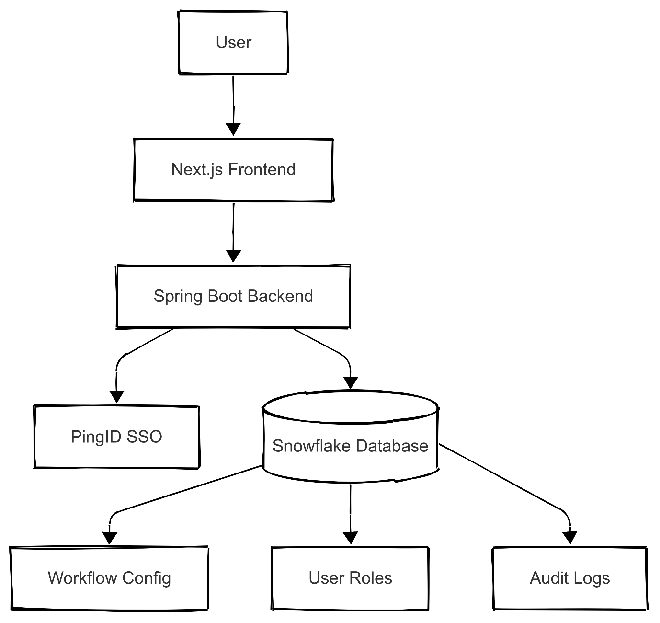

Component Interactions:
- Frontend: Built with Next.js for server-side rendering and static site generation.
- Backend: Spring Boot handles business logic, authentication, and database interactions.
- Database: Snowflake stores workflow configurations, user roles, and audit logs.
- Authentication: PingID manages SSO and MFA.

3. Authentication & RBAC
3.1 OAuth 2.0 Flow
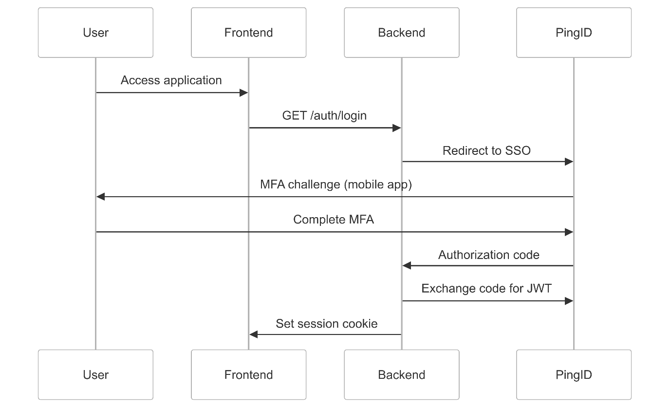

Key Security Features:
- JWT Validation: Backend verifies tokens using PingID’s public keys.
- Session Storage: Session data stored in Snowflake or Amazon Aurora.
- Cookie Attributes: HTTP-only, Secure, and SameSite=Strict.

3.2 Role-Based Access Control
Database Schema:
CREATE TABLE app_user (
id UUID PRIMARY KEY,
sso_id VARCHAR(255) UNIQUE NOT NULL,
email VARCHAR(255) NOT NULL
);

CREATE TABLE role (
id UUID PRIMARY KEY,
name VARCHAR(50) UNIQUE NOT NULL
);

CREATE TABLE user_role (
user_id UUID REFERENCES app_user(id),
role_id UUID REFERENCES role(id),
PRIMARY KEY (user_id, role_id)
);

Frontend Implementation:
// components/ProtectedRoute.tsx
const ProtectedRoute = ({ roles, children }) => {
const { userRoles } = useAppSelector(state => state.auth);

if (!roles.some(role => userRoles.includes(role))) {
return <Navigate to="/unauthorized" />;
}
return children;
};

4. Workflow Engine
4.1 Workflow Configuration
JSON Schema (Snowflake VARIANT Column):
{
"steps": [
{
"id": "manager_approval",
"name": "Manager Approval",
"required_roles": ["MANAGER"],
"actions": ["APPROVE", "REJECT"],
"next_step": "director_approval"
},
{
"id": "director_approval",
"name": "Director Approval",
"required_roles": ["DIRECTOR"],
"actions": ["APPROVE", "REQUEST_CHANGES"]
}
]
}

Backend Logic:
@Service
public class WorkflowService {

public WorkflowInstance createInstance(WorkflowRequest request, String userId) {
return jdbcTemplate.queryForObject(
"""
INSERT INTO workflow_instances
(config_id, created_by, context)
VALUES (?, ?, PARSE_JSON(?))
RETURNING id, current_step, status
""",
new WorkflowInstanceMapper(),
request.getConfigId(),
userId,
request.getContext()
);
}
}

5. Database Design
5.1 Core Tables
Table | Description
workflow_config | Stores JSON workflow templates
workflow_instance | Tracks active workflows
app_user | User details from PingID
audit_log | Records all approval actions

Example Audit Log Table:
CREATE TABLE audit_log (
id UUID PRIMARY KEY,
workflow_id UUID REFERENCES workflow_instance(id),
action VARCHAR(50) NOT NULL,
actor VARCHAR(255) NOT NULL,
timestamp TIMESTAMP_LTZ DEFAULT CURRENT_TIMESTAMP()
);

6. Frontend Implementation
6.1 Workflow Visualization
// components/WorkflowStepper.tsx
const WorkflowStepper = ({ steps }) => {
return (
<div className="stepper">
{steps.map((step, index) => (
<div key={step.id} className={`step ${step.status}`}>
<div className="step-number">{index + 1}</div>
<div className="step-name">{step.name}</div>
<div className="step-status">{step.status}</div>
</div>
))}
</div>
);
};

6.2 Redux State Management
// store/authSlice.ts
export const fetchUserData = createAsyncThunk(
'auth/fetchUser',
async () => {
const response = await axios.get('/api/auth/user');
return response.data; // { user, roles }
}
);

const authSlice = createSlice({
name: 'auth',
initialState,
reducers: { /* ... */ },
extraReducers: (builder) => {
builder.addCase(fetchUserData.fulfilled, (state, action) => {
state.user = action.payload.user;
state.roles = action.payload.roles;
});
}
});

7. Backend Implementation
7.1 Security Configuration
@Configuration
@EnableWebSecurity
public class SecurityConfig extends WebSecurityConfigurerAdapter {

@Override
protected void configure(HttpSecurity http) throws Exception {
http
.authorizeRequests()
.antMatchers("/api/admin/**").hasRole("ADMIN")
.antMatchers("/api/workflows/**").hasRole("USER")
.and()
.oauth2ResourceServer()
.jwt()
.jwtAuthenticationConverter(jwtConverter());
}

@Bean
public JwtDecoder jwtDecoder() {
return NimbusJwtDecoder.withJwkSetUri(pingIdJwksUrl).build();
}
}

8. Security Measures
8.1 JWT Validation
public class JwtValidator {
public void validate(Jwt jwt) {
if (!jwt.getIssuer().equals(pingIdIssuer)) {
throw new JwtException("Invalid issuer");
}
if (jwt.getExpiresAt().isBefore(Instant.now())) {
throw new JwtException("Token expired");
}
}
}

8.2 Rate Limiting
@Bean
public SecurityFilterChain filterChain(HttpSecurity http) throws Exception {
http.addFilterBefore(
new RateLimitFilter(10, 1), // 10 requests/minute
BasicAuthenticationFilter.class
);
}

9. Execution Plan
Phase | Tasks | Duration
Infrastructure Setup | Configure AWS, Snowflake | 3 Days
Core Development | Auth, Workflow Engine, UI | 3 Weeks
Testing | Security, Performance | 1 Week
Deployment | CI/CD, Monitoring | 3 Days

10. Appendices
A. PingID Auth Flow
