Contents

Setting time zone for app service 2

Reference 2

Adding custom host name to app service. 2

# Setting time zone for app service

To set the time zone for apps running under an app service plan, WEBSITE_TIME_ZONE appsetting need to be added with appropriate time zone value.

Ex: To set timezone of an application to Indian time, WEBSITE_TIME_ZONE need to be set to “India Standard Time”

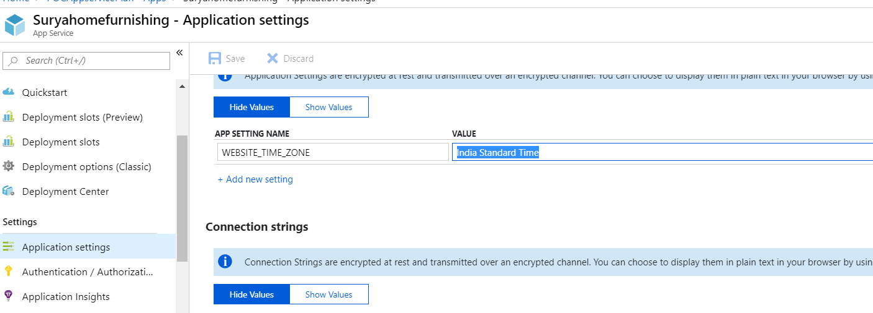

### Reference

Time Zone : <https://docs.microsoft.com/en-us/previous-versions/windows/it-pro/windows-vista/cc749073(v=ws.10)>

# Adding custom host name to app service.

Go to app service (ex: pocapp3) from which you want add custom domain name and click on Add hostname.

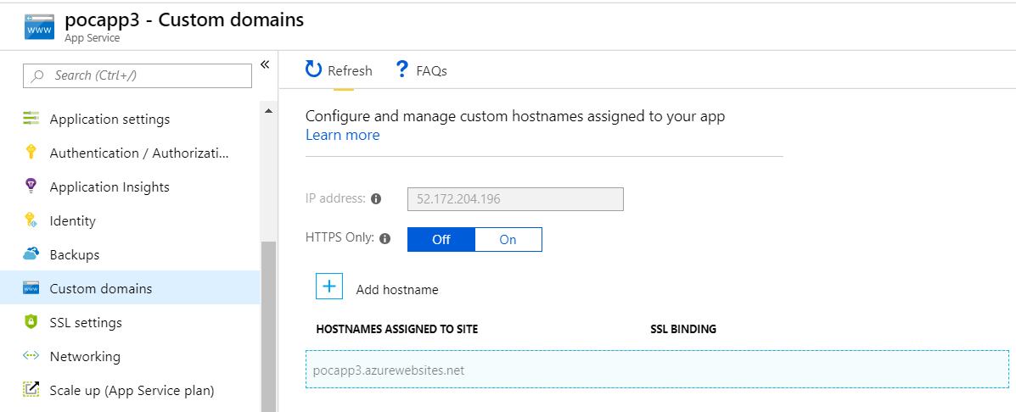

* Enter appropriate host name in following format <Subdomain>.suryahome.co.in as shown below for sample app.

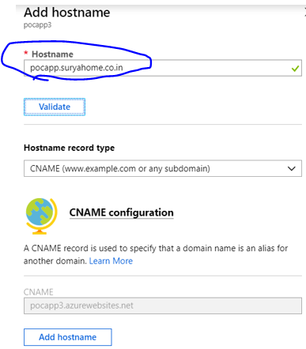

Finally click on Add hostname. You should see success message as shown below.

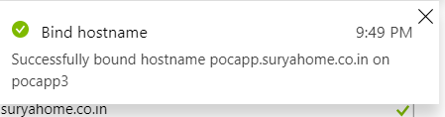

* Now we can access app using the new hostname

