CSCI251 Assignment 2 Test Cases

Name : Kenndy
Student No. : 6742014

General Instructions

- Prepare the following :

- Setup the exact same version of your program that you submitted to Moodle (before deadline), inside Ubuntu OS

- Open up Excel document ‘CSCI251_A2_Checklist.xls‘

- Perform test cases SEQUENTIALLY on your program, do not skip steps / sequence!

- FOR EACH test case :

  - Perform the test case on your program

  - If your program ‘pass’ the test case

- Do screen capture, and paste the image in this document, (CSCI251_A2_Test_Cases.doc), where indicated

- Update CSCI251_A2_Checklist.xls (select ‘yes’) at the row corresponding to your test case

Else // i.e. program ‘fails’ the test case

- No need for screen capture (leave the section blank)

- Update CSCI251_A2_Checklist.xls (select ‘no’) at the row corresponding to your test case

- Note : Please RESIZE your screen capture, Adjust the Spacing such that each
test case begins on a new page !!

Test Case #1a – Input (sensor) data for ‘Square’ displayed correctly

    - Start up your program, select ‘1) Input sensor data’

    - Key in only the Squares data from Appendix A, Table A1

    - Select ‘3) Print shapes report’

    - Do as many screen captures as necessary, your program’s output

    - Check your screen captures output to verify that data like ‘Name’, ‘Special Type’ & ‘Vertices’ are input and stored correctly in your program (i.e. should be the same as those shown in Appendix A, Table A1)

    - Update Excel file ‘CSCI251_A2_Checklist.xls’, select ‘Yes’ in column ‘C’, (for the row corresponding to Test Case #1a), if your program’s results are verified to be correct as described in step e)

< Paste Screen Capture(s) below >

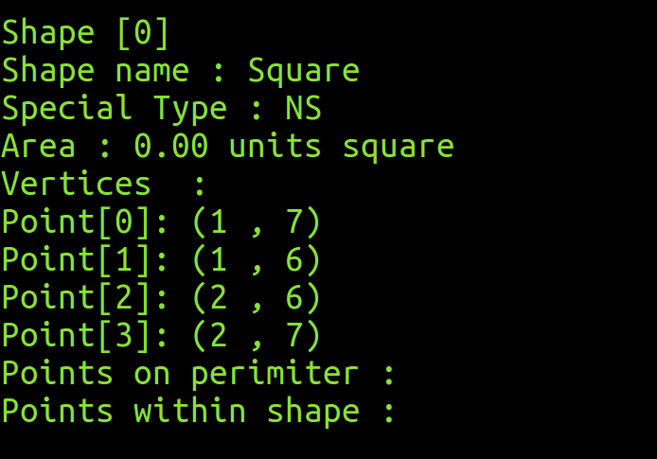

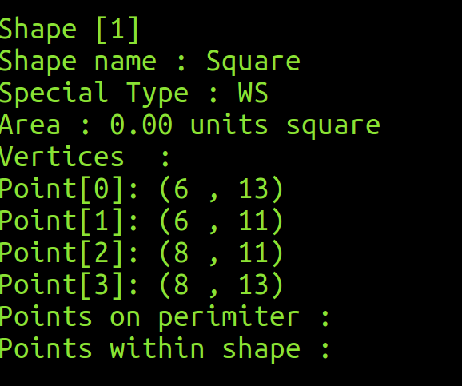

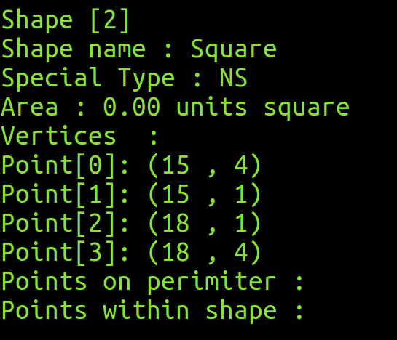

Test Case #1b – Area for ‘Square’ computed & displayed correctly

- Select ‘2) Compute area (for all records)’

- Select ‘3) Print shapes report’

- Do as many screen captures as necessary, your program’s output

- Check your screen captures output to verify that data like ‘Area’ are computed and displayed correctly in your program (i.e. should be the same as those shown in Appendix A, Table A2)

- Update Excel file ‘CSCI251_A2_Checklist.xls’, select ‘Yes’ in column ‘C’, (for the row corresponding to Test Case #1b), if your program’s results are verified to be correct as described in step d)

< Paste Screen Capture(s) below >

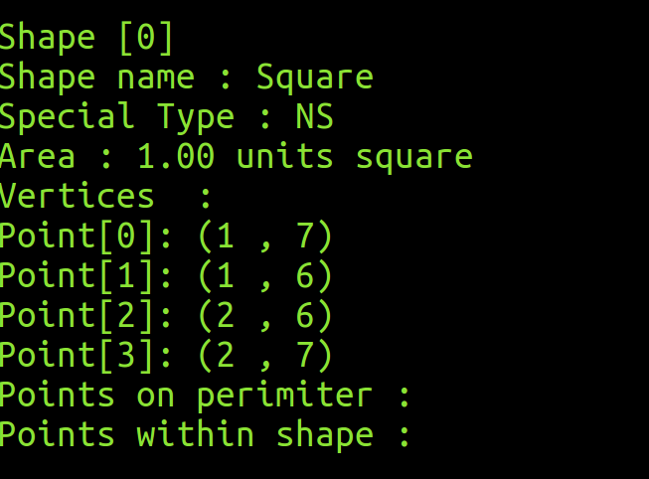

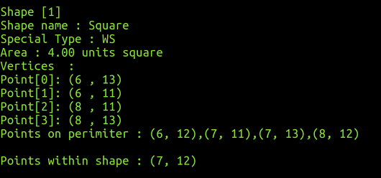

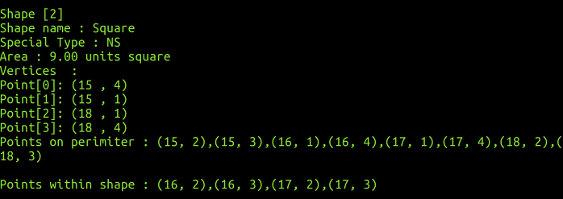

Test Case #1c – Points on Perimeter coordinates for ‘Square’ computed & displayed correctly

- With references to your screen captures in Test Case #1a) / #1b), check your screen captures output to verify that data like ‘Points on Perimeter’ coordinates are computed and displayed correctly in your program (i.e. should be the same as those shown in Appendix A, Table A2)

- Update Excel file ‘CSCI251_A2_Checklist.xls’, select ‘Yes’ in column ‘C’, (for the row corresponding to Test Case #1c), if your program’s results are verified to be correct as described in step a)

Test Case #1d– Points within Shape coordinates for ‘Square’ computed & displayed correctly

- With references to your screen captures in Test Case #1a) / #1b), check your screen captures output to verify that data like ‘Points within Shape’ coordinates are computed and displayed correctly in your program (i.e. should be the same as those shown in Appendix A, Table A2)

- Update Excel file ‘CSCI251_A2_Checklist.xls’, select ‘Yes’ in column ‘C’, (for the row corresponding to Test Case #1d), if your program’s results are verified to be correct as described in step a)

Test Case #2a – Input (sensor) data for ‘Rectangle’ displayed correctly

- Re-start your program, select ‘1) Input sensor data’

- Key in only the Rectangles data from Appendix A, Table B1

- Select ‘3) Print shapes report’

- Do as many screen captures as necessary, your program’s output

- Check your screen captures output to verify that data like ‘Name’, ‘Special Type’ & ‘Vertices’ are input and stored correctly in your program (i.e. should be the same as those shown in Appendix A, Table B1)

- Update Excel file ‘CSCI251_A2_Checklist.xls’, select ‘Yes’ in column ‘C’, (for the row corresponding to Test Case #2a), if your program’s results are verified to be correct as described in step e)

< Paste Screen Capture(s) below >

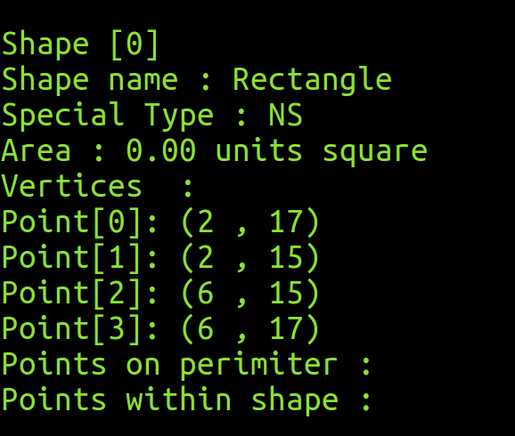

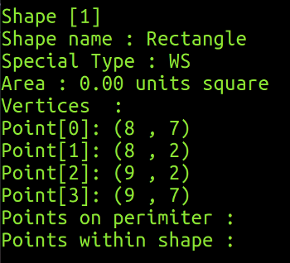

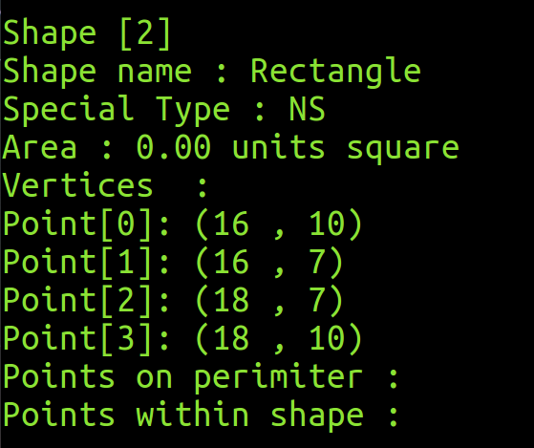

Test Case #2b – Area for ‘Rectangle’ computed & displayed correctly

- Select ‘2) Compute area (for all records)’

- Select ‘3) Print shapes report’

- Do as many screen captures as necessary, your program’s output

- Check your screen captures output to verify that data like ‘Area’ are computed and displayed correctly in your program (i.e. should be the same as those shown in Appendix A, Table B2)

- Update Excel file ‘CSCI251_A2_Checklist.xls’, select ‘Yes’ in column ‘C’, (for the row corresponding to Test Case #2b), if your program’s results are verified to be correct as described in step d)

< Paste Screen Capture(s) below >

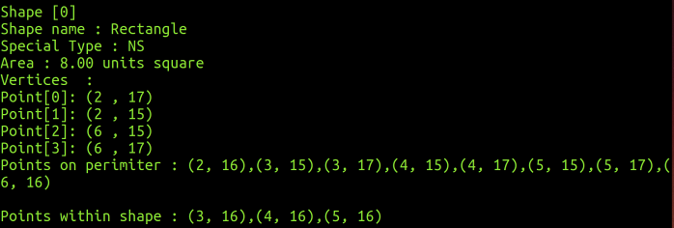

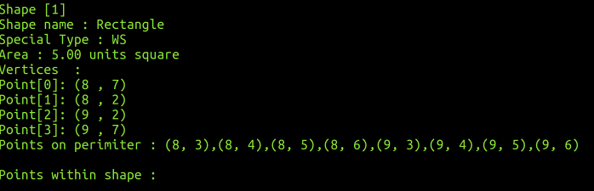

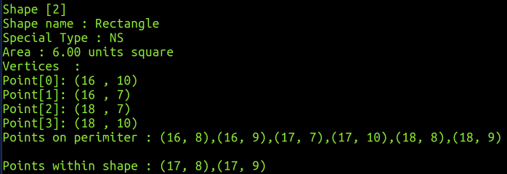

Test Case #2c – Points on Perimeter coordinates for ‘Rectangle’ computed & displayed correctly

- With references to your screen captures in Test Case #2a) / #2b), check your screen captures output to verify that data like ‘Points on Perimeter’ coordinates are computed and displayed correctly in your program (i.e. should be the same as those shown in Appendix A, Table B2)

- Update Excel file ‘CSCI251_A2_Checklist.xls’, select ‘Yes’ in column ‘C’, (for the row corresponding to Test Case #2c), if your program’s results are verified to be correct as described in step a)

Test Case #2d– Points within Shape coordinates for ‘Rectangle’ computed & displayed correctly

- With references to your screen captures in Test Case #2a) / #2b), check your screen captures output to verify that data like ‘Points within Shape’ coordinates are computed and displayed correctly in your program (i.e. should be the same as those shown in Appendix A, Table B2)

- Update Excel file ‘CSCI251_A2_Checklist.xls’, select ‘Yes’ in column ‘C’, (for the row corresponding to Test Case #2d), if your program’s results are verified to be correct as described in step a)

Test Case #3a – Input (sensor) data for ‘Circle’ displayed correctly

- Re-start your program, select ‘1) Input sensor data’

- Key in only the Circle data from Appendix A, Table C1

- Select ‘3) Print shapes report’

- Do as many screen captures as necessary, your program’s output

- Check your screen captures output to verify that data like ‘Name’, ‘Special Type’, 'Circle center' & 'Radius' are input and stored correctly in your program (i.e. should be the same as those shown in Appendix A, Table C1)

- Update Excel file ‘CSCI251_A2_Checklist.xls’, select ‘Yes’ in column ‘C’, (for the row corresponding to Test Case #3a), if your program’s results are verified to be correct as described in step e)

< Paste Screen Capture(s) below >

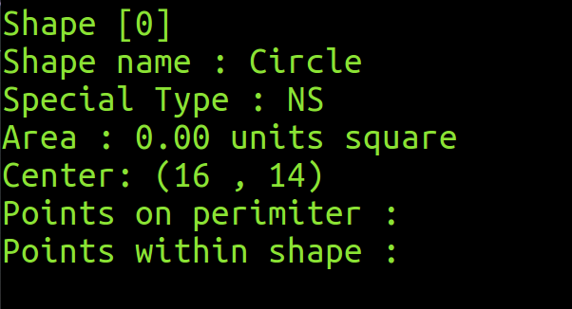

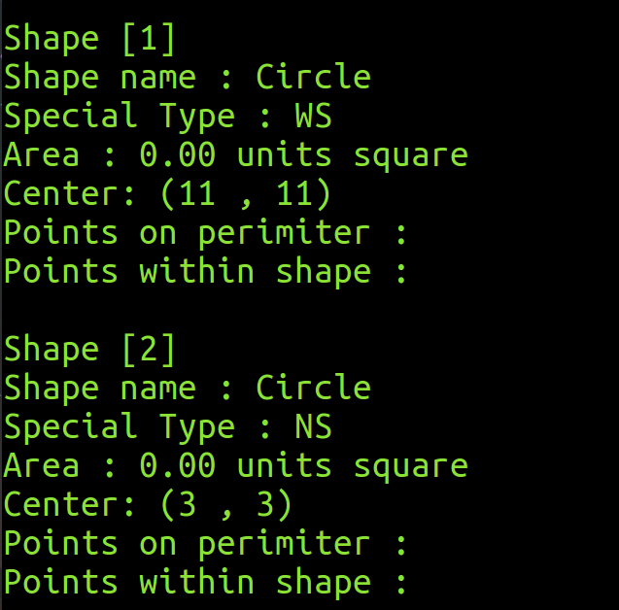

Test Case #3b – Area for ‘Circle’ computed & displayed correctly

- Select ‘2) Compute area (for all records)’

- Select ‘3) Print shapes report’

- Do as many screen captures as necessary, your program’s output

- Check your screen captures output to verify that data like ‘Area’ are computed and displayed correctly in your program (i.e. should be the same as those shown in Appendix A, Table C2)

- Update Excel file ‘CSCI251_A2_Checklist.xls’, select ‘Yes’ in column ‘C’, (for the row corresponding to Test Case #3b), if your program’s results are verified to be correct as described in step d)

< Paste Screen Capture(s) below >

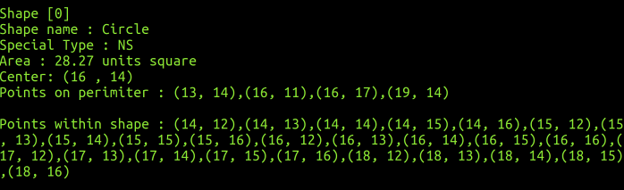

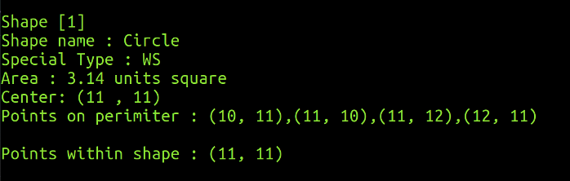

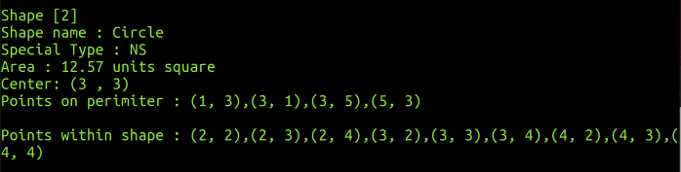

Test Case #3c – Points on Perimeter coordinates for ‘Circle’ computed & displayed correctly

- With references to your screen captures in Test Case #3a) / #3b), check your screen captures output to verify that data like ‘Points on Perimeter’ coordinates are computed and displayed correctly in your program (i.e. should be the same as those shown in Appendix A, Table C2)

- Update Excel file ‘CSCI251_A2_Checklist.xls’, select ‘Yes’ in column ‘C’, (for the row corresponding to Test Case #3c), if your program’s results are verified to be correct as described in step a)

Test Case #3d– Points within Shape coordinates for ‘Circle’ computed & displayed correctly

- With references to your screen captures in Test Case #3a) / #3b), check your screen captures output to verify that data like ‘Points within Shape’ coordinates are computed and displayed correctly in your program (i.e. should be the same as those shown in Appendix A, Table C2)

- Update Excel file ‘CSCI251_A2_Checklist.xls’, select ‘Yes’ in column ‘C’, (for the row corresponding to Test Case #3d), if your program’s results are verified to be correct as described in step a)

Test Case #4a – Input (sensor) data for ‘Cross’ displayed correctly

- Re-start your program, select ‘1) Input sensor data’

- Key in only the Cross data from Appendix A, Table D1

- Select ‘3) Print shapes report’

- Do as many screen captures as necessary, your program’s output

- Check your screen captures output to verify that data like ‘Name’, ‘Special Type’ & ‘Vertices’ are input and stored correctly in your program (i.e. should be the same as those shown in Appendix A, Table D1)

- Update Excel file ‘CSCI251_A2_Checklist.xls’, select ‘Yes’ in column ‘C’, (for the row corresponding to Test Case #4a), if your program’s results are verified to be correct as described in step e)

< Paste Screen Capture(s) below >

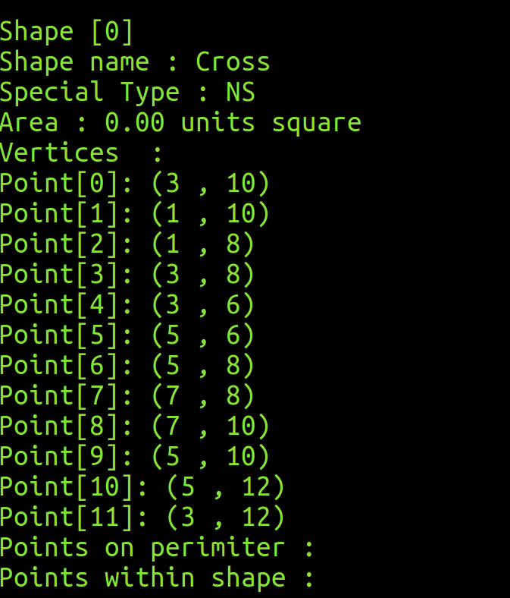

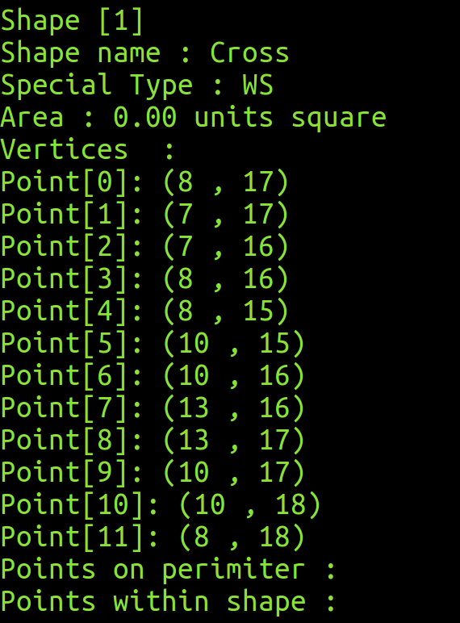

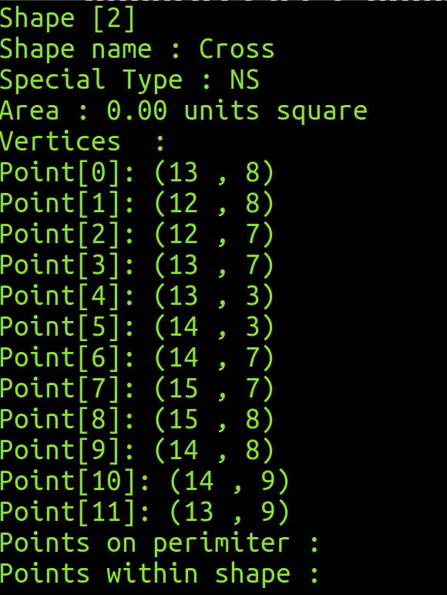

Test Case #4b – Area for ‘Cross’ computed & displayed correctly

- Select ‘2) Compute area (for all records)’

- Select ‘3) Print shapes report’

- Do as many screen captures as necessary, your program’s output

- Check your screen captures output to verify that data like ‘Area’ are computed and displayed correctly in your program (i.e. should be the same as those shown in Appendix A, Table D2)

- Update Excel file ‘CSCI251_A2_Checklist.xls’, select ‘Yes’ in column ‘C’, (for the row corresponding to Test Case #4b), if your program’s results are verified to be correct as described in step d)

< Paste Screen Capture(s) below >

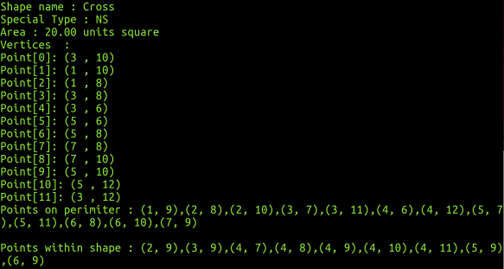

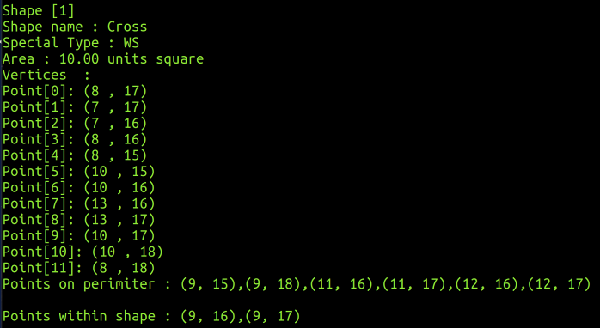

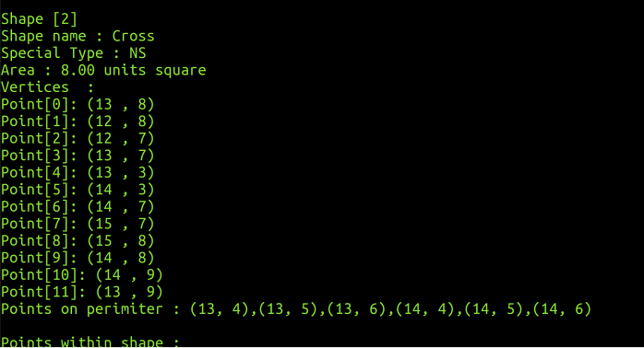

Test Case #4c – Points on Perimeter coordinates for ‘Cross’ computed & displayed correctly

- With references to your screen captures in Test Case #4a) / #4b), check your screen captures output to verify that data like ‘Points on Perimeter’ coordinates are computed and displayed correctly in your program (i.e. should be the same as those shown in Appendix A, Table D2)

- Update Excel file ‘CSCI251_A2_Checklist.xls’, select ‘Yes’ in column ‘C’, (for the row corresponding to Test Case #4c), if your program’s results are verified to be correct as described in step a)

Test Case #4d– Points within Shape coordinates for ‘Cross’ computed & displayed correctly

- With references to your screen captures in Test Case #4a) / #4b), check your screen captures output to verify that data like ‘Points within Shape’ coordinates are computed and displayed correctly in your program (i.e. should be the same as those shown in Appendix A, Table D2)

- Update Excel file ‘CSCI251_A2_Checklist.xls’, select ‘Yes’ in column ‘C’, (for the row corresponding to Test Case #4d), if your program’s results are verified to be correct as described in step a)

Note :

DO NOT END YOUR PROGRAM AFTER THIS TEST CASE !!

Re-key in the data for the earlier shapes (e.g. ‘Squares’, ‘Rectangle’, 'Circle' …) from the relevant Tables (A1, B1, C1 …) respectively

Test Case #5a– For ALL SHAPES. Sort by area (ASC) displayed correctly

- After all Shapes Data are entered, compute area for all of them again

- Select the ‘Sort by area (ASC)’ option

- Do as many screen captures as necessary, your program’s output

- Check your screen captures output to verify that data like ‘Name’, ‘Special Type’, ‘Area’ & ‘Vertices’ / (Circle center + Radius) of your shapes are sorted correctly (i.e. should be the same as those shown in Appendix B, Table 1)

- Update Excel file ‘CSCI251_A2_Checklist.xls’, select ‘Yes’ in column ‘C’, (for the row corresponding to Test Case #5a), if your program’s results are verified to be correct as described in step c)

< Paste Screen Capture(s) below >

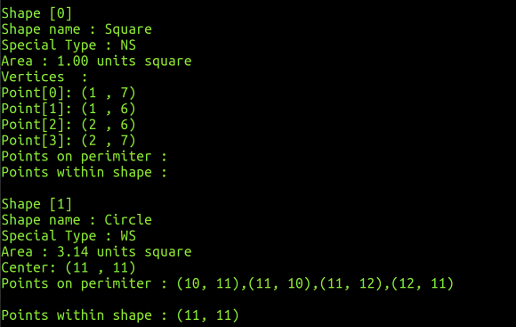

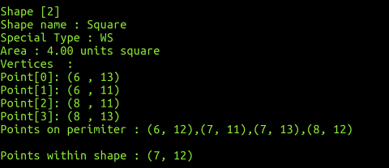

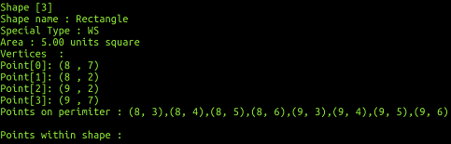

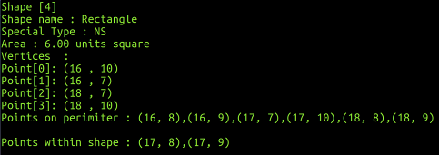

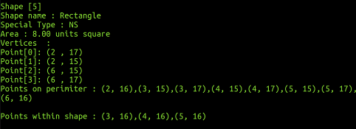

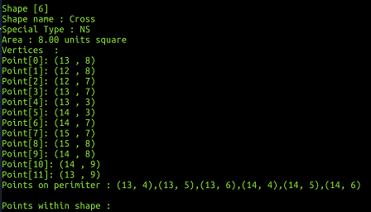

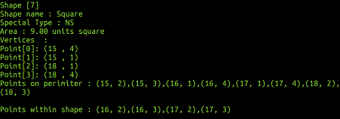

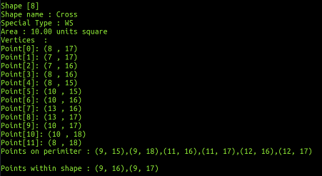

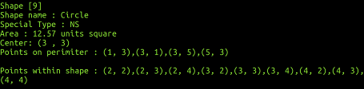

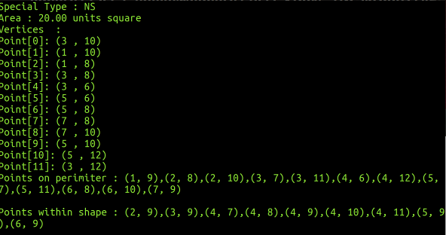

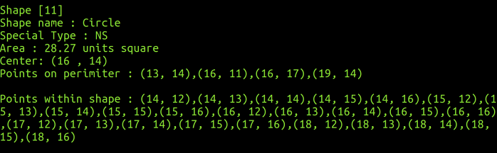

Test Case #5b– For ALL SHAPES. Sort by area (DSC) displayed correctly

- Assuming all Shapes Data are entered, select the ‘Sort by area (DSC)’ option

- Do as many screen captures as necessary, your program’s output

- Check your screen captures output to verify that data like ‘Name’, ‘Special Type’, ‘Area’ & ‘Vertices’ / (Circle center + Radius) of your shapes are sorted correctly (i.e. should be the same as those shown in Appendix B, Table 2)

- Update Excel file ‘CSCI251_A2_Checklist.xls’, select ‘Yes’ in column ‘C’, (for the row corresponding to Test Case #5b), if your program’s results are verified to be correct as described in step c)

< Paste Screen Capture(s) below >

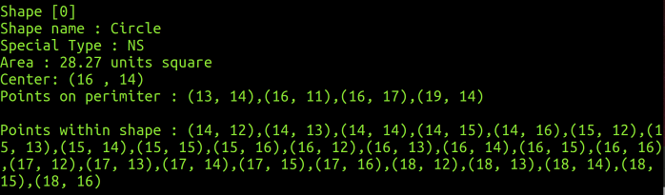

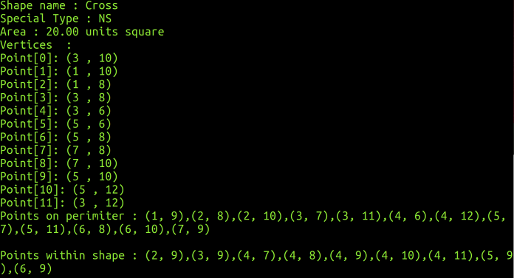

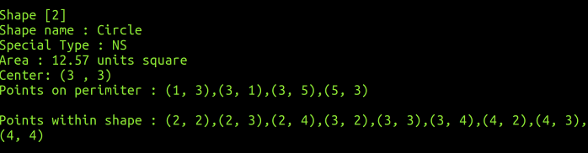

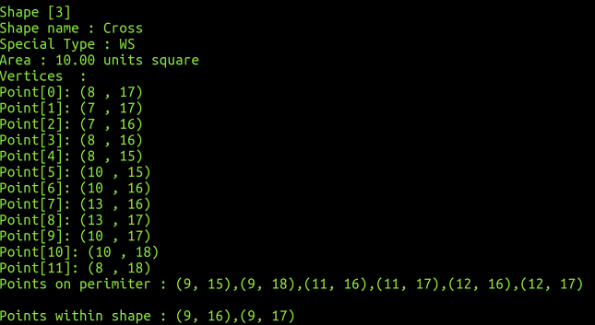

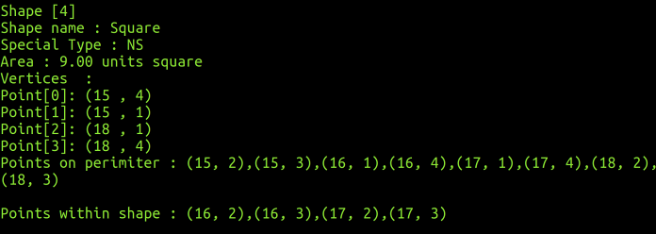

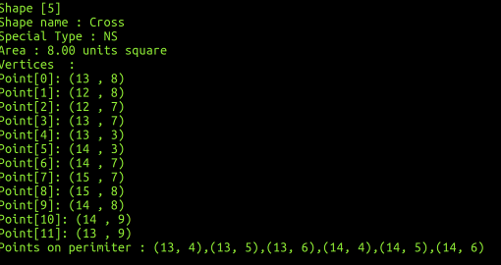

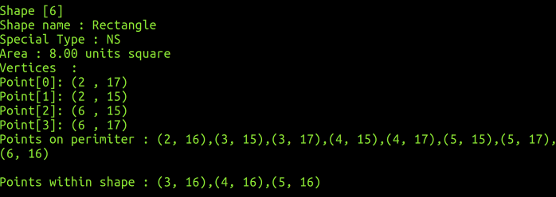

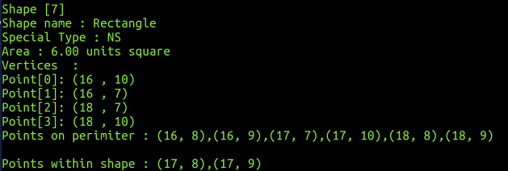

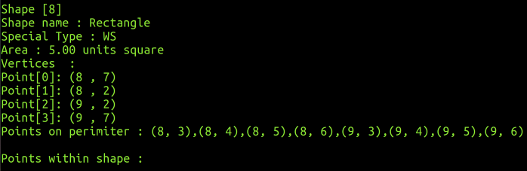

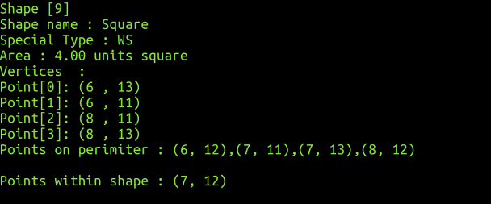

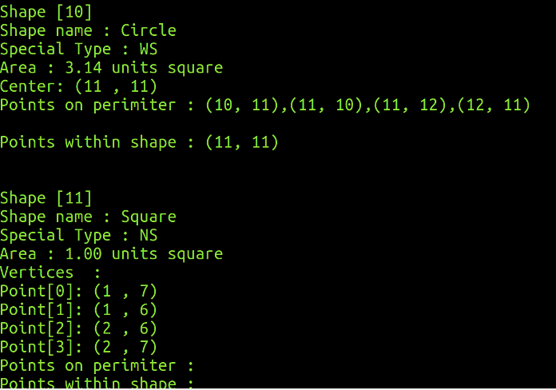

Test Case #5c– For ALL SHAPES. Sort by Special Type (DSC)
then by Area (DSC) displayed correctly

- Assuming all Shapes Data are entered, select the ‘Sort by Special Type and Area’ option

- Do as many screen captures as necessary, your program’s output

- Check your screen captures output to verify that data like ‘Name’, ‘Special Type’, ‘Area’ & ‘Vertices’ / (Circle center + Radius) of your shapes are sorted correctly (i.e. should be the same as those shown in Appendix B, Table 3)

- Update Excel file ‘CSCI251_A2_Checklist.xls’, select ‘Yes’ in column ‘C’, (for the row corresponding to Test Case #5c), if your program’s results are verified to be correct as described in step c)

< Paste Screen Capture(s) below >

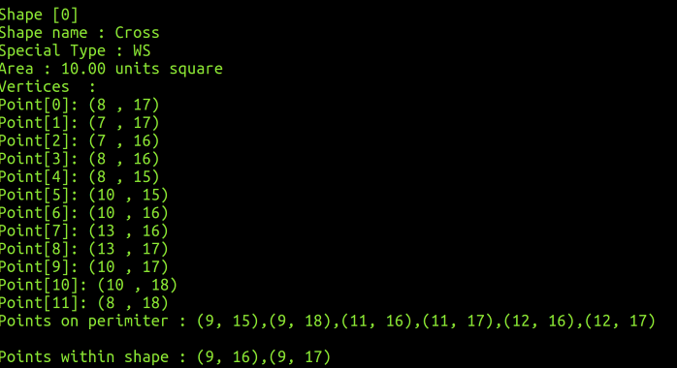

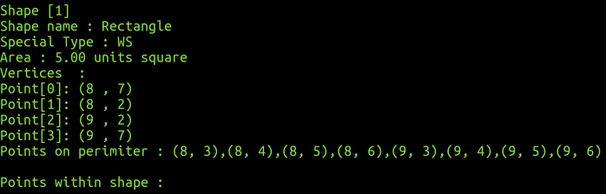

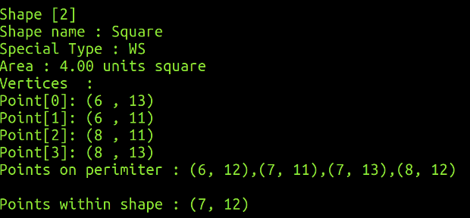

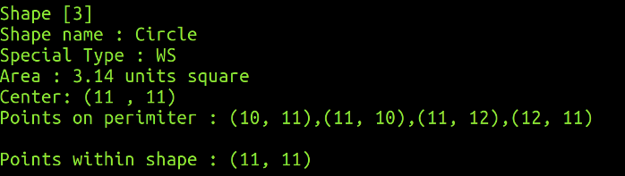

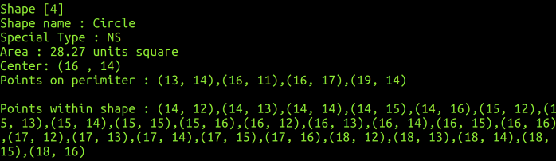

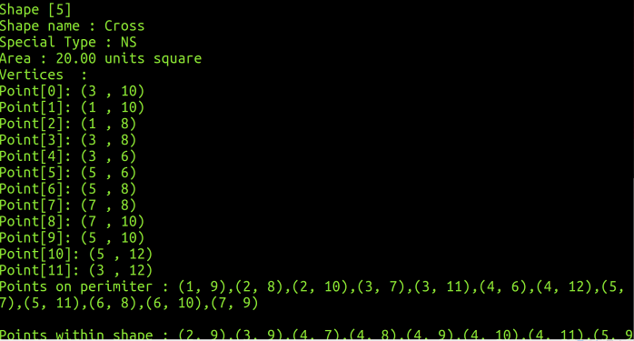

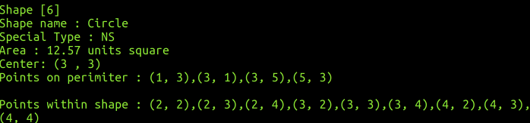

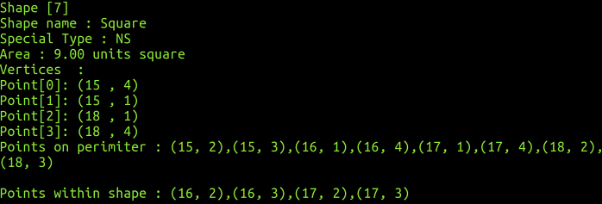

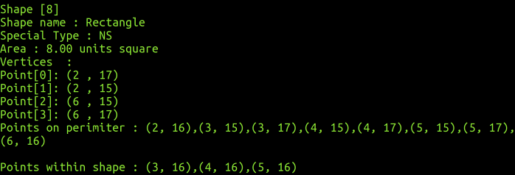

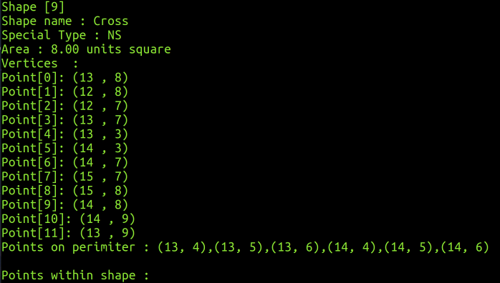

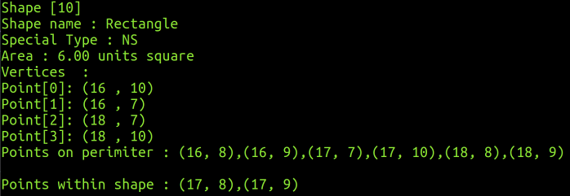

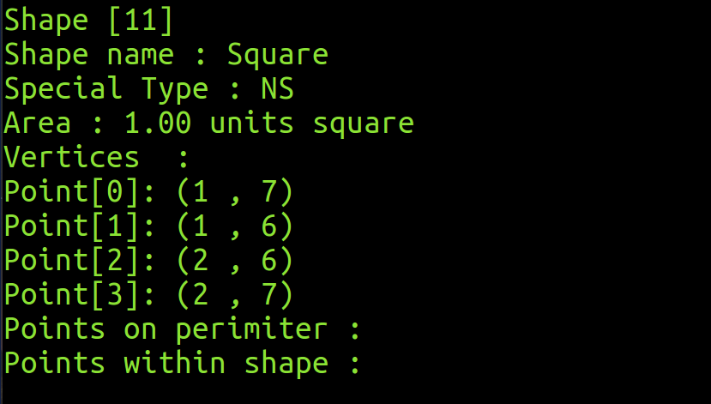

(Optional) Extra Feature / Functionality / Value Add

Description
(In the space below, type a short summary to describe the extra feature(s) implemented)

- If an incorrect shape name is entered, program will ask user to input the correct shape name
- If an incorrect warp space type is entered, program will ask user to input the correct warp space type
- Program will not generate duplicate in shape and on shape if user inputs compute area multiple times

< Paste Screen Capture(s) below >

(In the space below, use as many screen captures, MS Word arrows, textboxes, as necessary, to show that your extra feature(s) works!)

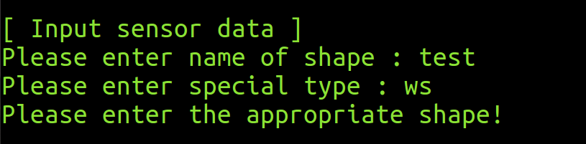

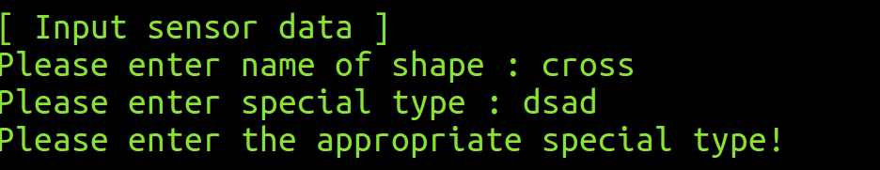

Appendix A

Table A1 – All Square’s Data

# | Shape | NS / WS | Vertex(s) Coordinates
1 | Square | NS | (1, 7), (1, 6), (2, 6), (2, 7)
2 | Square | WS | (6, 13), (6, 11), (8, 11), (8, 13)
3 | Square | NS | (15, 4), (15, 1), (18, 1), (18, 4)

Table A2 – All Square’s Area, Points On Perimeter & Points Within Shape info

# | Area (Unit²) | Points On Perimeter | Points Within Shape
1 | 1.00
2 | 4.00 | (6, 12), (7, 11), (8, 12), (7, 13) | (7, 12)
3 | 9.00 | (15, 3), (15, 2), (16, 1), (17, 1), (18, 2), (18, 3), (17, 4), (16, 4) | (16, 3), (16, 2), (17, 2), (17, 3)

Table B1 – All Rectangle’s Data

# | Shape | NS / WS | Vertex(s) Coordinates
1 | Rectangle | NS | (2, 17), (2, 15), (6, 15), (6, 17)
2 | Rectangle | WS | (8, 7), (8, 2), (9, 2), (9, 7)
3 | Rectangle | NS | (16, 10), (16, 7), (18, 7), (18, 10)

Table B2 – All Rectangle’s Area, Points On Perimeter & Points Within Shape info

# | Area (Unit²) | Points On Perimeter | Points Within Shape
1 | 8.00 | (2, 16), (3, 15), (4, 15), (5, 15), (6, 16), (5, 17), (4, 17), (3, 17) | (3, 16), (4, 16), (5, 16)
2 | 5.00 | (8, 6), (8, 5), (8, 4), (8, 3), (9, 3), (9, 4), (9, 5), (9, 6)
3 | 6.00 | (16, 9), (16, 8), (17, 7), (18, 8), (18, 9), (17, 10) | (17, 9), (17, 8)

Table C1 – All Circle’s Data

# | Shape | NS / WS | Center | Radius (units)
1 | Circle | NS | (16, 14) | 3
2 | Circle | WS | (11, 11) | 1
3 | Circle | NS | (3, 3) | 2

Table C2 – All Circle’s Area, Points On Perimeter & Points Within Shape info

# | Area (Unit²) | Points On Perimeter | Points Within Shape
1 | 28.27 | (13, 14), (16, 11), (19, 14), (16, 17) | (14, 12), (14, 13), (14, 14), (14, 15), (14, 16),  (15, 12), (15, 13), (15, 14), (15, 15), (15, 16),  (16, 12), (16, 13), (16, 14), (16, 15), (16, 16),  (17, 12), (17, 13), (17, 14), (17, 15), (17, 16),  (18, 12), (18, 13), (18, 14), (18, 15), (18, 16)
2 | 3.14 | (10, 11), (11, 10), (12, 11), (11, 12) | (11, 11)
3 | 12.57 | (1, 3), (3, 1), (5, 3), (3, 5) | (2, 2), (2, 3), (2, 4), (3, 2), (3, 3), (3, 4),  (4, 2), (4, 3), (4, 4)

Impt. Note :

For points within Circle shape, it is optional to display the center point [x, y] as highlighted in yellow.

However, all other "non-center" [x, y] values that falls within the circle's circumference, must still be displayed!

Table D1 – All Cross’s Data

# | Shape | NS / WS | Vertex(s) Coordinates
1 | Cross | NS | (3, 10), (1, 10), (1, 8), (3, 8), (3, 6), (5, 6), (5, 8), (7, 8), (7, 10), (5, 10), (5, 12), (3, 12)
2 | Cross | WS | (8, 17), (7, 17), (7, 16), (8, 16), (8, 15), (10, 15), (10, 16), (13, 16), (13, 17), (10, 17), (10, 18), (8, 18)
3 | Cross | NS | (13, 8), (12, 8), (12, 7), (13, 7), (13, 3), (14, 3), (14, 7), (15, 7), (15, 8), (14, 8), (14, 9), (13, 9)

Table D2 – All Cross’s Area, Points On Perimeter & Points Within Shape info

# | Area (Unit²) | Points On Perimeter | Points Within Shape
1 | 20.00 | (2, 10), (1, 9), (2, 8), (3, 7), (4, 6), (5, 7), (6, 8), (7, 9), (6, 10), (5, 11), (4, 12), (3, 11) | (2, 9), (3, 9), (4, 11), (4, 10), (4, 9), (4, 8), (4, 7), (5, 9), (6, 9)
2 | 10.00 | (9, 18), (9, 15), (11, 16), (12, 16), (12, 17), (11, 17) | (9, 17), (9, 16)
3 | 8.00 | (13, 6), (13, 5), (13, 4), (14, 4), (14, 5), (14, 6)

Appendix B
Table 1

Shape | NS / WS | Area (ASC) | Details
Square | NS | 1 | Vertices : (1, 7), (1, 6), (2, 6), (2, 7)
Circle | WS | 3.14 | Center : (11, 11), Radius : 1
Square | WS | 4 | Vertices : (6, 13), (6, 11), (8, 11), (8, 13)
Rectangle | WS | 5 | Vertices : (8, 7), (8, 2), (9, 2), (9, 7)
Rectangle | NS | 6 | Vertices : (16, 10), (16, 7), (18, 7), (18, 10)
Cross | NS | 8 | Vertices : (13, 8), (12, 8), (12, 7), (13, 7), (13, 3), (14, 3), (14, 7), (15, 7), (15, 8), (14, 8), (14, 9), (13, 9)
Rectangle | NS | 8 | Vertices : (2, 17), (2, 15), (6, 15), (6, 17)
Square | NS | 9 | Vertices : (15, 4), (15, 1), (18, 1), (18, 4)
Cross | WS | 10 | Vertices : (8, 17), (7, 17), (7, 16), (8, 16), (8, 15), (10, 15), (10, 16), (13, 16), (13, 17), (10, 17), (10, 18), (8, 18)
Circle | NS | 12.57 | Center : (3, 3), Radius : 2
Cross | NS | 20 | Vertices : (3, 10), (1, 10), (1, 8), (3, 8), (3, 6), (5, 6), (5, 8), (7, 8), (7, 10), (5, 10), (5, 12), (3, 12)
Circle | NS | 28.27 | Center : (16, 14), Radius : 3

Table 2

Shape | NS / WS | Area (DSC) | Details
Circle | NS | 28.27 | Center : (16, 14), Radius : 3
Cross | NS | 20 | Vertices : (3, 10), (1, 10), (1, 8), (3, 8), (3, 6), (5, 6), (5, 8), (7, 8), (7, 10), (5, 10), (5, 12), (3, 12)
Circle | NS | 12.57 | Center : (3, 3), Radius : 2
Cross | WS | 10 | Vertices : (8, 17), (7, 17), (7, 16), (8, 16), (8, 15), (10, 15), (10, 16), (13, 16), (13, 17), (10, 17), (10, 18), (8, 18)
Square | NS | 9 | Vertices : (15, 4), (15, 1), (18, 1), (18, 4)
Cross | NS | 8 | Vertices : (13, 8), (12, 8), (12, 7), (13, 7), (13, 3), (14, 3), (14, 7), (15, 7), (15, 8), (14, 8), (14, 9), (13, 9)
Rectangle | NS | 8 | Vertices : (2, 17), (2, 15), (6, 15), (6, 17)
Rectangle | NS | 6 | Vertices : (16, 10), (16, 7), (18, 7), (18, 10)
Rectangle | WS | 5 | Vertices : (8, 7), (8, 2), (9, 2), (9, 7)
Square | WS | 4 | Vertices : (6, 13), (6, 11), (8, 11), (8, 13)
Circle | WS | 3.14 | Center : (11, 11), Radius : 1
Square | NS | 1 | Vertices : (1, 7), (1, 6), (2, 6), (2, 7)

Table 3

Sort by Special Type and Area, DSC
Shape | NS / WS | Area | Details
Cross | WS | 10 | Vertices : (8, 17), (7, 17), (7, 16), (8, 16), (8, 15), (10, 15), (10, 16), (13, 16), (13, 17), (10, 17), (10, 18), (8, 18)
Rectangle | WS | 5 | Vertices : (8, 7), (8, 2), (9, 2), (9, 7)
Square | WS | 4 | Vertices : (6, 13), (6, 11), (8, 11), (8, 13)
Circle | WS | 3.14 | Center : (11, 11), Radius : 1
Circle | NS | 28.27 | Center : (16, 14), Radius : 3
Cross | NS | 20 | Vertices : (3, 10), (1, 10), (1, 8), (3, 8), (3, 6), (5, 6), (5, 8), (7, 8), (7, 10), (5, 10), (5, 12), (3, 12)
Circle | NS | 12.57 | Center : (3, 3), Radius : 2
Square | NS | 9 | Vertices : (15, 4), (15, 1), (18, 1), (18, 4)
Cross | NS | 8 | Vertices : (13, 8), (12, 8), (12, 7), (13, 7), (13, 3), (14, 3), (14, 7), (15, 7), (15, 8), (14, 8), (14, 9), (13, 9)
Rectangle | NS | 8 | Vertices : (2, 17), (2, 15), (6, 15), (6, 17)
Rectangle | NS | 6 | Vertices : (16, 10), (16, 7), (18, 7), (18, 10)
Square | NS | 1 | Vertices : (1, 7), (1, 6), (2, 6), (2, 7)

