**Hackathon Project: Identify Car Wash services**

**Framework Overview**

The given project is built using the following frameworks and libraries:

**Selenium:** Selenium is a popular open-source framework for automating web browsers.

**TestNG:** TestNG is a testing framework that provides advanced features like parallel test execution, data-driven testing, and test configuration through annotations.

**Cucumber:** Cucumber is a tool for behaviour-driven development (BDD)that allows you to write test scenarios in a human-readable format.

**Apache POI:** Apache POI is a library for working with Microsoft Office documents, including Excel files.

**Extent Reports:** Extent Reports is a powerful reporting library used for generating HTML reports in testing automation frameworks.

**Folder Structure:**

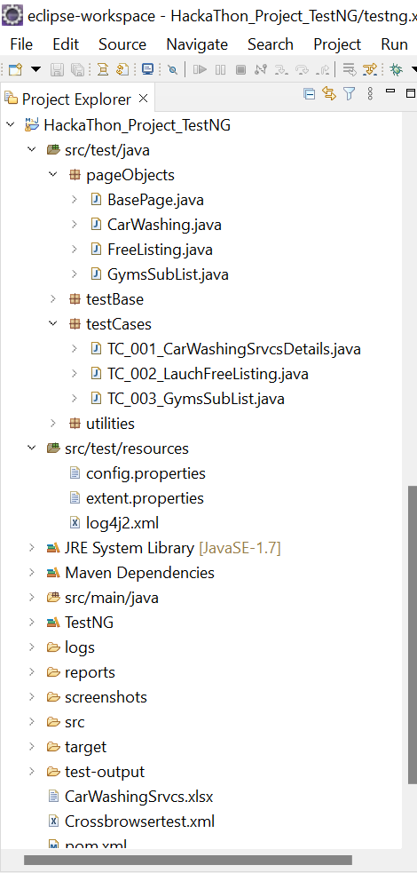

**To run the project, follow these steps:**

1. Download the Zip file and extract it to your local drive:
   * Download the project Zip file to your system.
   * Extract the contents of the Zip folder to your desired location on your system, preferably in the Local (C) drive.
2. Open Eclipse and import the project as a Maven project:
   * Launch Eclipse IDE on your system.
   * Go to "File" > "Import" > "Existing Maven Projects".
   * Browse to the location where you extracted the project and select the project folder.
   * Click "Finish" to import the project into Eclipse.
3. Update the project by saving the pom.xml file:
   * Locate the pom.xml file in the project structure.
   * Open the pom.xml file in Eclipse.
   * Press "Ctrl + S" to save the file.
   * This will update the project and download any required dependencies.
4. Install the TestNG plugin from the Eclipse Marketplace:
   * Open Eclipse IDE.
   * Go to "Help" > "Eclipse Marketplace".
   * Search for "TestNG" in the Marketplace search bar.
   * Find the TestNG Eclipse plugin and click "Go" or "Install".
   * Follow the installation instructions to install the plugin.
   * Restart Eclipse if prompted.
5. Run the project as a TestNG test:
   * Locate the TestNG.xml file in the project structure.
   * Open the TestNG.xml file in Eclipse.
   * Right-click within the file and select "Run As" > "TestNG Suite".
   * This will start the execution of the project using TestNG.

By following these steps, assuming you have already installed the TestNG plugin from the Eclipse Marketplace, you should be able to run the project successfully using TestNG.