**LAB # 3**

**OBJECT: To learn RMI basics: Generate the stubs and skeletons and run client and server.**

**TASK 1 : Create RMI program in which server performs basic arithmetic operations.**

**Program :-**

**Add.java**

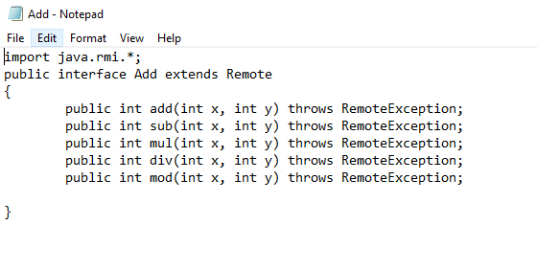

**AddImpl.java**

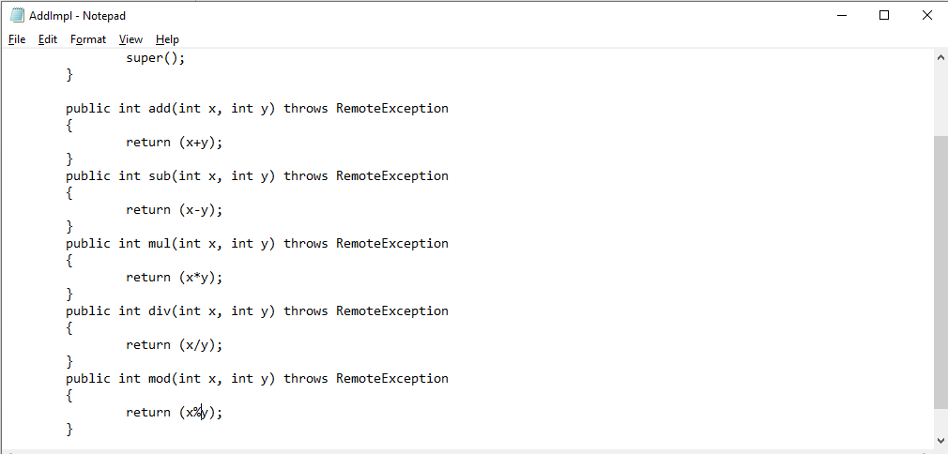

**RMISever.java**

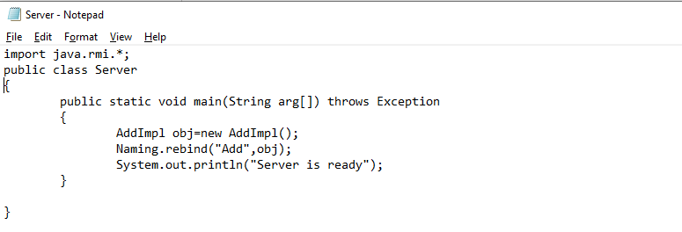

**RMIClient.java**

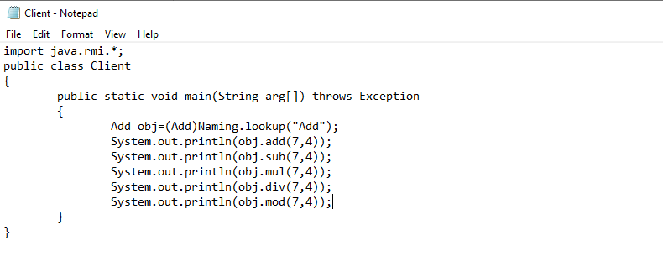

**OUTPUT :**

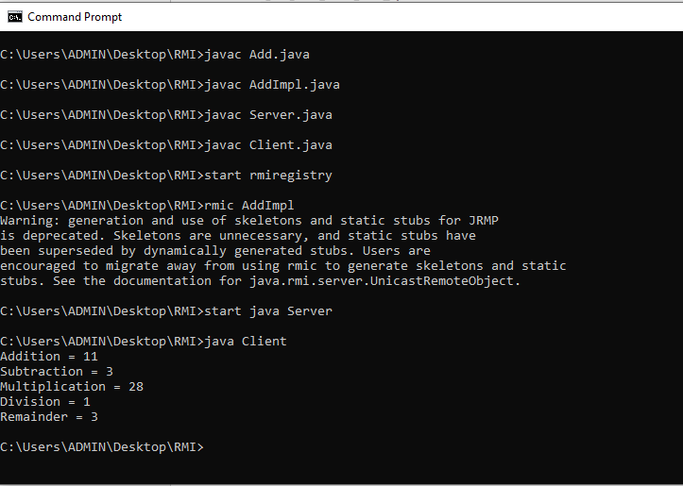

**TASK 2 : Create RMI program in which server sorts the numbers in ascending order.**

**Program :**

**Sort.java**

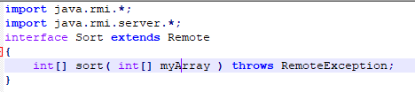

**SortImpl.java**

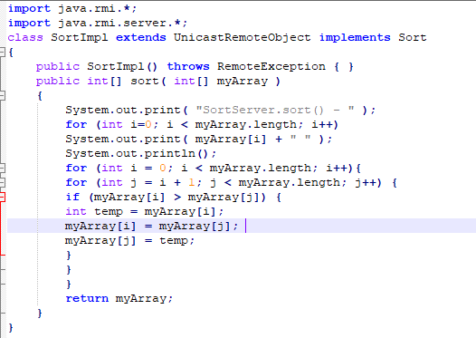

**SortServer.java**

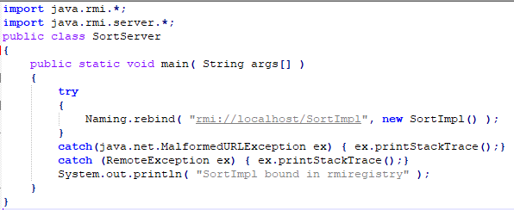

**SortClient.java**

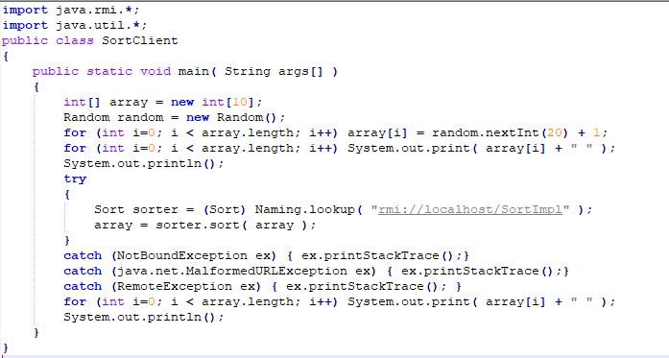

**OUTPUT :**

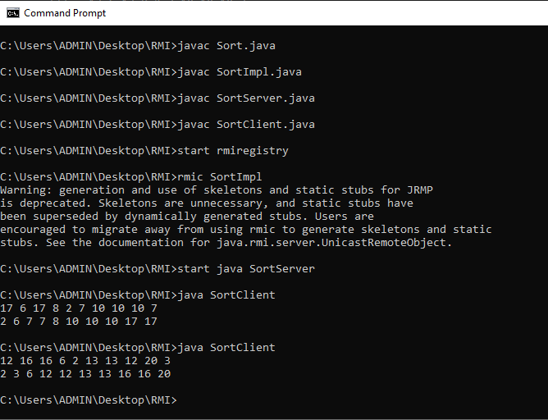

**TASK 3: (Optional Task) Write an RMI program to implement the Map/Reduce concept of Hadoop on the server program. In other words the client program asks user to provide multiple sentences and send to server, server sends back the word counts.**

**WordCount.java**

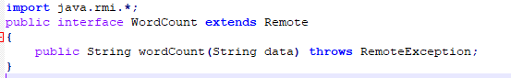

**WordCountImpl.java**

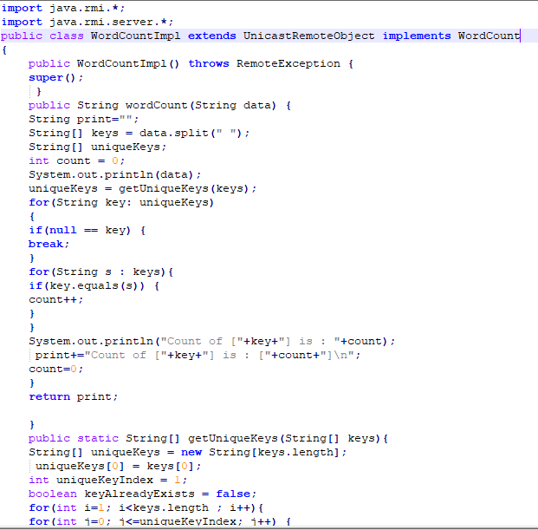

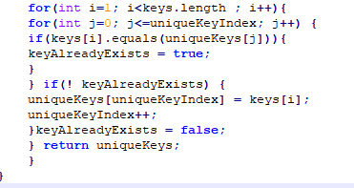

**WordCountServer.java**

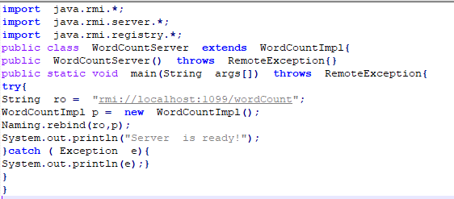

**WordCountClient.java**

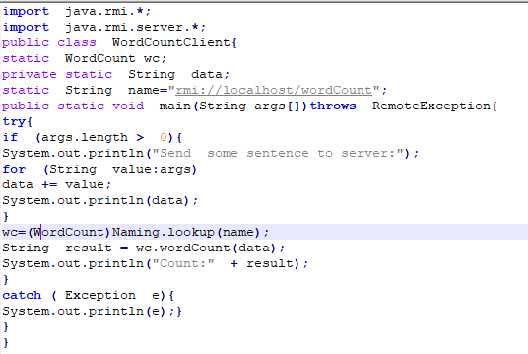

**OUTPUT :**

