LAB # 8
TASK: 01
Create an XML document structuring information for a store. (Shopping store of your choice)

<?xml version="1.0" encoding="ISO-8859-1" ?>
<store>
<name>Super Store Online </name>
<openDate>01-04-2010</openDate>
<closeDate>23-03-2018</closeDate>
<product>
<name>Rice</name>
<magDate>20-03-2018</magDate>
<expDate>23-9-2019</expDate>
<price>2000</price>
</product>
<employee>
<name>Munwar</name>
<address>C-17 phase 02 Qasimabad Hyderabad</address>
<salary>20000</salary>
</employee>
</store>

TASK:02

Create DTD for store XML Document. And validate on http://www.w3schools.com/xml/xml_validator.asp

DTD: (Validation)
<?xml version="1.0" encoding="ISO-8859-1" ?>
<!DOCTYPE store
[
<!ELEMENT store (name,openDate,closeDate,porduct,employee)>
<!ELEMENT name (#PCDATA)>
<!ELEMENT openDate (#PCDATA)>
<!ELEMENT closeDate (#PCDATA)>
<!ELEMENT porduct (name,magDate,expDate,price)>
<!ELEMENT name (#PCDATA)>
<!ELEMENT magDate (#PCDATA)>
<!ELEMENT expDate (#PCDATA)>
<!ELEMENT price (#PCDATA)>
<!ELEMENT employee (name,address,salary)>
<!ELEMENT name (#PCDATA)>
<!ELEMENT address (#PCDATA)>
<!ELEMENT salary (#PCDATA)>
]>

<store>
<name>Super Store Online </name>
<openDate>01-04-2010</openDate>
<closeDate>23-03-2018</closeDate>
<product>
<name>Rice</name>
<magDate>20-03-2018</magDate>
<expDate>23-9-2019</expDate>
<price>2000</price>
</product>
<employee>
<name>Munwar</name>
<address>C-17 phase 02 Qasimabad Hyderabad</address>
<salary>20000</salary>
</employee>
</store>

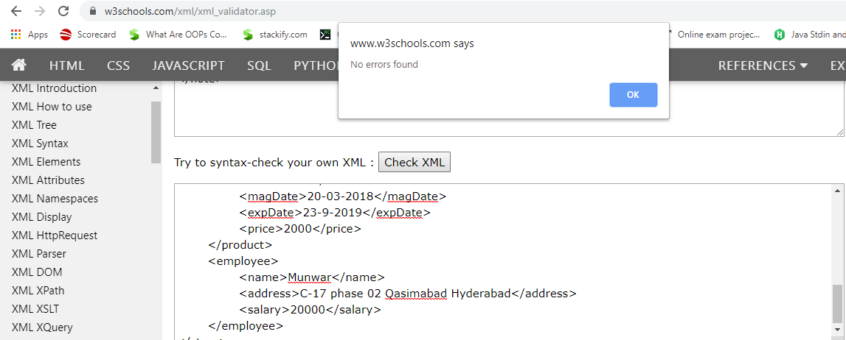

TASK:03

Write XML Schema for the following XML document and then validate the XML document along with its schema on the following website:
http://www.utilities-online.info/xsdvalidation/#.UlFx2tKmhIg

<?xml version="1.0" encoding="ISO-8859-1" ?>
<xs:schema attributeFormDefault="unqualified" elementFormDefault="qualified" xmlns:xs="http://www.w3.org/2001/XMLSchema">

<xs:element name="store">
<xs:complexType>
<xs:sequence>
<xs:element type="xs:String" name="name"/>
<xs:element type="xs:Date" name="openDate"/>
<xs:element type="xs:Date" name="closeDate"/>
<xs:element name="product">
<xs:complexType>
<xs:sequence>
<xs:element type="xs:String" name="name"/>
<xs:element type="xs:Date" name="magDate"/>
<xs:element type="xs:Date" name="expDate"/>
<xs:element type="xs:float" name="price"/>
</xs:sequence>
</xs:complexType>
</xs:element>
<xs:element name="employee">
<xs:complexType>
<xs:sequence>
<xs:element type="xs:String" name="name"/>
<xs:element type="xs:String" name="address"/>
<xs:element type="xs:float" name="salary"/>
</xs:sequence>
</xs:complexType>
</xs:element>
</xs:sequence>
</xs:complexType>
</xs:element>
</xs:schema>

<store>
<name>Super Store Online </name>
<openDate>01-04-2010</openDate>
<closeDate>23-03-2018</closeDate>
<product>
<name>Rice</name>
<magDate>20-03-2018</magDate>
<expDate>23-9-2019</expDate>
<price>2000</price>
</product>
<employee>
<name>Munwar</name>
<address>C-17 phase 02 Qasimabad Hyderabad</address>
<salary>20000</salary>
</employee>
</store>

