EDISON Data Science Model Curriculum Addendum

EDSF 2020 Release 4 (EDSF2020)

**Extended Bloom's taxonomy consolidated presentation of learning levels, action verbs, and associated learning instruments**

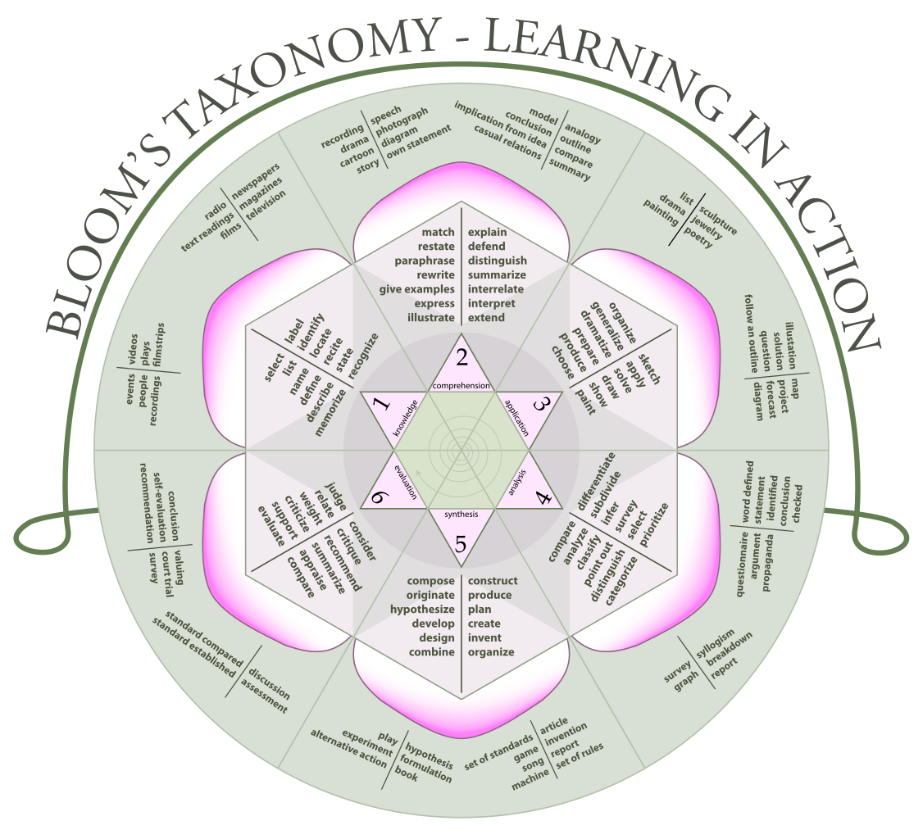

[ref] <https://en.wikipedia.org/wiki/Bloom%27s_taxonomy>

|  |  |  |
| --- | --- | --- |
| **Mapping to 3 levels LO by Knowledge levels (compliant to ACM CSC 2013)**  **and key verbs** | | |
| **Familiarity** | **Usage** | **Assessment** |
| Choose, Classify, Collect, Compare, Configure, Contrast, Define, Demonstrate, Describe, Execute, Explain, Find, Identify, Illustrate, Label, List, Match, Name, Omit, Operate, Outline, Recall, Rephrase, Show, Summarize, Tell, Translate | Apply, Analyze, Build, Construct, Develop, Examine, Experiment with, Identify, Infer, Inspect, Model, Motivate, Organize, Select, Simplify, Solve, Survey, Test for, Visualize | Adapt, Assess, Change, Combine, Compile, Compose, Conclude, Criticize, Create, Decide, Deduct, Defend, Design, Discuss, Determine, Disprove, Evaluate, Imagine, Improve, Influence, Invent, Judge, Justify, Optimize, Plan, Predict, Prioritize, Prove, Rate, Recommend, Solve |

**Simple Bloom's taxonomy: Learning levels and action verbs.**

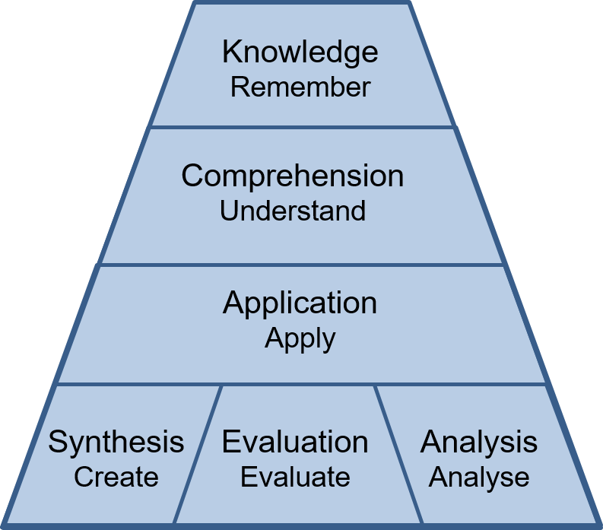

**Knowledge**

Exhibit memory of previously learned materials by recalling facts, terms, basic concepts and answers

Knowledge of specifics - terminology, specific facts

Knowledge of ways and means of dealing with specifics - conventions, trends and sequences, classifications and categories, criteria, methodology

Knowledge of the universals and abstractions in a field - principles and generalizations, theories and structures

**Questions like[1]:** What are the main benefits of implementing Big Data and data analytics methods for organisation?

Questions like: What are the main benefits of outsourcing company’s IT services to cloud?

**Comprehension**

Demonstrate understanding of facts and ideas by organizing, comparing, translating, interpreting, describing, and stating the main ideas

Translation, Interpretation, Extrapolation

**Questions like:** Compare the quantitative analytics methods and qualitative analytics methods.

Questions like: Compare the business and operational models of private clouds and hybrid clouds.

**Application**

Using new knowledge. Solve problems in new situations by applying acquired knowledge, facts, techniques and rules in a different way

**Questions like:** What data analytics methods should be applied for specific data types analysis or for specific business processes and activities. Which Big Data services architecture is best suited for medium size organisation, and why?

Questions like: Which cloud service model is best suited for medium size software development company, and why?

**Analysis**

Examine and break information into parts by identifying motives or causes. Make inferences and find evidence to support generalizations

Analysis of elements, relationships, organizational principles

**Questions like:** What data analytics methods and services are required to support typical business processes of a web trading company? Give suggestions how these services can be implemented with the selected data analytics platform, including on-premises or outsourced to cloud. Provide references to support your statements.

Questions like: What cloud services are needed to support typical business processes of a web trading company, give suggestions how these services can be implemented with PaaS or IaaS clouds? Provide references to support your statements.

**Synthesis**

Compile information together in a different way by combining elements in a new pattern or proposing alternative solutions

Production of a unique communication, a plan, or proposed set of operations, derivation of a set of abstract relations

**Questions like:** Describe the main steps and tasks for implementing data analytics and data management services for an example company or research organisation? What services and data analytics can be moved to clouds and which will remain at the enterprise premises and run by company’s personnel?

Questions like: Describe the main steps and tasks for migrating IT services of an example company to clouds, what services and data can be moved to clouds and which will remain at the enterprise premises.

**Evaluation**

Present and defend opinions by making judgments about information, validity of ideas or quality of work based on a set of criteria

Judgments in terms of internal evidence or external criteria

**Questions like:** Do you think that implementing Agile Data Driven Enterprise model creates benefits for enterprises, short term and long term?

Questions like: Do you think that cloudification of the enterprise infrastructure creates benefits for enterprises, short term and long term?

1. Note, Examples are given for (1) Data Science and Analytics curriculum, and for (2) Cloud Computing Engineering curriculum