CprE 381: Computer Organization and Assembly-Level Programming

Project Part 1 Report

Team Members: ________Alek Norris ___________

________ Drew Kearns ___________________

______________________________________________

Project Teams Group #:_____Term Proj1_2_07___________________

Refer to the highlighted language in the project 1 instruction for the context of the following questions.

[Part 1 (d)] Include your final MIPS processor schematic in your lab report.

TODO:

[Part 2 (a.i)] Create a spreadsheet detailing the list of M instructions to be supported in your project alongside their binary opcodes and funct fields, if applicable. Create a separate column for each binary bit. Inside this spreadsheet, create a new column for the N control signals needed by your datapath implementation. The end result should be an N*M table where each row corresponds to the output of the control logic module for a given instruction.

[Part 2 (a.ii)] Implement the control logic module using whatever method and coding style you prefer. Create a testbench to test this module individually and show that your output matches the expected control signals from problem 1(a).
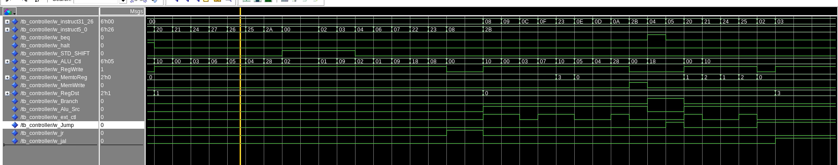
For this part to verify everything was working, I just simply set up a test bench to push every single instruction code, in the image you can see the first half using changing in instructions [5:0] or the funct field for R types. For he second half using changing in instructions corresponding to [31:26] or the opcode for I and J type instructions. I then went through and verified I was seeing the correct output on each line for our excel sheet.

[Part 2 (b.i)] What are the control flow possibilities that your instruction fetch logic must support? Describe these possibilities as a function of the different control flow-related instructions you are required to implement.

TODO

[Part 2 (b.ii)] Draw a schematic for the instruction fetch logic and any other datapath modifications needed for control flow instructions. What additional control signals are needed?

TODO

[Part 2 (b.iii)] Implement your new instruction fetch logic using VHDL. Use QuestaSim to test your design thoroughly to make sure it is working as expected. Describe how the execution of the control flow possibilities corresponds to the QuestaSim waveforms in your writeup.

TODO

[Part 2 (c.i.1)] Describe the difference between logical (srl) and arithmetic (sra) shifts. Why does MIPS not have a sla instruction?
The difference between logical (SRL) and arithmetic (SRA) right shifts lies in how the vacated positions are filled. In a logical shift right (SRL), the vacated positions are padded with zeros. Conversely, in an arithmetic shift right (SRA), the vacated positions are filled with the value of the most significant bit (MSB) to preserve the sign of the original number; this means if the MSB is 1 (indicating a negative number in two's complement), the shift operation pads with 1s. MIPS does not include a Shift Left Arithmetic (SLA) instruction primarily because arithmetic left shifts do not require sign bit management—left shifts by their nature multiply the number by two for each shift position, preserving the sign. Furthermore, adding an SLA instruction would complicate the instruction set without offering a significant benefit, as the logical shift left operation (SLL) already achieves the desired outcome without altering the number's sign.

[Part 2 (c.i.2)] In your writeup, briefly describe how your VHDL code implements both the arithmetic and logical shifting operations.

It utilizes a hierarchical structure of 2-to-1 multiplexers (muxes) organized into five stages, each stage doubling the shifting ability from 1-bit shifts up to 16-bit shifts, allowing for shift amounts ranging from 0 to 31 bits. The type of shift (logical or arithmetic) is determined by a shift type signal, and the amount of shift is controlled by a 5-bit shift amount input. This design efficiently achieves variable bit shifting by selecting the appropriate path through the muxes based on the shift amount, with the fill bit for arithmetic shifts dynamically determined by the input's most significant bit (MSB).

[Part 2 (c.i.3)] In your writeup, explain how the right barrel shifter above can be enhanced to also support left shifting operations.

To make a right barrel shifter work both ways, we add a simple trick: flipping the bits around before and after shifting. There's a new input called "shift direction" that lets us choose which way to shift. If we want to shift right, it just does its normal thing. But if we want to shift left, it first flips all the bits around, does a normal right shift, and then flips the bits back. This way, we end up with a shifter that can go both left and right.

[Part 2 (c.i.4)] Describe how the execution of the different shifting operations corresponds to the QuestaSim waveforms in your writeup.
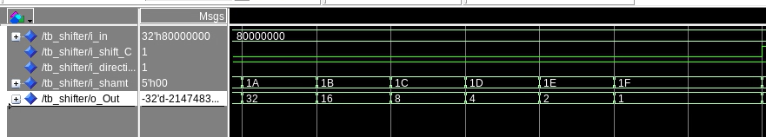
You can see here that when direction is 1(right) and the Control bit (logical), is set to 0 the the value decreases by dividing by 2 each time, until we get to 0. This is expected.

Here you can see that when the direction is set to 0, and the shift type is set to 1(logical), a normal bit shift occures, shifting the bit to the left by 1 place, effectivly doubling the value at every shift, the opposite of the above example.
In this example you can the right shift at work with the control bit set to 1 for arithmetic, in this setting the shifter adds a bit to the msb slot and removes one from the lsb slot each time. When adding bits, because a 1 is set in the msb at start, the shifter adds a 1 bit every time.

[Part 2 (c.ii.1)] In your writeup, briefly describe your design approach, including any resources you used to choose or implement the design. Include at least one design decision you had to make.
The Design approach we took was to first figure out what all the major things we needed to finish the design were. We then broke them down into smaller parts such as the ALU, control, Fetch logic, and register. Anything outside these were considered extra things needing to be implemented on the overall processor design.
We then go to work making and testing the individual parts separately with testing, and building up to throwing it all together. Once thrown together we were able to start running some real test benches with the provided tests and verify what we had working and what we didn’t have working. The following is a list of additional things we needed to implement.

Mux4t1_N, Mux8t1_N,Nor_N,Or_N,Xor_N,And_N, mux32t1, ByteDecoder, and WordDecoder … as well as I’m sure there’s some missing.

One of the design choices we decided to make was implementing a ByteDecoder, and a WordDecoder, these both work similarly, but do different things. Because of once everything was assembled, and all the basic ALU components passed their test, as well as LW, we needed a way to be able to implement a Lb, lbu, lh, and lhu. After looking at the outputs it became clear the we had the right chunk of memory, but not the right piece we were looking for, and because we knew that out CPU was word addressable there must be another way, outside of the ALU and DMEM to get the desired output. So that’s why we came up with these decoders. These decodes sit just between the mux used for Mux2reg(mux4 in our design) and the DMEM. These decoders then, in parallel hook up to the dmem and the alu output, and then into the mux4t1_N we implemented. Then depending on a ctl signal from the controller, pics between the decoders or the regular outputs etc. if Byte decoder is selected, it pulls off the desired byte, with offset. Then pads depending on the MSB and an ext type control signal. The word decoder works the same, but instead of having 4 offset possibilities, it only has 2. It also relies on bit (1) of the alu out to determine the shift amount, while the byte decoder relies on bits [1:0]

[Part 2 (c.ii.2)] Describe how the execution of the different operations corresponds to the QuestaSim waveforms in your writeup.
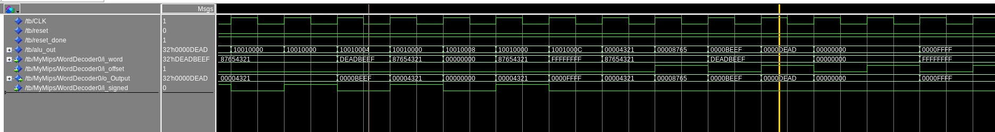
Showing the word decoder, as it’s easiest to see, you can see here in the test, at the two yellow vertical lines, when the offset is 1, we pull the upper 16 bits, and when the offset is 0, we pull the lower 16 bits, if you look anywhere actually, when the offset is zero, you can see the lower 16 bits are places. The testing for this used the given test benches by the students. The reason for not designing our own was because we needed it to a specific job, and we knew all the logic coming up to it was good, so what better way than to use our resources and use the given ones. With these docoders implemented, all lb, and lh, lhu instructions work.

[Part 2 (c.iii)] Draw a simplified, high-level schematic for the 32-bit ALU. Consider the following questions: how is Overflow calculated? How is Zero calculated? How is slt implemented?

TODO

[Part 2 (c.v)] Describe how the execution of the different operations corresponds to the QuestaSim waveforms in your writeup.

TODO

[Part 2 (c.viii)] justify why your test plan is comprehensive. Include waveforms that demonstrate your test programs functioning.

[Part 3] In your writeup, show the QuestaSim output for each of the following tests, and provide a discussion of result correctness. It may be helpful to also annotate the waveforms directly.

[Part 3 (a)] Create a test application that makes use of every required arithmetic/logical instruction at least once. The application need not perform any particularly useful task, but it should demonstrate the full functionality of the processor (e.g., sequences of many instructions executed sequentially, 1 per cycle while data written into registers can be effectively retrieved and used by later instructions). Name this file Proj1_base_test.s.

[Part 3 (b)] Create and test an application which uses each of the required control-flow instructions and has a call depth of at least 5 (i.e., the number of activation records on the stack is at least 4). Name this file Proj1_cf_test.s.

[Part 3 (c)] Create and test an application that sorts an array with N elements using the BubbleSort algorithm (link). Name this file Proj1_bubblesort.s.

[Part 4] Report the maximum frequency your processor can run at and determine what your critical path is. Draw this critical path on top of your top-level schematic from part 1. What components would you focus on to improve the frequency?

