QBUS2820 – Predictive Analytics

*Assignment 1*

490473041

Task A – Moneyball

# Introduction

While machine learning continues to empower us with insights, it are these methods of interest that we engage in, to produce predictive analytics for areas of research such as NBA salaries. This is an area of key concern given that these findings can assist in addressing financial constraints such as the NBA salary cap, where the increasing earnings gap between players has left many questions, such as, what are determinants to NBA player salaries and how to optimise team performance while being constrained financially (Academy, 2020).

Currently, players are chosen on the basis of numerous metrics that are specific to that player and thus, through evaluating strengths and weaknesses in these metrics, teams can be optimised for the best performance. This process is relatively time and cost intensive and made more difficult with the need to keep in consideration the NBA salary cap (Academy, 2020). Hence, through utilising predictive analytics to produce models that will output an NBA salary based on these metrics, this should ease the selection process through greater efficiency, and offer a potentially more reliable means to determining a player’s worth that is fair and consistent.

Overall, three different model types were constructed, and their effectiveness varied in being able to predict player salaries. All managed to achieve above target for their expected performance and are thus, valuable as means to further understanding NBA salary cap management based on player metrics. Although, these pose promising results, there are potential limitations that should be taken into consideration when drawing conclusions from the models.

Therefore, given that the process to best optimise team performance is heavily data driven in itself, these modelling methods definitely open new opportunities for NBA teams.

# Exploratory Data Analysis

Insight into the training and test dataset, and it is noticed that these are relatively small both sharing the same column and row dimensions.

Train dataset has 126 rows and 22 columns.

Test dataset has 127 rows and 22 columns.

(figure 1)

Examining into whether NA values would be a problem gave that with none being present it would not be an issue of concern. This should effectively ease the analytical process with less cleaning required.

There are 0 columns in train dataset with missing values.

(figure 2)

Identifying the datatypes of each column, it would be appropriate to create dummy variable columns for the categorical type data. This would involve modifying the columns "POSITION" and "TEAM" to be dummy variables. This will be applied after an individual inspection of each of the variables in feature engineering. (view full output in appendix i)

Train_ID int64

SALARY float64

POSITION object

TEAM object

Age int64

Games int64

Minutes int64

PER float64

…

(figure 3 - view full output in appendix i)

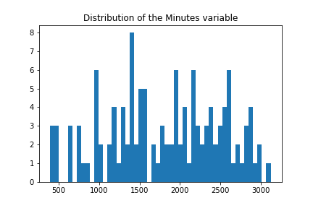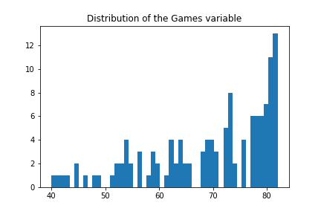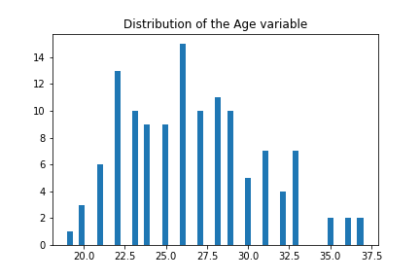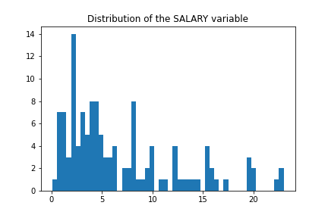Before identifying the most ideal features through a correlation heatmap feature engineering, we will first delve into each of the variables to ensure that the data having been inputted is logically consistent i.e. values correspond logically with the variable.

(figure 4 – refer to all other plots in appendix ii)

While everything seems logically consistent for all the variables, "SALARY" appears to have some values close to 0. We should examine this further to ensure no unreasonably low figures were inputted to give unrepresentative results.

count 126.0000

mean 6.7842

std 5.6480

min 0.1114

…

(figure 5)

Given that the lowest salary given was about $111k, we can appropriately conclude that the values are not unrealistically low.

Using an IQR approach to identify outliers, these should be noted.

(figure 6)

Overall, referring to the distribution visualisations, all the variables seem fairly reasonable with no illogical values e.g. negative salaries. The outlier diagnostic successfully identified 26 outliers. Any of the observations that are highlighted with a red background above has been identified as an outlier at the higher end of the distribution of the observation's feature. A yellow shade would indicate an outlier toward the lower end however none are present.

# Feature Engineering

First, we will add the dummy columns before commencing an inspection into correlations with salary for feature engineering.

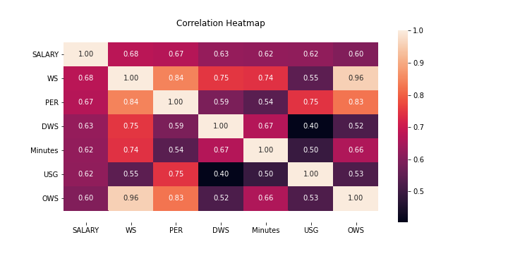Producing a correlation heatmap we should be able to derive some insights into features that would produce the most optimal model. First the data frame containing the correlations will be simplified to display the most relevant features to be considered in analysis. This would mean removing rows correlating to "SALARY" that are lower than 0.4.

(figure 7)

Considering the above correlation heatmap, a relatively high positive correlation with "SALARY" is seen associated with features "WS", "PER", "DWS", "Minutes", "USG" and "OWS". Conversely, all other variables retain much lower correlations with "SALARY" and are most likely to be ommitted in model construction. The highest correlating variables can be confirmed to have a relatively positive relationship with "SALARY" using the pairwise plot (refer to appendix iii).

Moreover, the heatmap poses potential multicollinearity amongst the variables "WS", "DWS" and "OWS", these symptoms can also be confirmed using the pairplot. For a proper diagnosis of the issue, the Variation Inflation Factor (VIF) can be used. The VIF results are as follows:

[4384.2016,

7.4714,

528.2425,

2.9828,

2.9187,

2667.2989]

(figure 8)

Given the results above, this confirms our suspicion of "WS", "DWS" and "OWS" being highly correlated with one another. Therfore, a solution would be to select only one of these to be part of the features used to predict "SALARY". The methodology on feature selection in model formulation will explained in modelling methodology.

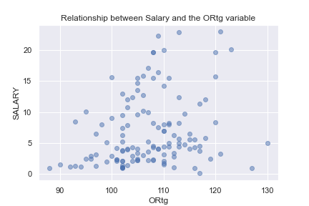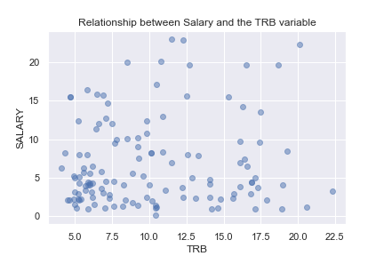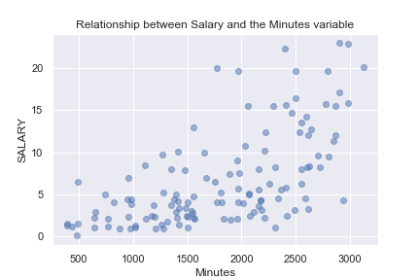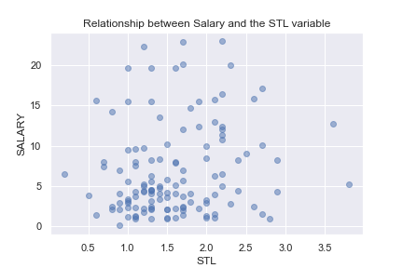While correlation plays a relatively important role in deriving an appropriate linear model, kNN models can rather model more irregular relationships. Therefore, since correlation is a measure the strength and direction of a linear relationship between variables a different dataframe should be ideally prepared for the kNN model if any non-linear relationships exists. Let's first produce a scatterplot of each of the variables with "SALARY" to see if any relationship is potentially present.

(figure 9 – refer to all other plots in appendix iv)

An examination into the plots and it is apparent that there are no non-linear relationships other than the linear ones established earlier (through correlation). Therefore, the model using kNN regression would continue ideally with the same features narrowed down with correlation.

It should be recognised that kNN would ideally require that its features be standardised to achieve the best results possible (KNN and Jones, 2020). Since the k-nearest-neighbour algorithm relies on averaging points that are the closest membership of a k number of points, this means nearness is typically based on Euclidean distance. Therefore, neighbours will be biased towards the direction of the axis in which it has a smaller range, since their distance would be recognised as closer. Therefore, by standardising we ensure that the values of the predictors are all comparable on the same scale and that the distances between points of features are of an equal weight.

Since the support vector regression (SVR) model is expected to use a linear kernel (explained in methodology and modelling), it will therefore construct a linear model using support vector machine principles. Thus, the same features that would be applied in the linear regression model would ideally be utilised here too. SVR is however scale invariant and therefore requires the features to be standardised (1.4. Support Vector Machines — scikit-learn 0.18.2 documentation, 2020).

# Methodology and Modelling

## Multiple Linear Regression

Having derived the most correlated variables with 'SALARY', we ensure to obtain the most optimal model not through simply using the selected features but by an assessment with each combination that can be made with the predictors.

Also, since multicollinearity is present between "WS", "DWS" and "OWS" we want to create combinations that only select one of these each time a set of combinations is made to be used in the model. This way we can ensure each combination does not suffer from multicollinearity.

First presence of outliers will be addressed, through identification and then their subsequent removal. This is critical since the influence of outliers can have a large impact on predictor performance, this will be shown below where the performance differences in the cross validation and test sets are apparent.

-------------------------------------------

---------------WITH OUTLIERS---------------

-------------------------------------------

------OVERALL BEST MODEL BY CV-RMSE--------

-------------------------------------------

-------------------------------------------

Overall Best mlr model uses the features ['PER', 'DWS', 'Minutes', 'USG']

CV RMSE: 3.7293

Test RMSE: 4.1146

…

-------------WITHOUT OUTLIERS--------------

-------------------------------------------

------OVERALL BEST MODEL BY CV-RMSE--------

-------------------------------------------

-------------------------------------------

Overall Best mlr model uses the features ['WS', 'Minutes', 'USG']

CV RMSE: 3.4782

Test RMSE: 4.0660

(figure 10 – full results in appendix v)

Therefore, comparing the cross validation and test performance between the dataset with and without outliers, the difference is clear. Since the model without outliers provides the most optimal results, we will continue to use the best model that used training data which excluded the outliers.

Now, considering the performance of each of the model possibilities without outliers the best one used features “WS”, “Minutes” and “USG”. This was selected as the most desirable, as it achieved the lowest cross-fold validation RMSE of $3.4782 million while also attaining an above target test RMSE of $4.0660 million. Although, there were models that performed better with the test dataset it is not correct methodology to select the best model on this basis.

While the model did perform overall well, it should be understood that multiple linear regression has a few assumptions that may impact its validity as a useful model. Therefore, these will be assessed to ensure that we are aware of limitations.

The first assumption is that the features used follow some linear relationship. As observed in the pair plots and a thorough assessment of the correlations earlier, the selected features satisfy this assumption, as it shows some linearity with “SALARY”.

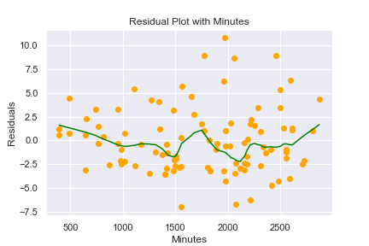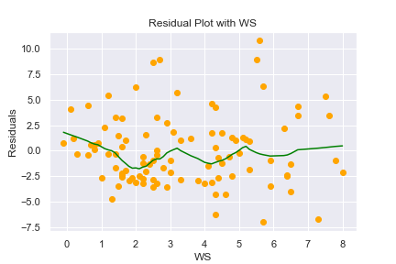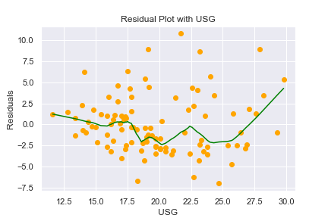Next, we need to assess for exogeneity i.e. the residuals are independent and uncorrelated. Since we would need to determine for omitted variable bias (OVB) through assessing the correlations of each variable, the fact that the dataset does not contain all the official NBA metrics of each individual, it is not possible to use OVB in understanding the assumption for exogeneity. However, through a residual plot with each of the predictor variables we should be able to determine if there is an indication of possible correlations amongst the errors.

(figure 11)

Examining the plots above, it is apparent that the residuals relatively random and thus suggest that the errors are not correlated. While we could accept this assumption as satisfied it is important to consider that our lack to be able to assess for OVB limits our confidence to do so and must be acknowledged.

Moreover, the residual plots also imply the presence of homoscedastic errors. This means that the errors are of constant variance, as indicated above. Hence, the assumption for homoscedasticity is satisfied.

In assessing for finite fourth moments, it can be concluded as satisfied since the predictor and response variables can only exist as finite values.

A simple VIF assessment of the selected features should be able to delineate if multicollinearity is present and thus if the assumption for no perfect collinearity is satisfied.

VIFs with WS, Minutes, USG: [2.0663, 2.1004, 1.0888],max_vif: 2.1004

(figure 12)

Since, the features all possess a VIF less than 3, its highest being only 2.1, it is appropriate to conclude that the assumption for no perfect collinearity is satisfied.

Unfortunately, the assumption for independence of the predictors might be problematic, given that the performance of an individual is hard to assess since much of it depends on overall team performance. Therefore, there is the slight possibility that some of the observations may be dependent across players from the same team.

Therefore, the use of the multiple linear regression model is relatively justified given its overall good performance and satisfying of most assumptions.

## kNN Regression

Similarly, to select the most optimal model we will construct one for every different combination of the selected features and then assess each combination against each other with its best k (i.e. the nearest neighbours parameter).

Since, we want to be sure that the models are not subject to multicollinearity, as we did earlier, we will attempt to build a model for each of the multicollinear features "WS", "DWS" and "OWS". That means each set of combinations will have a multicollinear feature replaced with a different one.

-------------------------------------------

------OVERALL BEST MODEL BY CV-RMSE--------

-------------------------------------------

-------------------------------------------

Overall Best kNN model uses the features ['PER', 'DWS', 'Minutes', 'USG']

CV RMSE: 3.6202

Test RMSE: 4.0645

Number of neighbours: 11

(figure 13 – full results in appendix vi)

After formulating each of the different model possibilities the best model used features “PER”, “DWS”, “Minutes” and “USG” with the k set to 11. This was decided as the most optimal, since it achieved the lowest cross-fold validation RMSE of $3.6202 million. It also successfully achieved an above target test RMSE of $4.0645 million, however, the model using the features “PER”, “WS” and “Minutes” was able to attain a lower test RMSE. Having said that, it is not correct methodology to select the best model on the basis of test data performance, but rather cross-validation performance. This is why we have accepted the model with “PER”, “DWS”, “Minutes” and “USG” as the best.

Since, the kNN model is non-parametric there are no assumptions made on the underlying data distribution, it is possible to accept the above best model as an alternative means to predicting “SALARY”.

## Support Vector Regression

Support vector regression (SVR) utilises similar principles as it does in support vector machine classification and may be a possible model solution alternative. SVRs operate on the basis of kernels, where they can adapt to either linear or non-linear type data and may offer more flexibility and control (Learning and Sethi, 2020). Moreover, the model is more robust to outliers and is less computationally expensive as compared to kNN and MLR models (Regression, 2020). It is through these advantages that the model could possibly outperform the other two.

Utilising principles in support vector machines, support vector regression selects the hyperplane between the features that covers the most points given a margin of tolerance from the hyperplane. SVR as a quadratic programming model, it uses a different method to optimising for errors in training, and that is through only taking the distances of points that are not bound within the constraints i.e. the margin of tolerance (Learning and Sethi, 2020).

As observed earlier in the scatter plots between the features and "SALARY", the best relationship that could be observed amongst the variables was a linear association. Therefore, we will use a linear kernel for the SVR model.

Although, a linear relationship is formulated amongst the features, no comparison of performance between training datasets, with and without outliers, is necessary. This is due to SVR being robust to outliers as mentioned before.

-------------------------------------------

------OVERALL BEST MODEL BY CV-RMSE--------

-------------------------------------------

-------------------------------------------

Overall Best svr model uses the features ['PER', 'DWS', 'Minutes', 'USG']

CV RMSE: 3.7372

Test RMSE: 4.0768

(figure 14 – full results in appendix vii)

The best model used the features 'PER', 'DWS', 'Minutes' and 'USG', attaining a CV RMSE of $3.7372 million and a test RMSE of $4.0768 million.

Similarly, to kNN regression, SVR does not require any assumptions to be satisfied. Thus, the above best model would be a valid approach to predicting "SALARY" of NBA players on the basis of 'PER', 'DWS', 'Minutes' and 'USG'.

# Model Evaluation

|  |  |  |
| --- | --- | --- |
|  | CV RMSE | Test RMSE |
| MLR | 3.4782 | 4.0660 |
| kNN | 3.6202 | 4.0645 |
| SVR | 3.7372 | 4.0768 |

(figure 15)

Having performed model construction, the following delves into the ability for the each of the best models to generalise with unseen data i.e. test data. Overall, each of the best models of each of the types, achieved an above target test RMSE of $4.1 million. Also, it should be noted that the bias-variance tradeoff is addressed most optimally with the use of cross validation. These are good results, however, the relatively large difference between the cross validation and test performance across all the models brings some concerns. One way of possibility as to why this was the case is the fact that the split of data between the training and test sets does not use the conventional 80 to 20, but rather a 50 to 50 split. Hence, the models could have generalised better if it had a larger training set that made them less prone to unfamiliar observations that inflate the test RMSE.

The multiple linear regression model achieves the best performance overall, attaining the lowest cross validation RMSE and close to lowest test RMSE. The kNN model does slightly worse in cross validation, however, it is important to recall that MLR produced only the best model once outliers were excluded, while kNN achieved above target results even with outliers. Therefore, the higher cross validation RMSE can be accounted to these outliers and also the tendency of kNN models to be typically sensitive to noisy data. Otherwise, its achieving of an above target RMSE is indicative of good generalising ability. Also, since the kNN model is non-parametric and does not make any assumptions on the distribution of the data and the fact that it performed similar, if not, just as well as MLR, it is a testament to kNN being an effective alternative to predicting NBA salaries.

It was expected that the SVR model would be robust to outliers and thus was trained with the data that included them. This robustness is evident in the results above. Its cross validation RMSE is still relatively worse than the other two, however, it was still able to achieve above target and thus implies that it can generalise well. Thus, it is recommended that further formulation testing that adjusts to different values for the margin of tolerance could potentially allow for us to derive a more improved model.

Therefore, the kNN model is the best performer overall, since the MLR’s validity is questionable given some of its assumptions could not be satisfied confidently and that SVR achieved a slightly worse performance in terms of cross validation and test RMSE.

# Conclusion

In conclusion, the outcomes of the research in predictive modelling of NBA salaries are quite promising. Each of the models achieved above target test RMSEs and gave results that were consistent with what was expected. While these reasons support the practical implementation of these models in assisting NBA teams, there are limitations that need to be noted. Improvements to consider is that the data provided could have been organised such that the training and test split was more conventional, so a better generalisation performance could have been achieved. Moreover, the data could have been more complete with a wider selection of metrics on players, so that they could have expanded the predictive abilities of the models, through a more accurate representation of NBA players overall. Also, while the predictors selected were posited to have some correlation with salary it is important to recognise that these are associations with salary and not causal relationships. Given these limitations, important considerations for future research is that the provided data is more complete with a better train-test split, the SVR model is reformulated against different margins of tolerance to potentially derive a more improved model, and that other models are experimented to explore other potentially better alternatives.

Therefore, while these models are definitely useful tools, these should not be the sole reasons to any final decisions. This requires that the users of these tools makes use of domain knowledge and takes into account other factors that may not be considered by them, such as the constantly changing circumstances of salary conditions in the NBA league.

Task B – Gradient Ascent

# Exploratory Data Analysis

The column and row dimensions of the dataset are as follows.

The dataset has 506 rows and 14 columns.

(figure 16)

Determining the number of NA values, none were present.

There are 0 columns in train dataset with missing values.

(figure 17)

Each of the features are of numerical datatypes with only one binary categorical variable, that being “chas”, as reported on the data description document and can be confirmed in the distribution plots (refer to appendix ix).

crim float64

zn float64

indus float64

chas int64

…

(figure 18 - view full output in appendix viii)

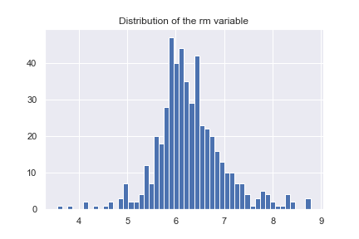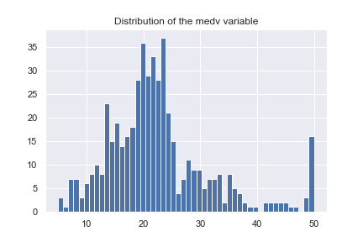Ensuring that all inputted values of the dataset are logically consistent, the distribution plots below will give insight.

(figure 19 – refer to all other plots in appendix ix)

Viewing the distributions and comparing them to the data descriptions provided, the variables appear to be logically consistent.

In detecting for outliers, using the IQR method, 288 were found.

The dataset has 288 outliers.

(figure 20)

# Feature Engineering

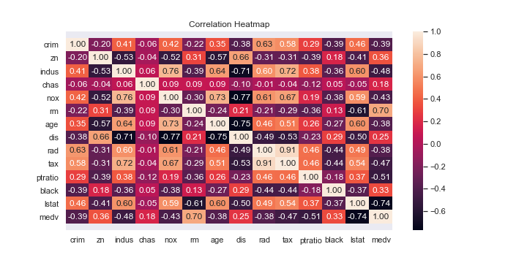To derive a good feature set for linear regression, we will conduct dimensionality reduction using a correlation heatmap to select the most relevant features.

(figure 21)

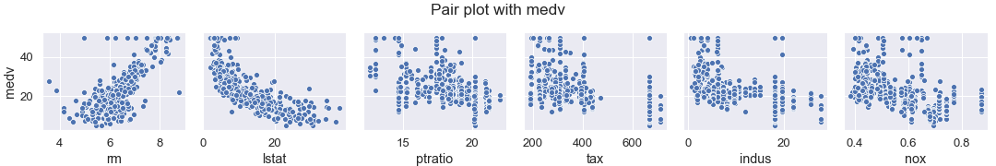Referring to the above plot, the top 3 most correlated features with “medv” are “rm”, “lstat” and “ptratio”. “rm” is positively correlated while the other two are correlated negatively. To confirm the strength and linearity of these relationships a pair plot will be examined. The next three most correlated features will also be included in the pair plot to see if these variables may be better at predicting "medv".

(figure 22 – for complete pair plot refer to appendix x)

The pair plot shows that “rm” has a relatively strong linear relationship with “medv”, while “lstat” seems to follow a rough exponential form. However, “lstat” would remain to be an appropriate feature to explain “medv” in the linear model. The rest seem to share similar patterns in a relationship with “medv”, and so on the basis of attaining the highest correlation, “ptratio” remains as the third best feature to include.

It should be noted however that, “lstat” and “ptratio” share a -0.61 correlation and thus introduces a concern for possible multicollinearity. This will be assessed further with the VIF.

VIFs with "rm", "lstat", "ptratio": [1.6534, 1.6794, 1.1981], \max_vif: 1.6794

(figure 23)

The results show that no multicollinearity is present between the best three features. Therefore, it is possible to conclude that “rm”, “lstat” and “ptratio” are the best to use in a linear regression model to predict “medv”.

# Gradient Ascent Implementation

Having constructed the gradient ascent algorithm, the algorithm is run through a leave one out cross validation across different values of alpha, whilst keeping the number of iterations fixed. This is because, it is expected that the performance of gradient ascent increases with greater values in the number of iterations. Thus, in assessing for different values of alpha whilst keeping the number of iterations fixed would be a sufficient method to deriving the maximum likelihood. Therefore, we fixed this value at 10 so to ensure algorithm had iterated enough to reach the optimum whilst retaining computational efficiency.

------------------|-------------------

ALPHA | CV RMSE

------------------|-------------------

0.001 | 0.9925

0.01 | 0.9322

0.1 | 0.7035

0.2 | 0.6743

0.5 | 0.6697

1.0 | 0.6702

3.0 | 796553.9641

6.0 | 2572815658.9413

(figure 24)

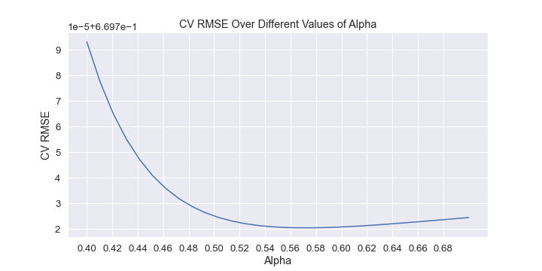Considering the provided output, the best alpha was 0.5, since it achieved the lowest cross validation RMSE. Now, it is possible to find a more precise value for alpha through running a cross validation over alphas close to 0.5.

(figure 25)

Therefore, from viewing the plot, the most optimal value of alpha is 0.57. This is since cross validation RMSE is depicted to be the lowest at this point as shown above.

References

Academy, U., 2020. Determinants Of NBA Player Salaries. [online] The Sport Journal. Available at: <https://thesportjournal.org/article/determinants-of-nba-player-salaries/> [Accessed 13 October 2020].

KNN, W. and Jones, D., 2020. Why Do You Need To Scale Data In KNN. [online] Cross Validated. Available at: <https://stats.stackexchange.com/questions/287425/why-do-you-need-to-scale-data-in-knn> [Accessed 10 October 2020].

Learning, S. and Sethi, A., 2020. Support Vector Regression In Machine Learning. [online] Analytics Vidhya. Available at: <https://www.analyticsvidhya.com/blog/2020/03/support-vector-regression-tutorial-for-machine-learning/> [Accessed 14 October 2020].

Regression, S., 2020. Support Vector Regression | Learn The Working And Advantages Of SVR. [online] EDUCBA. Available at: <https://www.educba.com/support-vector-regression/> [Accessed 14 October 2020].

Scikit-learn.org. 2020. 1.4. Support Vector Machines — Scikit-Learn 0.18.2 Documentation. [online] Available at: <https://scikit-learn.org/0.18/modules/svm.html#svm> [Accessed 13 October 2020].

# Appendix

## Appendix i

Train_ID int64

SALARY float64

POSITION object

TEAM object

Age int64

Games int64

Minutes int64

PER float64

TS float64

ORB float64

DRB float64

TRB float64

AST float64

STL float64

BLK float64

TOV float64

USG float64

ORtg int64

DRtg int64

OWS float64

DWS float64

WS float64

dtype: object

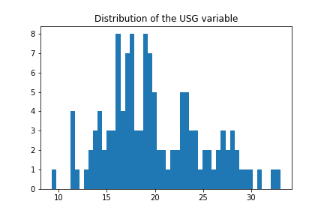

## Appendix ii

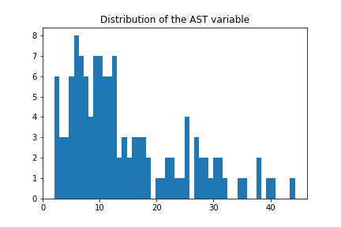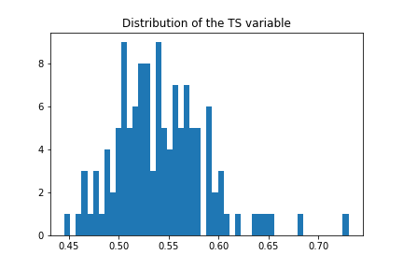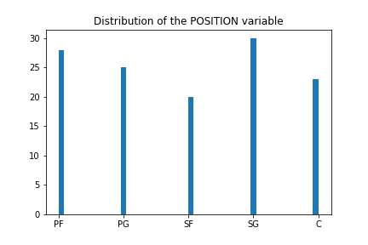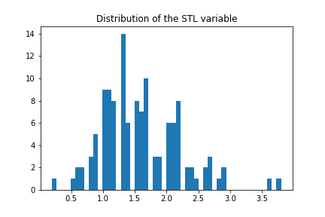

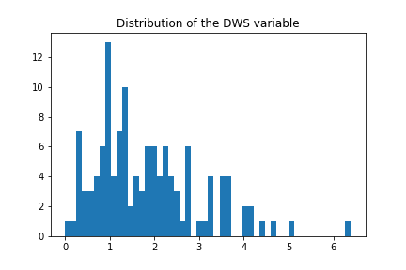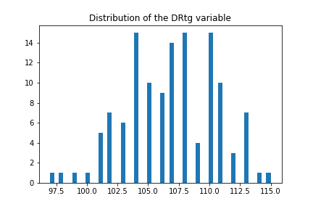

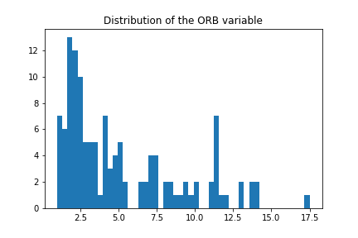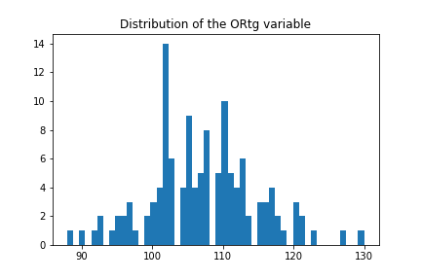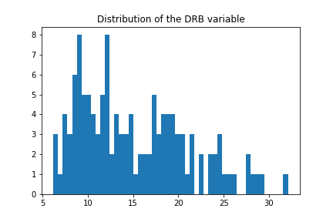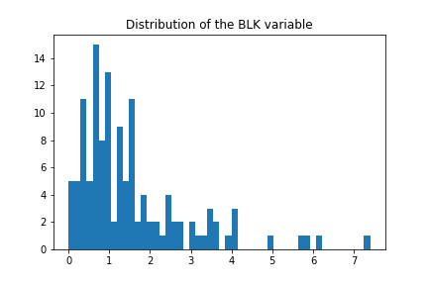

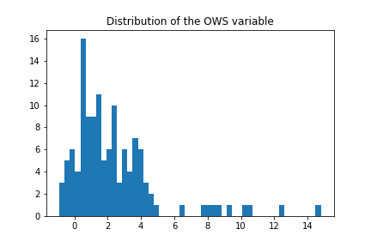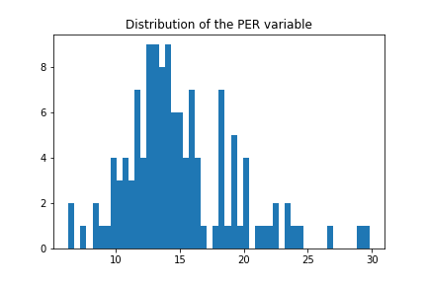

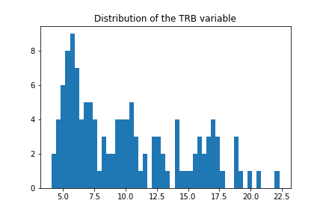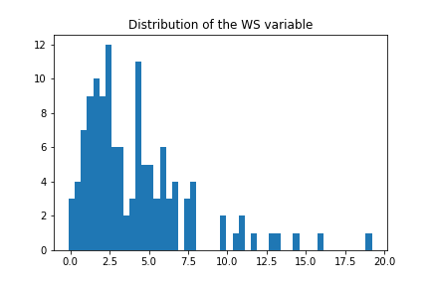

## Appendix iii

## Appendix iv

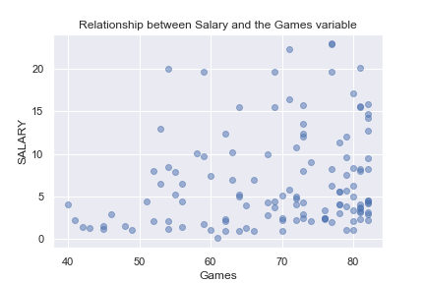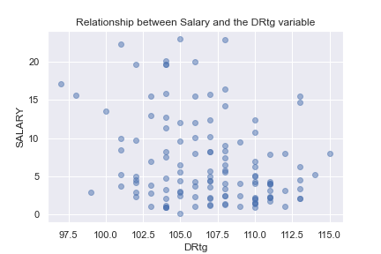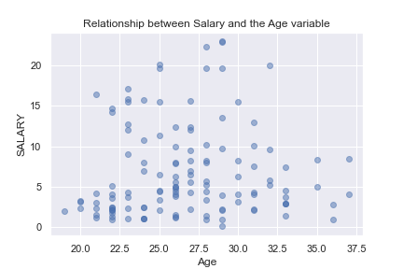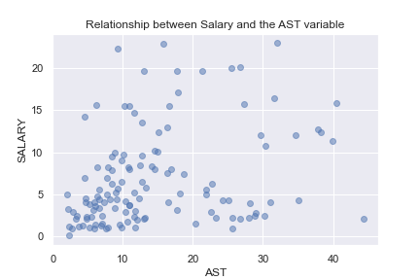

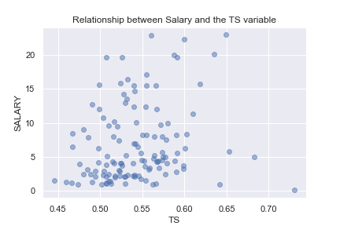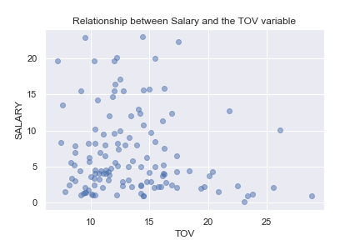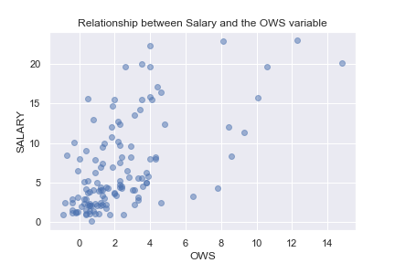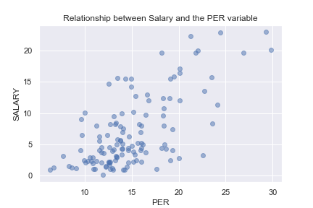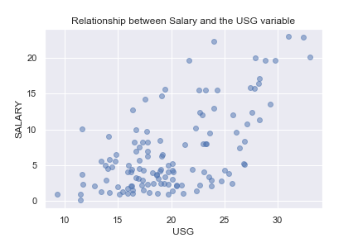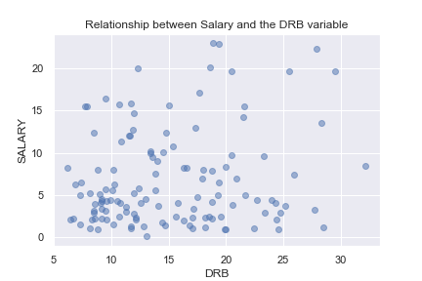

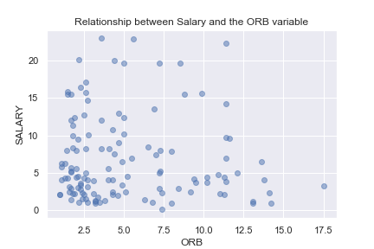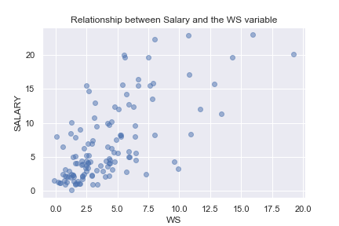

## Appendix v

-------------------------------------------

---------------WITH OUTLIERS---------------

-------------------------------------------

------OVERALL BEST MODEL BY CV-RMSE--------

-------------------------------------------

-------------------------------------------

Overall Best mlr model uses the features ['PER', 'DWS', 'Minutes', 'USG']

CV RMSE: 3.7293

Test RMSE: 4.1146

---------------WITH OUTLIERS---------------

-------------------------------------------

------OVERALL BEST MODEL BY TEST-RMSE------

-------------------------------------------

-------------------------------------------

Overall Best mlr model uses the features ['WS', 'Minutes']

CV RMSE: 4.0987

Test RMSE: 3.9841

…

-------------------------------------------

-------------WITHOUT OUTLIERS--------------

-------------------------------------------

------OVERALL BEST MODEL BY CV-RMSE--------

-------------------------------------------

-------------------------------------------

Overall Best mlr model uses the features ['WS', 'Minutes', 'USG']

CV RMSE: 3.4782

Test RMSE: 4.0660

-------------WITHOUT OUTLIERS--------------

-------------------------------------------

------OVERALL BEST MODEL BY TEST-RMSE------

-------------------------------------------

-------------------------------------------

Overall Best mlr model uses the features ['WS', 'Minutes']

CV RMSE: 3.8000

Test RMSE: 3.9761

## Appendix vi

-------------------------------------------

------OVERALL BEST MODEL BY CV-RMSE--------

-------------------------------------------

-------------------------------------------

Overall Best kNN model uses the features ['PER', 'DWS', 'Minutes', 'USG']

CV RMSE: 3.6202

Test RMSE: 4.0645

Number of neighbours: 11

-------------------------------------------

-------------------------------------------

------OVERALL BEST MODEL BY TEST-RMSE------

-------------------------------------------

-------------------------------------------

Overall Best kNN model uses the features ['PER', 'WS', 'Minutes']

CV RMSE: 3.9774

Test RMSE: 3.9741

Number of neighbours: 16

## Appendix vii

-------------------------------------------

------OVERALL BEST MODEL BY CV-RMSE--------

-------------------------------------------

-------------------------------------------

Overall Best svr model uses the features ['PER', 'DWS', 'Minutes', 'USG']

CV RMSE: 3.7372

Test RMSE: 4.0768

-------------------------------------------

------OVERALL BEST MODEL BY TEST-RMSE------

-------------------------------------------

-------------------------------------------

Overall Best svr model uses the features ['PER', 'WS', 'Minutes']

CV RMSE: 4.0052

Test RMSE: 4.0079

## Appendix viii

crim float64

zn float64

indus float64

chas int64

nox float64

rm float64

age float64

dis float64

rad int64

tax int64

ptratio float64

black float64

lstat float64

medv float64

dtype: object

## Appendix ix

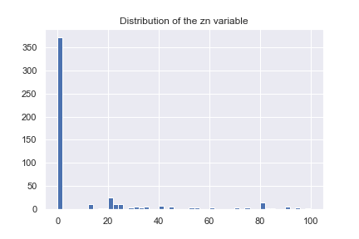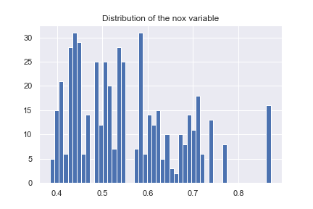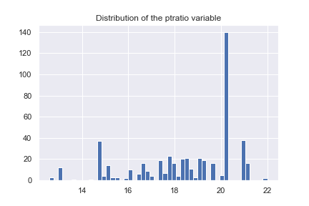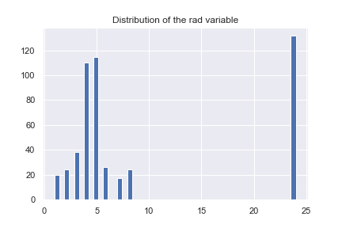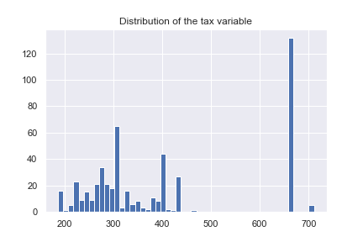

## Appendix x

