Chris Beatty

June 8, 2022

Mod 3 – PyBookCo

**Business Rules**

Each publisher can publish many books

Each book only has one publisher

Each author can write many books

Each book only has one author

**ORD**



**NoSQL Document Diagram**

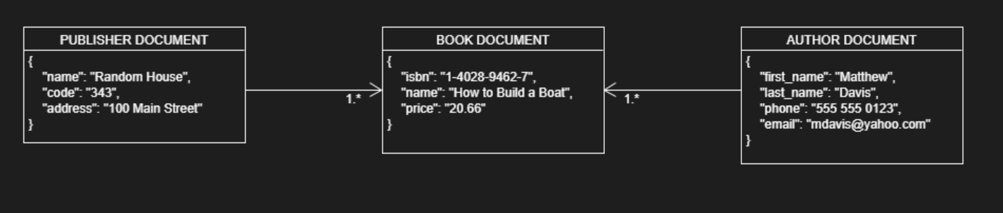

**NoSQL Data Structure**

Publishers:

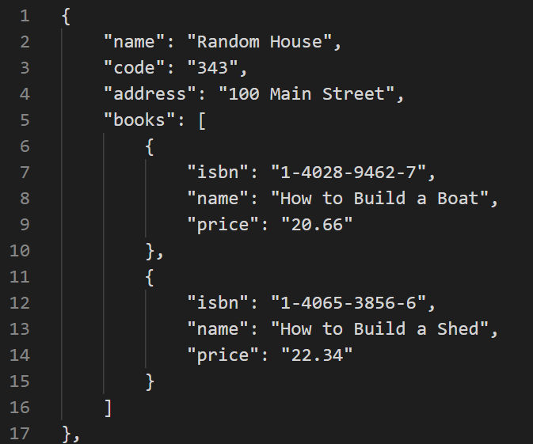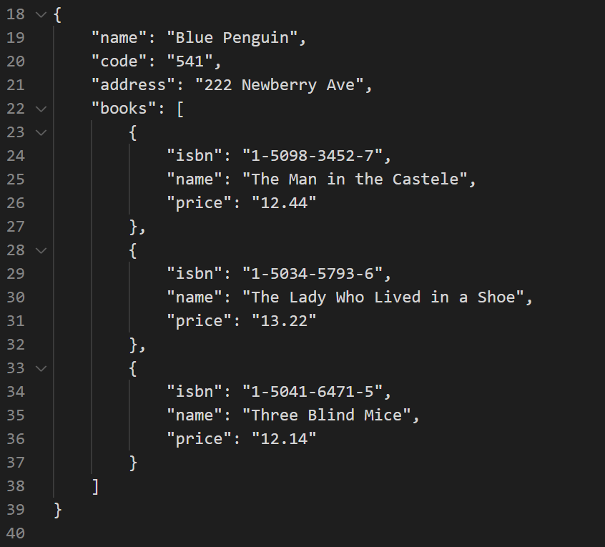

Authors:

