Chris Beatty

June 16, 2022

Mod 4.2 - MongoDB Atlas Setup

Cluster Setup:

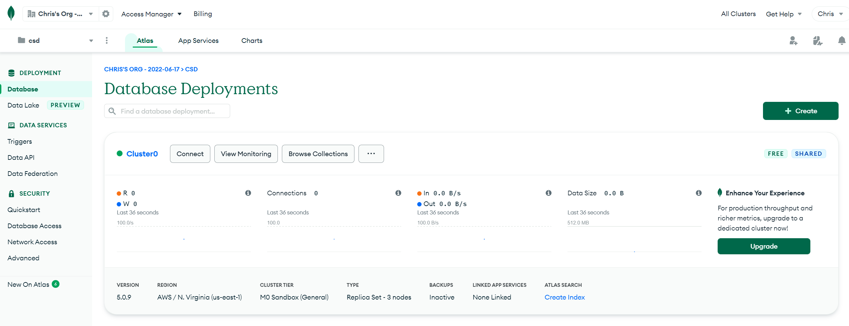

Project Setup:

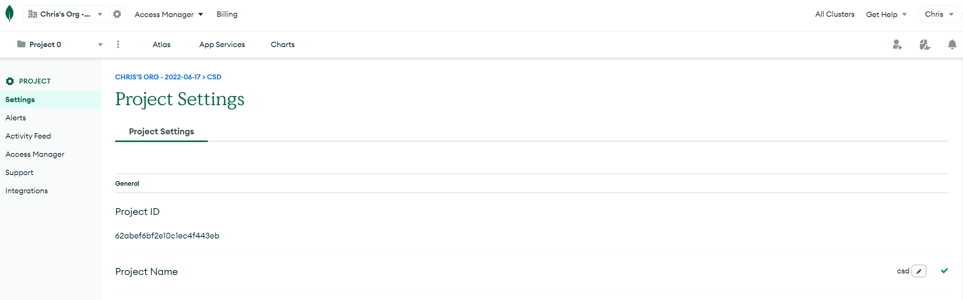

Security:

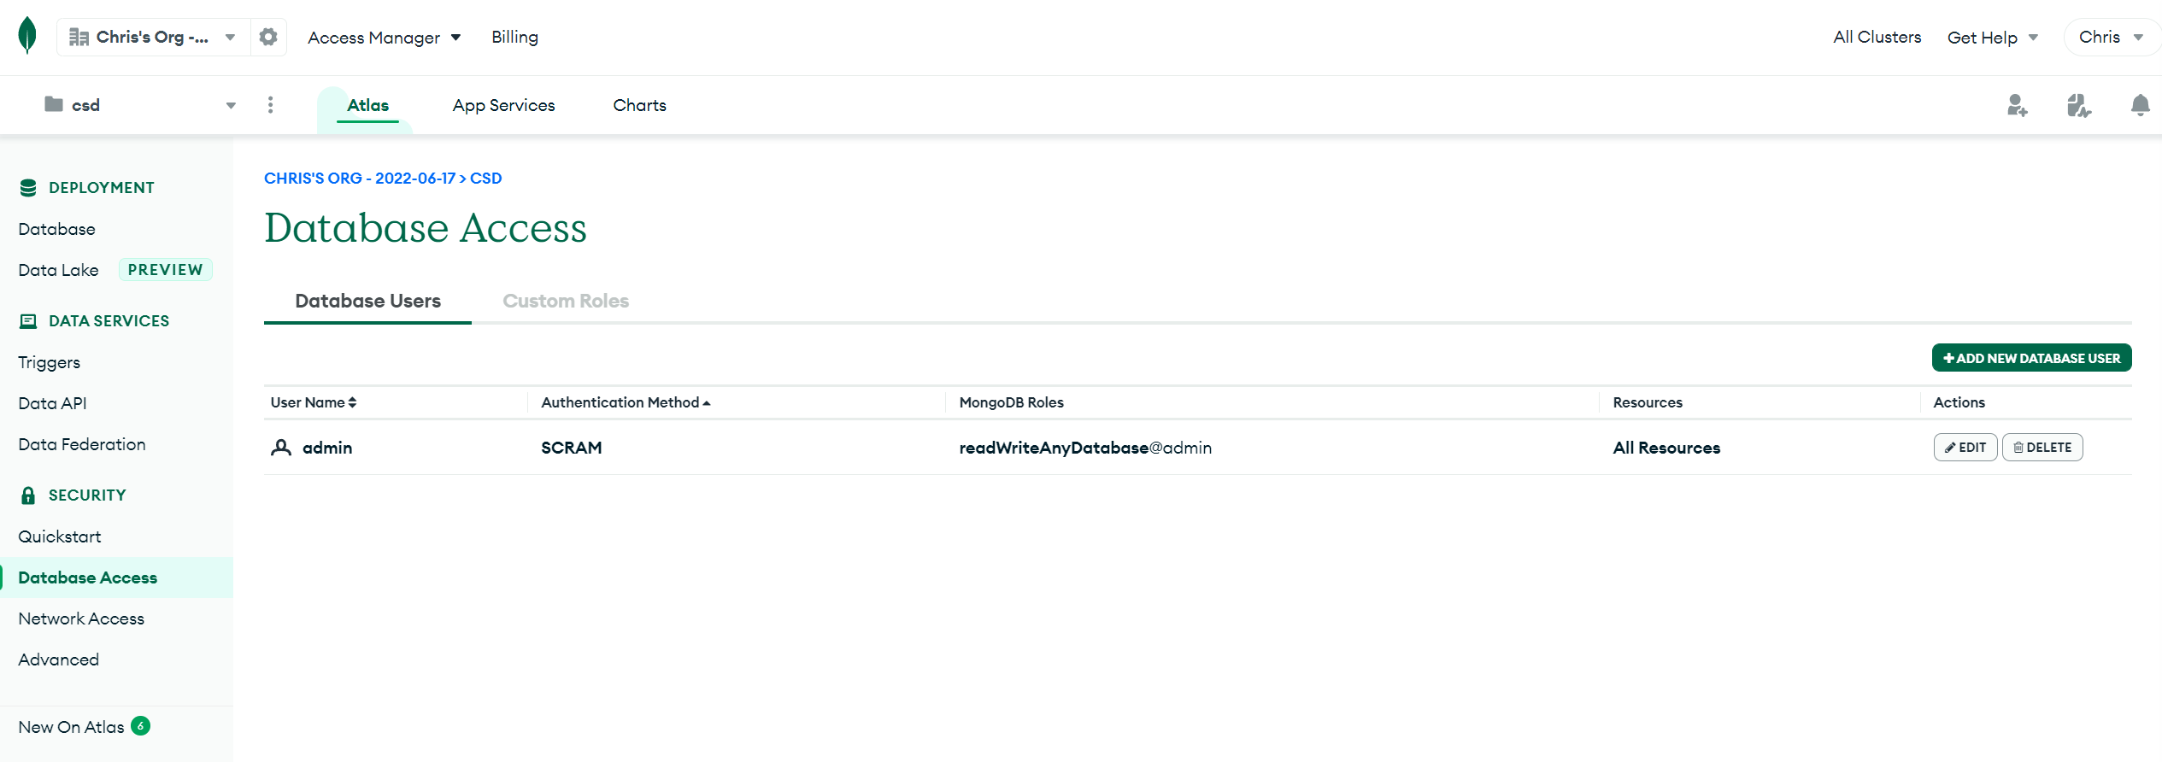

Network:

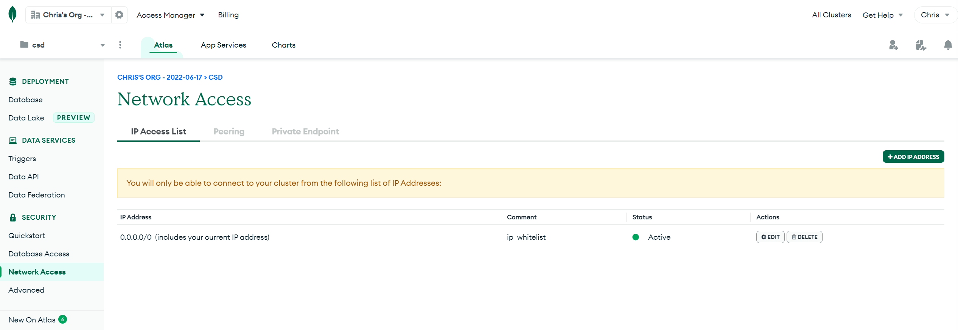

Collections:

