Chris Beatty

June 19, 2022

Mod 5.3 - PyTech Collection Queries

PyTech Insert:

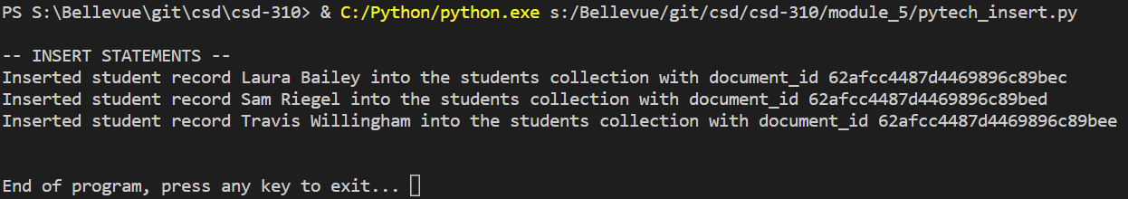

PyTech Queries:

