Chris Beatty

July 3, 2022

Mod 7.2 - MySQL Installation

Show Starting Databases:

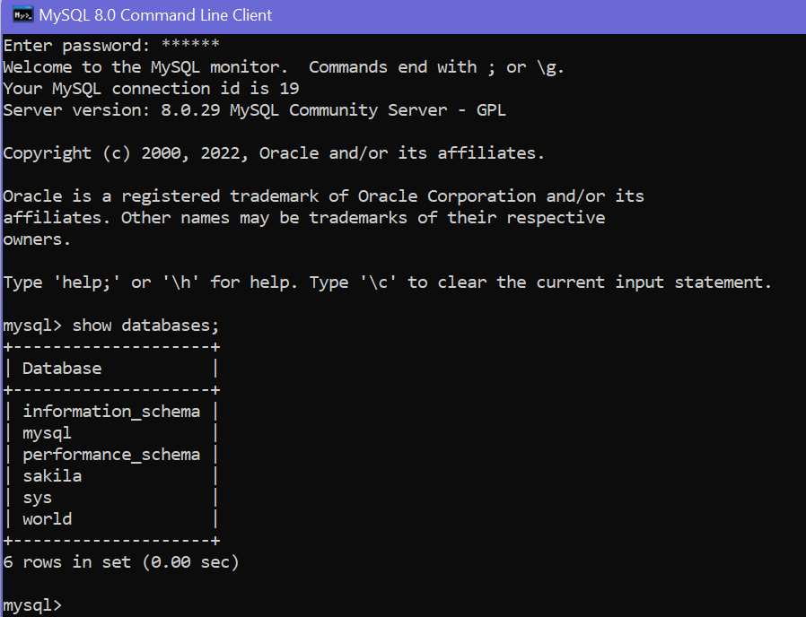

Create New Database PySports:



Show All Databases:

