Chris Beatty

July 3, 2022

Mod 8.2 - MySQL Test Python

DB_INIT Script:

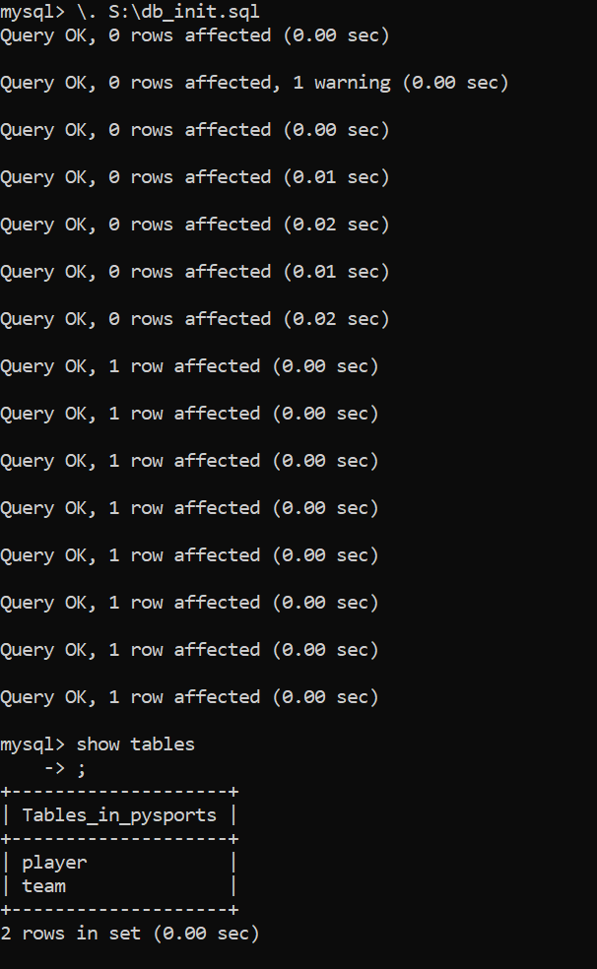

MySQL_test.py output:

