Chris Beatty

July 4, 2022

Mod 9.3 - PySports Update and Delete

Inserted Record:

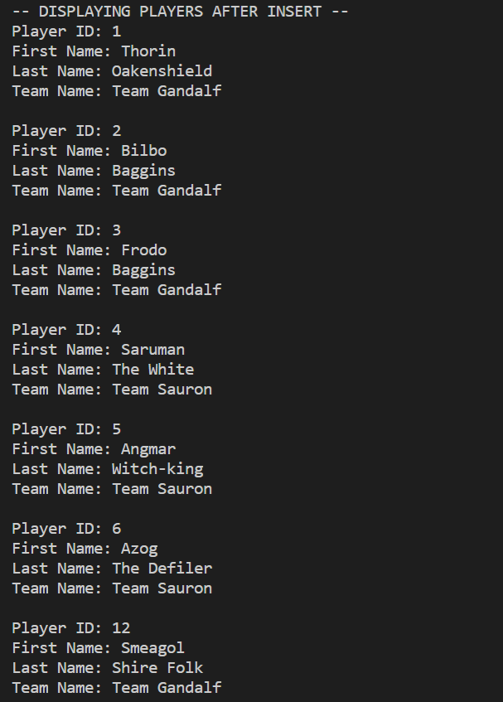

Updated Record:

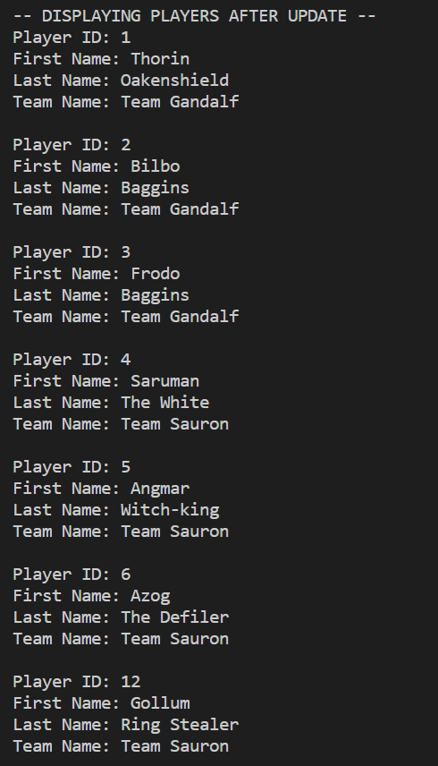

Deleted Record:

