Chris Beatty

Module 11 – Web Browser Development Tools

October 1, 2022

I had to take two separate screenshots to show the changes to both div classes. Selecting each div in the elements box in the development tools pane would only show the CSS styles for that specific div in the styles box. Selecting the columns-container div would not show both CSS style changes either as neither change effected the whole columns-container div.

Screenshot showing the left div has the background and font colors modified:

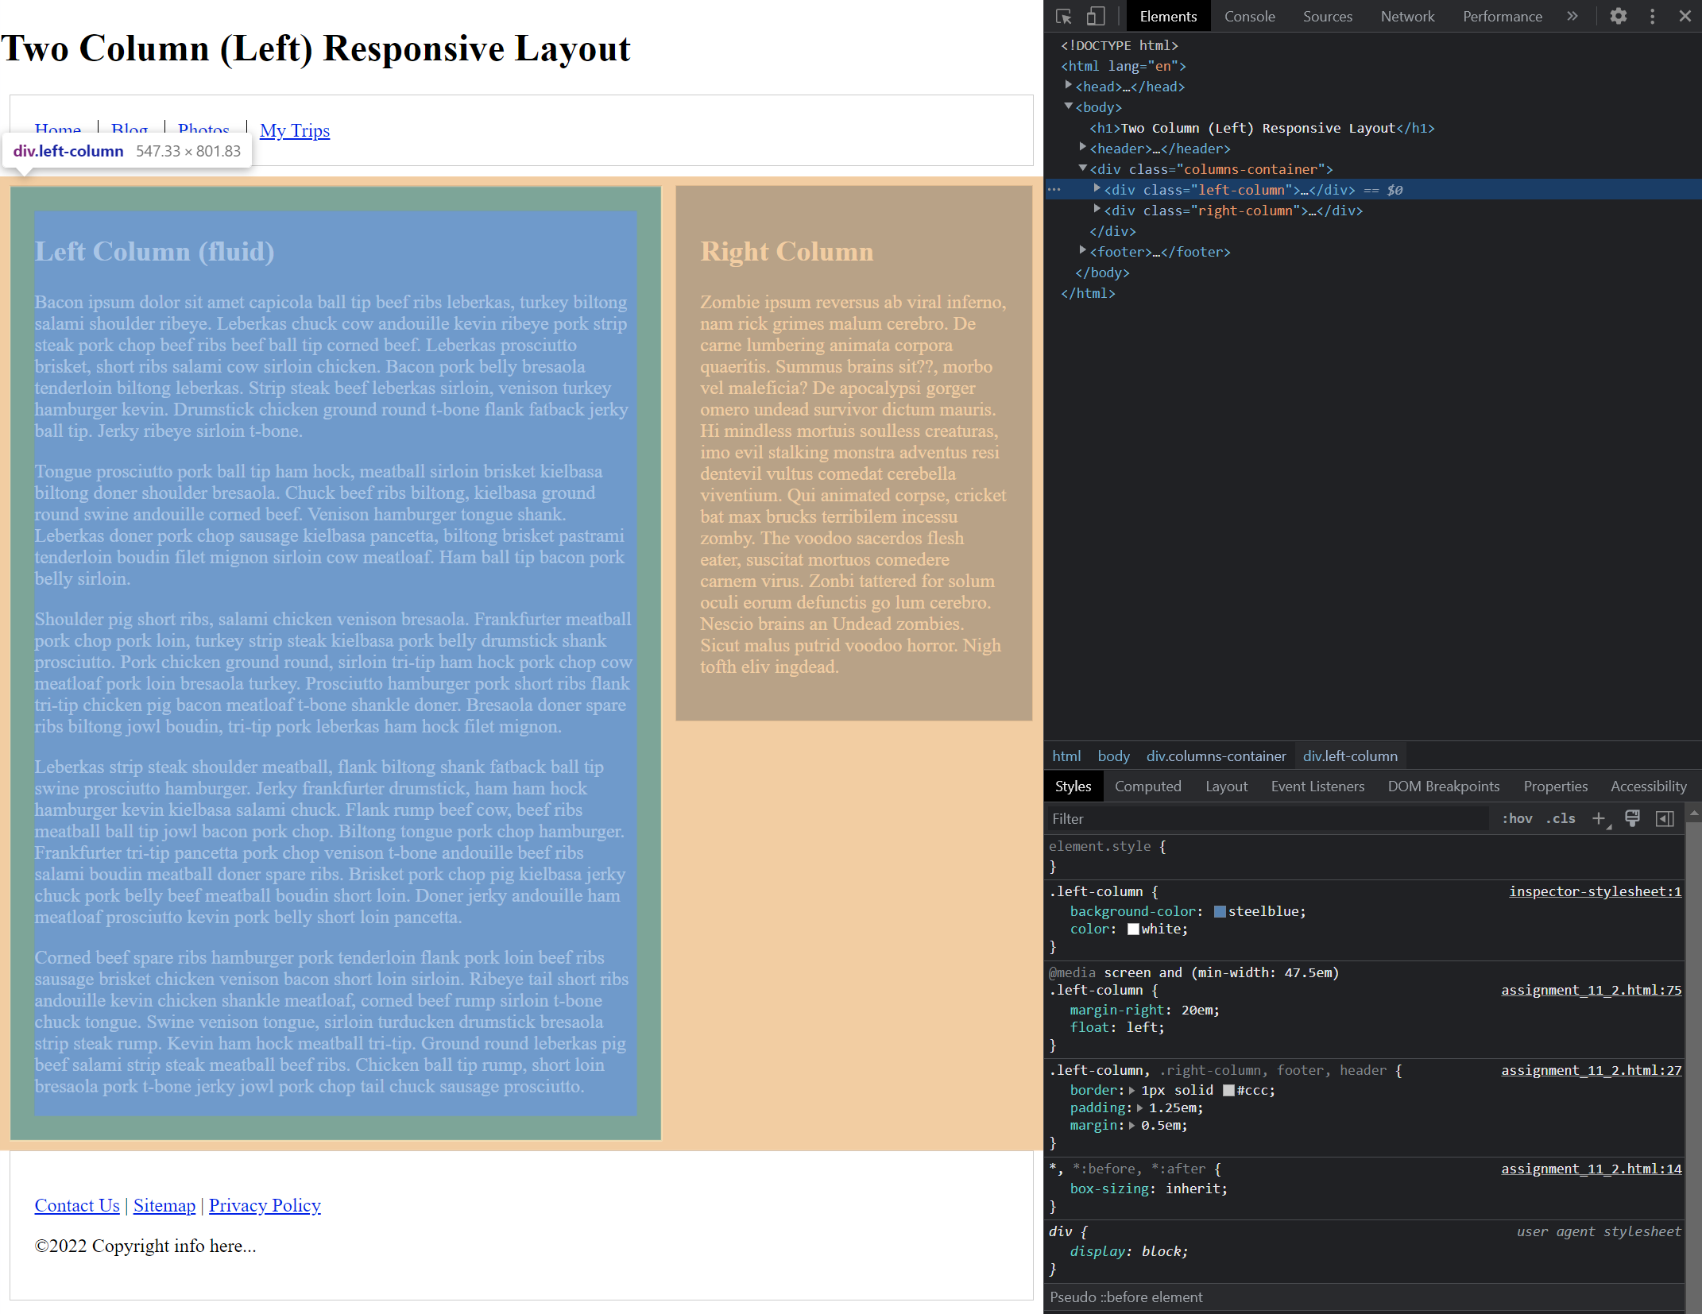

Screenshot showing the left div has the background and font colors modified:

