Chris Beatty

August 28, 2022

Module 4.2 - Index Page for GitHub

HTML Validator:

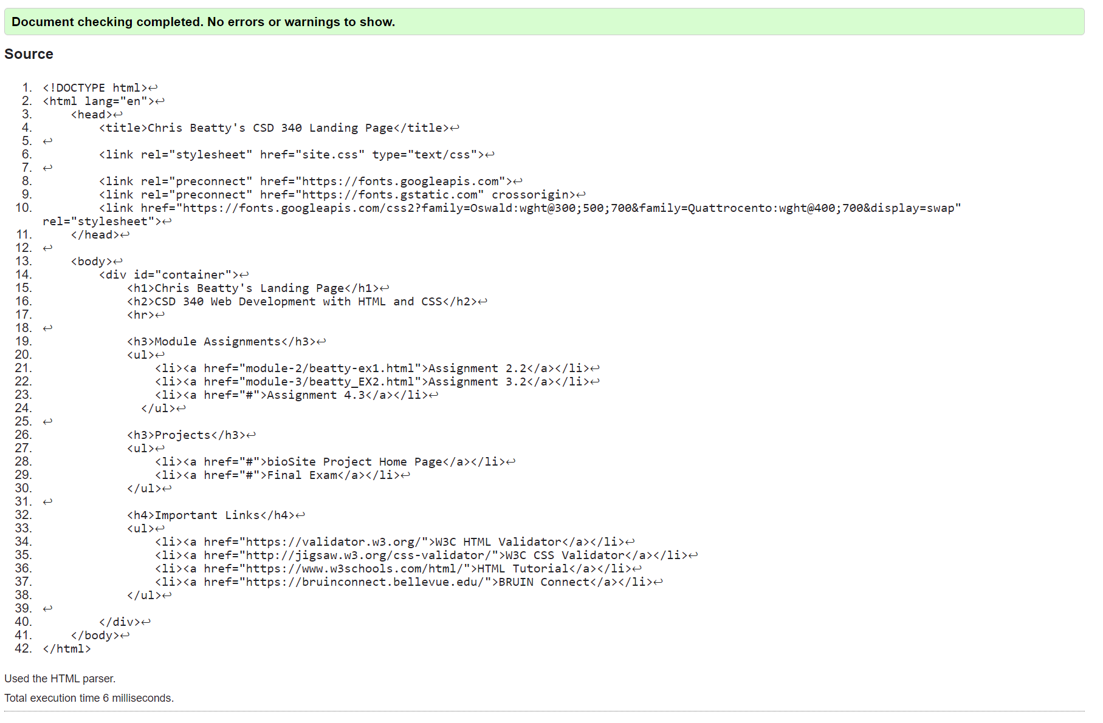

CSS Validator:

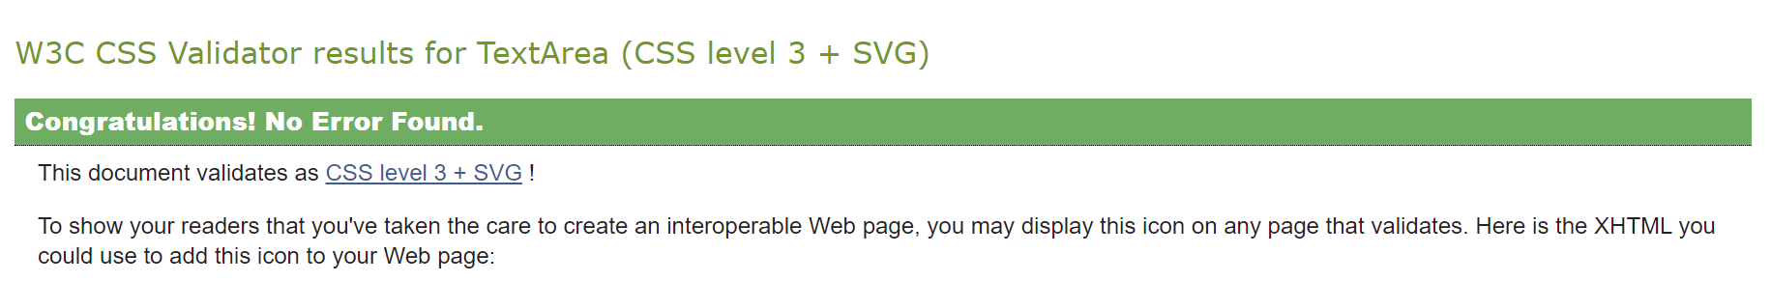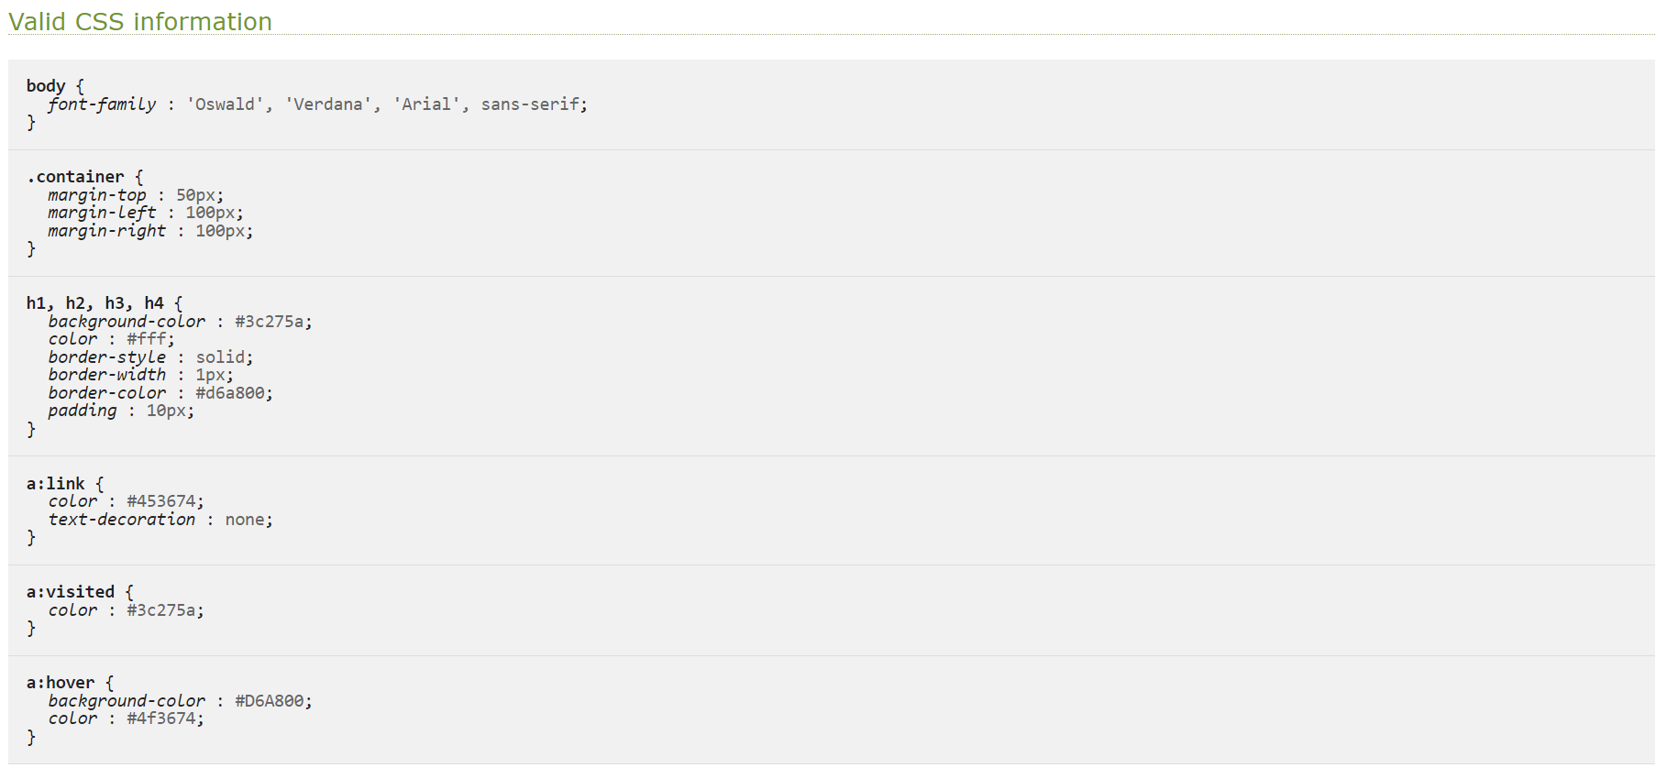

Final Webpage Visual:

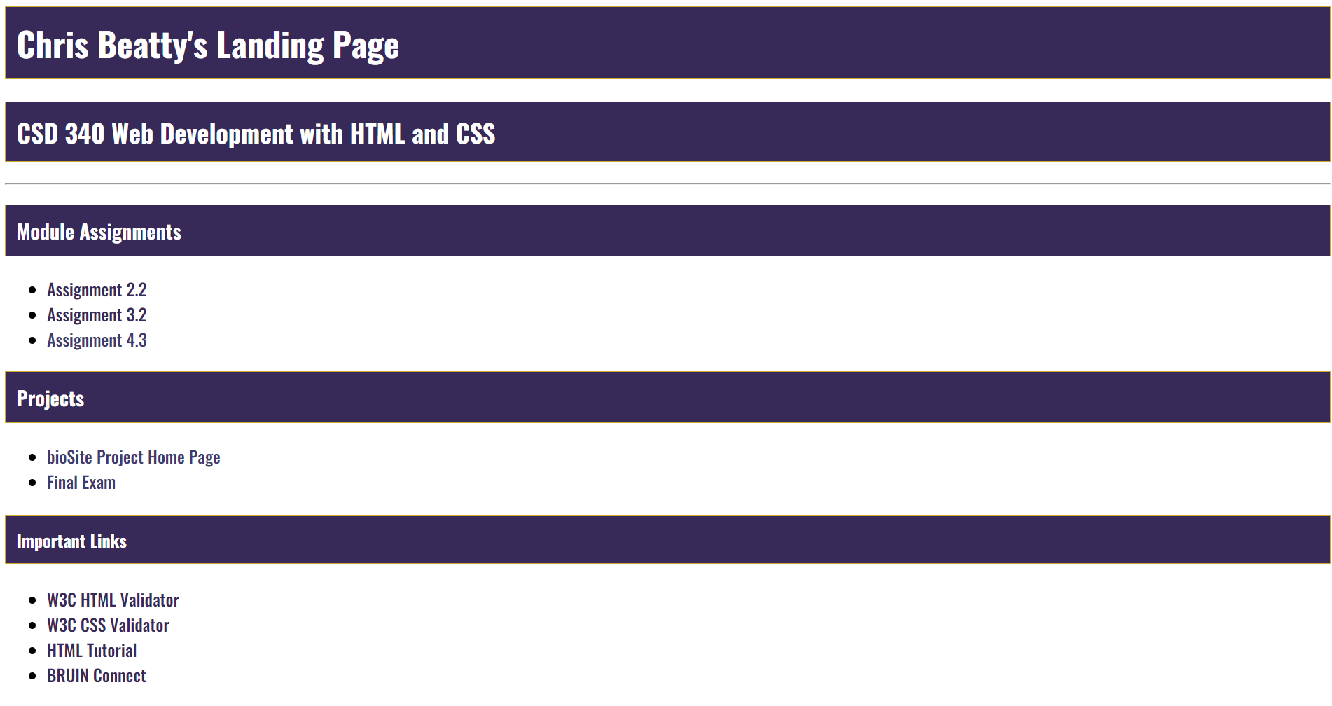

\* Notes \*

The instructions had one color for the heading backgrounds and the final solution visual had a different color for the heading backgrounds. I stuck with the color in the instructions as that color I had the hex code for.