# Using the Timesheets Spreadsheet

Version 1.5, 10 March 2020, Simon Elms

## Introduction

OpenAir, our time recording system, doesn't allow time recording against start and stop times, you can only enter the total amount of time you've spent on each project per day:

Figure : OpenAir times entry screen, showing that user only has the option of recording total hours against each project

This is fine for people who spend the whole day on a single project. However, if you're jumping between multiple projects throughout the day, and particularly if you spend several non-consecutive periods in a day on a project broken up by other tasks, keeping an accurate record of your time in OpenAir is difficult.

To get around this problem the Timesheets spreadsheet was developed. It has the following main features:

* It allows users to keep a note of time worked using start and end times (eg 0900-0930 – Stark AI Project – Meeting with Australian project team);
* It will sum all the time recorded against each project for the day, giving a total per project which can then be copied into OpenAir.

## Using the Spreadsheet

The spreadsheet is an optional tool, to make time recording easier. If you don't want to use it you don't have to.

OpenAir records time by week so it's easiest to start a new spreadsheet each week. That way you can compare the weekly totals in the spreadsheet and in OpenAir to make sure they match.

## The Two Sheets in the Spreadsheet

The spreadsheet has two sheets: Timesheet and Time Totals.

**Timesheet:** For recording time against projects, using start and end times.

**Time Totals:** A pivot table. Refresh the pivot table to see the total times recorded against each project for each day.

## The Timesheet Sheet

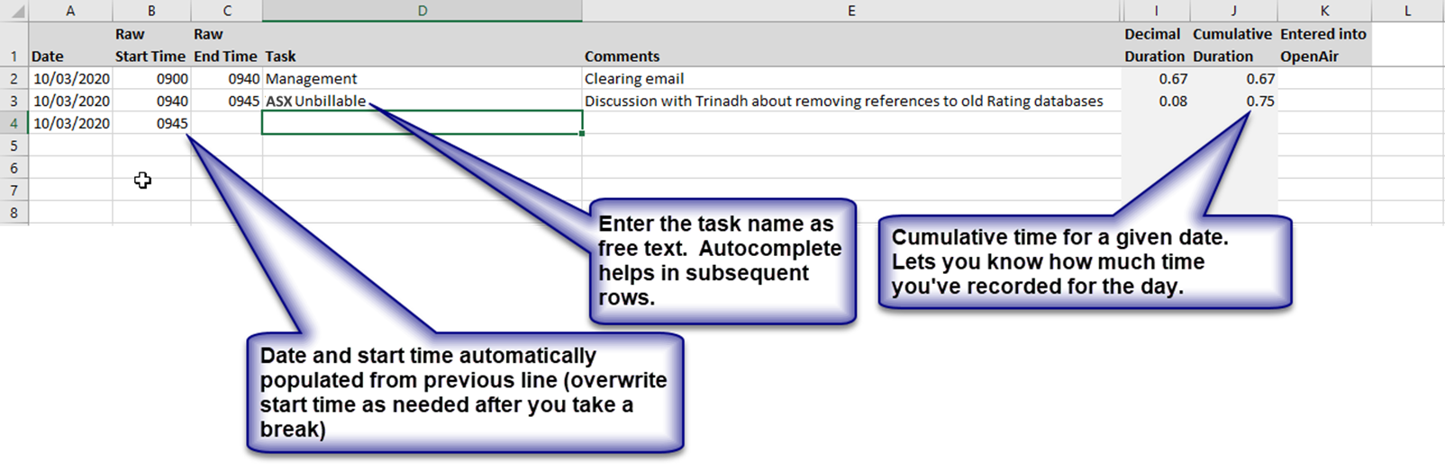

Figure : Basic time entry using the spreadsheet

### Useful Features

At the end of the day leave a blank in the Date column before starting recording the next day's time. That will automatically highlight the total time recorded on that day.

Entering a "y" in the Entered into OpenAir column will highlight the day's time in green. This helps to keep track of which days' time has been recorded in OpenAir:

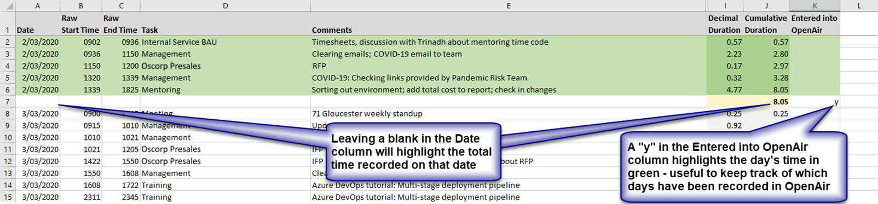

Figure : Useful features - highlighting the daily total time and highlighting time that has been copied into OpenAir

## Time Totals Sheet

Figure : Right-click in the pivot table to update total times

Figure : Sub-totals and totals in the pivot table