# Using the Timesheets Spreadsheet

Version 2.0, 19 Sep 2022, Simon Elms

## Introduction

OpenAir, our time recording system, doesn't allow time recording against start and stop times, you can only enter the total amount of time you've spent on each task per day:

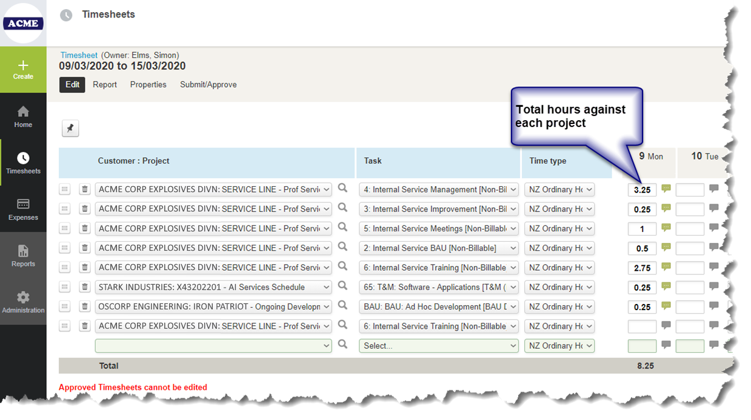

Figure 1: OpenAir times entry screen, showing that user only has the option of recording total hours against each project

This is fine for people who spend the whole day on a single task. However, if you're jumping between multiple projects and tasks throughout the day, and particularly if you spend several non-consecutive periods in a day on a project broken up by other tasks, keeping an accurate record of your time in OpenAir is difficult.

To get around this problem the Timesheets spreadsheet was developed. It has the following main features:

* It allows users to keep a note of time worked using start and end times (eg 0900-0930 - MyToll Project – Meeting with Australian project team);
* It will sum all the time recorded against each task for the day, giving a total per task which can then be copied into OpenAir.

## Using the Spreadsheet

The spreadsheet is an optional tool, to make time recording easier. If you don't want to use it you don't have to.

OpenAir records time by week so it's easiest to start a new spreadsheet each week. That way you can compare the weekly totals in the spreadsheet and in OpenAir to make sure they match.

## The Two Sheets in the Spreadsheet

The spreadsheet has two sheets: Timesheet and Time Totals.

**Timesheet:** For recording time against tasks, using start and end times.

**Time Totals:** A pivot table. Refresh the pivot table to see the total times recorded against each task for each day.

## The Timesheet Sheet

Figure 2: Basic time entry using the spreadsheet

### Useful Features

At the end of the day leave a blank in the Date column before starting recording the next day's time. That will automatically highlight the total time recorded on that day.

Entering a "y" in the Entered into OpenAir column will highlight the day's time in green. This is useful as a reminder of which days' time has been recorded in OpenAir:

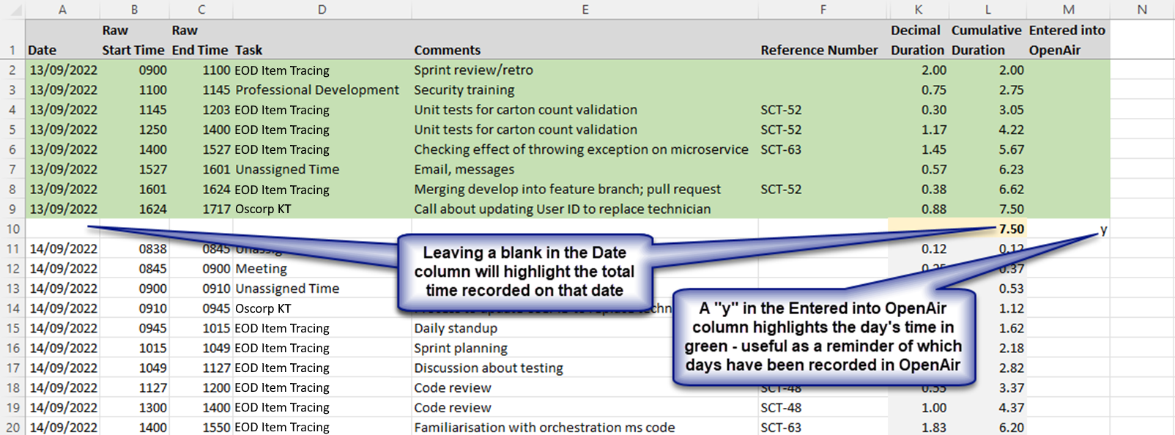

Figure 3: Useful features - highlighting the daily total time and highlighting time that has been copied into OpenAir

## Time Totals Sheet

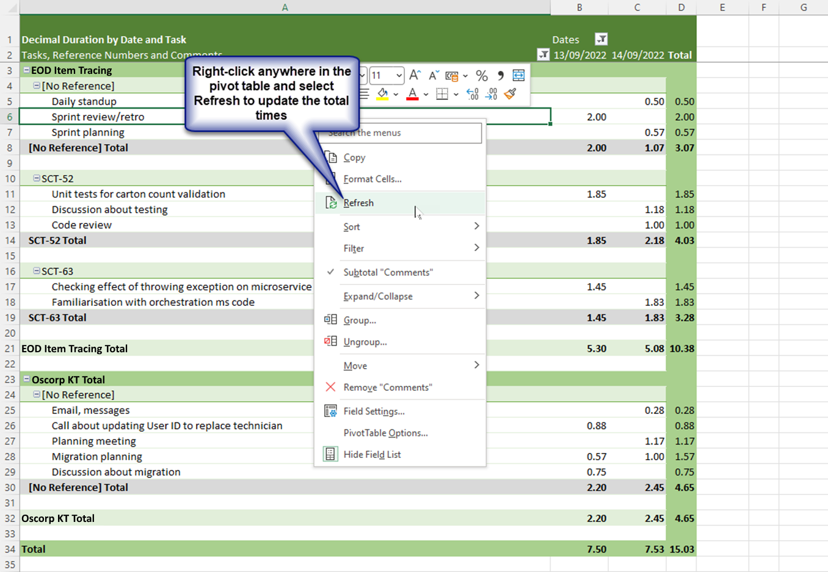

Figure 4: Right-click in the pivot table to update total times

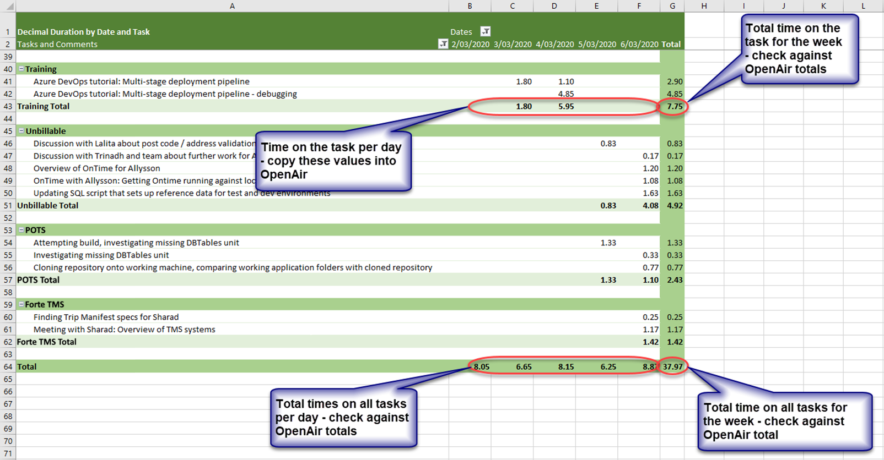

Figure : Sub-totals and totals in the pivot table

## TimesheetSpreadsheetOpen.ps1 PowerShell Script

The TimesheetSpreadsheetOpen.ps1 script automates the creation of a new spreadsheet each week. To use it:

* Create a folder for the timesheet spreadsheets and save a copy of the blank timesheet into the folder;
* Edit the variables at the head of the PowerShell script:
  + **$timesheetFolderPath:** Specifies the path to the timesheet folder;
  + **$timesheetTemplateFilePattern:** Specifies the name of the blank timesheet that will be used as a template, and copied to create each weekly timesheet
* Create a shortcut to run the PowerShell script. The target of the shortcut should be   
  *<path to PowerShell executable> -ExecutionPolicy Bypass -File <path to xxx>*.   
    
  For example:   
  C:\Windows\System32\WindowsPowerShell\v1.0\powershell.exe -ExecutionPolicy Bypass   
  -File "C:\Users\SimonE\Documents\PowerShell\TimesheetSpreadsheetOpen.ps1"  
    
  The *-ExecutionPolicy Bypass* allows the script to run if the PowerShell execution policy is highly restricted.
* Save the shortcut to your desktop.

Running the shortcut will try to open the current week’s timesheet spreadsheet. The spreadsheet name will include the date the timesheet starts, on Monday of the current week. If the spreadsheet doesn’t exist it will be created by copying the blank spreadsheet and renaming the copy.

If the end of the month falls during the week then running the shortcut on or after the first day of the new month will create a second timesheet spreadsheet for the week, with "_NewMonth" appended to the name.