Social Media Promotion Service Agreement
I. INTRODUCTION
This Agreement was made on ${DATE} between ${INFLUENCER_FULL NAME} (Influencer) and POVISON (Advertiser).

PARTIES
Influencer
Name: ${INFLUENCER_FULL NAME}
Email: ${INFLUENCER_EMAIL}
Phone: ${INFLUENCER_PHONE NUMBER}
Shipping Address: ${INFLUENCER_ADDRESS}

Social Media of the Influencer
Instagram: ${INSTAGRAM_LINK}
TikTok: ${TIKTOK_LINK}
YouTube: ${YOUTUBE_LINK}

Advertiser
Contact Name: Johnny Miller
Company Name: POVISON

II. ACKNOWLEDGMENT
The Advertiser and the Influencer acknowledge the terms of this Contract and will comply.

III. TERMS
This Agreement shall be valid for 2 years from the effective date.

IV. FORMS OF COMPENSATION
1. Free product
${PRODUCT_SPECS}
Product link: ${PRODUCT_LINK}

Shipping & Delivery Notice: Please kindly note that we will not be able to change the address after the product is shipped. Fees for returning ($1000) will be carried by the Influencer if the shipping address needs to be changed after shipping. The logistics company will be offering curbside delivery exclusively. It is highly recommended that you arrange assistance for bringing the furniture indoors.

2. Cash Compensation
- A one-time flat fee of ${FEE} USD.
- Payment Terms: Payment will be issued within 7 days after approved content is live and all deliverables (posts, Ad codes, RAW footage) are provided. Advertiser may withhold payment until incomplete or non-compliant items are cured.

V. CONTENT REQUIREMENTS
1. The influencer should create original content that is decent, honest, and factual.
Type of Production | Brief  Description | Quantity | Video Length/  Picture Requirements | Time of Uploading | Platform of  Uploading
Video, Stories, RAW footage | Showcase the product styling and its details based on the brief sent by the advertiser | 1 Short Video, IG Stories, RAW Footage | About 20-60 seconds, showcasing the details of the product | 1-2 weeks after receiving the product | Cross-post to IG Collab, TikTok, and YT Shorts. Tag Brands' handles
Ad Codes | / | / | Provide Advertiser with Ad Codes for all posted platforms. | Provided upon posting | Instagram/ TikTok/ YouTube
2. An approval from the Advertiser is requested before uploading the content.

3. The approved content will be shared on the listed social accounts and remain for the validity period. If content is late, removed, unapproved, or not uploaded, Advertiser may demand compensation, including product value, freight and storage fees.

4. The advertiser can request the Influencer to add tags, links, or titles in the description of the uploaded media.

5. The content should be compliant with the terms and conditions of the social media platform being used.

6. The content should not contain any vulgar language and should be suited for everyone.

VI. COPYRIGHT
Influencer retains ownership. Advertiser is granted a non-exclusive, royalty-free license to use approved content and RAW footage for ads, marketing, reposting, and paid media during the validity period.

VII. CONFIDENTIALITY
This Agreement is strictly confidential and only authorized persons are allowed to see it.

VIII. AMENDMENT
This Agreement can only be changed or modified through the written consent of both parties (Advertiser and Influencer).

IX. CHOICE OF LAW
This Agreement shall be construed and enforced pursuant to the laws and decisions of California / USA.

X. AGREEMENT EXECUTED DATE
Terms of this Agreement come into effect once the Influencer replies to confirm.

Advertiser’s Signature: Influencer’s Signature:
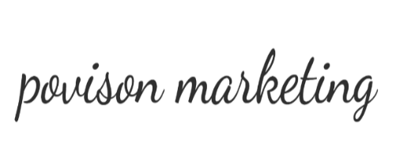


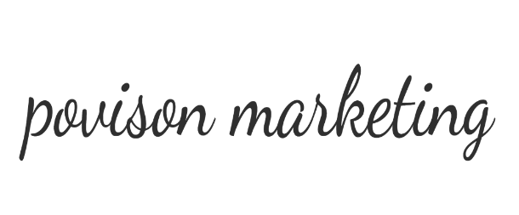
Date: ${DATE} Date:

