PROJECT PROCESS GUIDE

Membership Inference Attacks
on Federated Learning
Analysis and Privacy-Preserving Defense
Purpose
Demonstrate, with a live or reproducible experiment, how a model trained through federated learning can leak clues about whether a particular record was part of training, and then test whether a privacy defense reduces that leakage.
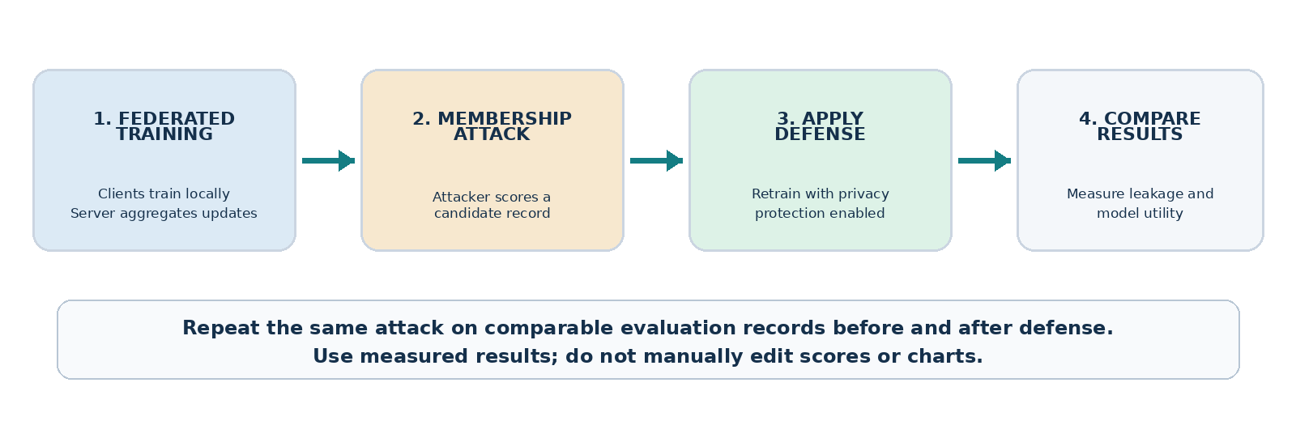
The complete story: train → attack → defend → compare
Core principle: Federated learning keeps raw records on client devices during training, but model outputs or updates can still reveal information. The demo makes that risk visible and measures what changes when protection is applied.
What the evaluator should experience
- See several clients train locally and send model updates to an aggregation server.
- Watch an attacker classify a selected record as a likely member or non-member.
- Reveal the true membership label after the prediction to check whether the attack was correct.
- Enable a privacy defense and compare measured leakage with predictive performance.

The Demonstration, Step by Step
Follow these stages in order. Each stage should produce a visible event or result, so the demo tells one connected story instead of showing unrelated charts.

1. Train the federated model
WHAT HAPPENS | Divide a public sample dataset among several simulated clients. Each client trains on its own records. The server combines client model updates into a global model and sends the new model back for the next round.
WHAT TO SHOW | Show clients, the current training round, participation, and the global model’s test accuracy or loss. Make clear that raw client records are not uploaded in this simulated protocol.
MESSAGE | “The clients collaborate to train one model without sharing their raw training records. That reduces direct data sharing, but it does not automatically guarantee membership privacy.”

2. Choose a candidate and run the attack
WHAT HAPPENS | Select one candidate record and query the trained global model. Use signals such as prediction loss or confidence to estimate whether the record was used during training. The attack produces a Member / Non-member guess and, if supported, a continuous score.
WHAT TO SHOW | Show the candidate, the target model’s predicted class, its confidence or loss, and the attacker’s separate membership prediction. After the guess is shown, reveal the hidden ground-truth membership label and whether the guess was correct.
MESSAGE | “The attacker does not need to see the raw training dataset. It uses how the model behaves on a candidate to infer whether that candidate may have been seen during training.”

3. Apply the privacy defense
WHAT HAPPENS | Train a second version of the model with a privacy defense enabled. For a record-level differential privacy demonstration, limit each individual record’s influence through per-example gradient clipping and calibrated noise during training. Calculate the privacy budget using an accounting method appropriate to the actual training process.
WHAT TO SHOW | Clearly mark that the protected model is being trained. Show the defense setting and the resulting privacy-accounting output when valid. Run the same membership attack on the same evaluation candidates.
MESSAGE | “We have changed the training process, not the chart. The attack is repeated to see whether the defense really reduces the information available about individual records.”

4. Compare the baseline and defended model
WHAT HAPPENS | Compare results from the unprotected and protected runs. Keep the membership evaluation records, attack method, and scoring procedure comparable. Report the change in attack performance alongside any change in model usefulness.
WHAT TO SHOW | Show a side-by-side baseline-versus-defense comparison, member and non-member loss distributions, an attack ROC curve or ROC-AUC, global test accuracy, and the valid privacy budget when available.
MESSAGE | “A useful defense lowers membership leakage while retaining acceptable model performance. The experiment measures both sides of this trade-off.”

How to Make the Demonstration Trustworthy

Keep membership ground truth hidden
Members were used to train the target model; non-members were excluded. Hide these labels from the attacker during evaluation, reveal them after each prediction, and then calculate the metrics.

Use a fair before-and-after comparison
- Use the same evaluation records and attack procedure before and after defense.
- Keep attack-training/calibration data separate from attack-evaluation data.
- Repeat across random seeds where practical; report variation.
- Generate charts from measured results. Label all mock values as illustrative.

Metrics to show
Metric | What it tells the audience
Attack ROC-AUC | How well the attack separates members from non-members; 0.5 is random ranking, 1.0 is perfect.
Model test accuracy / loss | Whether the global model remains useful after defense.
Privacy budget ε and δ | Formal DP guarantee, only when validly calculated for the actual protocol and privacy unit.

Important cautions
- DP may reduce but not eliminate attacks; report what the experiment measures.
- Noise alone is not a privacy guarantee: ε depends on sampling, clipping, steps, and valid accounting.
- Secure aggregation hides individual updates from the server but does not alone protect a released global model. State the attacker’s access and experiment limits.

Short presentation script
TRAIN | “Clients train locally; the server aggregates their updates.”
ATTACK | “We test whether model behavior reveals a candidate’s training membership.”
DEFEND | “We retrain with protection and repeat the same attack.”
COMPARE | “We compare measured leakage, model accuracy, and valid privacy accounting.”
Definition of a successful demo: show real federated training, an actual membership prediction, a defense that changes training, and a measured before-and-after comparison.

