Table of Contents

J-AIL

Just-in-time Artificial Intelligence Library

Executive Summary 2

J-AIL

Executive Summary

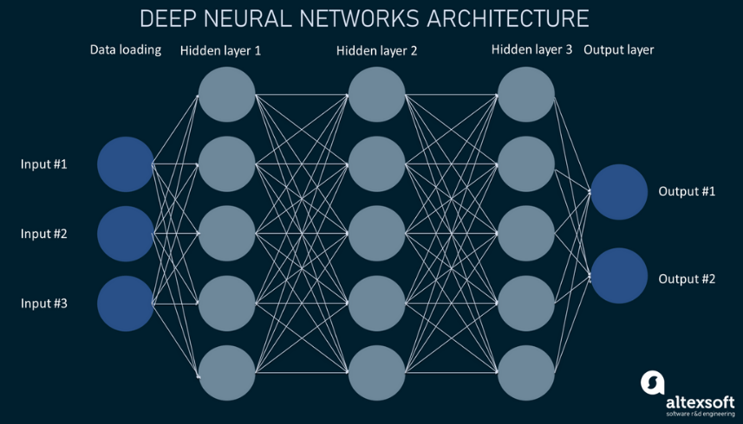Python is the leading programming language for AI development. However, its performance limitations hinder large-scale computations. Top end AI models make billions of computations per operation, and Python’s performance becomes a bottleneck. J-AIL aims to solve this bottle neck by leveraging the computational speed of C++.

In addition to performance, J-AIL aims to solve key issues found in existing AI development libraries. Many of them are bloated, complex and too generalized. By building a custom library, we can create a high-performance and lightweight toolkit tailored to our specific needs. With this tool our development team will be able to push the boundaries of AI and contribute to the future of technology.