ABESIT CRC
Training Project Documentation
Brûlée Coffee

AI-Powered Coffee Booking Platform on AWS
Name | Anurag Giri
Roll No. | 2302901550010
Branch | Internet of Things (IoT)
Subject | Advanced Cloud Computing

May 2026

1. Project Overview
Brûlée Coffee is a fully deployed, production-grade AI-powered coffee booking web application. The project was built to practically demonstrate real-world cloud deployment, containerization, database management, and CI/CD automation using industry-standard tools.

The platform allows coffee shop owners to manage their menu and view bookings via an admin panel, while customers can book coffee either through a conversational AI agent chatbot or a traditional manual form.

Live Website | http://15.206.222.83 ( will not work later)
GitHub Repo | https://github.com/Anrg-init/Ai-coffee-booking-Agent-website-
Backend API | http://13.205.138.223:8000/docs
Region | AWS Asia Pacific (Mumbai) — ap-south-1

2. Features Built

AI Agent Chatbot
- Customers can book coffee by chatting naturally with an AI barista
- Agent is built with LangGraph and powered by Groq API (Claude AI)
- Handles full booking flow: name, coffee selection, time, and confirmation
- Quick-reply chips for common actions: Menu, Book Now, Recommend, Location

Manual Booking Form
- Traditional form-based booking as an alternative to the AI agent
- Customers can select coffee, choose time, and submit directly

Live Menu
- Menu is loaded dynamically from the PostgreSQL database via API
- Displays coffee name, origin, description, price, and roast level
- Admin can add/remove/update menu items from the admin panel

Admin Panel
- Separate admin.html page for the coffee shop owner
- View all bookings placed by customers
- Add new coffees to the menu with full details

3. Tech Stack Used

Technology | Purpose
FastAPI (Python) | Backend REST API and AI agent endpoints
PostgreSQL (AWS RDS) | Database for coffees and bookings
LangGraph + Groq | AI agent framework powering the chatbot
Docker + ECR | Containerization and image registry
AWS EC2 (x2) | Frontend and backend servers
AWS RDS | Managed PostgreSQL database
AWS VPC | Private network with public/private subnets
Nginx | Web server serving frontend HTML on EC2
GitHub Actions | CI/CD pipeline for auto deployment
HTML / CSS / JS | Frontend — vanilla, served via Nginx

4. System Architecture
The application is deployed on AWS Mumbai region (ap-south-1) with a two-tier EC2 setup, managed database on RDS, and a fully automated CI/CD pipeline via GitHub Actions.

Architecture Flow:
- User visits the frontend EC2 (Elastic IP: 15.206.222.83) served by Nginx
- Frontend makes API calls to the backend EC2 (Elastic IP: 13.205.138.223:8000)
- Backend runs FastAPI inside a Docker container pulled from AWS ECR
- Backend connects to AWS RDS PostgreSQL for all data operations
- AI agent calls Groq API to generate intelligent responses
- GitHub Actions pipeline auto-deploys on every git push to main branch

5. AWS Services Used

EC2 Instances
Two EC2 t3.micro instances were created — one for the frontend and one for the backend. Both are assigned Elastic IPs so the URLs never change even after restart.

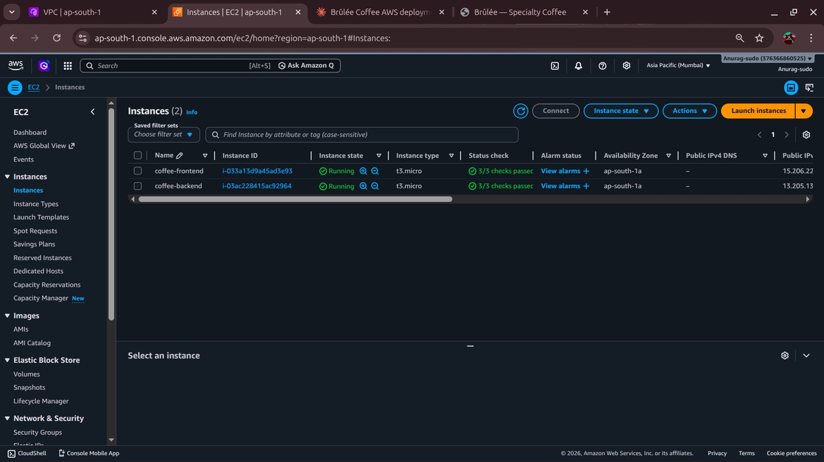
Figure 1: Both EC2 instances running in AWS Console

Elastic IPs
Static public IP addresses assigned to both EC2 instances to ensure consistent access URLs.

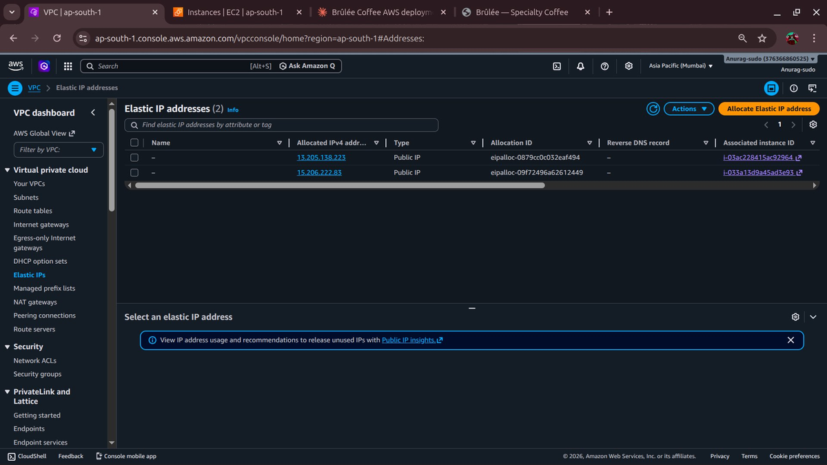
Figure 2: Elastic IP addresses assigned to EC2 instances

VPC — Virtual Private Cloud
A custom VPC (Coffee-VPC) was created with two subnets — a public subnet for the frontend EC2 and a private subnet reserved for future backend migration. Route tables and an Internet Gateway were configured for public access.

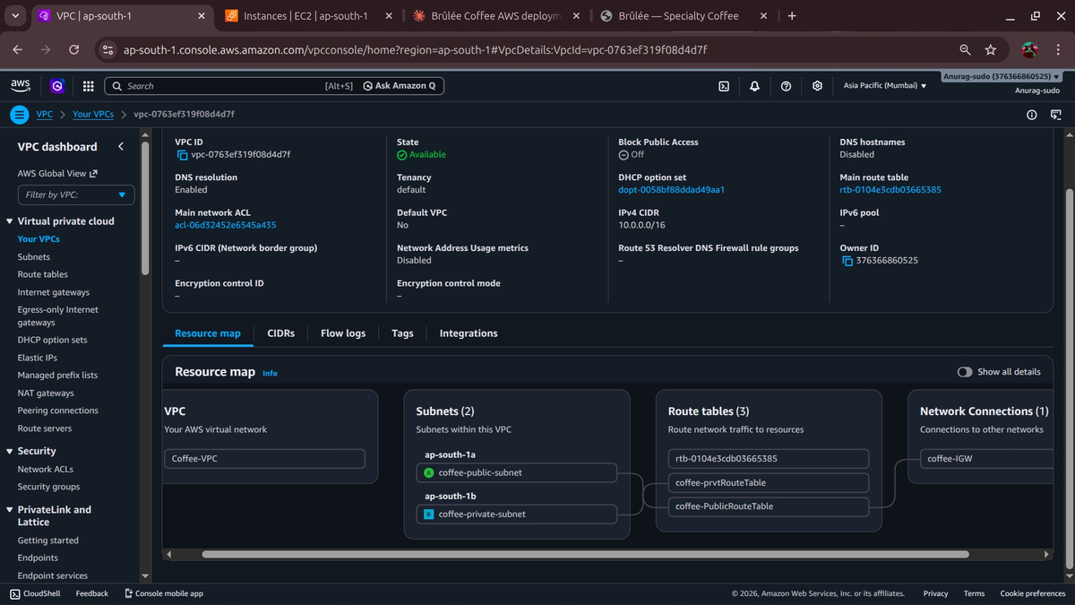
Figure 3: VPC resource map with public and private subnets

RDS — PostgreSQL Database
- Managed PostgreSQL instance: coffee-db.cfi0muysomx8.ap-south-1.rds.amazonaws.com
- Connected to backend EC2 via Security Group rules (port 5432)
- Stores all coffees and booking records
- coffee-rds-sg allows access only from the backend security group

ECR — Elastic Container Registry
- Private Docker image registry on AWS
- CI/CD pipeline builds and pushes new image on every code push
- Backend EC2 pulls the latest image from ECR on each deployment

6. CI/CD Pipeline — GitHub Actions
A fully automated deployment pipeline was set up using GitHub Actions. Every time code is pushed to the main branch, the pipeline automatically builds, pushes, and deploys the new version to the backend EC2.

Pipeline Steps:
- Step 1 — Checkout code from GitHub repository
- Step 2 — Configure AWS credentials using GitHub Secrets
- Step 3 — Authenticate with Amazon ECR
- Step 4 — Build new Docker image from the Dockerfile
- Step 5 — Push Docker image to ECR with :latest tag
- Step 6 — SSH into backend EC2 using stored private key
- Step 7 — Pull new image from ECR on the EC2 server
- Step 8 — Stop and remove old container, start new container

GitHub Secrets used (no keys stored in code):
- AWS_ACCESS_KEY_ID — AWS IAM access key
- AWS_SECRET_ACCESS_KEY — AWS IAM secret key
- EC2_HOST — Backend EC2 Elastic IP address
- EC2_SSH_KEY — Private PEM key for SSH access

7. Deployment Process
The project was deployed in 8 structured parts:

Part | Task | Description
Part 1 | Dockerize Locally | Created Dockerfile, built and tested the FastAPI backend container locally
Part 2 | Push to ECR | Pushed Docker image to AWS Elastic Container Registry
Part 3 | RDS Setup | Created managed PostgreSQL database on AWS RDS, configured security groups
Part 4 | Backend EC2 | Launched Ubuntu EC2, pulled Docker image from ECR, ran the backend container
Part 5 | Frontend EC2 | Launched Amazon Linux EC2, installed Nginx, deployed HTML frontend files
Part 6 | CI/CD Pipeline | Set up GitHub Actions workflow for automated build and deploy on git push
Part 7 | Private Subnet | VPC configured with private subnet for future backend migration (planned)
Part 8 | SSM Parameters | AWS SSM Parameter Store for secrets management (planned)

8. Live Website Screenshot
The Brûlée Coffee website is live and accessible publicly. The frontend features a clean, professional design with an AI chatbot widget, live menu loaded from the database, and two booking methods.

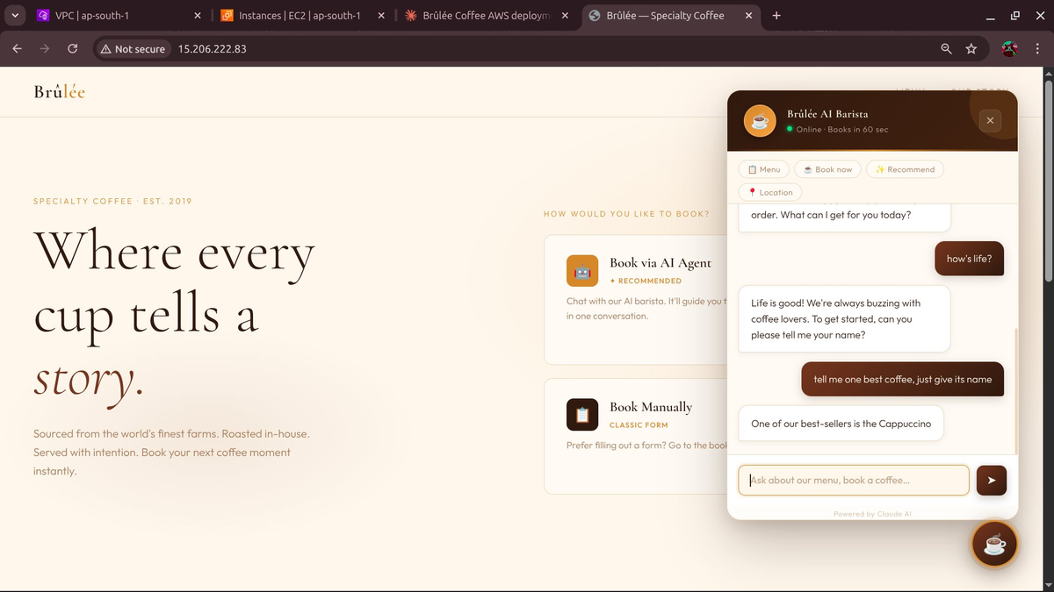
Figure 4: Brûlée Coffee live website with AI agent chatbot

The AI barista chatbot supports natural conversation:
- Greets the customer and collects their name
- Shows available coffees from the live menu
- Confirms the booking and saves it to the database
- Handles general questions about the cafe

9. Skills Demonstrated

Skill | What was done
AWS EC2 | Launched, configured, and managed two EC2 instances from scratch
AWS RDS | Created and connected a managed PostgreSQL database
AWS ECR | Built and pushed Docker images to a private container registry
AWS VPC | Designed custom VPC with public/private subnets, route tables, IGW
Docker | Containerized the FastAPI backend with a custom Dockerfile
CI/CD (GitHub Actions) | Built automated pipeline: push code → build → deploy, zero manual steps
FastAPI | Built REST API with CRUD endpoints and AI agent integration
LangGraph + Groq | Developed conversational AI agent for end-to-end coffee booking
Nginx | Configured web server on EC2 to serve static frontend
Linux / SSH | Managed EC2 servers via SSH, ran Docker commands, troubleshot issues
Security Groups | Configured port access rules for EC2 and RDS instances
Git / GitHub | Version control, branch management, secrets management

10. Project Links

Live Website | http://15.206.222.83
GitHub Repository | https://github.com/Anrg-init/Ai-coffee-booking-Agent-website-
API Documentation | http://13.205.138.223:8000/docs
AWS Region | ap-south-1 (Mumbai, India)

This project was built entirely from scratch as a practical cloud deployment exercise, implementing industry-standard tools and workflows used in real-world software development.

