RivelloMultimediaConsulting.com

info@ RivelloMultimediaConsulting.com

Tips for

Eclipse & Flex Builder 3 Optimizations

**Eclipse & Flex Builder 3 Optimizations**

1. **Add RAM to Eclipse to Speed Up Everything** (Figure 1 Below)
   * Allocate more RAM to Eclipse (PC instructions here).  Create a shortcut which you click to open Flex builder.  Odds are you already use a shortcut.
   * Right-Click the shortcut and choose ‘Properties’
   * Add these arguments to the end of the target value “-Xms=256m -Xmx=512m”  Add it **without** the quotes I’ve written though and AFTER the end of the quote that’s already in the textinput.
   * Close Eclipse and open using the shortcut from now on.
   * Simply allocating ram you may now see some speed improvements in all areas of using it.
2. **Reduce Human-Delays for Each Publish** (Figure 2 Below)
   * Setup a keyboard shortcut to publish your project instead of clicking a menu button or right clicking within the project browser.
   * See Window->Preferences->General->Keys.  Then set ‘Debug Flex Application’ to have a ‘Binding’ of something you like.  I recommend a key that is easy for your non-mouse hand.
   * If when you publish a dialog shows something like ‘Save all open files’, choose ‘autosave’ or whatever means to never see that box again.
   * Simply using a keyboard shortcut can save you a few seconds per publish and reduce fatigue.  If you don’t think it’s all that great, give it a week and see if you notice the improvement.
3. **Reduce System-Delays for Each Publish** (Figure 3.1 and 3.2 and 3.3 Below)
   * This assumes that you don’t NEED html around your application.  Many projects don’t, so don’t bother spawning your project in a browser window.
   * This may be faster, which is good, and it also doesn’t ‘steal’ your browser from you as Flex Builder likes to do.  My instructions are for ‘debug’ which is the operation I use to publish most often.  You can also apply these directions to ‘run’ and ‘profile’ as you see fit.
   * Assuming you are in the Flex Developer perspective, Click the arrow next to the bug icon (Figure 3.1).  Choose ‘other’ from the menu, then change the ‘URL or path to launch’ for ‘debug’ to the .swf not the .html extension.  See Figure 3.2.  If you don’t like the size of the window change the compiler parameters to a larger window by right clicking your project and choosing properties ->Flex compiler.  Add “-default-size 800 600 “ (without the quotes). See Figure 3.3.
   * Simply not spawning an html window should reduce the system delays for each publish by 1 second or so.

**FIGURE 1**

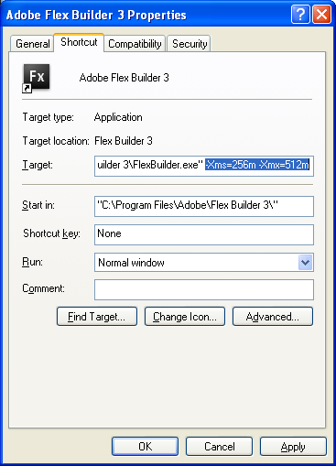

**FIGURE 2**

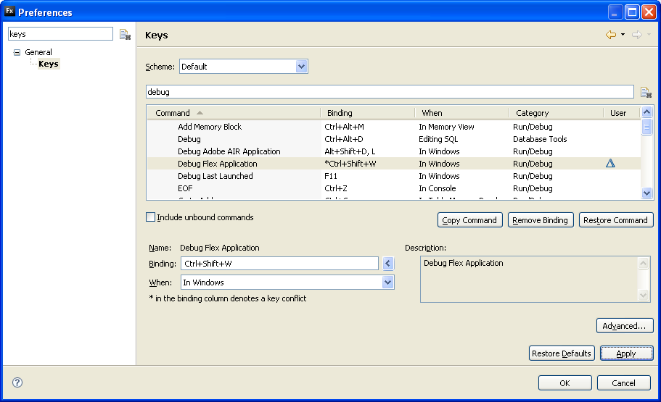

**FIGURE 3.1**

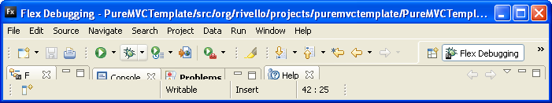

**FIGURE 3.2**

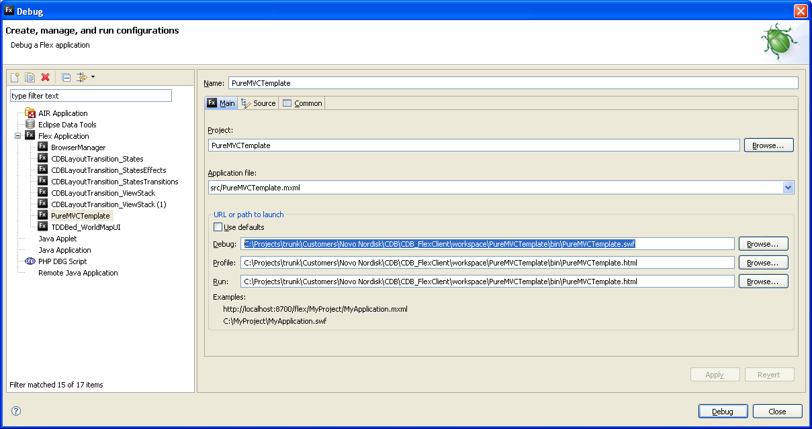

**FIGURE 3.3**

