**3. Preparing and segmenting the single monkey anatomical image**

Overview:

FreeSurfer is a set of automated tools for reconstruction of the brain’s cortical surface from structural MRI data, and overlay of functional MRI data onto the reconstructed surface. This chapter is meant to be an introduction to the first part. For overlaying functional data onto the reconstructed surface, please review chapter 11C.

You should have a high-contrast, low noise MPRAGE of your monkey's brain for the reconstruction. We typically use 0.4 mm isotropic voxel resolution, and scan between 12 to 16 times (each scan runs for 15 minutes) to generate a good mean image. The raw images are normally in DICOM format. You could convert DICOMs into NIFTIs by following the procedure in chapter 2B. Then you can do the averaging to generate the mean image and following steps to reconstruct the cortical surface in FreeSurfer.

Step 1: Starting up FreeSurfer

FreeSurfer is installed on all the LINUX machines. To be able to uses the FreeSurfer tools type in the command:

**>> source /fmri/bashrc**

**>> source freesurfer-5.0.0**

Make sure that the variable SUBJECTS_DIR is set to /data/fmri_monkey_raw/fs/subjects.

This can be checked and changed by the command:

check: **>> echo $SUBJECTS_DIR**

change: **>> setenv SUBJECTS_DIR /data/fmri_monkey_raw/fs/subjects**

Now you can use the tools of freesurfer by typing them on the command line. (e.g. mri_convert, mri_info, recon-all, tkmedit, tksurfer, tkregister2, ....).

*Note: info about the tools can be obtained by typing in the tool name on the command line without any arguments. More info can also be found on the FreeSurfer wikipage:*

*http://surfer.nmr.mgh.harvard.edu/fswiki*

Step 2: Average several runs to generate the mean image

This is done once using the following command:

**mri_motion_correct.fsl -o rawavg.mgz -i 001.nii –i 002.nii –i 003.nii (-i 004.nii –i 005.nii ……)**

The inputs and output can be any format accepted by mri_convert.

This command will have the same effect as you do arithmetic averaging on the consol of the Siemens scanner. The only difference is that this command will also check if all input images perfectly aligned with each other. If not, motion correction will be performed before averaging.

Step 3: Correct for sphinx position and scale the voxel size to 1x1x1 mm

The orientation information in the mean image (rawavg.mgz) is derived from the DICOM file that you got from the scanner. It’s wrong for the monkeys, because the monkey was in the scanner in the ‘sphinx’ position instead of head-first-supine (HFS).

In addition, FreeSurfer wants 1mm isotropic voxels, but your images are 0.4 mm iso, so if you ask FreeSurfer to work with them, it will have to downsample them to 1mm. To avoid this, you can only change the header information of the data, instead of changing the data itself.

You can correct for the orientation information and scale the voxel size at one time by using the following command:

**mri_convert -i rawavg.mgz -o orig.mgz --in_orientation <ostring> -iis 1 -ijs 1 -iks 1**

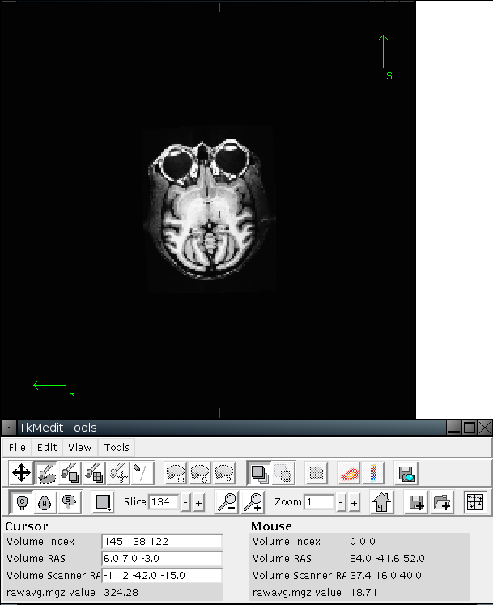*Note:*

1. *Ostring means orientation string (ostring). It has three letters that roughly describe how the volume is oriented. The first character of ostring determines the direction of increasing column. The second character of ostring determines the direction of increasing row. The third character of ostring determines the direction of increasing slice.*

*You can check the actual orientation of your data by using the following command:*

***Tkmedit –f rawavg.mgz***

*This command will bring you a window to show the brain in different view, and a TKMedit Tools menu with the “volume index information” on it. By moving your mouse around the volume window, you can change the* ***volume index*** *value in the* ***mouse*** *panel. The direction (according to the brain) along which you can increase the first (second or third) value of the volume index is the direction for the first (second or third) character of the ostring.* ***Be careful about the left/right orientation.*** *Since you cannot read it easily from the image itself, you need to confirm it through other markers.*

1. *Check the voxel size of your rawavg.mgz carefully. If it is 0.4 mm iso (it’s the case for most of our anatomical images), you can directly scale them to 1x1x1 mm. But if the voxel size is different, you need to resample your rawavg.mgz into 0.4 mm iso resolution, to keep your scale ratio consistent with all the other anatomies. You can do this through this command:*

**mri_convert -i rawavg.mgz -o rawavg2.mgz –vs 0.4 0.4 0.4**

*then rawavg2.mgz will be your input for the upper command.*

Step 4: Crop the matrix to 256x256x256 around the center of the brain

In the following steps, Freesurfer will automatically crop the matrix of your data to 256x256x256. To avoid some unknown problems, you’d better crop it by yourself. You can do it with the following command:

**mri_convert -i orig.mgz -o origfinal.mgz --crop 160 160 160 --conform –nc**

Theoretically, --crop <x> <y> <z> will ask the program to crop the matrix to 256 around center (x,y,z), but it doesn’t works very well. Try to play around this parameter to put your image centered in the middle.

Step 5: Run the first step of recon-all.

**recon-all -i origfinal.mgz -subjid <subjid> -autorecon1 -no-wsgcaatlas -wsthresh 30**

*Note:*

1. *You can see the help information of recon-all for individual steps that will be run during this step, by typing recon-all without any argument.*
2. *This command will Import your data (original.mgz) and create a subject data directory named <subjid> under $SUBJECTS_DIR folder. The outputs of this step (as well as all the outputs from the following steps) will be all put to this <subjid> folder. Once this folder is created, you do not need to use the -i flags again.*
3. *Check the skull strip when this command is done*

***Tkmedit*** ***<subjid> brainmask.mgz –aux T1.mgz***

*If the skull strip is bad, you can adjust the –wsthresh parameters to fix it. If you want the algorithm to be more conservative (i.e. if part of the brain has been removed), you can make the number larger. If you want the algorithm to be more aggressive (i.e. part of the skull has been left behind), you can make the number smaller. For redoing the skull strip, you can run:*

***recon-all -subjid <subjid> -skullstrip -no-wsgcaatlas -wsthresh 35 -clean-bm***

*If the skull stripping process has left just a few slices with either missing brain regions or too much skull you can edit these manually using tkmedit.*

***Tkmedit <subjid> brainmask.mgz –aux T1.mgz***

*If part of the brain is missing, in the tkmedit toolbar, you can go to:*

***Tools -> Configure Volume Brush...***

*Set Mode to "Clone", and Clone Source to "Aux Volume". Click the Close button to close the configuration window. You can also change the size and shape of your brush, to do this go to:*

***Tools -> Configure Brush Info...***

*Select a radius and shape that you are comfortable using. Close the configuration menu, and click the "Edit Voxels" button in tkmedit toolbar.*

*Use Ctrl-1 and Ctrl-2 to cycle between the two volumes. Find a place in the image where the cerebellum is missing in the output volume, and then use the middle button on the mouse to paint in cerebellum from the auxiliary volume. Cycle back and forth between the volumes frequently so you know where you are.*

*Continue painting until the slice is no longer missing part of the brain. Repeat for the other slices in the output volume.*

***Go to File -> Save Main Volume As... and save your output****.*

*If there are small pieces of skull still remaining on only a few slices you can manually remove the voxels. To do this make sure that the "Edit Voxels" button is still selected. Removing voxels is very similar to painting in voxels, except you use the right mouse button instead of the middle button. Use Ctrl-1 and Ctrl-2 to cycle between the volumes. Find a place in the image where skull remains. Use the right mouse button to delete the voxels. Continue on the other slices until all skull is removed. Save your volume.*

*For more details, please check:*

*http://surfer.nmr.mgh.harvard.edu/fswiki/FsTutorial/SkullStripFix*

Step 6: Run segmentation

This step will cut the hemispheres from each other and the brainstem from the brain. For monkey the cutting planes are not set in the right place automatically. So you need to specify the seed points.

For the –cc-crs, pick a point (mouse button-1) in the corpus callosum and verify with both the horizontal view and the coronal view that your cursor is central in all three views. Once you have a good point you can use the volume index of this point as coordinate.

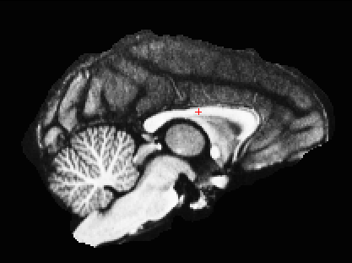 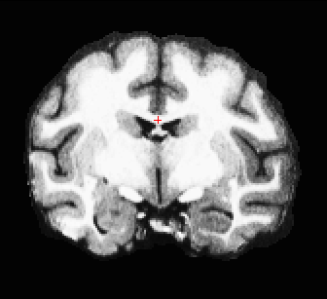 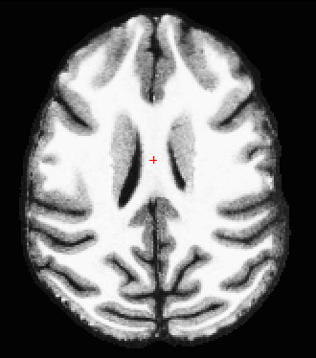

For the –pons-crs, find a horizontal slice in which the white matter of the brainstem is disconnected from the rest of the brain. This slice should be near the top of the pons. Click on a point (left mouse button) and verify in both the sagittal and the coronal views that your cursor is in the center of the pons.

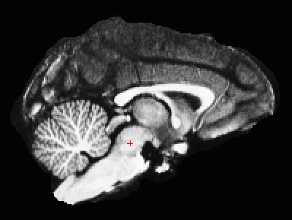 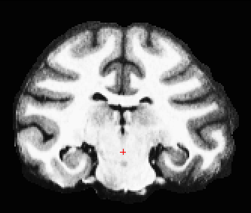 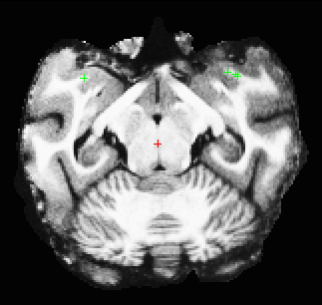

Then run:

**recon-all -s <subjid> -autorecon2-inflate1 -noaseg -cc-crs <x> <y> <z> -pons-crs <x> <y> <z>**

When it is done, check the initial automatic segmentation and add control points to the place where the segmentation failed (white matters that are excluded from the surface) by using the following command:

**tkmedit <subjid> wm.mgz –aux T1.mgz –surface rh.smoothwm.nofix –aux-surface lh.smoothwm.nofix**

Scroll through this subject and find the location where the white matter is being excluded from the surface. The volumes that you marked will subsequently be normalized to an intensity of 110 (normalized intensity for white matter).

To add control points you will first need to select the Edit Control Points tool.

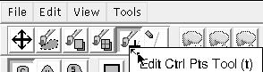

Middle-mouse-button clicking will create a control point; right-button clicking will delete a control point. As you select control points, they will appear as small green crosshairs. Select a few control points around your trouble areas, space them out throughout the brain and on different slices.

For more information, please check:

http://surfer.nmr.mgh.harvard.edu/fswiki/FsTutorial/ControlPoints

After adding control points to every necessary place, you can run the following commands to redo the segmentation:

**recon-all -s <subjid> -autorecon2-inflate1 -noaseg -cc-crs <x> <y> <z> -pons-crs <x> <y> <z>**

*Note: you should use the same –cc-crs and –pons-crs coordinates as you used for the first segmentation.*

Repeat adjusting control points and redoing the segmentation, until you cannot benefit much anymore. Then edit the white matter manually if it is necessary (which normally will be the case).

For editing white matter, just use the same command as adding control points, go over all the slices, use Ctrl-1 and Ctrl-2 to switch back and forth between the T1 and wm volumes to check if some voxels that should be white matter are excluded, or if some voxels that should not be white matter are included in error. For the former case, click on the Edit Voxels Tool button , then go to “Tools --> Configure Brush Info” to set the radius and shape of the brush, then use the middle button on your mouse to begin painting in the voxels on the white matter (wm) volume. By default tkmedit will edit on the main volume loaded, if the wm volume is loaded as your aux volume you will need to select Aux volume as the Target for the brush. If you fill in too many voxels, the right mouse button acts as an eraser. For the latter case, just use the right mouse to delete those voxels.

You can also use the following tksurfer command to open the surface in another window to help you pinpoint the bad segmented regions.

**tksurfer <subjid> rh inflated.nofix**

On the surface, you can click the left mouse to mark the region that you want to fix, and then use “save point” to save the coordinate of this point. Through “Goto saved point” in the tkmedit tool menu, you can find the corresponded region on the volume.

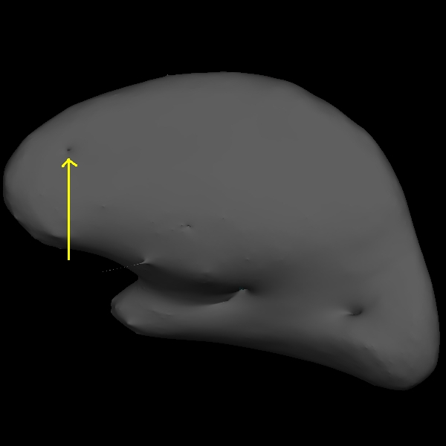 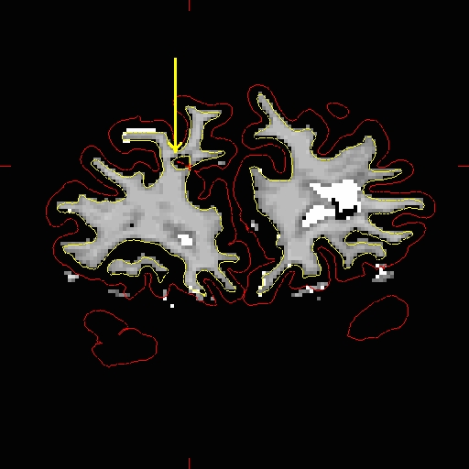

 

Some small problems, for example, small protrusions or small dimples on the surface, can be fixed by the automatic topology fix in the following step. You don’t need to manually fix them all.



But for a defect like that shows in the figure on the right side, you’d better manually get rid of them. This defect is caused by too much gray matter being left by the segmentation. This essentially connects two adjacent strands of white matter, creating a “bridge” or “handle” on the surface. By marking either side of the “bridge foundation”, and use the “Goto saved point” in tkmedit, you can pinpoint the problems.

For more information, please check:

http://surfer.nmr.mgh.harvard.edu/fswiki/FsTutorial/WhiteMatterEdits

Step 7: Inflate the surface

After you are satisfied with the wm segmentation, you can run the following command to do the final inflating.

If you added the control points, re-run the inflated1 step, then edited the white matter, then you can run:

**recon-all -s <subjid> -autorecon2-wm -noaseg -cc-crs <x> <y> <z> -pons-crs <x> <y> <z>**

If your image quality is good enough that you only need to add the control points, and you also want to directly do the final inflating step without editing white matter, you can use the following command:

**recon-all -s <subjid> -autorecon2-cp -noaseg -cc-crs <x> <y> <z> -pons-crs <x> <y> <z>**

*Note: This step will run for serveral hours (~10 hours). When it finished, you need to check the inflated surface to see if more mannual work (adding more control points or editing the white matter segmentation) need to be done.*