Block Diagram:

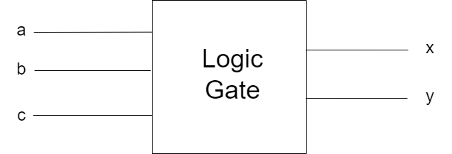

Circuit Diagram:

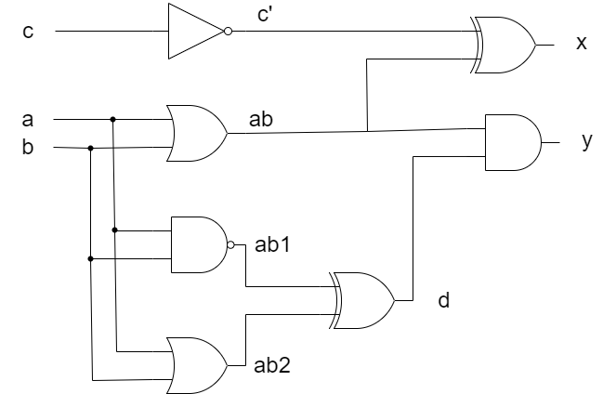

Truth Table:

|  |  |  |  |  |  |  |  |  |  |
| --- | --- | --- | --- | --- | --- | --- | --- | --- | --- |
| a | b | c | c’ | ab | ab1 | ab2 | d | x | y |
| 0 | 0 | 0 | 1 | 0 | 1 | 0 | 1 | 1 | 0 |
| 0 | 0 | 1 | 0 | 0 | 1 | 0 | 1 | 0 | 0 |
| 0 | 1 | 0 | 1 | 1 | 1 | 1 | 0 | 0 | 0 |
| 0 | 1 | 1 | 0 | 1 | 1 | 1 | 0 | 1 | 0 |
| 1 | 0 | 0 | 1 | 1 | 1 | 1 | 0 | 0 | 0 |
| 1 | 0 | 1 | 0 | 1 | 1 | 1 | 0 | 1 | 0 |
| 1 | 1 | 0 | 1 | 1 | 0 | 1 | 1 | 0 | 1 |
| 1 | 1 | 1 | 0 | 1 | 0 | 1 | 1 | 1 | 1 |

Errors in code:

* First error was syntax error in listing 4.
* Assign was not used before sum in line 08.
* In list 5 code there were syntax error and end was not used.
* In start carry1 variable was not declare.