**EXPERIMENT NO.6**

**Sequential Circuit Design**

SUBMITTED TO:

Dr. Ubaid Ullah Fayyaz

SUBMITTED BY:

Ans Qasim

2022-EE-171

**UNIVERSITY OF ENGINEERING & TECHNOLOGY, LAHORE**

Hand sketched diagram:

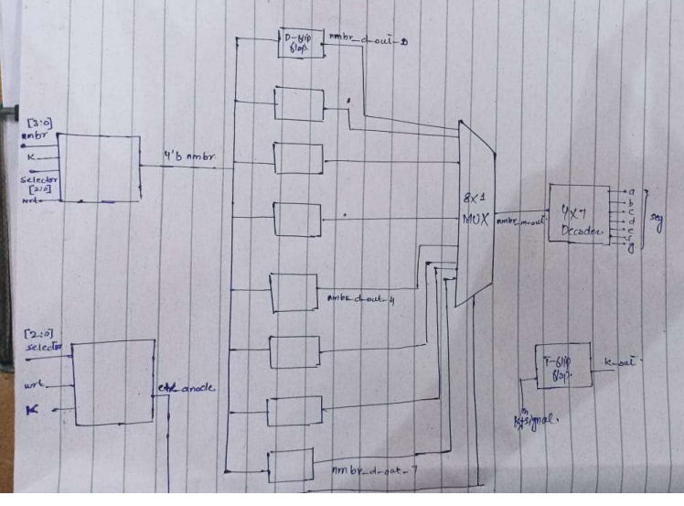

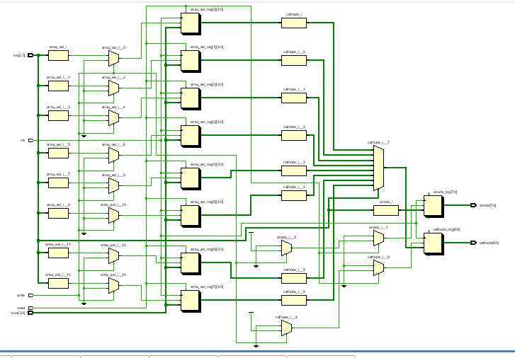

Synthesis Combinational Delay:

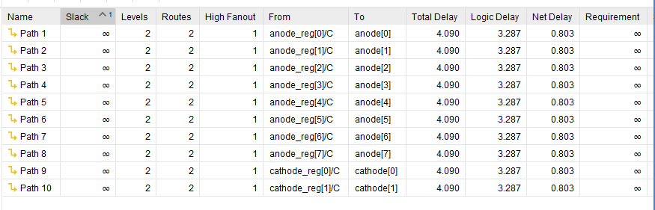

Implementation Combinational Delay:

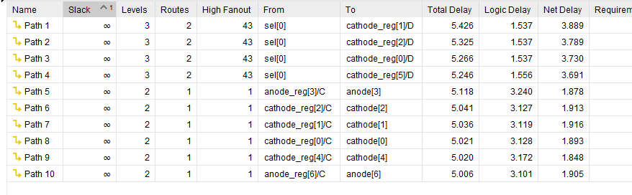

Path 1 has the maximum combinational delay.

**Resources Utilization Summary:**

