**EXPERIMENT NO.4**

**COMBINATIONAL CIRCUIT DESIGN USING K-MAPS**

SUBMITTED TO:

Dr. Ubaid Ullah Fayyaz

SUBMITTED BY:

Ans Qasim

2022-EE-171

**UNIVERSITY OF ENGINEERING & TECHNOLOGY, LAHORE**

**Truth Table:**

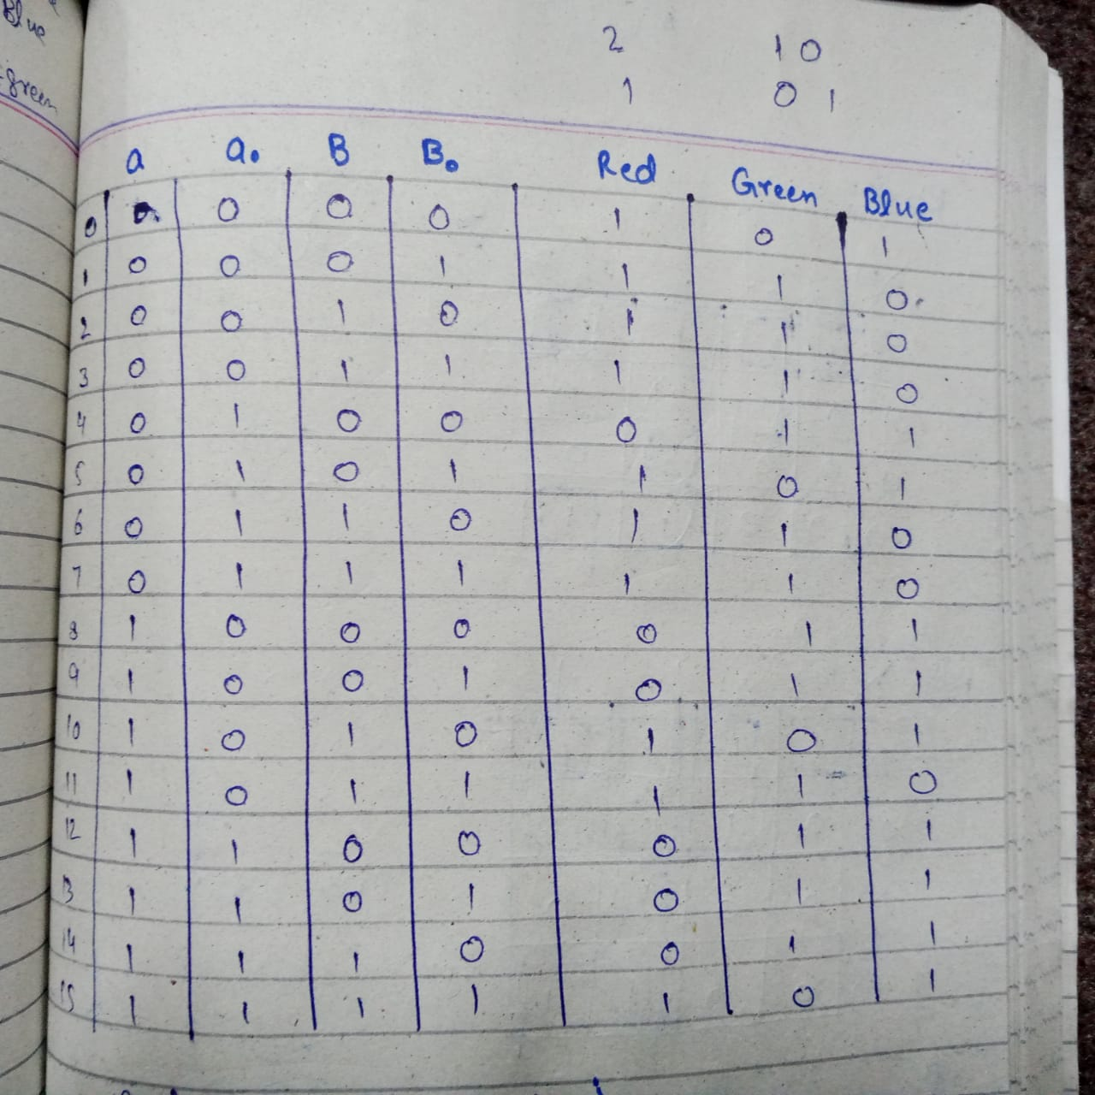

K-maps:

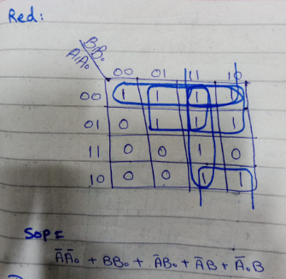

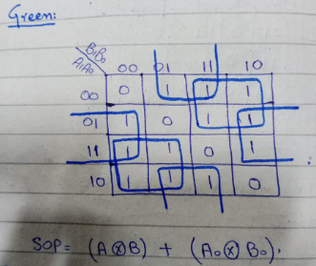

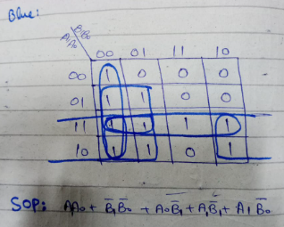

Circuit Diagram:

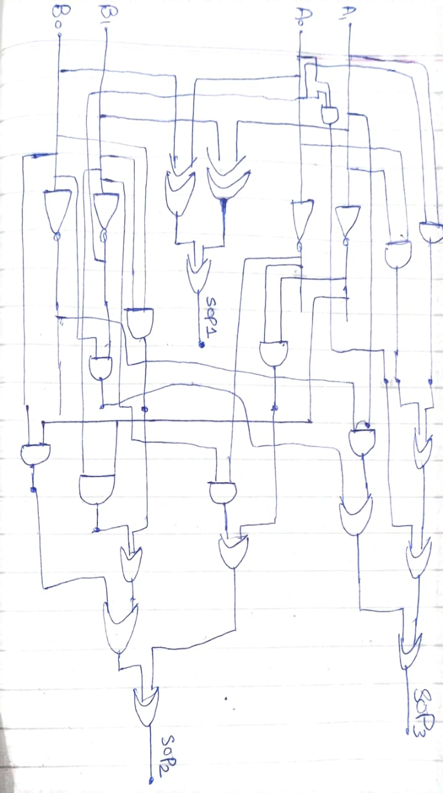

Circuit diagram using vivado:

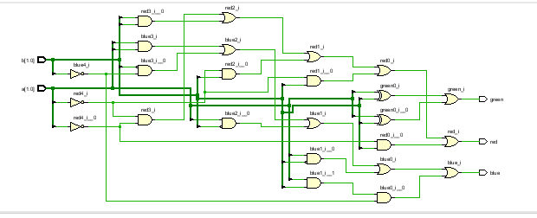

Delay in synthesis:

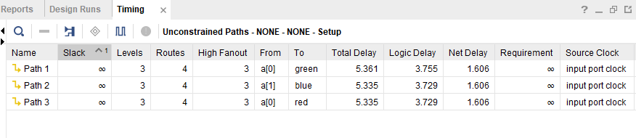

Resource Utilization:

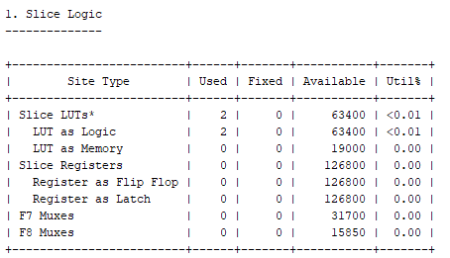

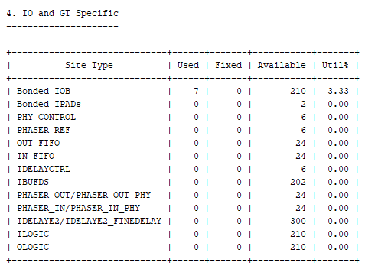

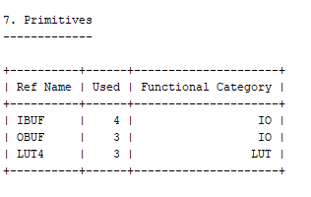

**System Verilog Code:**

