SMARTPHONE RECOMMENDATION SYSTEM
Content-Based • Utility-Based • Hybrid
Recommender Systems Mini-Project | Group 6 | October 2026

Group Members
Student | University ID
Shadi Dhaifallah Al-Zaidi | 451110617
Mohammed Majed Al-Bakhit | 451110579
Anas Ibrahim Al-Mutairi | 461110105
Abdulaziz Zayed Al-Mutairi | 461110104
Real Dataset: Global Mobile Phone Specifications & Prices 2026 (Kaggle)
Data currency: BDT (Bangladeshi taka), NOT Saudi riyal or USD. Prices are source listings and not live quotations.

1. Introduction and Problem Definition
A smartphone recommendation system helps users choose phones under a budget while accounting for device attributes and individual preferences. Different users prioritize gaming memory, camera resolution, battery capacity, or a balanced feature mix.
Problem: Given a catalog of devices with comparable attributes, a user-selected budget and preference profile, produce the five highest-ranked valid smartphones. The project implements three distinct approaches and compares their rankings without claiming predictive accuracy.

2. Project Objectives
- Build Content-Based Filtering with cosine similarity over standardized phone specifications.
Gaming ranking uses memory/storage proxies rather than measured CPU/GPU benchmark performance; users should not interpret it as a hardware gaming benchmark.
- Build a Utility-Based scoring model with interpretable preference weights and affordability.
- Combine both methods into an adjustable Hybrid recommender.
- Demonstrate actual rankings from the downloaded dataset and document their limitations.

3. Dataset and Provenance
Dataset: Global Mobile Phone Specifications & Prices 2026 by UTSHO DEY, available at https://www.kaggle.com/datasets/utsh0dey/global-mobile-phone-specifications-and-prices. The user-supplied ZIP contains 6,620 original records and 168 source columns. The catalog includes tablets, feature phones and wearables, so it must be filtered for smartphone recommendations.
Processing stage | Rows
Original published file | 6,620
Smartphones or Mobiles labeled by source | 5,457
Usable catalog after price validation and de-duplication | 4627
Under sample budget BDT 30,000 | 2802

4. Preprocessing and Feature Engineering
- Keep General_Device categories Smartphones and Mobiles; exclude tablets and wearables.
- Extract numeric listed prices from the Price strings, denominated in Bangladeshi taka (৳). When multiple listed amounts occur, the leading listed price is used.
- Extract the leading numeric values of RAM, internal storage, battery, rear camera and screen size from text fields. Compound specifications can be ambiguous.
- Convert source Rating on a 0–10 scale to an approximate 0–5 representation by dividing by two.
- Exclude prices outside the valid positive range; remove duplicate brand–model records.
Additional runtime domain screening: retain known RAM in 2–32 GB, storage in 16–2048 GB, battery in 2,500–20,000 mAh, main camera in 2–250 MP, display in 5–9 inches and rating in 0–5. Missing fields remain eligible for median imputation. These are educational plausibility thresholds, not proof of accurate source specifications.
- Impute missing specification features using the catalog median and apply Min–Max normalization for method scoring.
Important limitation: leading numeric parsing of multiple hardware variants does not fully capture variant-dependent price and storage differences. The source appears to include historical and regional listed prices. Recommendations are educational, not purchasing advice.
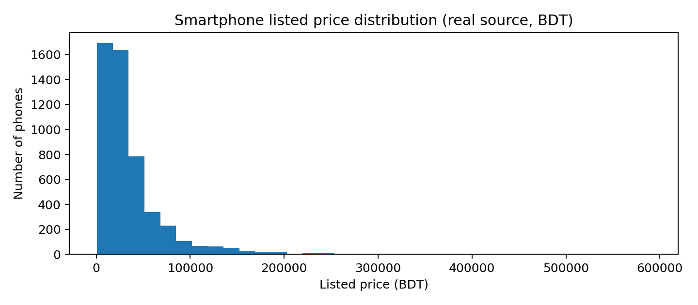

5. Recommendation Methods

5.1 Content-Based Filtering
Each candidate is represented by normalized RAM, storage, battery, camera, screen size and rating. The method calculates cosine similarity with a selected reference phone or priority-profile target vector. Similarities are scaled within budget-eligible candidates to [0, 1].
Cosine similarity(a,b) = (a · b) / (||a|| ||b||).

5.2 Utility-Based Recommendation
Utility scores combine user-weighted feature quality and affordability. For priority-specific weights w_i, Q = Σ(w_i × normalized_feature_i). Affordability A = max(0, 1 − price/budget). The utility score is U = 0.8Q + 0.2A. Different priority profiles use different weights.

5.3 Hybrid Recommendation
The final combined score is H = α × normalized_content_similarity + (1 − α) × U. Default α = 0.50. The interface permits changing α. Scores represent heuristic rankings, not probabilities or evaluation accuracy.

5.4 Recommended System Flow
Load approved CSV → validate/filter source devices → parse attributes and normalize → apply budget constraints → compute content, utility and hybrid scores → sort scores → display Top-5 candidates.

6. Implementation
Python 3 implementation uses pandas, NumPy, scikit-learn and Streamlit. src/recommender.py handles preprocessing and recommendation logic; app.py is an interactive interface; run_cli.py provides a terminal runner.
- Install packages: pip install -r requirements.txt
- Run GUI: streamlit run app.py
- Run CLI: python run_cli.py --budget 30000 --priority gaming --method hybrid
- Dataset CSV: data/phones_2026_real_bdt.csv
The program accepts a maximum budget in BDT, main priority (balanced, gaming, camera or battery), recommendation method, and optional reference phone. Budget constraints are applied before Top-N ranking.

7. Real Dataset Results
Fixed demonstration setup: budget BDT 30,000; gaming preference; five recommendations. This section reports actual program outputs on the processed real Kaggle catalog, not synthetic records.
Rank | Device | Price (BDT) | Hybrid Score
1 | Xiaomi Redmi Turbo 3 | 28,000 | 0.689
2 | Xiaomi Redmi Note 12R Pro | 28,000 | 0.682
3 | T-Mobile REVVL 7 Pro | 15,000 | 0.669
4 | Oscal Pilot 3 | 30,000 | 0.669
5 | Motorola Edge 60s | 30,000 | 0.667

8. Evaluation and Comparison
For the gaming example, 2,802 of the 4,627 usable phones satisfy the budget filter. Content vs. Utility overlap@5 = 0.00. Mean listed price of Hybrid top-5 = BDT 26,200; mean rescaled source rating = 3.86/5.
These are descriptive statistics: recommendation relevance, precision@K, recall@K and NDCG cannot be validated without a trusted user-preference ground truth. Since no such labels are present, the work avoids unsupported accuracy claims.
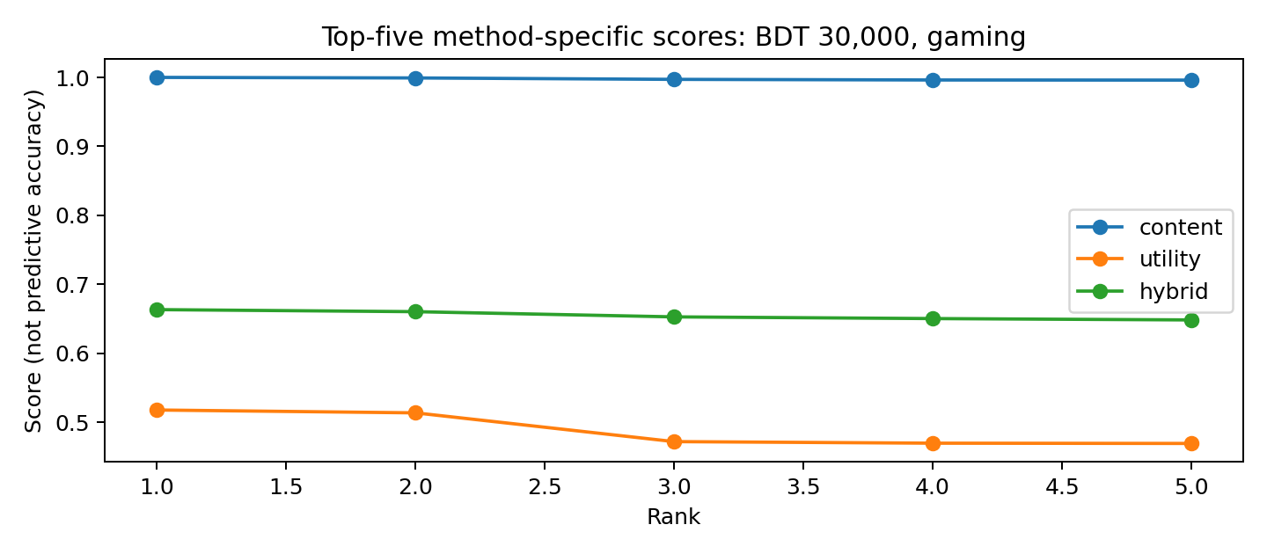
Method | Strength | Limit
Content-Based | Similarity of catalog attributes | Requires meaningful feature targets
Utility-Based | Transparent weighted trade-offs | User weights are subjective
Hybrid | Combines similarity and utility | Not proven superior by relevance labels

9. Comparison Across User Priorities
Preference | Eligible | Content/Utility overlap@5 | Hybrid mean price BDT
Balanced | 2802 | 0.00 | 20,598
Gaming | 2802 | 0.00 | 26,200
Camera | 2802 | 0.00 | 26,600
Battery | 2802 | 0.00 | 17,200
The ranking varies when weights change from gaming to camera, battery or balanced. Such descriptive variation indicates that the preference controls affect the recommendation outcome; it does not establish user satisfaction or objective superiority.

10. Conclusion and Future Work
The project implements Content-Based, Utility-Based and Hybrid smartphone recommendations on a real dataset. After excluding non-phone device categories and invalid/deduplicated price records, 4,627 catalog rows remain. Real-data results replace earlier synthetic demonstrations. Limitations include text-based feature extraction, missing/ambiguous variants, historical regional prices, and lack of labeled relevance data.
Future work: manually validate compound specifications; localize source prices to the Saudi market with reliable timestamps; collect user preference judgments; tune algorithm weights on a separate development set and measure held-out ranking effectiveness.

11. References
- UTSHO DEY. Global Mobile Phone Specifications & Prices (2026). Kaggle. https://www.kaggle.com/datasets/utsh0dey/global-mobile-phone-specifications-and-prices
- Ricci, F., Rokach, L., & Shapira, B. (eds.) Recommender Systems Handbook. Springer.
- scikit-learn. cosine_similarity API documentation. https://scikit-learn.org/stable/modules/generated/sklearn.metrics.pairwise.cosine_similarity.html
- Streamlit Documentation. https://docs.streamlit.io/
Revision note (October 2026): Original processed Kaggle CSV kept unchanged; runtime domain checks now screen out clearly implausible/feature-phone records. All numerical tables in this report were regenerated on the filtered catalog. Scores are heuristic and are not precision/recall or validated accuracy.

