**Figures**

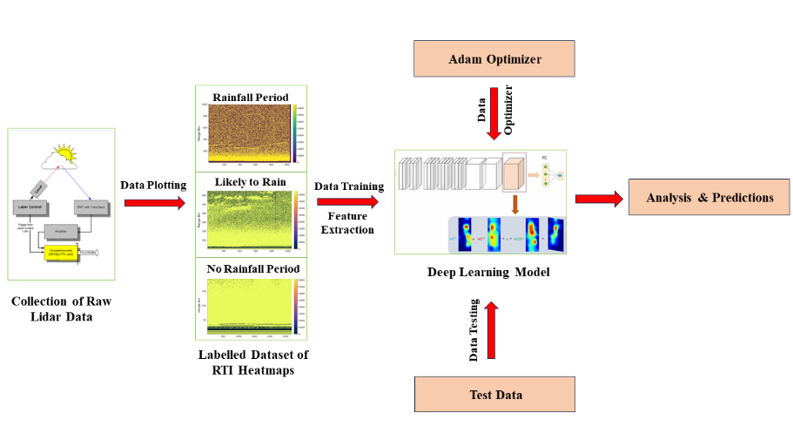**Fig. 1. Architectural Representation of Proposed Methodology**

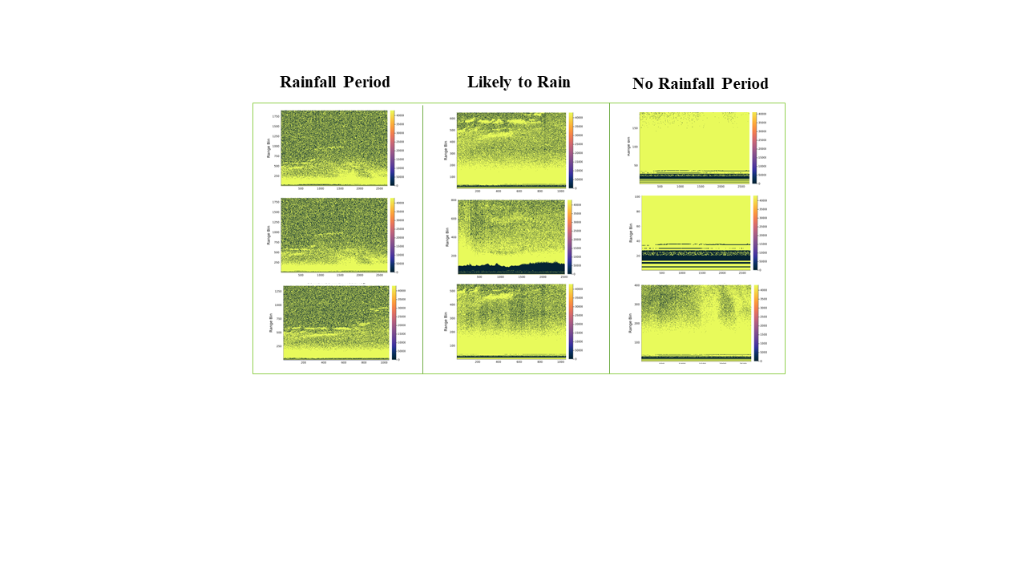**Fig. 2.** **A Sample Representation of Dataset**

**Fig. 3.** **A Sample Representation of Preprocessed RTI Signal Map Images**

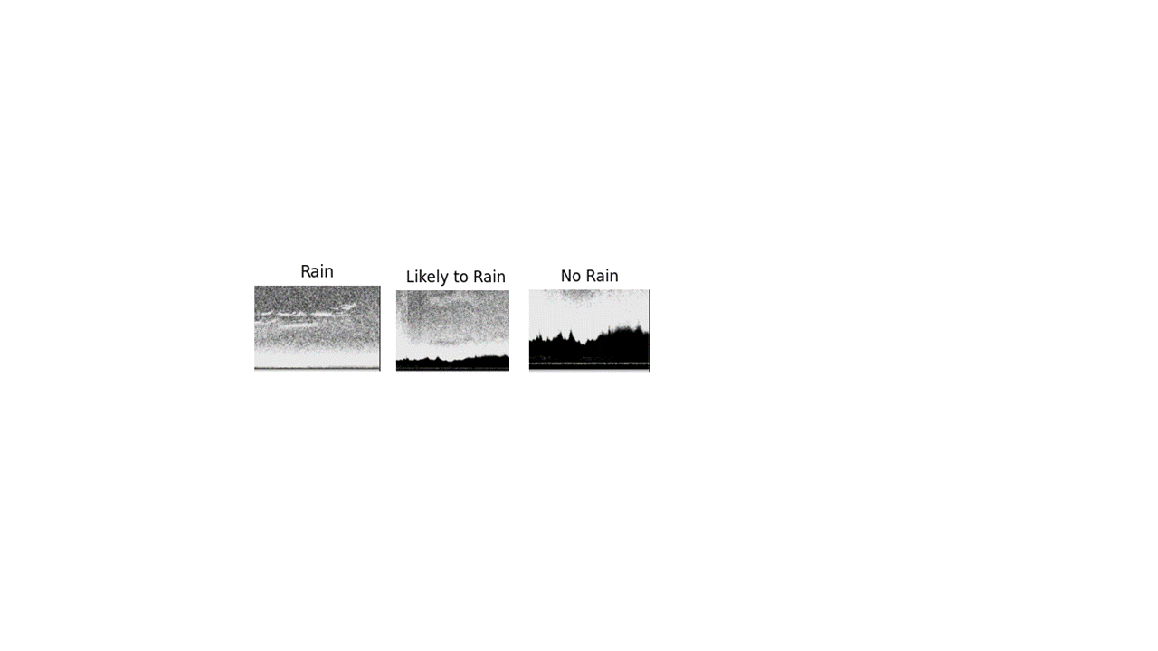

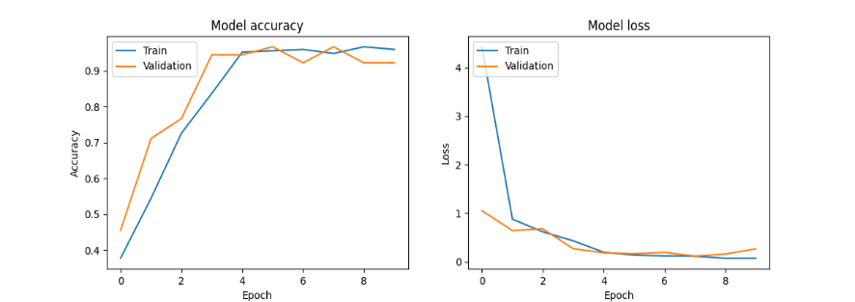 **Fig. 4. Graphical Representation of the Training Performance**

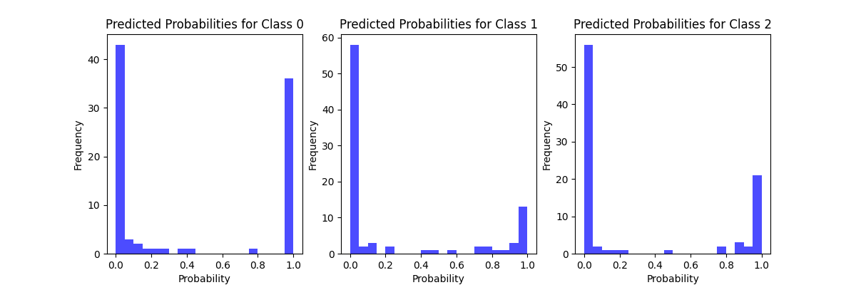 **Fig. 5. Graphical Representation of Predicted Probability Distribution**

**~~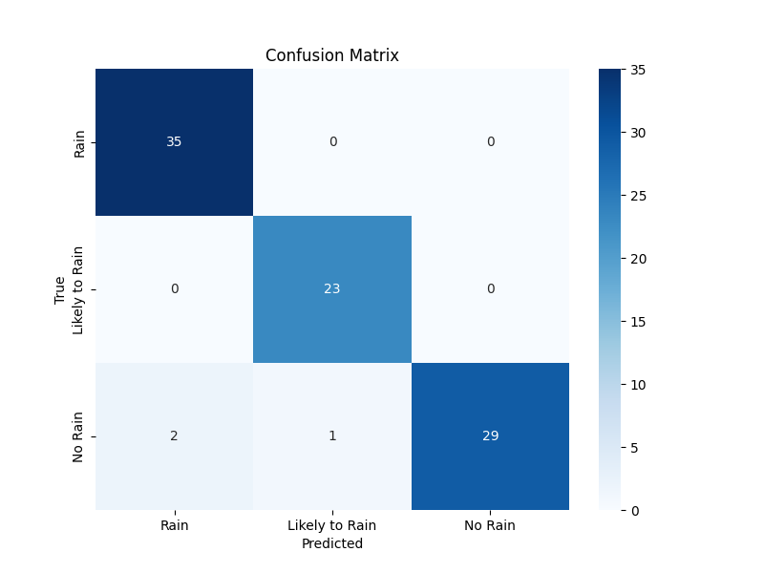~~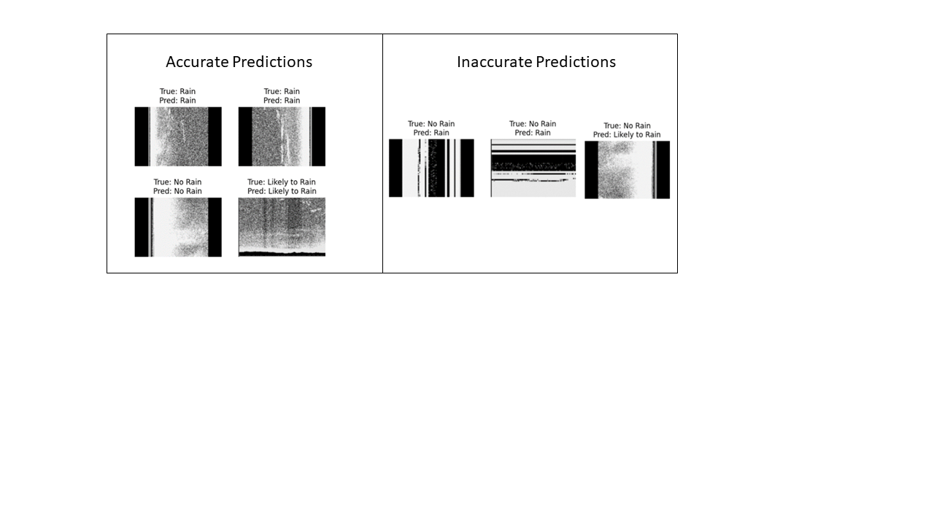 Fig. 6. Confusion Matrix of the Model with Sample Accurate and Inaccurate Predictions**

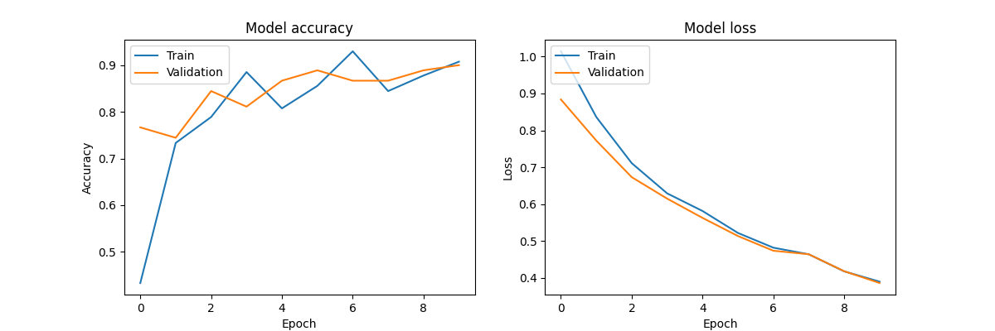 **Fig. 7. Graphical Representation of the Training Performance – VGG16 Model**

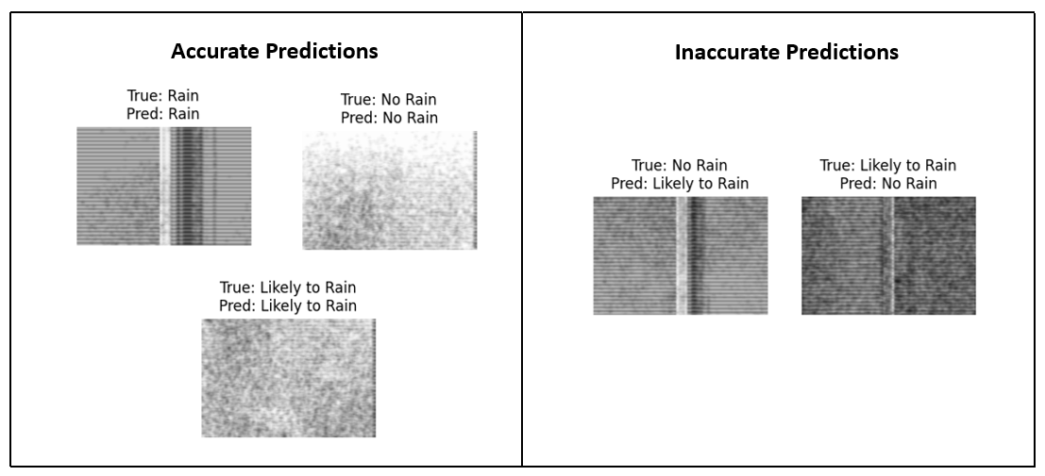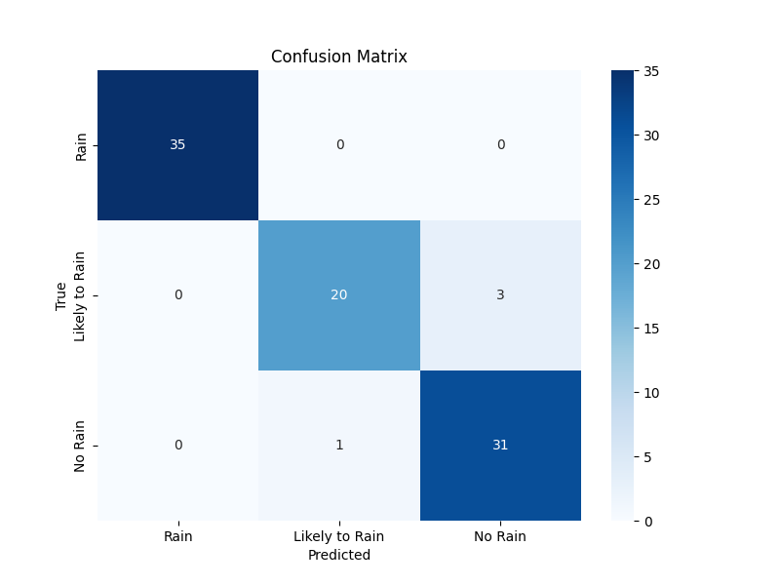**Fig. 8. Confusion Matrix with Sample Accurate and Inaccurate Predictions – VGG16 Model**

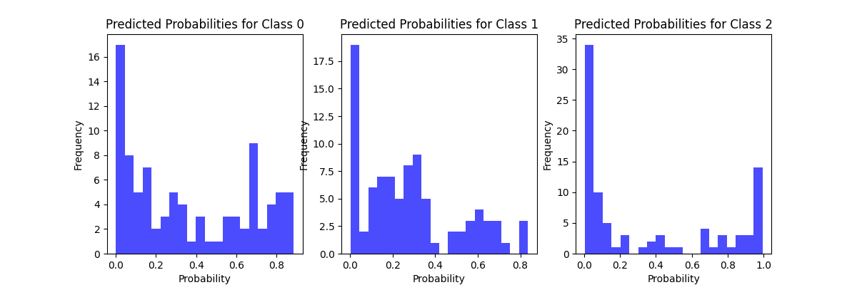**Fig. 9. Graphical Representation of Predicted Probability Distribution – VGG16 Model**

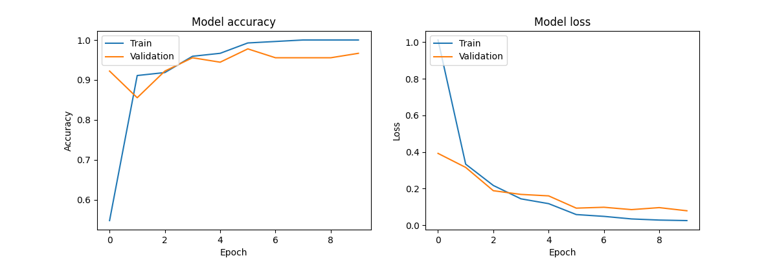 **Fig. 10. Graphical Representation of the Training Performance – InceptionV3 Model**

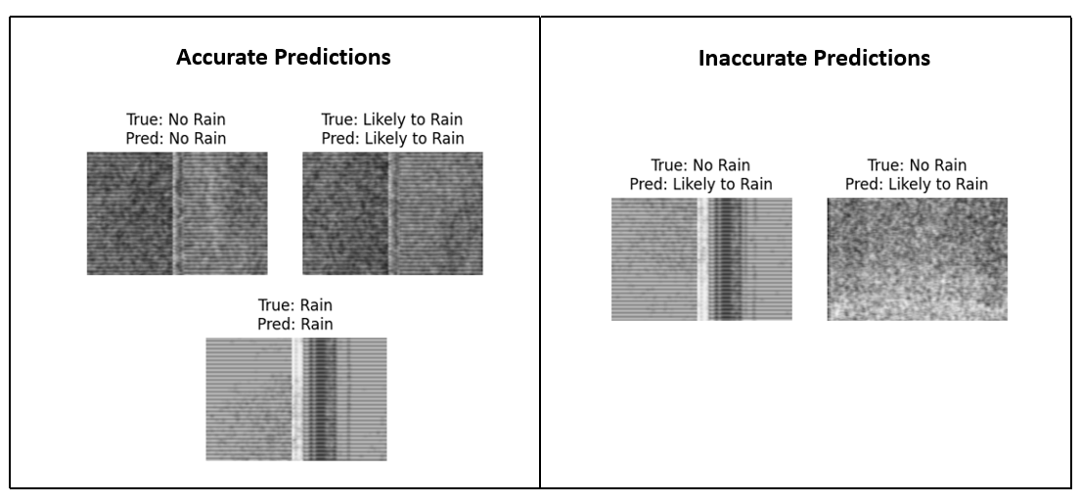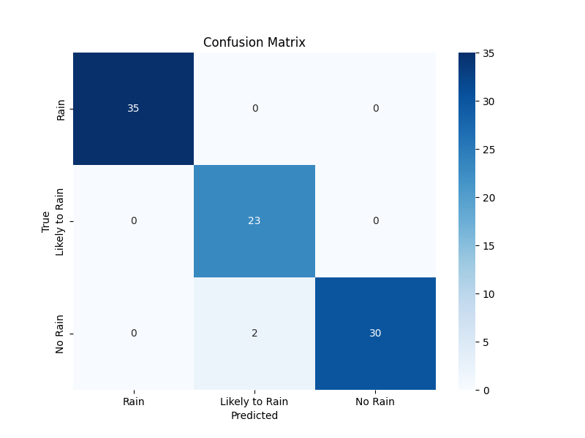**Fig. 11. Confusion Matrix with Sample Accurate and Inaccurate Predictions – InceptionV3 Model**

**Fig. 12. Graphical Representation of Predicted Probability Distribution – InceptionV3 Model**

