Custom Report Customization

This step-by-step guide can be used as a Generic one for customizing new reports. For reference, we have to create new custom template in Jaspersoft studio according to client requirements. Please refer this guide carefully while you make change to new custom reports.
Link to download JasperSoft Studio:
https://community.jaspersoft.com/download-jaspersoft/community-edition/

Steps to create new custom report in JasperSoft Studio:
- Open the TIBCO jaspersoftclick on File click on New and then click on jasper report.
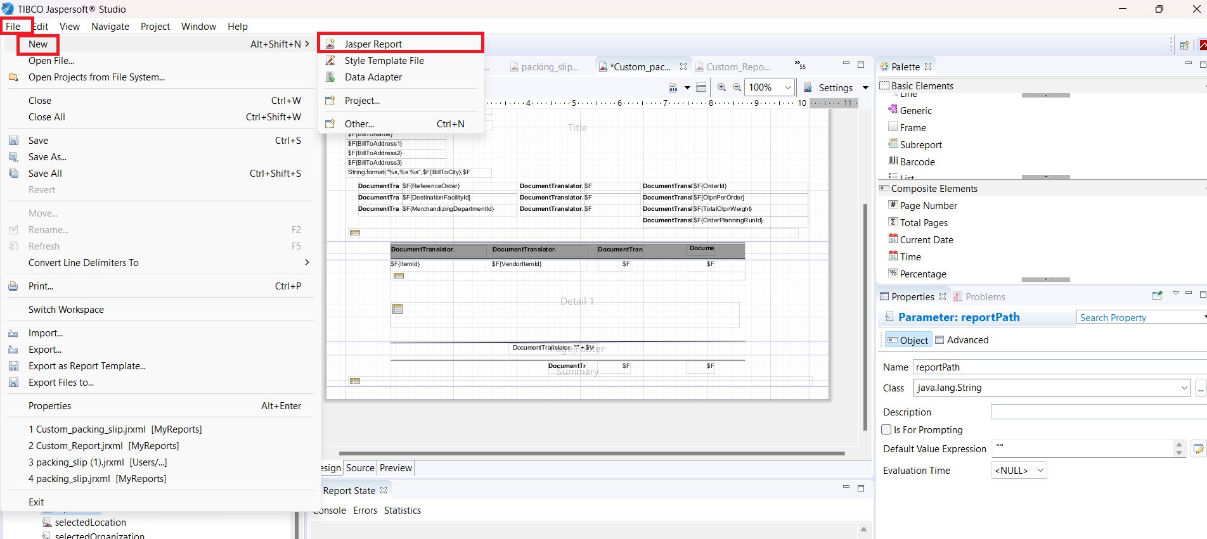

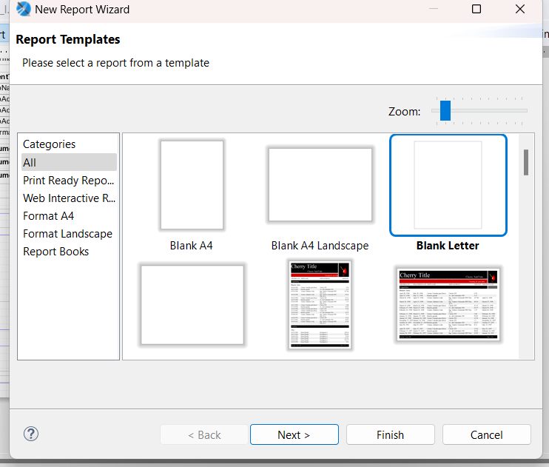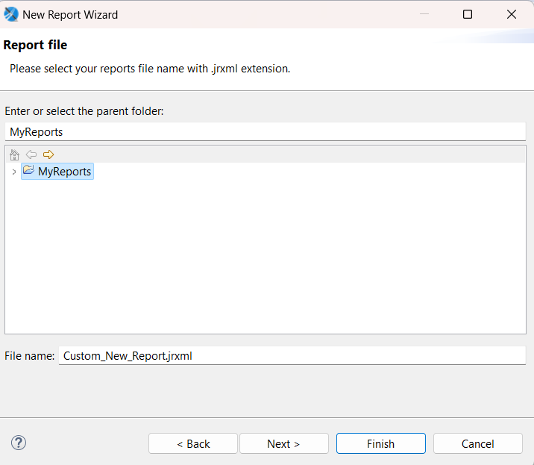

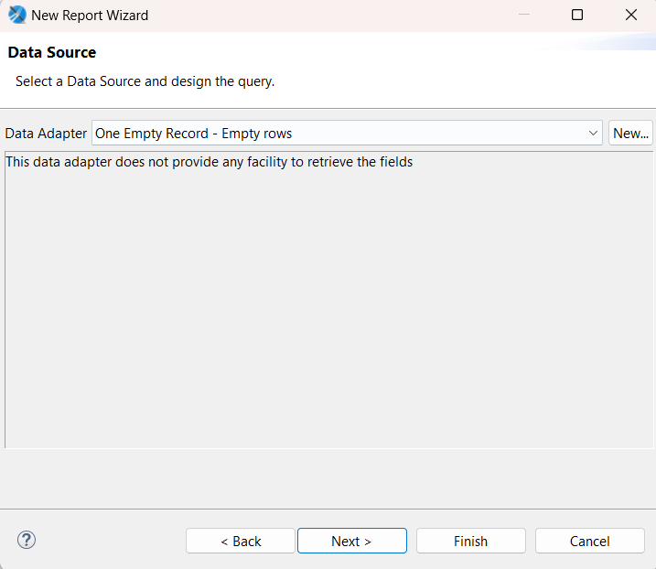
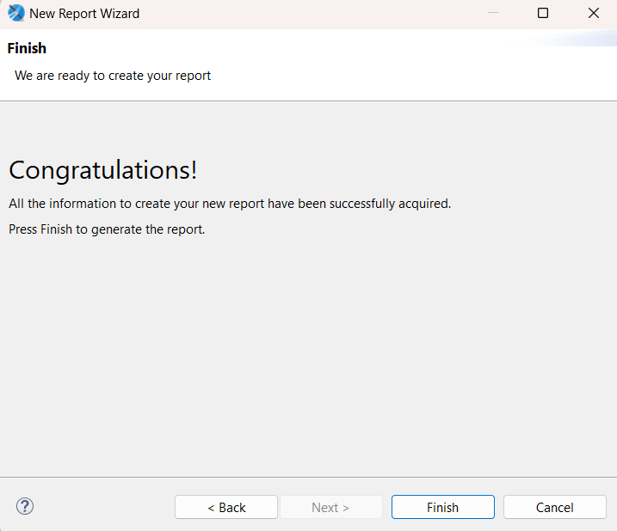

- Steps to add data adapter

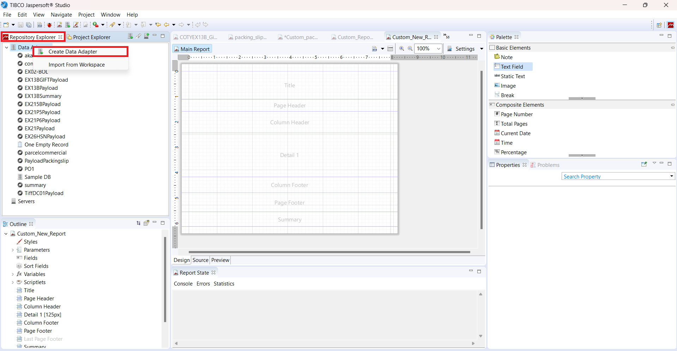

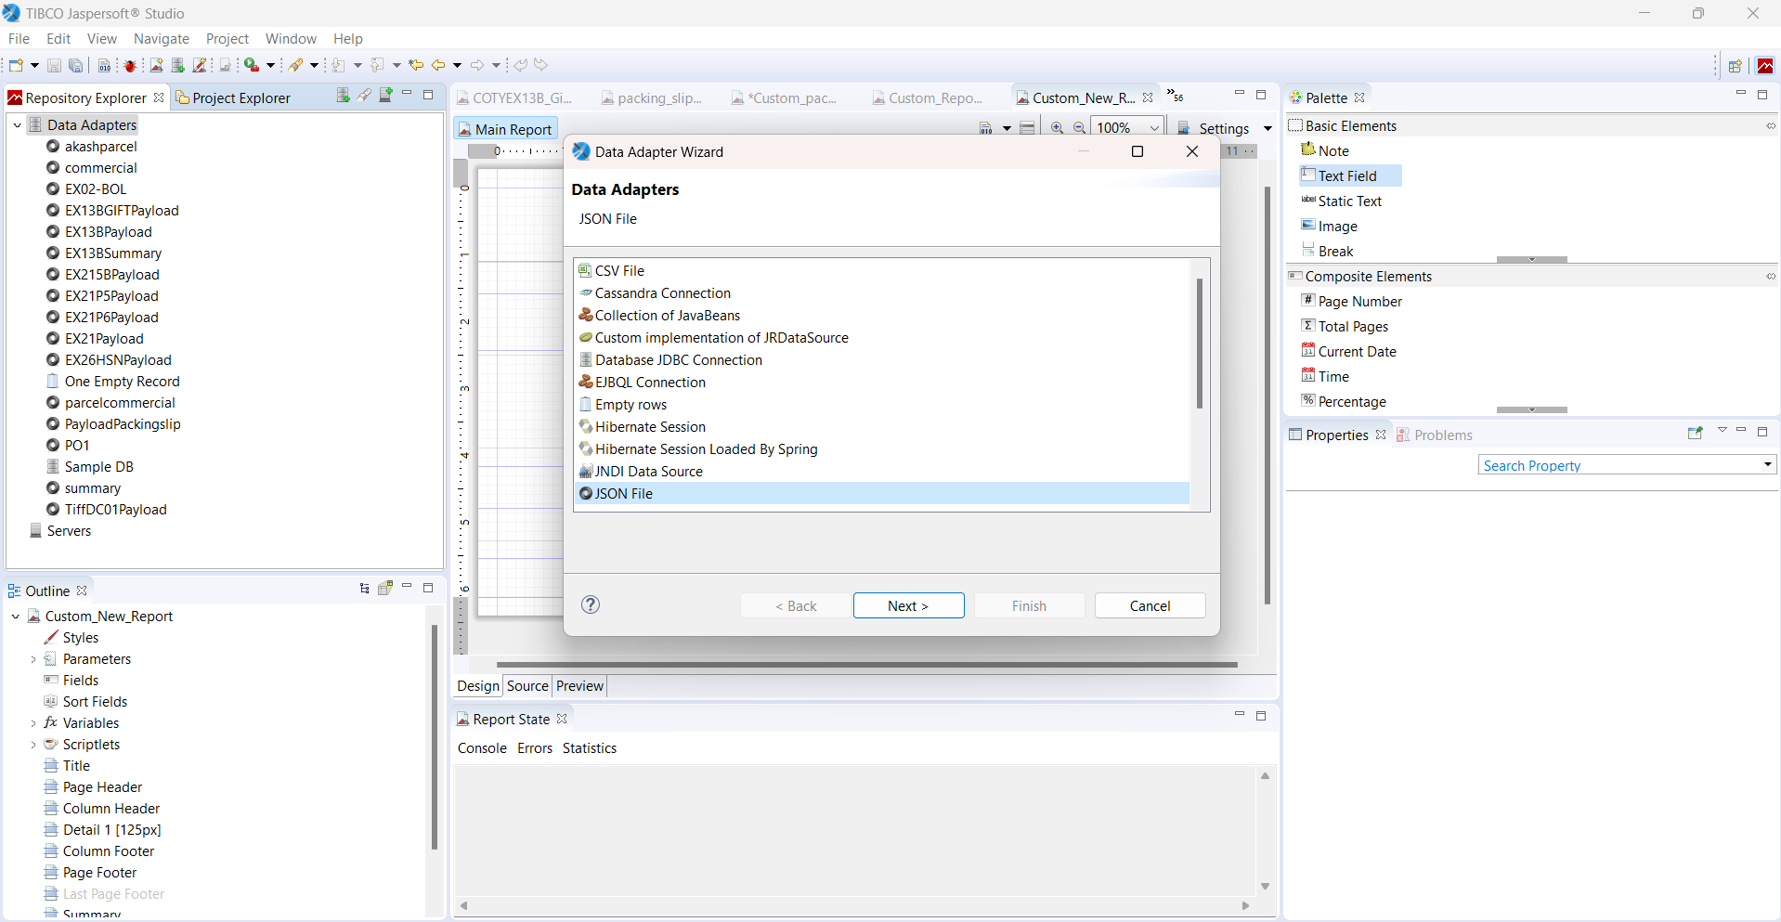

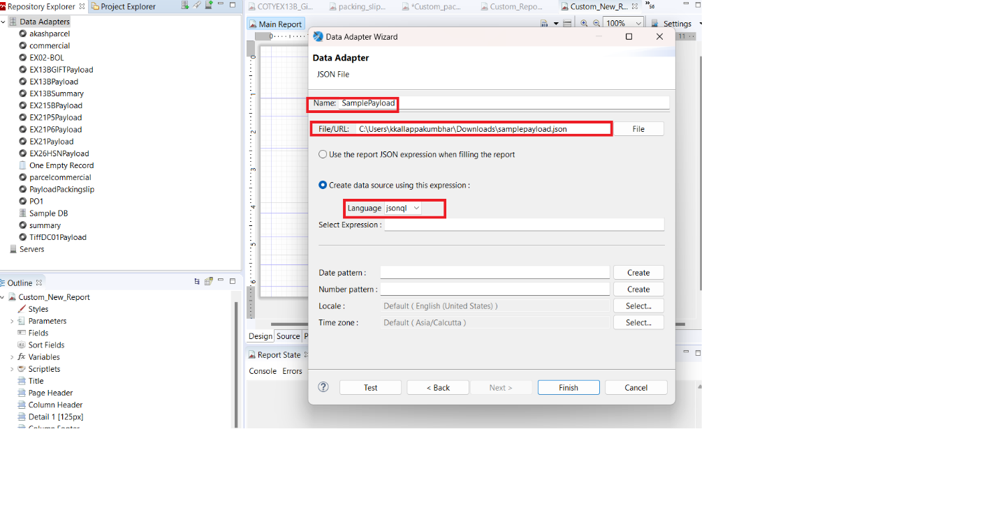

- A new custom Report will be displayed. We can then make all the required customizations on this report.
- Before making changes, we will set up datasets and query i.e. json file and language and then click on Read Fields.
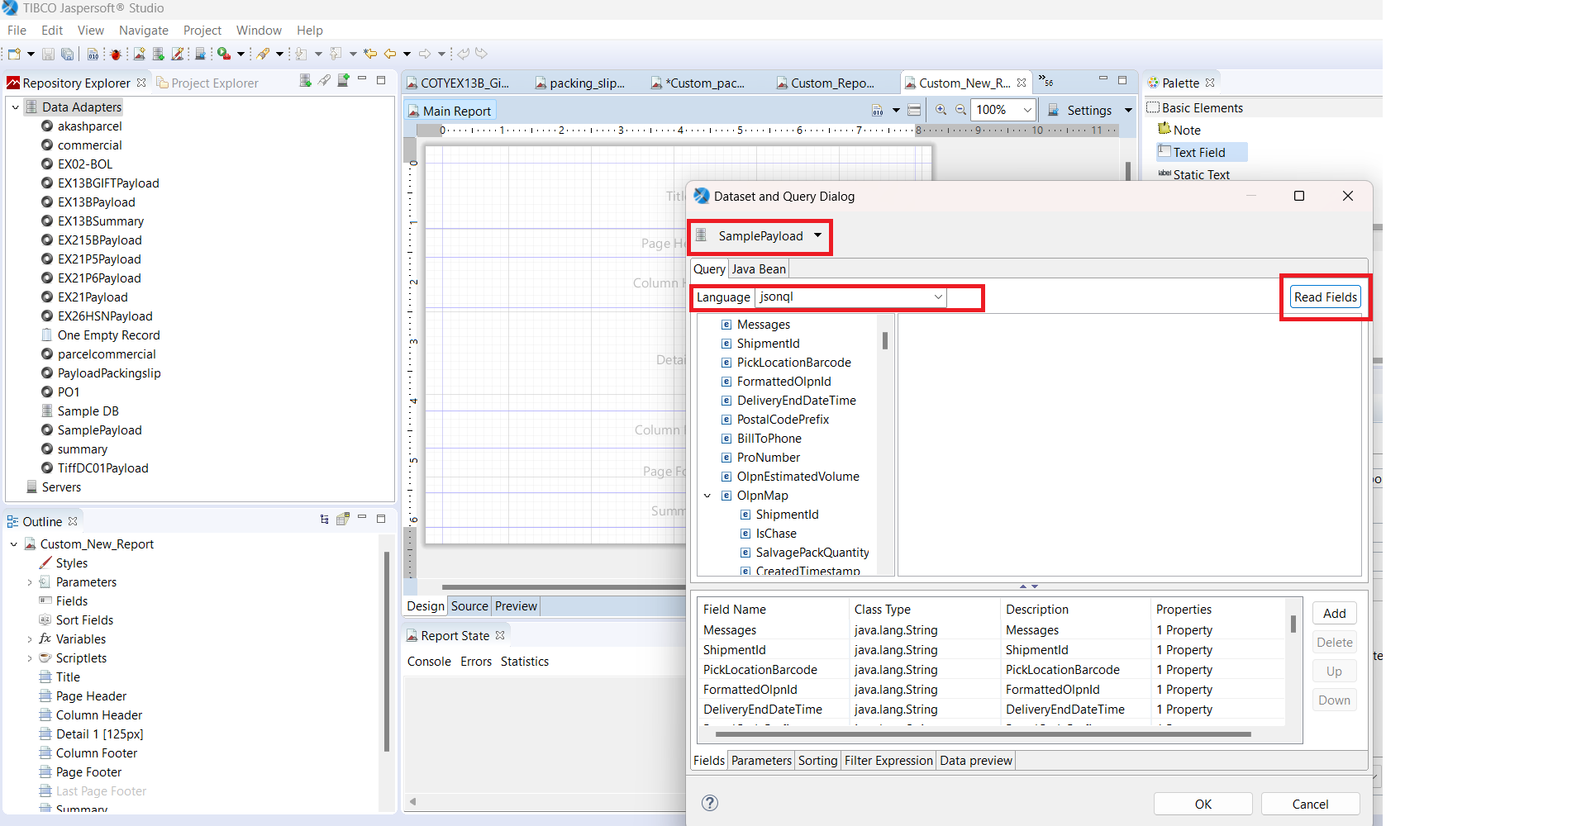

- For example, if we want to add static field then we select “Static Text” and just drag and drop from Basic Elements.
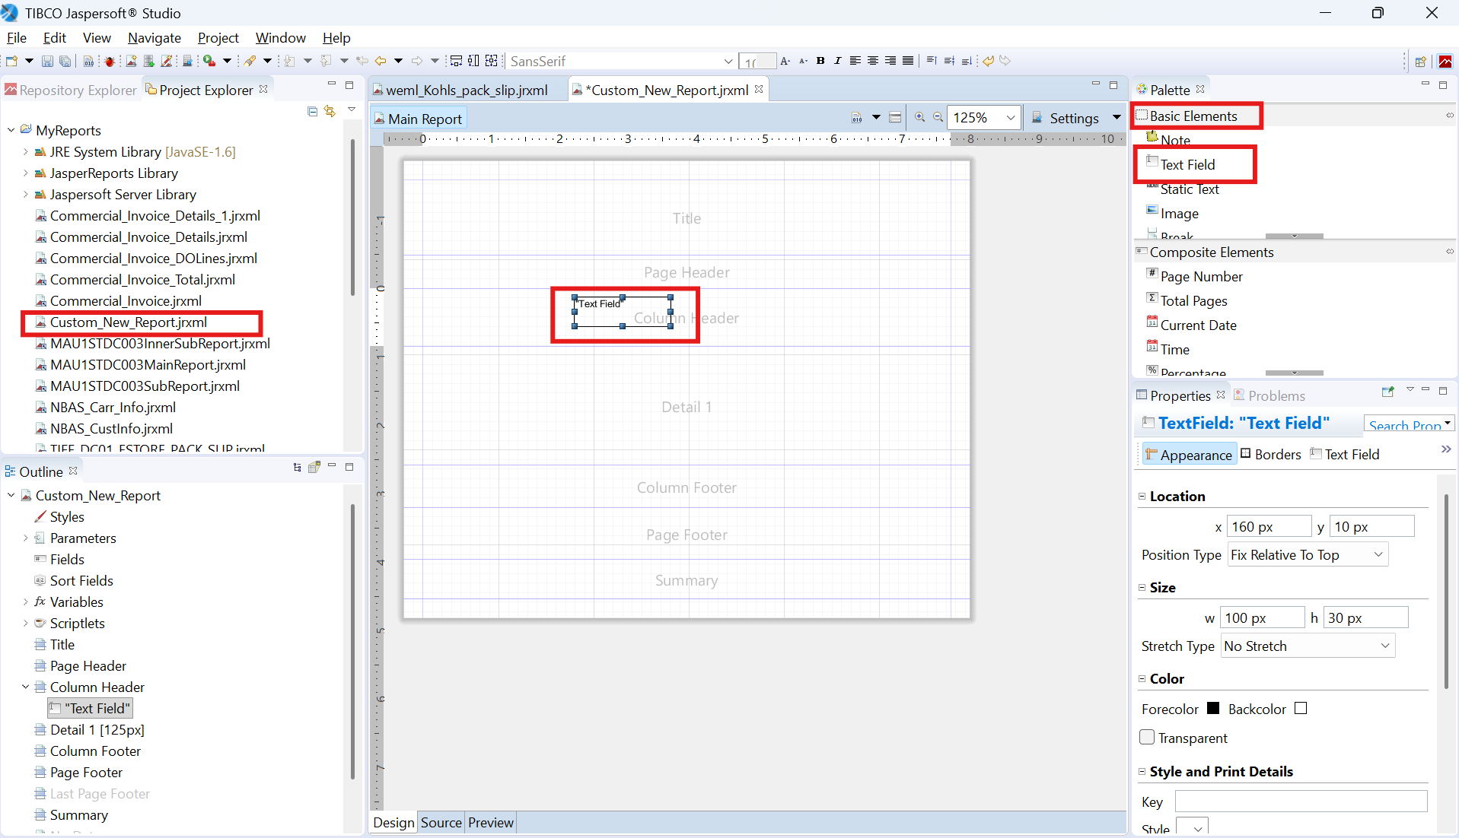
- For example, if we want to add dynamic field then we select “Text Field” and just drag and drop from Basic Elements.


- After selecting text field, it will open “expression editor” display and then select dynamic field (According to requirement) from “fields”. And then click on finish.

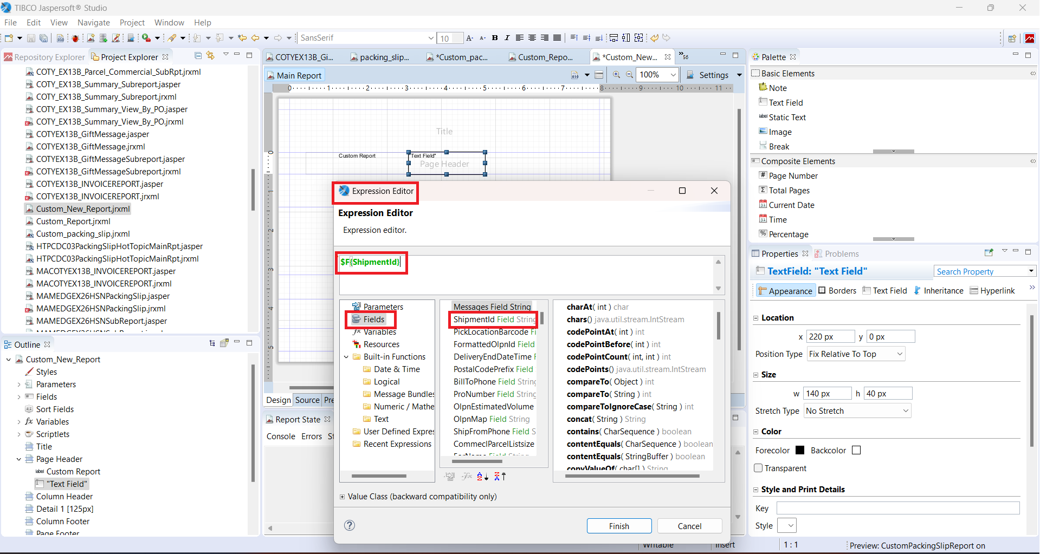

- If we want to add multiple details or list of details with table, then we can add “SubReport” and just drag and drop from Basic Elements.
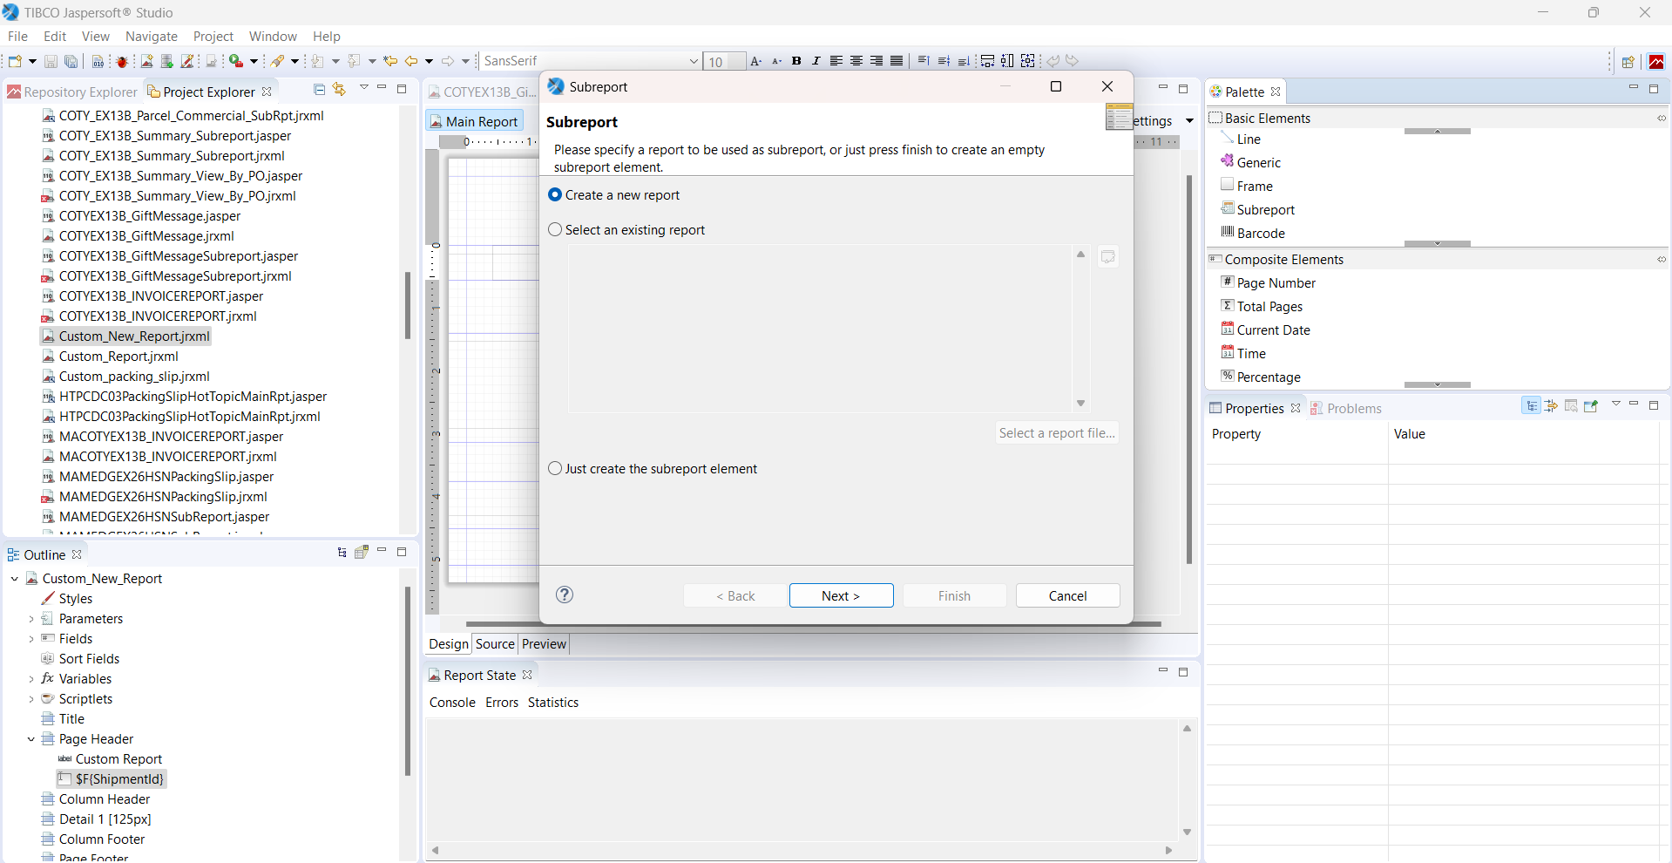

- Select report template based on client requirement and change the file name.

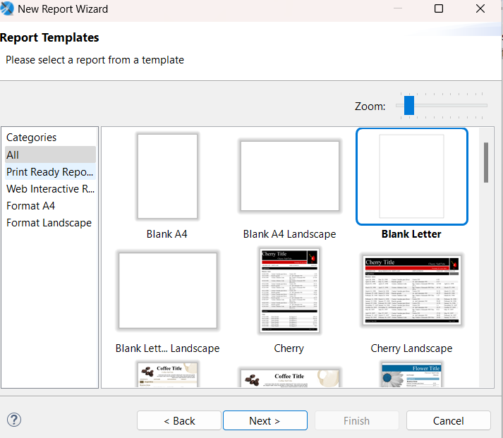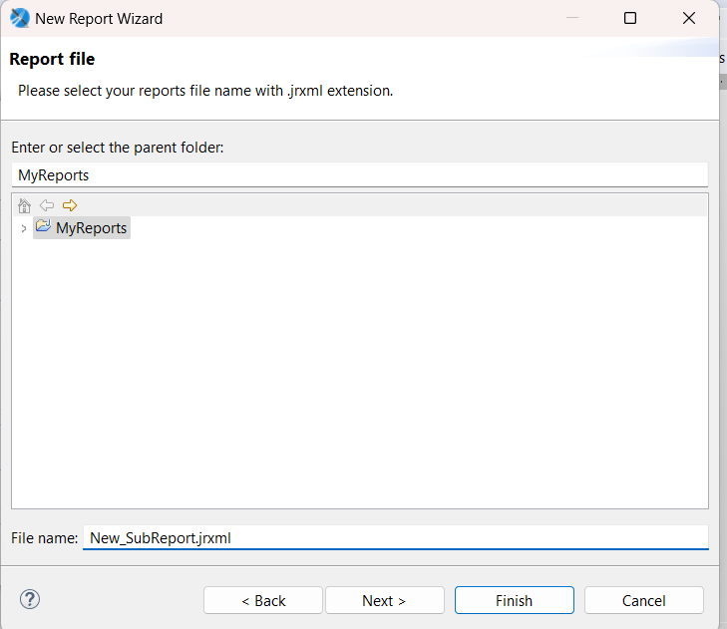

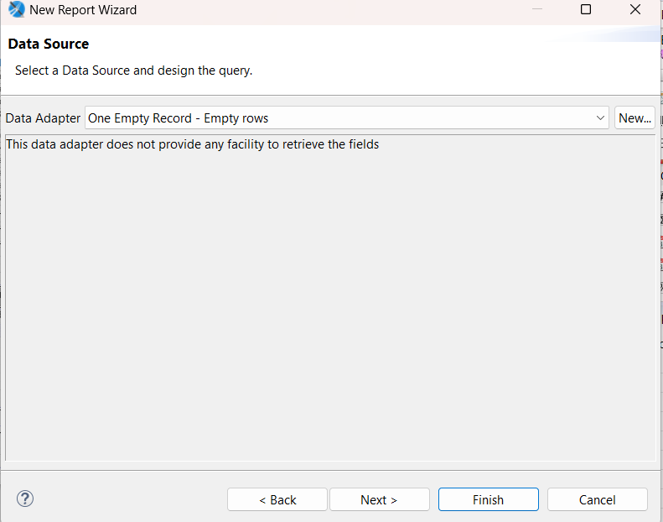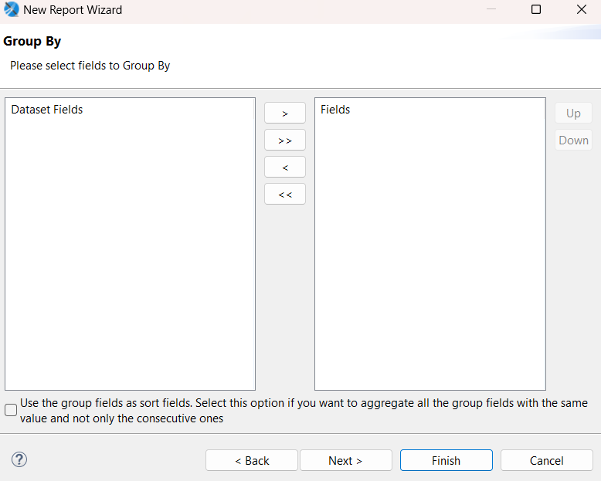

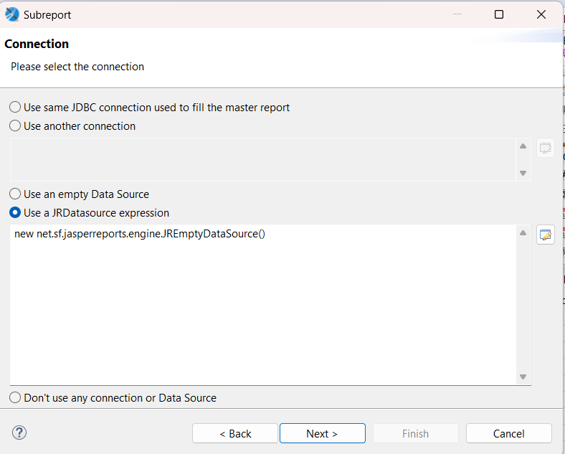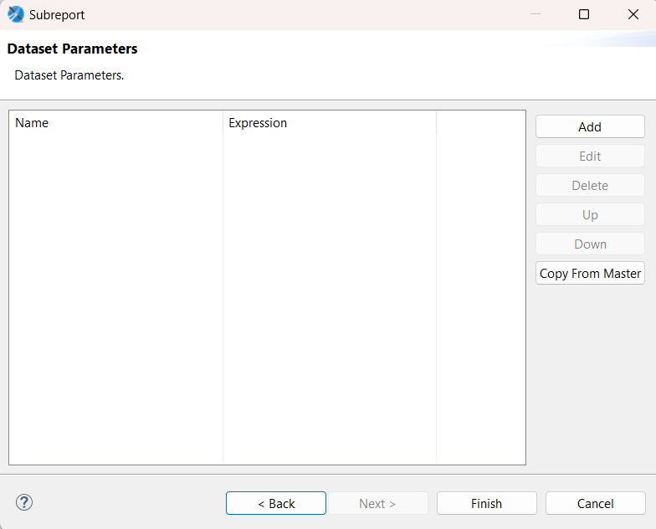

- Now you will see subreport added in detail band and then you can add static and text field based on requirement.
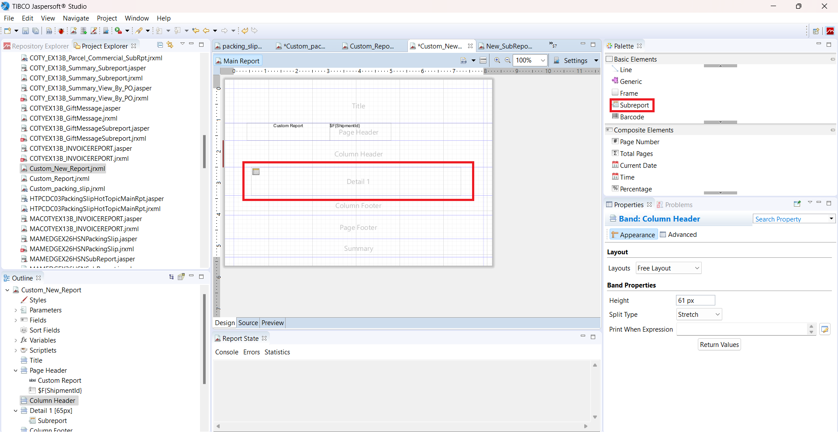

- Add JRDataSource Expression
Expression:
((net.sf.jasperreports.engine.data.JsonQLDataSource)$P{REPORT_DATA_SOURCE}).subDataSource("detail")
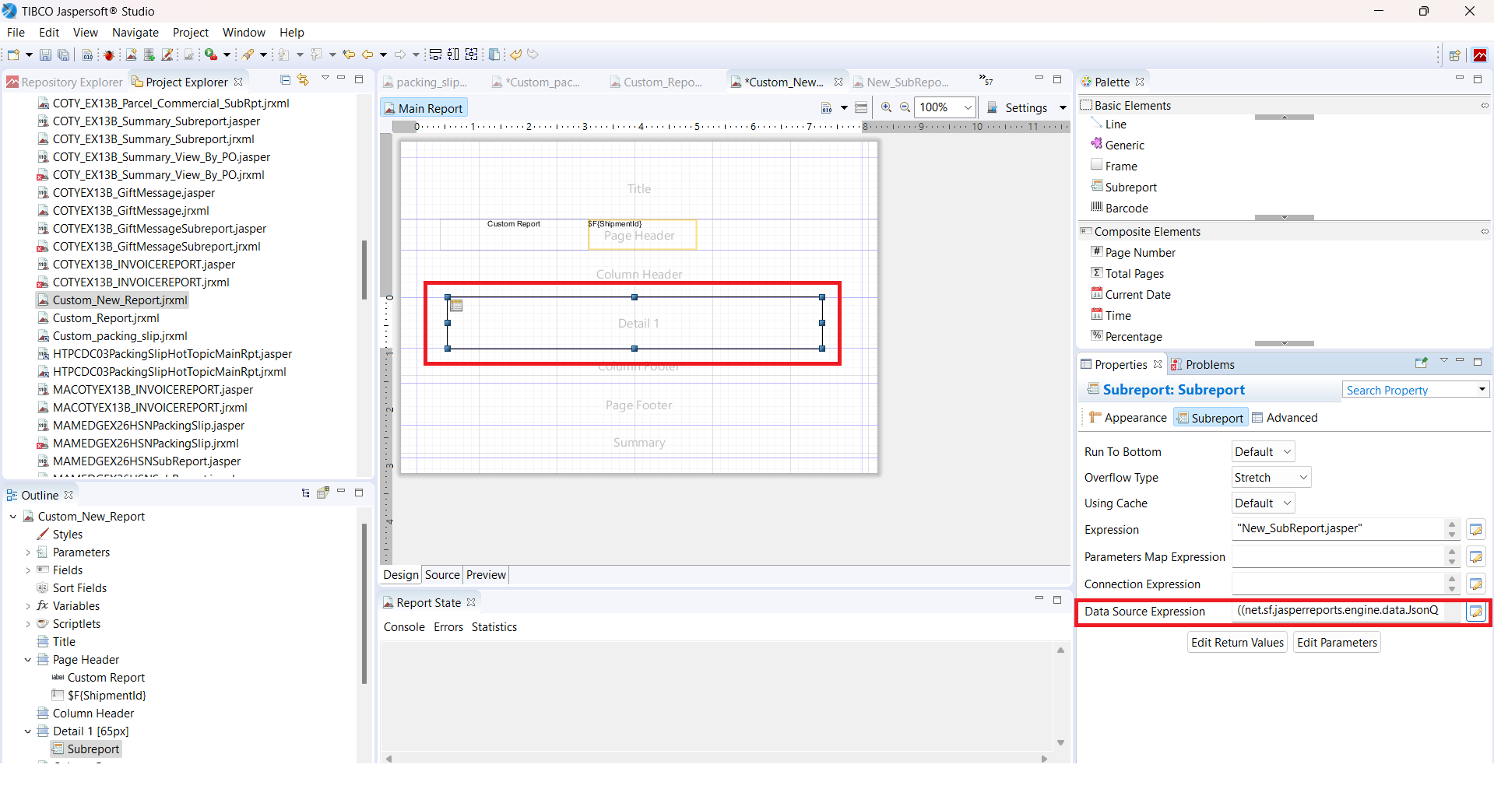
- If your changes are done you can compile and preview the report in JasperSoft local and see how report is printing.
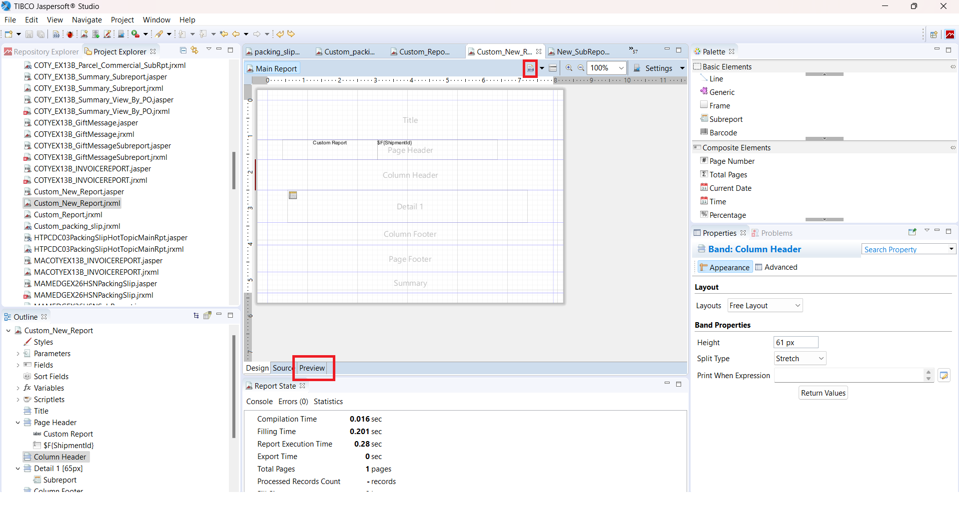
- For example set the Payload by clicking at below shown option
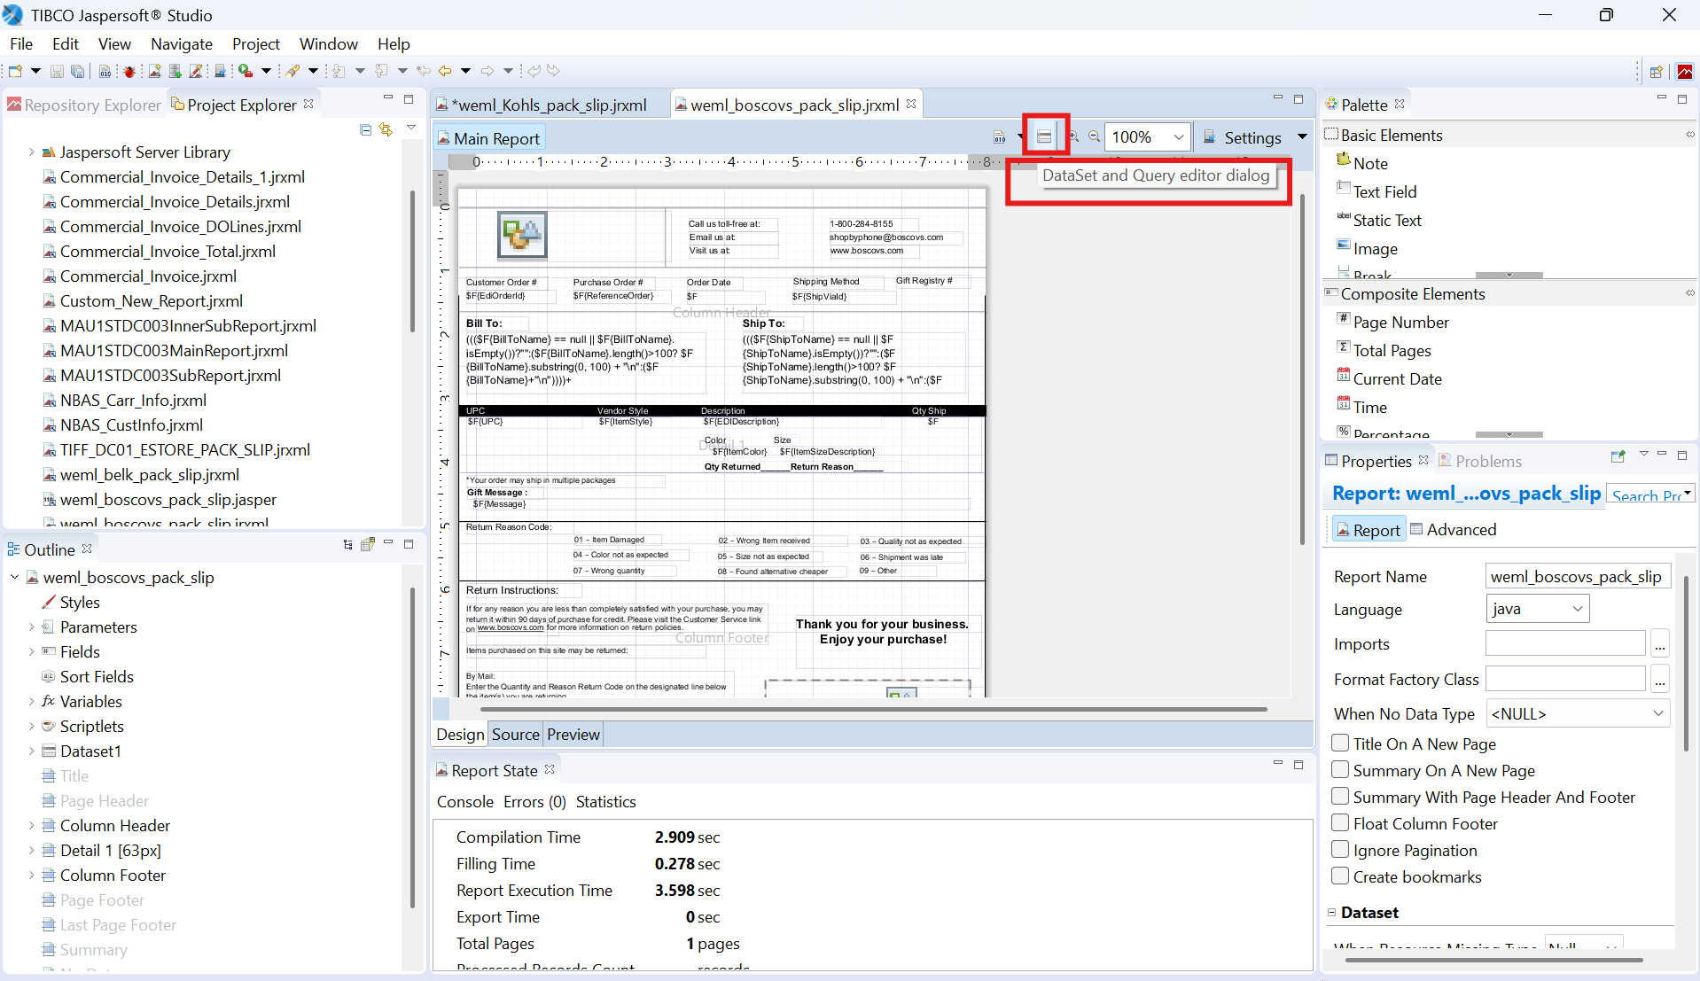

- Fill the highlighted part and click on “ok” BUTTON
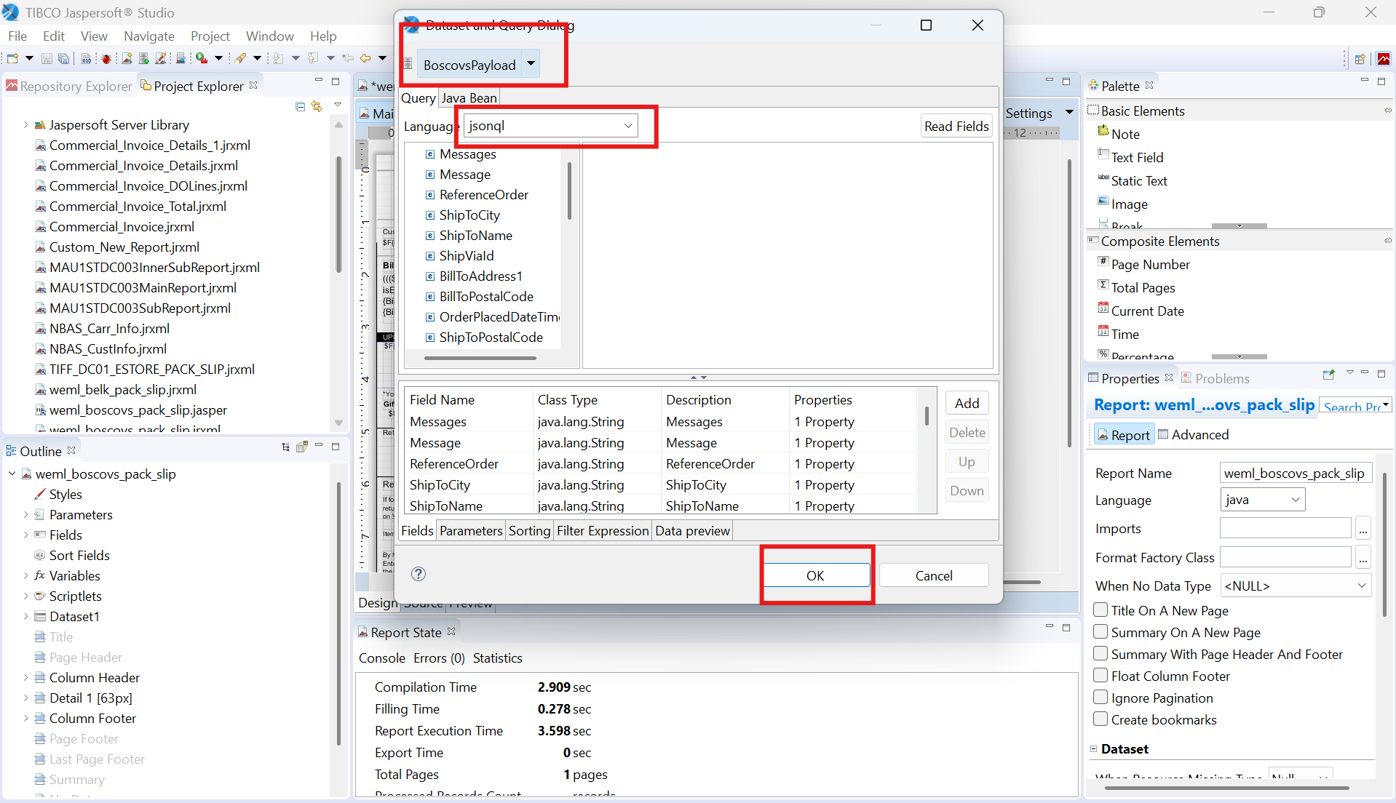
- Click on “Preview” button and see the designed report in JasperSoft local environment as below.
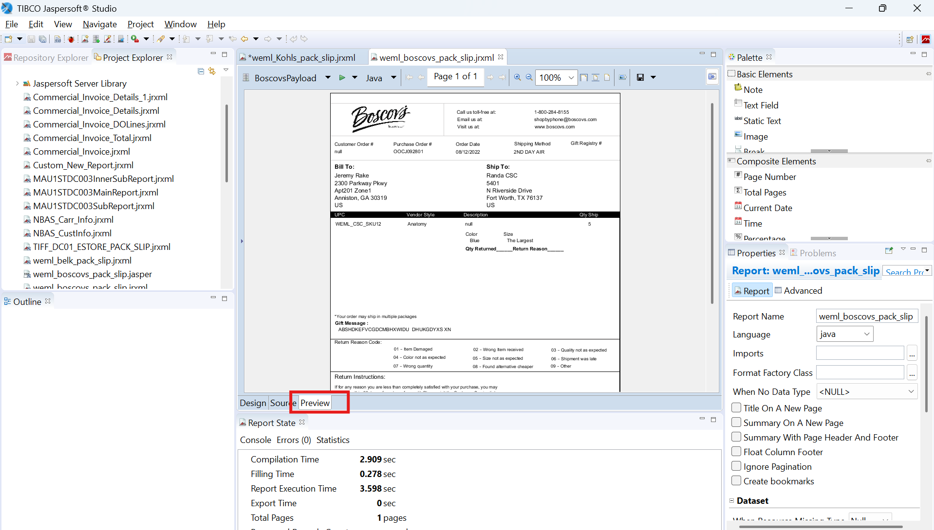

- Add reportPath, selectedOrganization, selectedLocation, token in parameter section
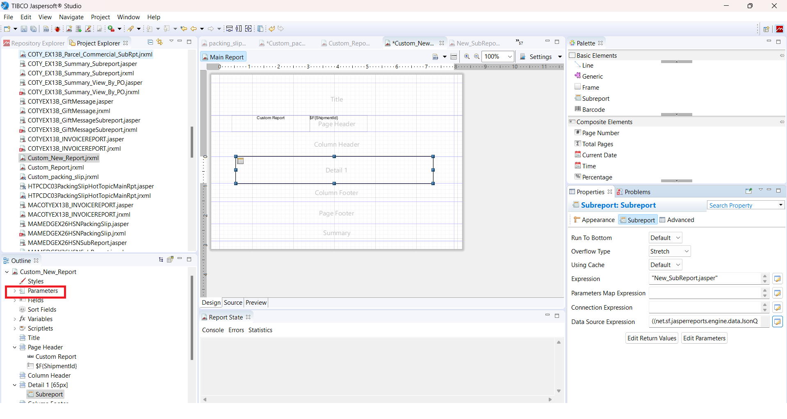

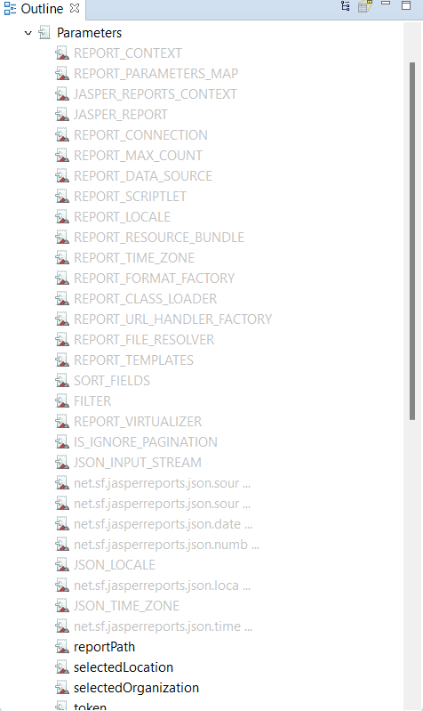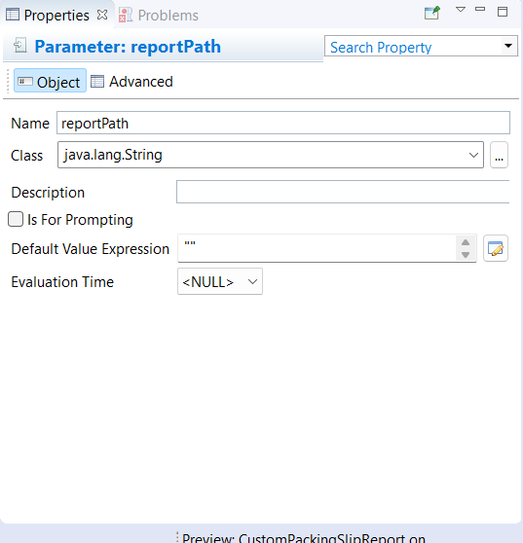

Steps to follow in uploading the jrxml to environment :
Open postman and using the following api upload the jrxml (MainReport and SubReport) using user token.
  - Api for main report: {{url}}pickpack/api/override/upload/key/Custom_New_Report.jrxml/type/document-templates/description/Report

  - Api for SubReport:
{{url}}pickpack/api/override/upload/key/New_SubReport.jrxml/type/document-templates/description/SubReport

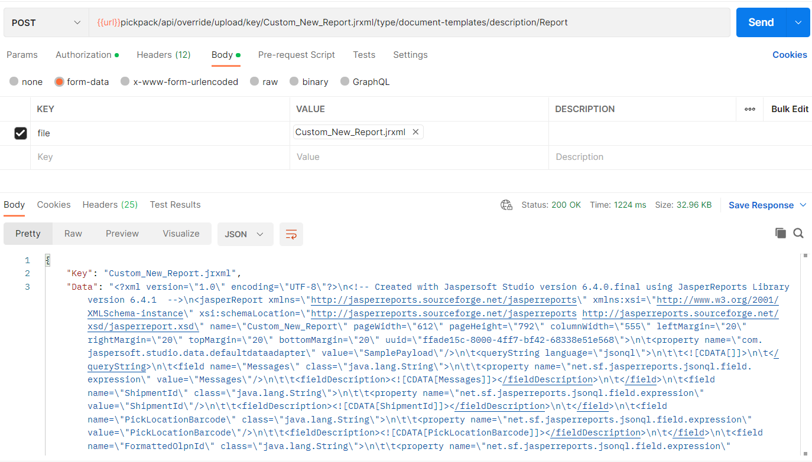

Configuration required to print the report:
- Navigate to Pickpack Document Template Type à filter out with Document Template Type “PACKING_SLIP” à Select the document template and click on edit
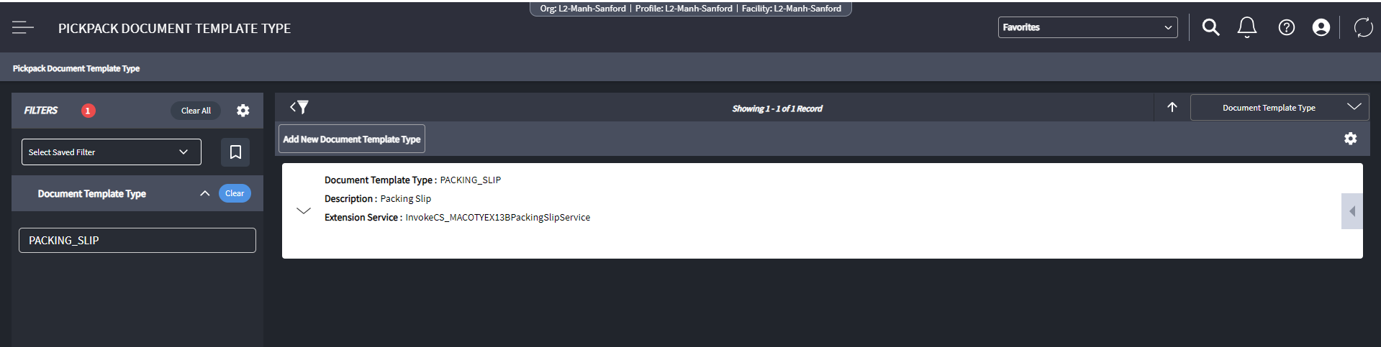

- Link the Composite Service name where you want to massage the payload and then click on save and continue.
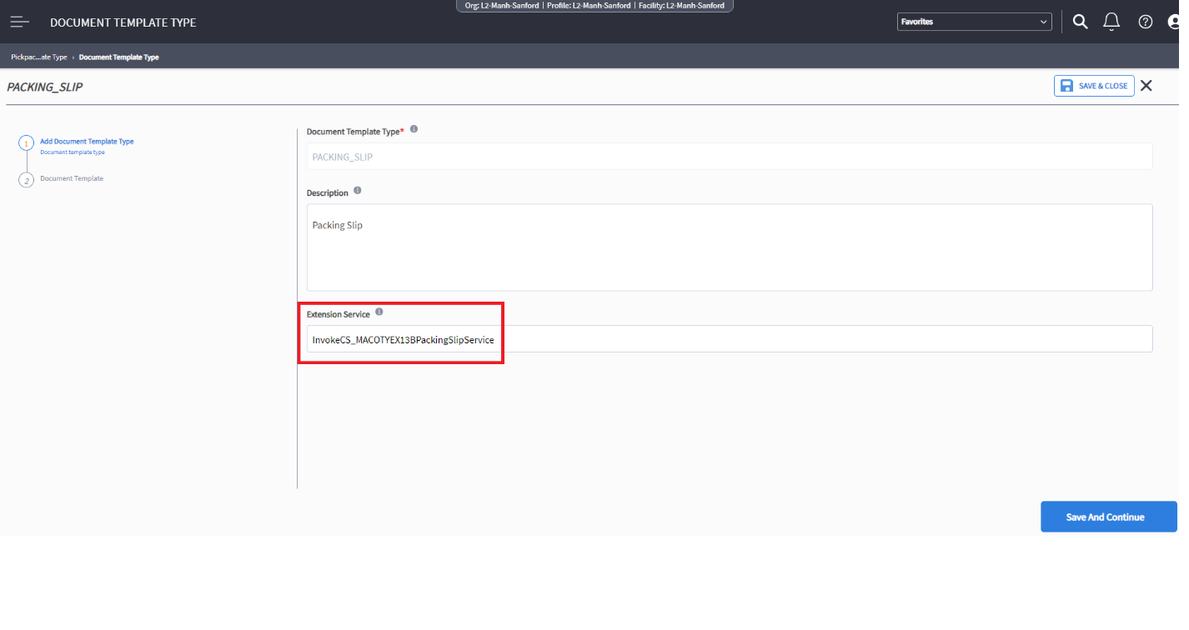
- In the next screen, click on add new Document Template. Fill the fields as shown in the screenshot below and click on submit. Next click on Save and Finish
(Note: fill as per the requirement)
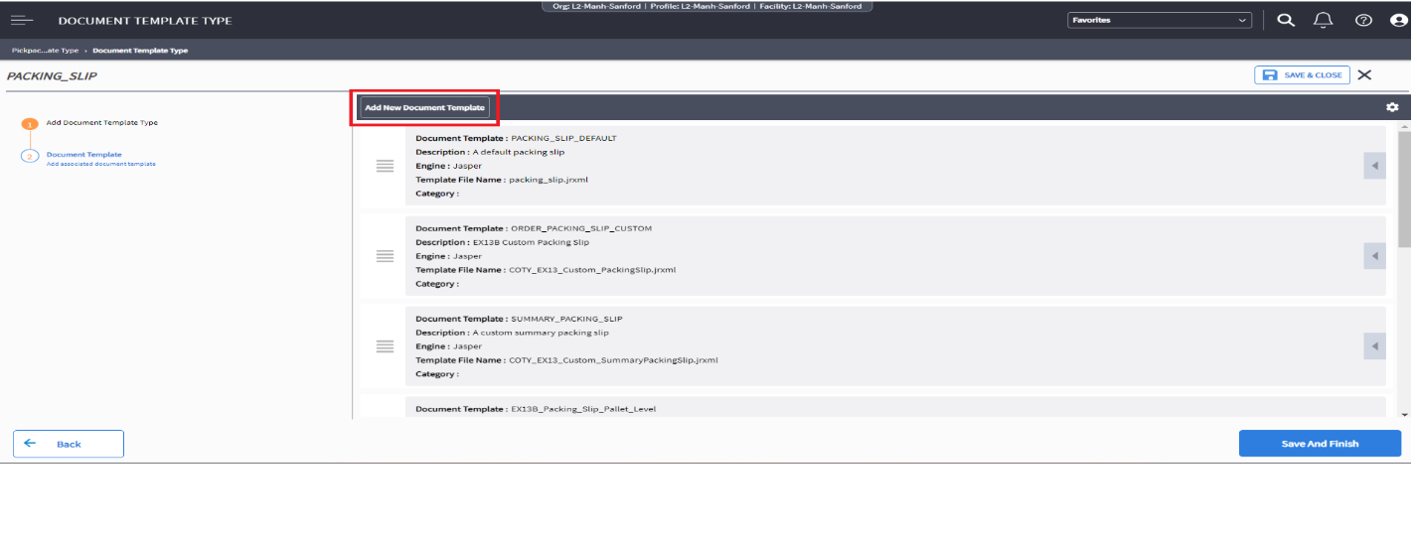

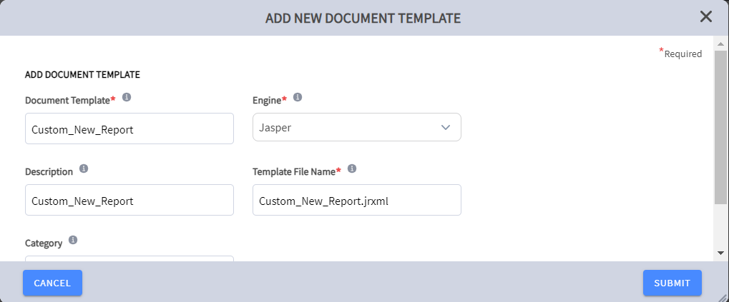

4. Navigate to Pickpack Printer Type Eligibility à Add new Printer Type Eligibility
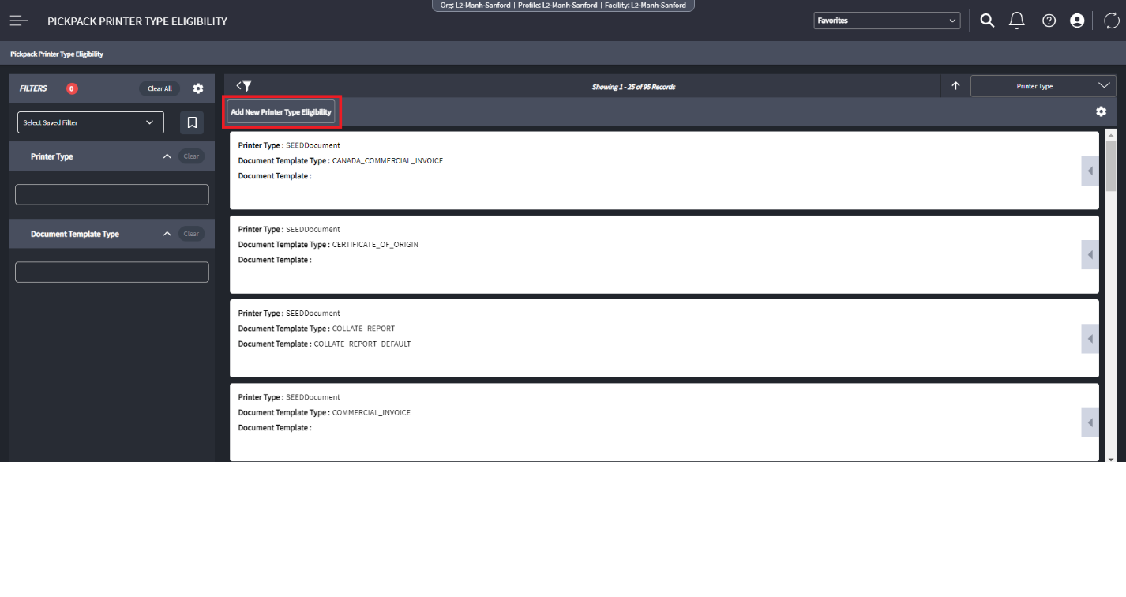
5. Fill the fields as shown in the screenshot below and click on save.(Note: fill as per the requirement)
