HTML & CSS Manual + Lab Tasks

**Objectives**

Web Development

HTML / Basic HTML Tags

Headings, Title, Paragraph

Tables, Forms, Images, Links, Lists

Buttons, Checkbox, Bold, Italic, Color, Comments

Text Box, Email, Password, Front End

**Tags**

Tags are enclosed in <angle brackets>.

The closing tag has the forward slash </tag>.

Tags can be upper or lower case — lower case is recommended.

**Attributes**

Attributes add extra properties to tags.

They are added in the opening tag within <>.

Example: <html lang="en"> adds a language attribute to <html>.

Attributes can use single, double, or no quotes (best practice: always quote).

**Basic HTML Template**

<html>  
 <head>  
 <title>HTML Template</title>  
 </head>  
 <body>  
 <h1>Main Heading Here</h1>  
 <p>Paragraph here.</p>  
 </body>  
</html>

**Headings**

There are six heading levels <h1> to <h6>.

They represent a hierarchy of importance.

<h1> to <h3> are most common.

Formatting handled by CSS.

**Lists**

Unordered List: <ul><li>Item</li></ul>

Ordered List: <ol><li>Item 1</li></ol>

Nested List: Combine <ul> and <ol> inside each other.

**Hyperlinks**

<a href="url">Link Text</a> creates hyperlinks.

href specifies the destination of the link.

Examples: External links, local files, and internal page markers.

**Images**

<img src="image.jpg" alt="description" width="100" height="100">

src is the path, alt is the description, width and height define size.

Images can be clickable by wrapping in an <a> tag.

**Tables**

HTML tables organize data in rows and columns.

Syntax Example:

<table>  
 <caption>Student Marks</caption>  
 <tr>  
 <th>Name</th>  
 <th>Subject</th>  
 <th>Marks</th>  
 </tr>  
 <tr>  
 <td>Ali</td>  
 <td>Math</td>  
 <td>95</td>  
 </tr>  
 <tr>  
 <td>Fatima</td>  
 <td>Science</td>  
 <td>90</td>  
 </tr>  
</table>

The <caption> tag adds a table title.

Use <th> for headings, <td> for normal data cells.

Attributes like colspan and rowspan help merge cells.

**Colspan and Rowspan**

The colspan attribute merges columns horizontally.

The rowspan attribute merges rows vertically.

Example:

<table border="1">  
 <tr>  
 <th colspan="2">Student Info</th>  
 </tr>  
 <tr>  
 <td>Name</td>  
 <td>Ali</td>  
 </tr>  
 <tr>  
 <td rowspan="2">Subjects</td>  
 <td>Math</td>  
 </tr>  
 <tr>  
 <td>Science</td>  
 </tr>  
</table>

**Div Tag**

The <div> tag is a container element used to group HTML elements together.

It does not add any visual change by itself but helps in layout and styling.

Divs are commonly used with CSS to structure web pages.

Example:

<div style="background-color:lightblue; padding:10px;">  
 <h2>Welcome</h2>  
 <p>This is inside a div block.</p>  
</div>

**Quotations**

<q> for short inline quotes.

<blockquote> for long block quotes.

**Line Breaks and Comments**

<br> forces a new line.

<!-- comment --> adds a comment.

<hr> adds a horizontal line.

**Forms**

HTML forms collect user input.

Syntax Example:

<form action="/action_page.php">  
 <label for="fname">First name:</label><br>  
 <input type="text" id="fname" name="fname" value="John"><br>  
 <label for="lname">Last name:</label><br>  
 <input type="text" id="lname" name="lname" value="Doe"><br><br>  
 <input type="submit" value="Submit">  
</form>

Dropdown Example:

<form action="/action_page.php">  
 <label for="cars">Choose a car:</label>  
 <select id="cars" name="cars">  
 <option value="volvo">Volvo</option>  
 <option value="saab">Saab</option>  
 <option value="fiat">Fiat</option>  
 <option value="audi">Audi</option>  
 </select>  
 <input type="submit">  
</form>

**CSS Linking Styles**

Three types: Inline, Internal, External.

Inline example: <h1 style="color:blue;">Heading</h1>

Internal example: <style> body {background-color: powderblue;} </style>

External example: <link rel="stylesheet" href="file.css">

# Procedure to Create and Run an HTML File

Follow these steps to create and run your first HTML file:

1. Open a text editor such as Notepad, VS Code, or Sublime Text.

2. Type your HTML code. Example:  
  
<html>  
 <head>  
 <title>My First Web Page</title>  
 </head>  
 <body>  
 <h1>Welcome to HTML</h1>  
 <p>This is my first HTML page.</p>  
 </body>  
</html>

3. Save the file with the extension .html (for example, first.html).

4. Open the file in any web browser (Chrome, Firefox, Edge) by double-clicking it or dragging it into the browser window.

You will see your HTML content displayed as a web page.

# Basic CSS Example – Changing Text and Background Color

CSS (Cascading Style Sheets) is used to control the appearance of HTML elements.

Below are examples of adding color and background color in different ways:

1. Inline CSS Example:

<h1 style="color:blue; background-color:yellow;">Welcome to My Web Page</h1>

2. Internal CSS Example:

<html>  
 <head>  
 <style>  
 body {background-color: lightgray;}  
 h1 {color: darkblue;}  
 p {color: green;}  
 </style>  
 </head>  
 <body>  
 <h1>This is a Heading</h1>  
 <p>This is a paragraph styled with CSS.</p>  
 </body>  
</html>

3. External CSS Example:

<html>  
 <head>  
 <link rel="stylesheet" href="style.css">  
 </head>  
 <body>  
 <h1>This is a Heading</h1>  
 <p>This paragraph is styled using an external CSS file.</p>  
 </body>  
</html>

External CSS File (style.css):

body {  
 background-color: pink;  
}  
h1 {  
 color: navy;  
}  
p {  
 color: darkgreen;  
}

**In Lab Exercise:**

**Task 01:**

The objective of this lab task is to learn how to implement a hyperlink and how to insert an image on a web page.

* Create New HTML Page
* Add Paragraphs
* Make some content of paragraph as Bold, Italic and Underline
* Different font sizes
* Make a new three paragraphs and align them to Right, left and centre alignments
* Insert a hyper link.
* Insert an image.
* Display in the browser

**Task 02:**

* Implement a nested list.

**Sample Output:**

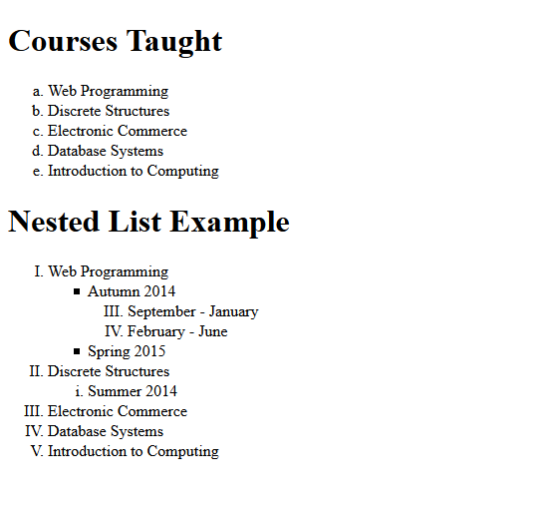

**Task 03:**

Create a form.

**Sample Output:**

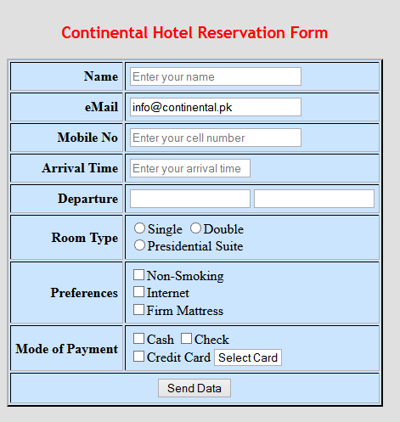

**Task 04:**

The task is to organize journal.html by adding ids, classes, spans and divss. Then, add "boxes" around these sections of the website by adding to style sheet.

* Apply border, margin and padding properties.
* Apply float, font-family and font-weight properties.

**Sample Output:**

