**Citizen AI – Project Documentation**

1. Introduction

* Project Title: Citizen AI
* Team Members:
* Ansar Ali
* Buvanesh
* Shatrock
* Ashwin Kumar

2. Project Overview

Purpose: Citizen AI is an intelligent citizen engagement platform designed to enhance interaction between governments and the public. Using AI and real-time data, the assistant provides city safety insights, government service query resolution, and sentiment analysis of citizen feedback.

Features:

* Conversational Interface – Natural language interaction for citizens.
* City Safety Analysis – Summarized crime and accident statistics.
* Sentiment Analysis – Classifies citizen feedback.
* Citizen Feedback Dashboard – Visual analytics of sentiment distribution.
* Gradio UI – Interactive multi-tab dashboard.

3. Architecture

* Frontend: Built with Gradio (interactive UI).
* Backend: Python + Transformers + Torch.
* LLM Integration: IBM Granite model.
* Visualization: Matplotlib for charts.

4. Setup Instructions

* Python 3.9+ required.
* Install dependencies: transformers, torch, gradio, textblob, matplotlib.
* Run: python app.py
* Access Gradio dashboard in browser.

1. Folder Structure

project/

■■■ app.py # Main script

■■■ requirements.txt # Dependencies

■■■ models/ # Model configs

■■■ ui/ # Gradio layouts

■■■ utils/ # Utility functions

1. Running the Application

* Launch Gradio app.
* Use City Analysis, Citizen Assistant, Sentiment Analysis, and Dashboard tabs.

7. API Documentation

* POST /city-analysis – Returns AI-generated safety report.
* POST /citizen-assist – Handles citizen queries.
* POST /analyse-sentiment – Performs sentiment analysis.

1. Authentication

Currently open for demo use. Future enhancements include token-based authentication, role-based access (citizens, officials, admins).

1. User Interface

Tabbed layout for each feature, dashboard visualization of sentiment, and clean accessible design for non-technical users.

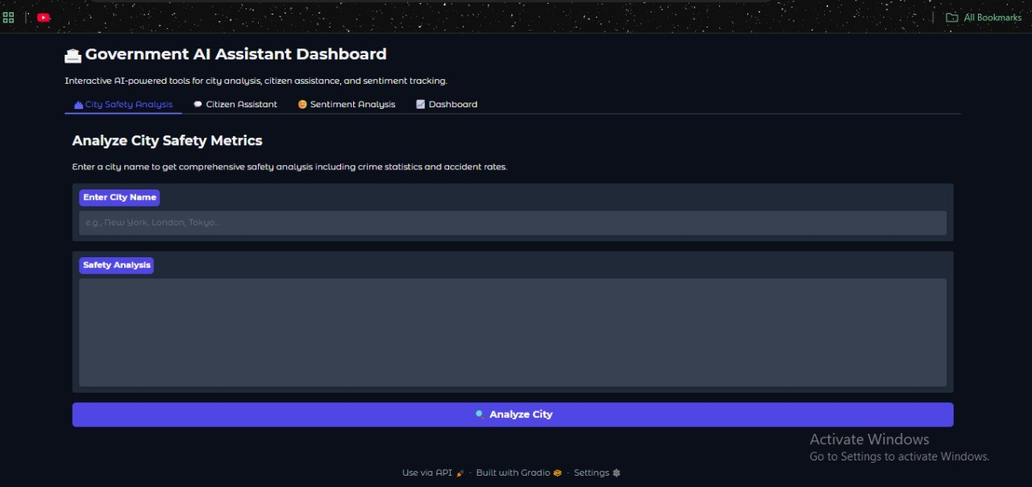

1. Testing

* Unit Testing – for AI response functions.
* Manual Testing – UI flows.
* Edge Cases – large queries, empty input.

11. Known Issues

* AI sometimes repeats prompt text.
* Model slower on CPU.

12. Future Enhancements

* Integration with real-time city data APIs.
* Multi-language support.
* Role-based authentication.
* Advanced analytics and forecasting.